2Solli Raphael Creating Texts Masterclass

During this pre-recorded lesson students will learn the craft of writing from Victorian Premiers’ Reading Challenge author ambassador Solli Raphael.

Learning Intention | To develop a distinctive writing voice by drawing on knowledge, experimenting with language features and refining work through deliberate drafting and feedback.
Success Criteria | I can:  - recall knowledge from my framework of ideas  - identify a specific purpose for a target audience  - identify and/or use language features to refine writing

Materials Required:
- Projector and Masterclass video link
- Solli Raphael Masterclass Worksheet, one per student
- Lotus Diagram graphic organizer (A3) one per student
- Optional: examples of strong vs limited knowledge based on your school’s framework of ideas
- Optional: Printed examples of writing that uses metaphor, repetition and bookending well

Activity 1: Knowledge base

- After Solli explains that a strong knowledge of content distinguishes between robust writing and vague writing, students read two excerpts on the same topic. After identifying the stronger piece, they highlight examples that show knowledge of the topic of homelessness.

Example showing limited knowledge:
They sit on the streets of our cities and towns. Homeless people deserve to have a place where they belong. It is unfair that people don’t have a home to go to. We need to stand up and fight for people who are homeless. In 2026 no person should be homeless in a rich country like Australia, and yet, many people are. Having a place to live is having a place to belong. Join me in standing up for the most vulnerable in society. Join the fight against homelessness.

Demonstrates knowledge that homelessness comes in different forms
From definition of homelessness provided by ABS
Statistics from 2021 census provided by ABS
Indicates understanding of who is in a position to bring about change
Example showing stronger knowledge base:
They sit on the streets of our cities and towns, couch surf from friend to friend, or find temporary accommodation when they can. They may have shelter, but not a home. Homeless people deserve to have a place where they belong.

I stand here today, within these four walls of the prestigious Melbourne University, knowing that I have safe and adequate housing to return home to. But this privilege is not shared with everyone. Every day, more than 122,000 Australians experience homelessness. For them, being left out is a metaphor as much as it is a physical challenge. They may not have the opportunity to come here and take a stand for action that affects their lives, but we do. We have the privilege to support those experiencing homelessness by signing this petition to Minister for Homelessness, Hon Clare O’Niel. Housing is the helping hand for those waiting on a chance to stand on their own two feet. Having a place to live is having a place to belong.

Suggested adjustment:
- Use examples from your chosen framework of ideas. You can use deidentified past student work or VCAA Examiner’s Report samples.
- The next part of the activity requires students to recall knowledge about their Framework of Ideas. Students use the Lotus Diagram to brainstorm the specific details of what they know under the subheadings:

- Events: historical, current or ongoing events social, political or cultural
- Experiences: personal anecdotes or family stories
- Ideas: thoughts, questions, statistics, themes, opposing views within the framework
- People: significant historical figures, current social, political or cultural figures, friends, family acquaintances, fictional characters, quotes
- Places: describe (using sensory imagery-hear, smell, feel, taste, see)
- Mentor texts: students write the name of the mentor text in the coloured box and then note significant details.

v
Suggested adjustment:
- Allow students to brainstorm on their own for 5 minutes making notes in one colour pen, then share ideas with a partner (or whole class discussion) to make more notes with a different coloured pen. This supports students to visually see how peer feedback builds their own knowledge.
- If your students are struggling to think of unique ideas for their writing, you might like to complete our Creating Texts Masterclass focused on State Library Victoria’s Rebel Hearts exhibition: https://www.slv.vic.gov.au/form/vces-creating-texts-masterclass
- Solli references doing research using State Library Victoria’s catalogue and databases. If you would like a guide for how to access these free resources, you can view them in our Research Masterclass: https://www.slv.vic.gov.au/form/vces-research-masterclass

Activity 2: Planning purpose and audience
- Students will now have a go at planning their piece focusing on the overarching idea, their target audience and the purpose. The overarching idea is to remind them to always connect their piece to the set title and stimulus. You can use a sample title and stimulus relevant to your Framework of Ideas, or you can use the one provided. Students are encouraged to try to change the audience and see how that can change the purpose. For example, if you are addressing young people, how would that change if you instead spoke to their parents, or the local council?

Activity 3: Writer’s Toolkit

- v The final activity includes three short activities to identify, annotate and apply the language techniques. The students are then encouraged to try to apply the techniques in their own writing. They might like to rewrite a portion of a practice SAC incorporating the techniques.
v
Suggested adjustments:
- As a class, read and discuss longer pieces that incorporate these techniques:
- Metaphors: Watch your words, Starlight, Solli Raphael
- Repetition: A Journey Worth Travelling, Starlight, Solli Raphael
- Bookending: The getting of nan’s wisdom, Tony Wright, The Age, 3 April 2010


Thank you for joining us! We would love your feedback:



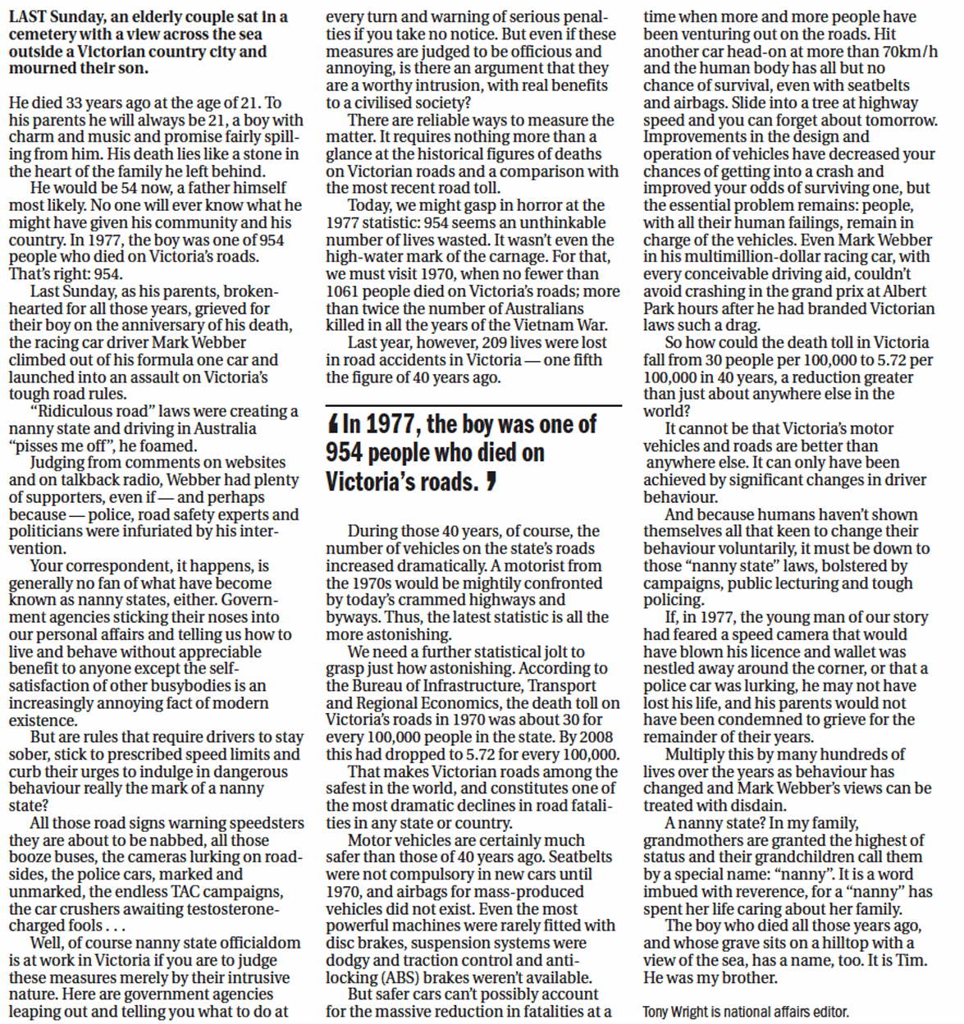
Wright, T 2010, ‘The getting of nan’s wisdom’, The Age, 3 April, p.16.

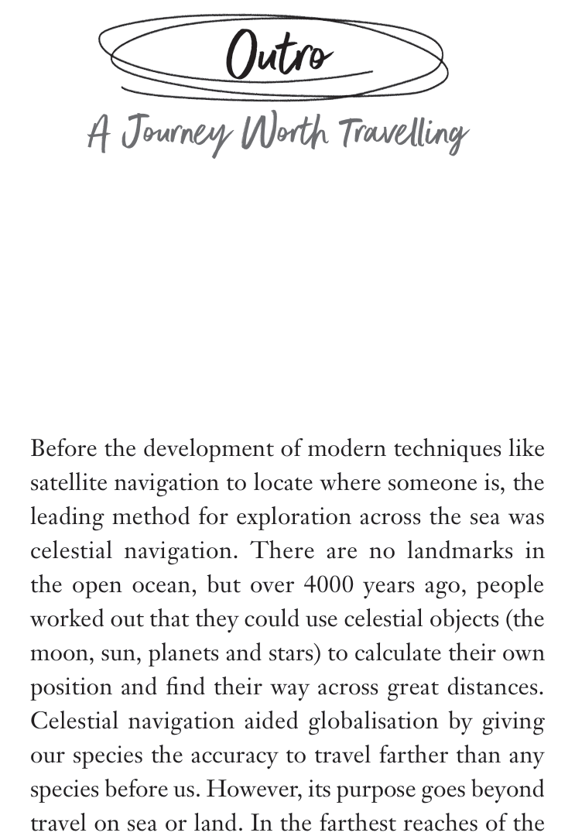
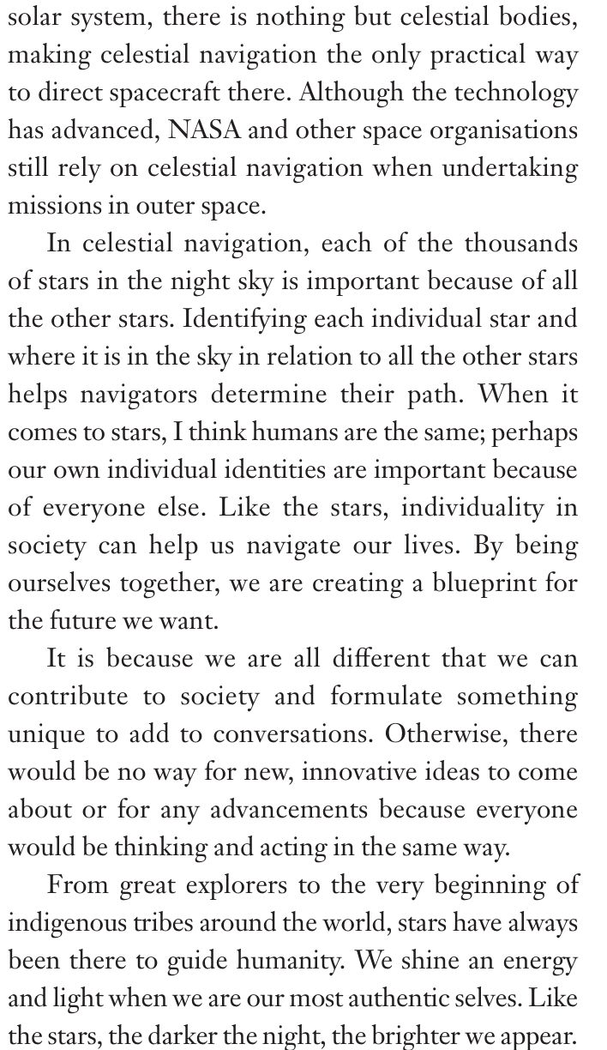

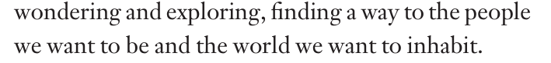
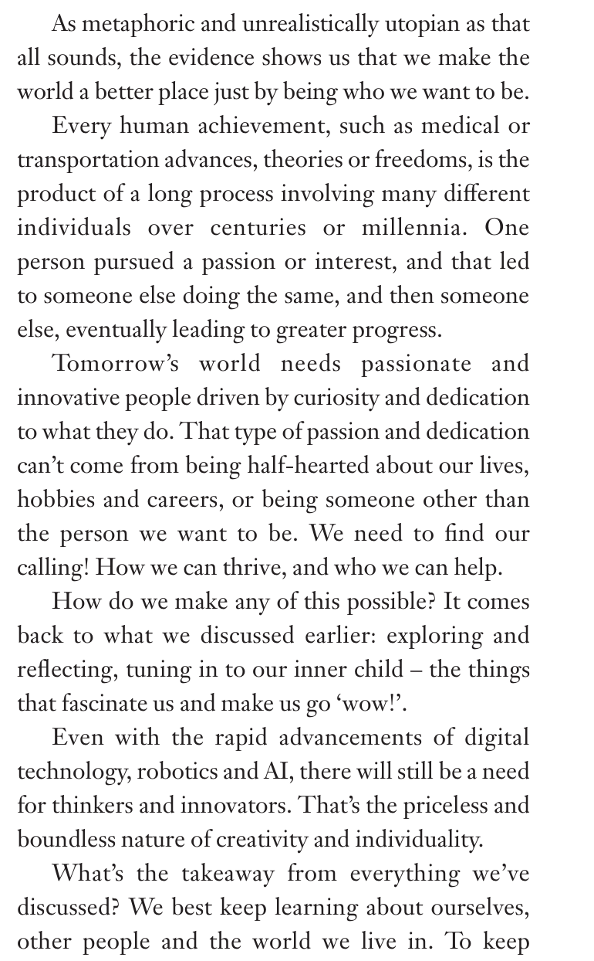

Raphael, S 2025, Starlight, Penguin Books, Australia, pp. 83-86.

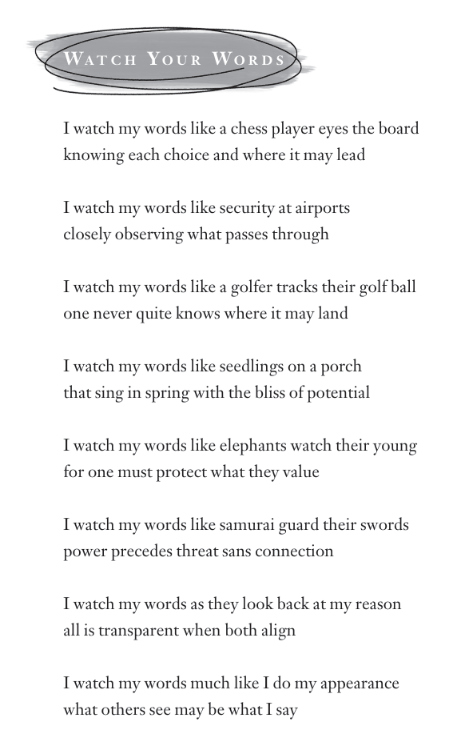
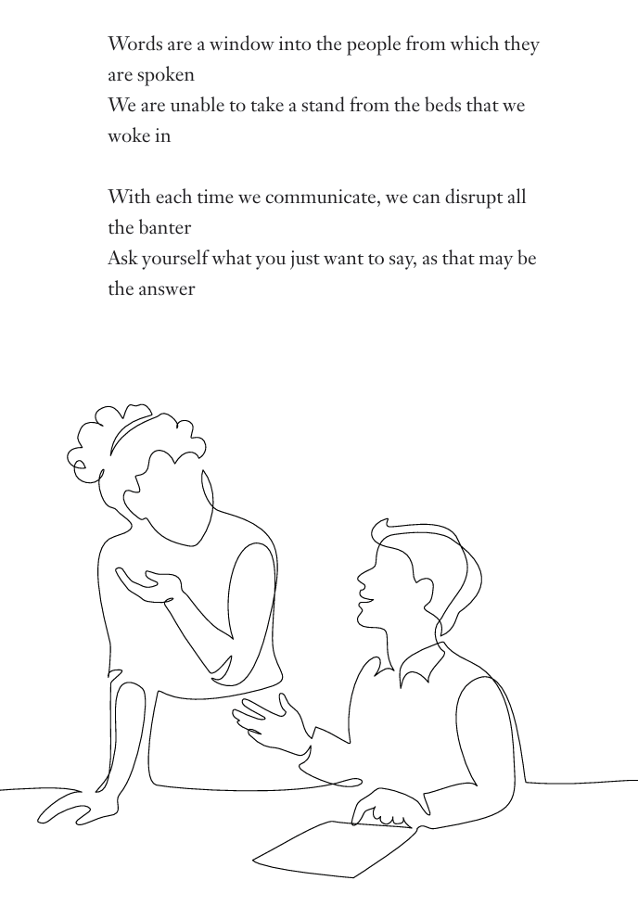
Raphael, S 2025, Starlight, Penguin Books, Australia, pp. 108-109.

