You & Me and the Gigantic Knucklehead
Book launch with Andy Griffiths
We are so excited you can join us for the online launch of Andy’s brand-new book… You & Me and the Gigantic Knucklehead!
During the session, Andy will take students on a wild and wacky adventure to the land of the Giant Knucklehead and beyond. There is sure to be a few detours on the way and lots of opportunities for your students to interact with Andy and steer the direction of the session. He will ask a series of adventure related questions throughout the presentation and prompt responses according to student preferences, using the emoji reactions available on Zoom.
After venturing through his creative process, Andy will encourage students unlock their own imaginations and introduce the ‘You & Me and the Gigantic…’ activity sheet to complete in class.

Share your students’ work on Padlet and enter the draw to win a signed copy of Andy’s new book!

Andy would love to see your students’ completed ‘You & Me and the Gigantic…’ front covers. Simply follow the instructions below to upload an image to our ‘You & Me’ Padlet board. Include your school name and postcode in the subject line and remember to cover any student names to ensure they remain anonymous.
Your school will automatically enter the draw to win books signed by Andy Griffiths!
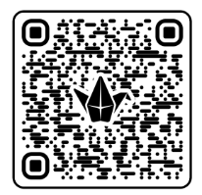
To access the Padlet board, scan the QR code or click on the following link:
https://padlet.com/statelibraryvictoria/andy-griffithsbook-launch-nbwxztbl8j7w6q5j

Padlet instructions are provided on the next page.

CREATING A POST ON PADLET
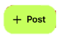  Step 1  Click on the icon at the bottom of the Padlet board.  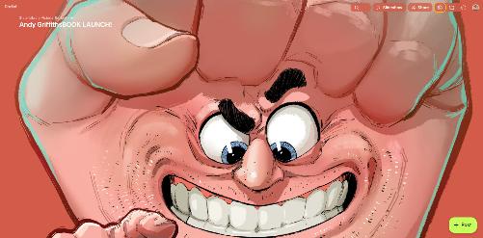 | 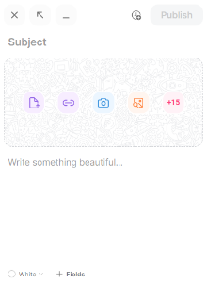  Step 2  Enter your school name and postcode in the subject line.  Insert student work sample by uploading from your device or using the camera icon to take a picture.  Optional: name the activity in the caption
Step 3  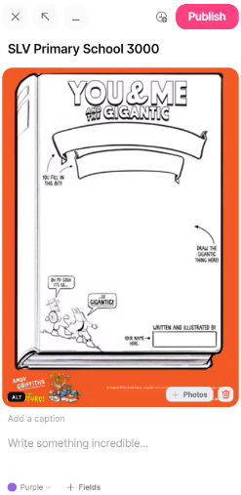  Click Publish  Your post might take a minute or two to pop up on the board; our moderators will be doing their best to keep up! | PRIZE DRAW DETAILS  - Enter as many times as you like with different student work samples.  - The Padlet board will stay open for submissions until 3pm on 14 August 2026.  - Schools will be selected at random and be notified by 19 August 2026 via the name and email provided at the time of booking.  Good luck!

