Ways to reduce waste Information Sheet:
Here are just a few ways that you and your school could consider to reduce waste.

- Nude Food Days
Nude food days focus on the packaging our food comes in. On nude food days food is not wrapped in any packaging, with containers being used that can be washed and reused.
Think about the type of packaging that you have in your lunchbox like cling wrap and other soft plastics like chip packets, yoghurt tubes, muesli wrappers etc., you might also have tetra packs from juice boxes, or cans from soft drink, maybe even foil from trays.
Food needs to be packaged for a variety of reasons such as food safety (i.e. reduction in contamination), to increase shelf life, to maintain flavour for longer (think about those rice crackers eaten a week after opening, the flavour isn’t as intense!) and so on.
As you know, packaging creates a huge amount of waste, much of which ends up in landfill. Nude food days encourage bringing food to school without this disposable packaging.
- No cook recipes
There are a number of websites which offer no cook recipes to reduce the amount of food waste.
These include:
- Australian eggs
- Ozharvest
- Second Bite
- Heart Foundation
- Food bank
- Nutrition Australia
- Fare Share

- Paper/Cardboard and how it can be reused
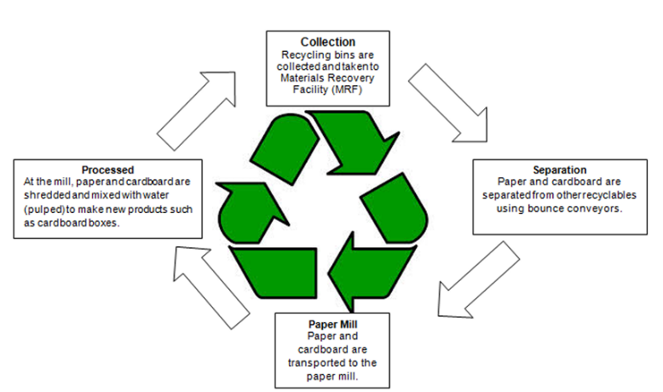
Because paper and cardboard are made from wood fibres it can be recycled up to eight times before becoming biodegradable waste (see image; source: Recycling fact sheet - Paper and cardboard).
But there are other ways you can reuse paper and cardboard in the classroom before recycling it.
For example, you can:
- Place paper that only has information/old work on one side in a container to reuse the unused side.
- Place paper or cardboard in another container that can be used for collages or other art and craft activities.
- Instead of throwing away cardboard boxes (like A4 printer boxes) you can repurpose them to store exercise books, classroom resources etc.
- You can use cardboard in your school garden to keep weeds down or as part of mulching

- Decanting food
Instead of set nude food days you can also endeavour to make your lunchbox as sustainable as possible by decanting food from home that use packaging (and disposing this packaging in a sustainable way) in larger formats and bringing this to school.
For example, instead of purchasing smaller chip packets you could purchase one large chip packet and decant a smaller portion into a reusable container to bring to school. Or another example, purchase a large tub of yoghurt rather than smaller individualised tubs and decant a smaller portion into a container, bringing this and a spoon to school.
Although this process is similar to nude food days, it is on a larger scale as you reduce not only the packaging brought to school but also packaging used overall in the household.

