Big Ideas for Young Minds
Online Sessions
Victorian Curriculum 2.0 Connections

We are excited to welcome you to our online sessions for Big Ideas for Young Minds, 2026.
This information sheet outlines what your students will achieve in the ResourceSmart Schools session and provides you with the lesson outline and resources required.
Please note this workshop has two options for the activity. A “clean” option where students complete a waste audit using photos of waste or a waste audit of the classroom bin (from the previous 24 hours).

Session 1: ResourceSmart Schools
Learning Intentions:
- To understand the scale and impact of waste in Australia, exploring the consequences of poor waste management and reflect on their own contribution to the problem through their habits at school.
- To apply their knowledge of Victorian waste management by brainstorming a solution through a hands-on classroom waste audit identifying practical ways they can improve waste management at school.
Overview:
In this workshop, students will learn from ResourceSmart Schools (RSS) about waste management practices in their school community and beyond. By understanding the problem of poor waste management, students will be challenged to think about how their own habits and choices contribute to broader environmental issues and explore how schools can play an active role in driving meaningful change.
For the key learning activity, students have two options. They can conduct a live waste audit of their classroom, examining the different types of waste collected over a 24-hour period and categorising each item based on its correct disposal method. Alternatively, students will be provided with a "clean" waste audit that mimics what is commonly found in classroom bins, allowing them to complete the activity in a more controlled setting. Through either option, students will uncover the gaps between current waste practices at their school and what best practice looks like, leaving with practical ideas for how they can lead change in their school community.
Please refer to the relevant information depending on the activity option selected.
Optional Incursion – Contact prior to the livestream:
You have the option of connecting with your RSS facilitator directly through the ResourceSmart School portal. If possible, your regions facilitator may be able to run the waste audit workshop on the same day of the livestream. You can also complete this at a later date. If you need additional support, you can contact Inga directly at Inga.hamilton@sustainability.vic.gov.au.

Option 1: Classroom Waste Audit
You will likely need to liaise with cleaning staff, support workers and other staff and students who might use your classroom. They may have access to some of the resources required (rubbish bags, gloves, tarp etc.).
We do recommend conducting the audit outside where there is good ventilation. Whilst your waste shouldn’t be too smelly, you may have sensitive nostrils in your class.

Resources Required:
- Classroom waste for 24 hours
  - You can empty your bin(s) into a large bag the day before and store it.
  - Also include waste from the day of the audit. For example, the livestream is scheduled to start at 10:30am so collect waste from 10:30am the day prior.
  - Only include the usual amount of waste from your classroom.
- A large tarp (for the waste to be poured onto)
- Gloves or tongs (to pick the waste and sort it)
- A printed copy of the waste audit worksheet (to record your findings)
- X1 large rubbish bag
- Labels for each corner of the room in preparation for sorting (provided to you)
- Camera to record your findings (to post to the padlet)
- Access to Padlet (ResourceSmart Schools X State Library Victoria)
- A brush/pan set or shovel to place waste into rubbish bag after sorting
- A scale (if you don’t have access to one that is okay, you can estimate the size and weight of what you gather)
- “Ways to reduce waste” information sheet
- Optional: Classroom set of traffic light card resource
Classroom Set Up:
- Allocated room in your classroom for the waste to be laid out.
  - If you are completing the audit in the classroom, it is best to move tables to the walls and place chairs in front of the tables, so students have somewhere to sit while watching the livestream.
  - Otherwise, you can set up the audit after the livestream at a time that suits you (the padlet will be open to comments for one week after the livestream for feedback).
  - You will need four locations or stations, one for each type of waste: Paper and Cardboard, Organics (food and garden waste), soft plastics and general waste, comingled recycling (glass, steel, aluminium, hard plastics).
  - You will also need a central location to tip out the waste for students to sort onto a tarp.
- Place Tarp over each chosen surface.
- Place one sign per station.
- The scale should be placed at the front of the classroom with the gloves and tongs.
- One printed version of the waste audit worksheet (A3 size)
- Optional: Printed class set of traffic light cards (provided)
- Bag of waste collected in the last 24 hours.
- Printed “Ways to reduce waste” information sheet.

Lesson Outline (Option 1):
Livestream (25 minutes)

Section: | What will students be doing? | How will you support your students?
Welcome | Listening as Inga introduces RSS, how the program came about and the need for change. | Encourage active listening.
Trivia Quiz | Listening to Inga and actively participating in the quiz. Students can use the traffic light cards if they wish. | By typing the majority answers to the quiz in the livestream chat.
Waste Management practices Discussion | Listening to Inga, discussing her questions about waste management practices at school and home and reflecting on what they might be able to do to create change. | Encourage active listening, typing student answers into the chat.
Clean up Australia Day | Students will listen to Inga explain more about Clean up Australia Day and how they can get involved. | Encourage active listening.
Common waste items – What do we do with them? | Listening to Inga give examples of what can and can’t be recycled. Students can ask questions about specific items in the chat. | Encourage active listening, typing student answers into the chat.
What is a waste audit? How do I conduct one? | Listening to Inga explain what a waste audit is, and how to complete one. | Encourage active listening.
Introduce activity | Inga will pass over to the teacher who will explain the chosen classroom activity, prompting students to post their results to the Padlet. | Log out of the livestream and provide instructions to your students of the activity.
Classroom Activity (30 minutes)

Pre-Waste Sorting
- Once Inga has completed the livestream element of the RSS workshop, the livestream can be turned off.
- Go to the location you will be completing the waste audit (this can be at a later time/day, it does not need to occur directly after the livestream).
- Tip the classroom waste onto the tarp in the central location.
- Provide each student with a pair of gloves and tongs.
- Reiterate the points that Inga covered about how to categorise the waste items. Show the waste audit table and explain how it should be used.
- Using the waste in front of them, students will agree on a prediction for the total weight of each of the four categories. Ask a student to record this on the labels in each corner. (Estimated weight = X(grams or kgs)
- Each student should then record on the whiteboard what they think the TOTAL amount of waste is in front of them.

Waste Sorting
- Note the audit can take up to 30 minutes, if you don’t get everything sorted this is fine, you will still have a good idea of how much waste you are producing.
- Students begin categorising waste using the method that Inga explained. You may wish to select a student to record the results in the auditing table provided as they go along or you may wish to complete this at the end once everything has been sorted.
- Students should place the item on the tarp, so that you have a visual representation of each type of waste (see example photos below).
- Allocate one student to take photos of each station once the sorting is complete (to add to the padlet).

Post Waste sorting
- As a class ensure the waste audit sheet is complete.
- First review the waste that remains in the general sorting location – is this waste here because it couldn’t be categorised? (if you ran out of time skip this step)
- Then, go to each waste station and consider:
  - the amount that is located at each station
  - discuss with students how they feel seeing the amount and size of waste
  - for the comingled recycling, organic waste and paper and cardboard stations also discuss knowing these items don’t need to go to landfill do they think they might reconsider where they place their waste at school?
- Place sorted waste into the rubbish bag and record the total weight for each section and discuss whether this amount is similar or different to the prediction made at the beginning of the activity? Why do they think this is the case?
- Once you’ve reviewed each station as a class, discuss how you could improve the waste management process of your classroom. Are there any solutions your class can come up with?
- Share with students some of the solutions RSS suggests to classes by reading out the information from the “Ways to reduce waste Information sheet”.
- Students should discuss which, if any, of these solutions could work for them and write down a pledge in their workbooks or on butchers’ paper for the class to sign and display in a prominent location around the room (i.e. [Class title] pledges to reduce waste by [solution proposed]).
End of activity

After the activity:
- If you have not already done so you can reach out to your RSS facilitator for your region via the ResourceSmart School portal.
- You can complete a full school audit of waste using the module designed by ResourceSmart schools.
This is only the beginning to spur your students on to make a change for the earth we all share. This is about building a community of support and not shaming anyone for their choices.

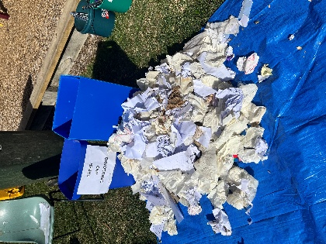
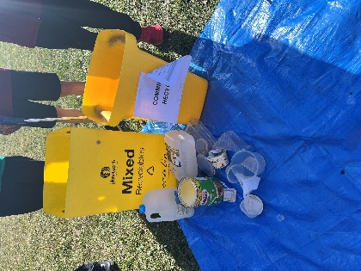
Example photos of what the waste audit could look like once all waste has been sorted:
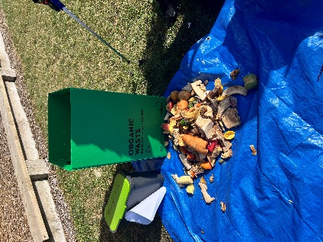
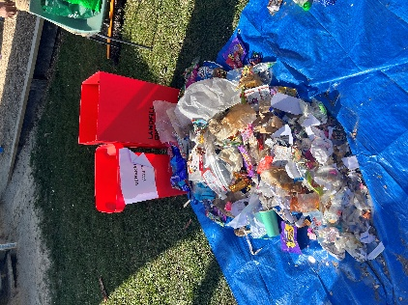
Option 2: “Clean” Waste Audit
Resources Required:
- Waste item images with item weight (4 to a page cut up)
- Station labels (Paper and Cardboard, Organics (food and garden waste), soft plastics and general waste, and comingled recycling (glass, steel, aluminium, hard plastics)
- One printed version of the waste audit worksheet (A3 size)
- Optional: Printed class set of traffic light cards (provided)
- Printed “Ways to reduce waste” information sheet.
- Camera to record your findings (to post to the padlet)
- Access to Padlet (ResourceSmart Schools X State Library Victoria)
- Calculator to add up the “weights” of the waste.

Classroom Set Up:
- Divide the classroom tables into four groups prior to the livestream and hand out the set of traffic light cards (if using them)
- After the livestream, place the one station label per station.
- Place waste item images at the front of the classroom with the waste audit worksheet.

Lesson Outline (Option 2):
Livestream (25 minutes)

Section: | What will students be doing? | How will you support your students?
Welcome | Listening as Inga introduces RSS, how the program came about and the need for change. | Encourage active listening.
Trivia Quiz | Listening to Inga and actively participating in the quiz. Students can use the traffic light cards if they wish. | By typing the majority answers to the quiz in the livestream chat.
Waste Management practices Discussion | Listening to Inga, discussing her questions about waste management practices at school and home and reflecting on what they might be able to do to create change. | Encourage active listening, typing student answers into the chat.
Clean up Australia Day | Students will listen to Inga explain more about Clean up Australia Day and how they can get involved. | Encourage active listening.
Common waste items – What do we do with them? | Listening to Inga give examples of what can and can’t be recycled. Students can ask questions about specific items in the chat. | Encourage active listening, typing student answers into the chat.
What is a waste audit? How do I conduct one? | Listening to Inga explain what a waste audit is, and how to complete one. | Encourage active listening.
Introduce activity | Inga will pass over to the teacher who will explain the chosen classroom activity, prompting students to post their results to the Padlet. | Log out of the livestream and provide instructions to your students of the activity.
Classroom Activity (30 minutes)

- Once Inga has completed the livestream element of the RSS workshop, the livestream can be turned off.
- Explain to students that they will be completing a “clean” waste audit mimicking what would be completed with real waste – but without the smell!
- Reiterate the points that Inga covered about how to categorise the waste items. Show the waste audit table and explain how it should be used.
- Spread out the different waste image cards on the floor in front of students or on a table so they can see the “type” of waste and amounts.
- Using knowledge from the livestream and a cursory look at the waste images, students should predict the total weight of each of the four categories. Ask a student to record this on the labels in each station. (Estimated weight = X(grams or kgs)
- Each student should then record on the whiteboard what they think the TOTAL amount of waste is in front of them.

Waste Sorting
- The sorting should only take around 10-15 minutes. Students should try to complete two waste items individually (with a total of 50 waste images provided).
- Students begin categorising the waste images using the method that Inga explained. You may wish to select a student to record the results in the auditing table provided as they go along or you may wish to complete this at the end once everything has been sorted.
- Students should place the waste image face up, ensuring each image is clearly shown for a visual representation of each station.
- Allocate one student to take a photo of each station once the sorting is complete (to add to the padlet).

Post Waste Sorting
- As a class ensure the waste audit sheet is complete.
- Review each waste station and consider:
  - the amount that is located at each station (students will need to use a calculator), record this on the waste audit sheet if not already done so
  - discuss with students how they feel seeing the amount and size of waste
  - for the comingled recycling, organic waste and paper and cardboard stations: also discuss knowing these items don’t need to go to landfill do they think they might reconsider where they place their waste at school?
- Review the total amount of waste is similar or different to the prediction made at the beginning of the activity? Why do they think this is the case?
- Once you’ve reviewed each station as a class, discuss how you could improve the waste management process of your classroom. Are there any solutions your class can come up with?
- Share with students some of the solutions ResourceSmart schools suggests to classes by reading out the information from the “Ways to reduce waste Information sheet”.
- Students should discuss which, if any, of these solutions could work for them and write down a pledge in their workbooks or on butchers’ paper for the class to sign and display in a prominent location around the room (i.e. [Class title] pledges to reduce waste by [solution proposed]).
End of activity

After the activity:
- If you have not already done so you can reach out to your ResourceSmart schools facilitator for your region via the ResourceSmart School portal.
- You can complete a full school audit of waste using the module designed by ResourceSmart schools.
This is only the beginning to spur your students on to make a change for the earth we all share. This is about building a community of support and not shaming anyone for their choices.

