Political Cartoons with Megan Herbert
Curriculum Connections:
The student worksheet complements Megan Herbert’s workshop for Big Ideas for Young Minds. This workshop meets the following content descriptors from the Victorian Curriculum 2.0 in the English, Civics & Citizenship and Critical and Creative Thinking domains. It also relates to the VCE curriculum in English/EAL and Politics (see below).
Victorian Curriculum 2.0
English Curriculum | Critical & Creative Thinking | Civics and Citizenship
Level 9  understand how the language of evaluation and substantiation expresses individual views and values through language features such as allusion, evocative vocabulary and metaphor VC2E9LA02  explore the ways that text structures and language features can be adapted and altered according to purpose VC2E9LA03  analyse how symbols in still and moving images and the use of sound augment meaning VC2E9LA07  analyse how literary devices and language features, and still and moving images, shape an audience’s preference about the social, moral or ethical positions presented in literary texts VC2E9LE03  analyse the effect of text structures, language features and literary devices such as extended metaphor, metonymy, allegory, symbolism and intertextual references VC2E9LE04  Level 10  analyse text structures and language features and evaluate their effectiveness in achieving their purpose VC2E10LA03  evaluate the features of still and moving images, and the use of sound, and the effects of those choices on representations VC2E10LA07  analyse the ways that social, moral or ethical positions are represented in a range of literary texts VC2E10LE03  analyse how text structure, language features, literary devices and intertextual connections shape interpretations of literary texts VC2E10LE04  compare and evaluate how ‘voice’ as a literary device is used in a range of texts to evoke emotional responses and to create aesthetic qualities VC2E10LE05 | Levels 9-10  when and how to critically reflect on suspension of judgement when generating and evaluating alternative ideas and possibilities from different perspectives VC2CC10Q02  strategies for generating new ideas and possibilities including identifying links and patterns across multiple information sources and perspectives VC2CC10Q03  ways to analyse and evaluate claims and grounds for claims for the qualities of accuracy, precision, depth or breadth when reasoning, and ways to identify what qualities are required in different contexts VC2CC10R02  the importance of critical analysis of thinking processes in different contexts, including for problem-solving, considering factors such as cognitive biases VC2CC10M02 | Levels 9-10  the processes through which government policy is shaped, developed and implemented, including the role of political parties, interest groups, the media and legislative processes VC2HC10K02  the influence of a range of media, including social media, in shaping identity and attitudes to diversity VC2HC10K11  develop and evaluate questions to investigate contemporary political, legal and civic issues VC2HC10S01  evaluate information, data, perspectives and ideas from a range of sources on contemporary issues VC2HC10S02

VCE
English/EAL | Politics
Unit 2 Outcome 2/Unit 4 Outcome 2:  - Use of contention and supporting arguments including:  - sequence and structure  - supporting evidence  - language  - techniques and strategies  - the role of visuals in supporting and augmenting argument  - the ways authors employ arguments to position intended audiences  - the features of print and digital, and audio and/or audio visual, texts used by authors to position intended audiences  - the context in which a text appears and how the identity of the author can affect an audience’s reaction to a text intended to persuade  - the ways that effective persuasive texts counter arguments through rebuttal, respectful disagreement, and a focus on the arguments, tempering personal responses to powerful, challenging or contentious issues  - the features of analytical responses to texts that position audiences, including relevant metalanguage | Several elements of the curriculum are explored within these activities of note see:  Unit 1 Outcome 1:  access to power and participation in decision-making in Australia, such as through social movements, campaigns and protests and citizen power, party membership, submissions to committees, and the media.  Unit 2 Outcome 1:  the significance of a democratic political culture in contributing to political stability and change in Australia, such as participation in and engagement with democratic processes, trust in government, the existence of many political parties, political ideology, the acceptance of democratic values, the constitution, agreement on the validity of elections to determine government, leadership and succession, and the influence of the media and the interests and perspectives of political actors involved in at least one political issue.  Unit 2 Outcome 2:  the challenges to the legitimacy and spread of democracy globally, such as authoritarianism, illiberalism, populism, media misinformation and disinformation, cyber interference, perceived western cultural bias, and problems with the current rules-based international order

Teacher Notes for Activity 1: Find the Metaphors
Over the page is an annotated version of the cartoon highlighting the various metaphors used. For modified students see connections numbered below. In addition, a glossary is provided for students if required.
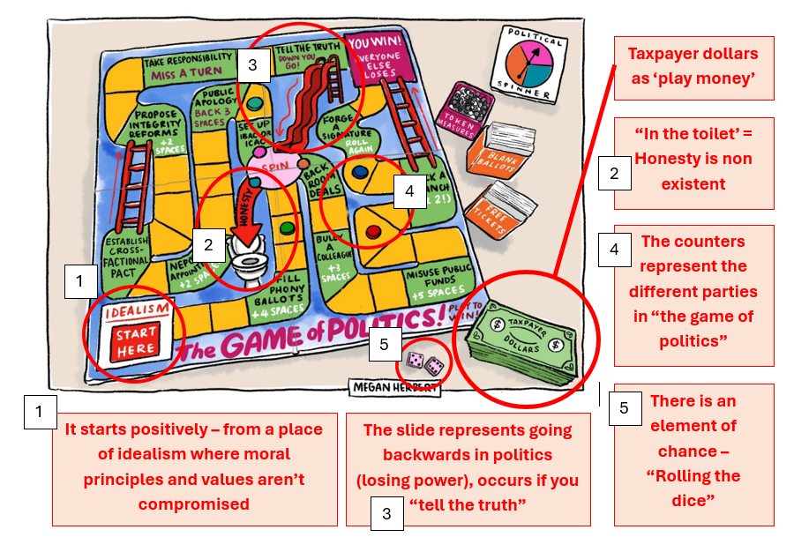
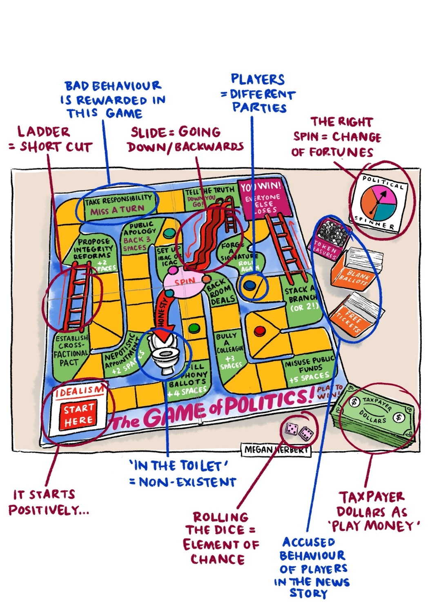

Glossary:
PHONY BALLOTS: The party leaders had members sign blank nomination ballots when they were organising which candidates would be selected to run in an election. The party leaders then later filled in the signed ballots with the candidates they wanted to win in order to rig the outcome.
SPIN: This has a double meaning: 1. Spin as a form of game play to determine your next move and 2. Political Spin, which means reframing a story, usually via a public or PR statement , to make the situation appear better than or different to how it is.
NEPOTISITC APPOINTMENT: Hiring a member of your family or someone with whom you have a close personal connection, usually instead of hiring the most qualified candidate.

CROSS-FACTIONAL PACT: Within political parties, there are factions, or smaller groups, that tend to vote together on certain issues. These factions often disagree with each other. A cross-factional pact is a deal made behind closed doors so that factions vote together, usually in exchange for a favour or compromise on another issue.
INTEGRITY REFORMS: These are recommendations that are released following an investigation or sometimes recommended to avoid an investigation. They are not binding, which means that often they are released as statements, but are not implemented. So, proposed reforms are sometimes presented to appear to be doing something positive without actually having to do it.
IBAC / ICAC: This stands for Independent Broad-based Anti-corruption Commission, and Independent Commission Against Corruption, respectively. The IBAC is Victorian and ICAC is in NSW. They are both bodies set up to investigate potential corrupt conduct by politicians.
BACK ROOM DEAL: A deal or compromise made in private party meetings that are not revealed publicly to voters or other party members not involved in the deal.
STACK A BRANCH: Branch stacking is a process used to recruit certain party members who will be politically useful to you in your branch by paying for their membership. It’s a way to gain political power or to influence which candidates are chosen to run for office.
TOKEN MEASURE: An action taken to make it appear as though something important is being done when in reality the action is just a small or meaningless gesture.

Teacher Notes for Activity 2: Create Your Own Political Cartoon
Students are provided with a variety of headlines and potential metaphors. An example of how to fill in the table is provided using the cartoon Megan explored in the workshop.
In the modified version a collection of relevant clip art is provided which links to the two headlines students can choose from. These are intended to help students “start” their cartoon, but students do not need to use any of them. We expect students to expand on the clip art elements with their own drawings/annotations.

