Political Cartoons with Megan Herbert
Introduction to Political Cartoons:
Political cartoons are a form of political commentary, usually found in newspapers, but also increasingly online that presents an opinion on an issue of the day. Political cartoons are a way to sum up an issue or to point out inconsistencies or ironies.
Metaphors are frequently used by cartoonists to convey a message. A metaphor is an expression or description that compares a person or object to something else by suggesting similar characteristics. A visual metaphor uses a pictorial representation of an object or an action to suggest an association or similarity.
For example, a wrecking ball in action could be used as a visual metaphor for a person or institution that is destroying something.

Activity: Find the Metaphors!
Below is a cartoon published by Megan titled, “The Game of Politics” it has several metaphors embedded throughout. Locate three metaphors in this image by circling them and annotating what you think the metaphor represents. One has been done for you.
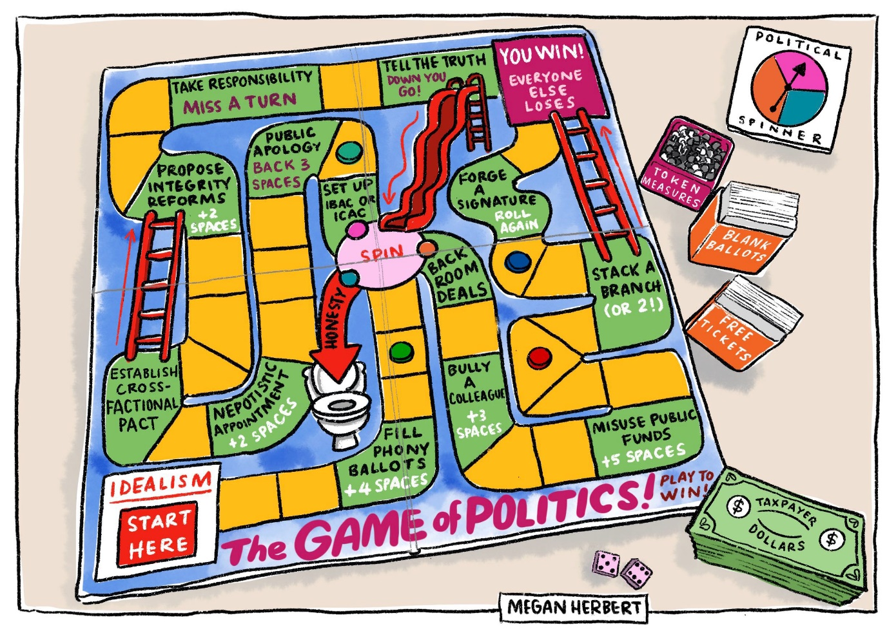
Taxpayer dollars as ‘play money’

Activity: Create Your Own Political Cartoon!
Now it’s your turn to create your very own political cartoon.
First, choose the headline you think you’d be able to design a political cartoon around from the examples on the next page. Make sure to consider your knowledge about the topic and your passion – the more passionate you are about a topic the more evocative your cartoon.
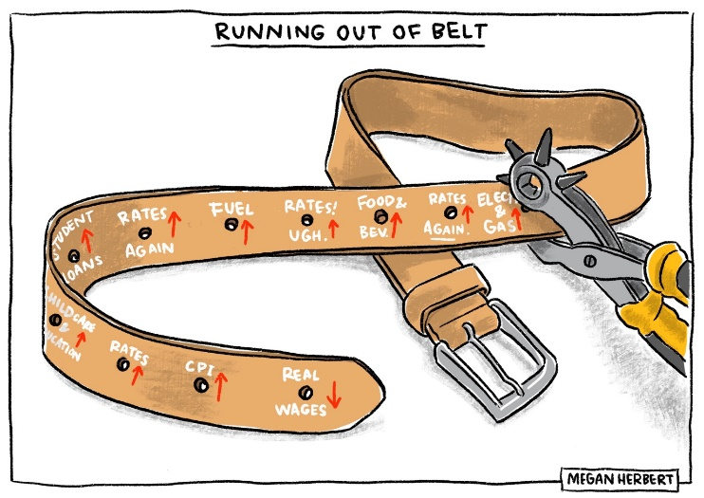
Each headline has suggested metaphors to use to help explore the idea. Select one of the suggested metaphors and brainstorm how you could incorporate this metaphor into the topic expressed in the headline. An example on how to fill in the table is provided below using Megan’s “Running out of belt” cartoon.
Headline | Chosen Metaphor | How can I incorporate this metaphor into my cartoon? What am I trying to say? | Description of what my cartoon could look like? (i.e. how I will draw the metaphor)
Reserve Bank announces 13th successive interest rate rise. | A belt tightening | “Tightening your belt”, which is what the RBA advised stressed mortgage holders – it was meant to cut unnecessary spending but led to cutting necessary spending. | It will have a belt that has new holes being punched in but each new hole represents an increased financial pressure point on mortgage holders. It is getting to the point where ‘tightening the belt’ any further would be impossible

CHOOSE YOUR HEADLINE:  Consider something that you agree with or feel passionate about | CHOOSE YOUR METAPHOR:  Which metaphor do you think best fits the headline? Circle the one you think you’d like to use.
Latest environmental report says that governments are ignoring the warning signs of climate change. | Incoming tidal wave / tsunami | Sinking ship / Titanic | Ostrich with head in the sand
Charity boss caught stealing from charity’s funds | Robin Hood | Wolf in sheep’s clothing | Pinocchio
Bank Boss says low-income workers should ‘just work harder’. | Cat versus Mouse or Bird versus Worm | Drowning person | Person on a steep mountain (or other difficult geographical feature)
AI set to be the biggest threat to job market. | Big Bad Wolf / any other classic villain | A cliff / some other dangerous geographical feature | A Robot versus a Human
New tax on top 1% of earners, is condemned by rich list. | Birds in their nest getting food | The Princess and the Pea | A King and Peasants
Community Group wins fight to keep fast food chain out of country town | David and Goliath | The Pied Piper | Food pyramid / food groups chart

Fill in the table below:
Headline | Chosen Metaphor | How can I incorporate this metaphor into my cartoon? What am I trying to say? | Description of what my cartoon could look like? (i.e. how I will draw the metaphor)

Draw your cartoon:

