Political Cartoons with Megan Herbert
Introduction to Political Cartoons:
Political cartoons are a way people can express their political point of view. They are usually found in newspapers, but also increasingly online. The purpose of the cartoon is to present an opinion on an issue of the day.
Metaphors are frequently used by cartoonists to convey a message. A metaphor is an expression or description that compares a person or object to something else by suggesting similar characteristics. A visual metaphor uses a drawing of an object or an action to suggest an association or similarity.
For example, a wrecking ball in action could be used as a visual metaphor for a person or institution that is destroying something.

Activity: Find the Metaphors!
Below is a cartoon published by Megan titled, “The Game of Politics” it has several metaphors embedded throughout. Connect the visual metaphors circled to the text box that explains them. One has been done for you.
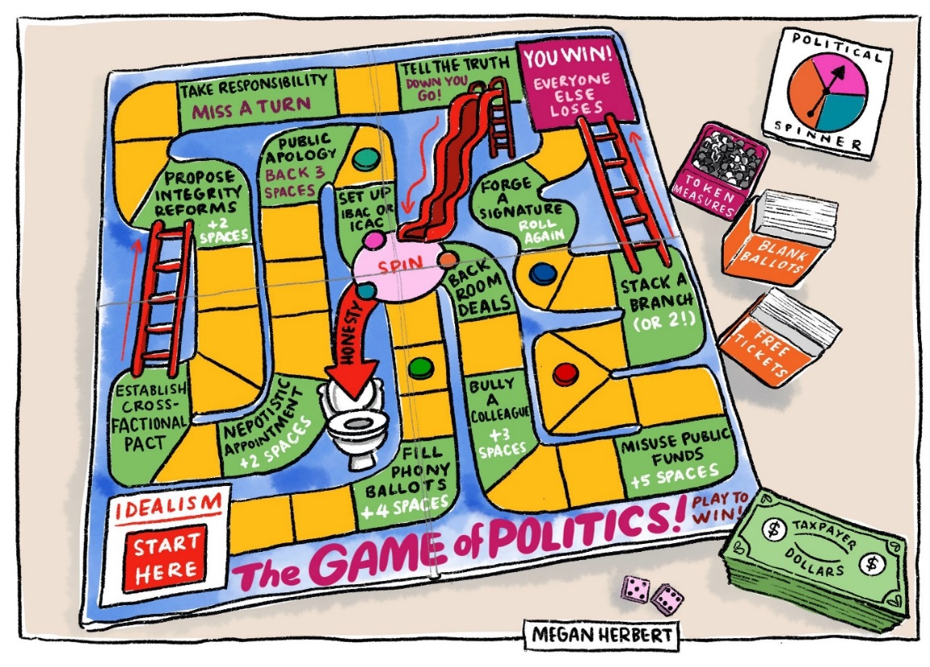
The counters represent the different parties in “the game of politics”
“In the toilet’ = Honesty is non existent
Taxpayer dollars as ‘play money’
There is an element of chance – “Rolling the dice”
The slide represents going backwards in politics (losing power), occurs if you “tell the truth”
It starts positively – from a place of idealism where moral principles and values aren’t compromised

Activity: Create Your Own Political Cartoon!
Now it’s your turn to create your very own political cartoon.
First, choose the headline you would like to design a political cartoon around from the examples below.
Each headline has suggested metaphors to use to help explore the idea. Select one of the suggested metaphors and create a cartoon using the associated images over the page.

CHOOSE YOUR HEADLINE:  Consider something that you agree with or feel passionate about | CHOOSE YOUR METAPHOR:  Which metaphor do you think best fits the headline? Circle the one you think you’d like to use.
Latest environmental report says that governments are ignoring the warning signs of climate change. | Incoming tidal wave / tsunami | Ostrich with head in the sand
AI set to be the biggest threat to job market. | Big Bad Wolf / any other classic villain | A Robot versus a Human

Cut out the relevant images to your chosen metaphor to create your own political cartoon over the page. You can then add your own drawings to this to expand your ideas.
You will need another piece of paper to glue all the images together to make your political cartoon.

