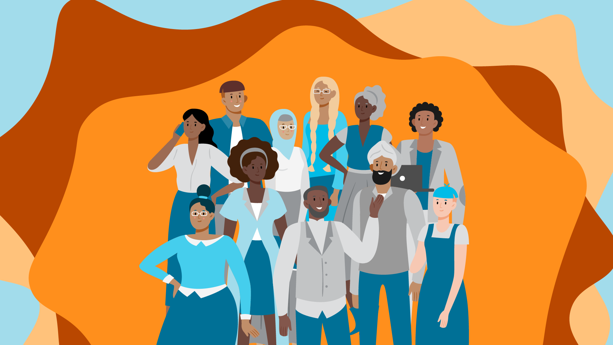



Shared Leadership Program 2023

Diversity, Equity and   
Inclusion in Public Libraries

Identifying key themes for success

Diversity, Equity and Inclusion in Victorian Public Libraries

Identifying key themes for success

Contents

Acknowledgement of Country 6

About the Shared Leadership Program 6

Acknowledgement of people 6

About the project team 7

Sponsor statement 8

Definitions 9

Introduction 9

Project scope 10

Methodology 12

Survey findings and analysis 14

Demographics 14

Target groups 16

Confidence in design and delivery 19

Impact of DEI specialist roles and policies 19

Key responsibilities 22

How to equip and empower library services 22

Case Studies 27

**Addiction and social stigma** 27

Case Study: Sharing Stories; Strengthening Communities 29

**Culturally and Linguistically Diverse Communities (CALD)** 31

Case Study: Talking Together 32

**First Nations peoples and cultures** 37

Case Study: First Nations identified roles in libraries 39

**LGBTQIA+** 44

Case Study: LGBTQIA+ events and programs 46

**Neurodivergence** 51

Case Study: ‘Magic: the Gathering’ and ‘Warhammer 40K’ 53

**People experiencing homelessness** 56

Case study: ‘What you need to know to survive on the streets’ zine 58

**People with disability** 62

Case study: Disability Access Hub 65

**Socio-economically disadvantaged** 70

Case Study: Sprout Time 72

Spaces and buildings 75

Glenroy Community Hub, Merri-bek Libraries 75

Ivanhoe Library and Cultural Hub, Yarra Plenty Regional Library Service 76

Springvale Community Hub and Library, Greater Dandenong Libraries 76

Victorian Indigenous Research Centre, State Library Victoria 77

Key themes for success: 79

Program design 79

Outreach 80

Building on Core Offerings 81

Specialist Staff 82

Partnerships 82

Patron-centred 83

Recommendations for next steps 85

Conclusion 87

References 88

Appendices 97

Appendix 1 97

Survey questions 97

Appendix 2 100

Case study questions 100

Appendix 3 101

Sprout Time program plan 101

# Acknowledgement of Country

We acknowledge the Traditional Custodians of all the lands and waterways of Victoria, and their diverse cultural practices and knowledge systems. We pay our respects to Elders past, and present, and extend this respect to all First Nations peoples as knowledge holders with continuing connections to Country and community.

# About the Shared Leadership Program

The Shared Leadership Program (SLP) is an annual development program offered by State Library Victoria (SLV) for free to Victorian public library and SLV staff. The challenging program is focused on increasing the leadership capabilities of participants, now and for the future, through theoretical, practical and experiential learning opportunities. Facilitated by Sue Upton and John Martin of Upton Martin Consulting, the program covers self-awareness, team dynamics, communication, stress management, change management, team building, people management, negotiation, influence, coaching, feedback, collaboration and presentation skills.

The program helps participants to:

* Grow professionally, resulting in increased motivation and confidence
* Develop and practise enhanced leadership and teamwork skills
* Establish and consolidate peer networks across the Victorian Public and State Library sector
* Be better prepared to take the next step in their career

# Acknowledgement of people

Our project team wishes to extend our most sincere and gracious acknowledgement to all the people who have supported us, and this project from February to now. To our respective Library Managers at Eastern Regional Libraries, Latrobe City Council, Maribyrnong Libraries, SLV and Yarra Libraries, thank you for the opportunity to participate, for supporting our nominations, and for investing in our potential.

To John and Sue Upton, your ability to inspire courage and compassion in all the work we do will not be lost or forgotten as we continue this valuable work. To Jacqui Horwood and Nadyne Eggleton at SLV who continually work to ensure public library staff have opportunities to be captured by an idea and nurture that enthusiasm to spread across the sector, thank you.

To the other SLP participants, we all feel bonded as one meta project team and feel your kindness and care in holding space for us all at various times. We hope to offer the same to those we work with going forward. To Adam Cooper, your ability to listen, guide, motivate and get stuck in with ease has made this report come to life in its full and flourishing entirety.

To all of those who spent their time to complete the survey and share their expertise, honesty, pride, and pitfalls so generously with us, especially those who shared even more by way of their case studies, thank you.

And finally, to the staff and patrons who come together every day across Victoria to make our common spaces truly inclusive, welcoming, and special for today and tomorrow, thank you for journeying with us.

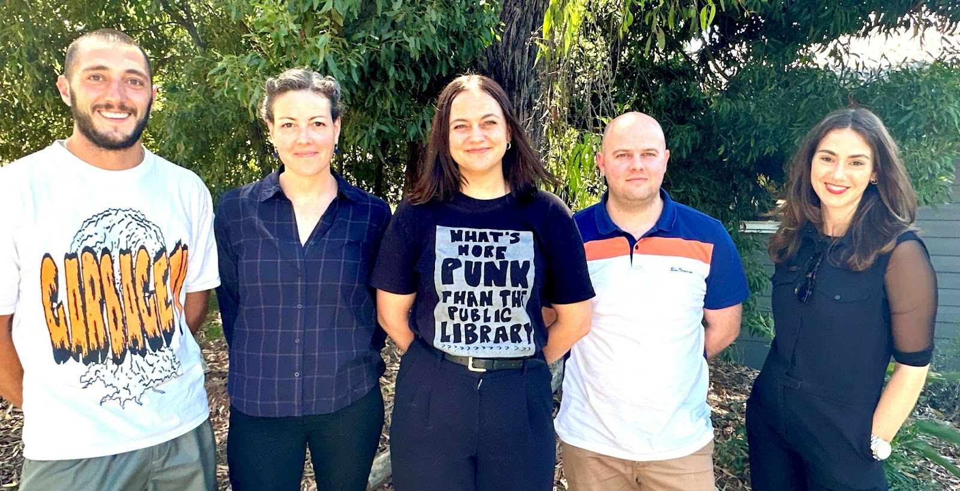

Left to right: Dylan Oosterweghel, Leah Williams, Gabrielle Ryan, Alan Sewell, Georgia Karavis

# About the project team

Bringing a diverse range of lived experiences to the table, our team is united by a motivation to ensure that all people have the opportunity and encouragement to connect, learn and grow through their engagement with Victorian public libraries. This project has enabled us to explore and share the incredible diversity, equity and inclusion (DEI) work already being done in the sector to achieve this vision, and, we hope, will build tangible pathways for others to have the confidence to follow suit.

If working in this project team has taught us one thing, it is that intentionally creating spaces of grace and celebration with others is one of the most dignifying and meaningful things we can do professionally and personally.

**Georgia Karavis** - Team Leader Library Programs and Engagement, Latrobe City

**Dylan Oosterweghel** - Team Leader Community Engagement and Outreach, Yarra Libraries

**Gabrielle Ryan** - Senior Team Leader Library Partnerships and Engagement, Maribyrnong Libraries

**Alan Sewell** - Branch Manager, Eastern Regional Libraries

**Leah Williams** - Preventive Conservator, State Library Victoria

# Sponsor statement

‘Libraries are for everyone’ is the ubiquitous catch cry of the modern librarian. But is this statement enough or do we need to back it up more aggressively with direct action?

Skye Patrick, Director of Los Angeles County Library, would likely agree with the latter. In an inspirational keynote at the 2023 Public Libraries Victoria (PLV) Conference, Skye showed us what it means to truly be diverse, equitable and inclusive. Skye challenged her library leaders to apply an ‘equity lens’ to determine which groups ‘might not be fully served’ across their 87 library branches. Everything from policy to programs, collections to recruitment was put under the equity lens and the culture of the library network has changed as a result. This is diversity, equity and inclusion *first* in practice. LA County Library was named Library Journal’s Library of the Year in 2019 (Berry III 2019).

This SLP report arrives at a moment in time where a historically momentous referendum is set to take place to constitutionally embed an Aboriginal and Torres Strait Islander ‘Voice’ to Parliament, meanwhile an unprecedented cost of living and housing crisis is attacking our most vulnerable. These are also polarised times. In 2017 the nation said ‘yes’ to marriage equality however five years and one pandemic later in 2023, Victorian Libraries and their Librarians have been under siege for delivering Drag Storytimes in a climate eerily reminiscent of the ‘Safe Schools’ scandal of 2016. In Victoria, it is our librarians who have been on the frontlines when it comes to defending diversity, equity and inclusion.

In their joyous rebuttal to a New York Times opinion piece (Kurtz 2022), five ferocious librarians remind us that:

‘to serve our communities, libraries must be safe spaces where all people can come together, see themselves represented, and discover and share different points of view. And because of the historic inequalities against people of colour and the LGBTQ community, for example, the library profession’s commitment to equity, diversity, and inclusion is not only warranted, it is imperative.’ (Cooke et al. 2022)

Libraries might be ‘for everyone’ which implies a certain neutrality but we also hold values. And what became clear as this project unfolded was that DEI *first* is a core value that collectively defines our ethos and our work as librarians.

I’m proud and humbled to act as Sponsor for this project, although it became pretty clear to me early on that I would be more of a spectator than a Sponsor. And with that I would like to thank this group of extremely talented and inspirational leaders, Alan, Dylan, Gab, Georgia and Leah, who so generously allowed me to tag along with them on this journey. I also want to acknowledge and thank all of the brave librarians/heroes who stood tall during the storm of hatred that has been so unfairly directed towards yourselves and the LGBTQIA+ community. I hope you find the following report as inspiring and hopeful as we did.

**Adam Cooper**  
Head of Libraries, City of Port Phillip

# Definitions

**Inclusion** means welcoming diversity and offering everyone a sense of belonging. Differences are respected and valued in an environment free from discriminatory attitudes and behaviours, people have equal opportunity, and reasonable adjustments are made to accommodate difference where needed.

**Diversity** describes all the ways in which people are different, including age and generation, racial, cultural and linguistic background, intellectual and physical ability, gender identity, sexual orientation, socio-economic background, level of education and faith, as well as skills, knowledge, experience and perspectives.

**Equity** refers to fairness and equality in outcomes recognising that each person has different circumstances that require the allocation of specific resources and opportunities to reach an equal outcome.

**Access** means ensuring people can contribute and participate equally in library activities, services or opportunities, removing or overcoming barriers or functional limitations.

(Adapted from State Library Victoria’s Inclusion, Diversity and Access Policy 2023)

# Introduction

This research project set out, within the Victorian Public Libraries context, to ‘document what libraries are doing to achieve DEI and to share this information to equip and empower our sector.’ The intention of the report is to communicate, upskill and network stakeholders within the Victorian Public Library sector interested in beginning or expanding their DEI work.

Public libraries are celebrated as safe spaces for all, and ‘services of the public library are provided on the basis of equality of access for all, regardless of age, ethnicity, gender, religion, nationality, language, social status, and any other characteristic’ (International Federation of Library Associations and Institutions 2022).

Public libraries have increasingly adopted DEI practices; however, as Chris Bourg, Director of Libraries at Massachusetts Institute of Technology, writes, ‘we need to move beyond the notion of being welcoming and we need to consider real fundamental, cultural and structural changes that would foster inclusion and justice’ (Bourg 2017).

DEI principles are embedded in many of the APLA-ALIA Standards and Guidelines for Australian Public Libraries (Australian Public Library Alliance & Australian Library and Information Association 2021); and the Australian Library and Information Association's (ALIA) Stretch Targets 2020-2030 include that ‘Library workforce, collections and services reflect the diversity of Australia’s population and local communities’ (2021).

An essential aspect of DEI is workforce diversity (Larsen 2017; Masterson 2020). APLA-ALIA’s Standards and Guidelines for Australian Public Libraries (2021, p. 78) state:

‘As far as possible, the composition of the library workforce embraces and reflects the diverse profile of the community. This includes people from culturally and linguistically diverse backgrounds, people with a disability, young people, Aboriginal and Torres Strait Islander peoples and people identifying as LGBTIQ.’

However, according to 2016 Australian Bureau of Statistics (ABS) Census data, the Library and Information Studies (LIS) sector is disproportionately white, older, and female compared to the total labour force (ALIA 2019a, p. 3). This data is supported by both state and national surveys into LIS workforce diversity (Derr et al. 2019; *INCITE Magazine* 2021, pp. 4-7). Creating workforce diversity can be achieved through reviewing hiring practices and creating identified roles (Aalia 2021, p. 16; Derr et al. 2019, p. 40; Norman & Pugh 2022; Stute & Dempster 2021, p. 14).

The library sector is increasingly focused on diversity, in many professional development environments. The theme of the ALIA National Conference 2022 was Diversity, featuring presentations on workplace diversity, LGBTQIA+ programming and services, services for Culturally and Linguistically Diverse (CALD) communities, and more (Australian Library and Information Association 2022).

As mentioned above, the 2023 PLV Conference opened with a keynote address from Los Angeles County Library Director Skye Patrick on the importance of DEI in libraries, and closed with a keynote address from Terri Janke and Neane Carter, lawyers and consultants on a Cultural Competency and Safety Report for SLV and PLV (Public Libraries Victoria 2023a).

Public libraries have long provided services for the state’s diverse communities, including CALD communities, people with disability, LGBTQIA+ communities, First Nations people, people experiencing gender-based violence, neurodivergent people, refugees and asylum seekers, people experiencing addiction, people experiencing homelessness, older people, people experiencing socio-economic barriers, and a multitude of visible and invisible intersectional identities. Increasingly, libraries have adopted co-design strategies in these services, adopting the principle ‘nothing about us, without us’.

This project sets out to celebrate existing DEI work in public libraries and provide useful case studies that other library services may replicate or draw inspiration from for their own communities.

# Project scope

The project team set out to survey the library sector to collect DEI data and identify potential case studies. The objective was to provide a toolkit for libraries to work with in developing their own DEI activities.

Following the survey, case studies were selected representing CALD communities, people experiencing homelessness, socio-economically disadvantaged people, people with disability, LGBTQIA+ events and programs, neurodivergent people, people experiencing addiction, and inclusive spaces.

## Exclusions

This report does not feature case studies on older people, the digital divide, young people, or people experiencing gender-based violence. The project team notes the importance of these community groups and social issues, and the extensive work of public libraries to support these communities.

Collections

Many libraries already have diverse and inclusive collections that reflect their communities, including but not limited to Languages Other Than English (LOTE) collections (Nguyen 2023, pp. 38-39), content that represents marginalised or underrepresented groups, and collections that meet the needs of people with disability (ALIA 2019b). As such, a case study focusing on collections was excluded from the project scope. For more detail on LGBTQIA+ collections, see the LGBTQIA+ section of this report.

Gender

In the 2022 Victorian Public Library Census and Survey, 60% of Census respondents and 74% of Survey respondents identified as female, compared with an average of 51% in the Victorian population (State Library Victoria & Public Libraries Victoria 2023, p. 9). Under Victoria’s *Gender Equality Act 2020* libraries are required to take positive action towards achieving workplace gender equality and consider and promote gender equality in their policies, programs and services, noting that gender inequality may be compounded by intersectional issues related to age, socio-economic disadvantage, ethnicity, Aboriginality, sexual orientation and so on. While gender was not a specific focus in the case studies, there are many examples of gender targeted library programs, including:

* English conversation classes for Dari Women at Connected Libraries
* Gender diverse book club and trans and gender diverse writers' group at City of Melbourne Libraries
* Jobs support for women, non-binary folk, and First Nations women at Port Phillip Libraries
* Program addressing social isolation for older men at Latrobe City Libraries
* Social connection program for women experiencing gender-based violence at Maribyrnong Libraries

Intensive community consultations

Where possible, the project team sought to speak with community partners who worked on projects highlighted in case studies. However, due to the timeframe of the project, extensive community consultation was not feasible.

# Methodology

The method selected for capturing this data was an online survey (SurveyMonkey), distributed to Victorian Public Libraries as well as SLV and the Vision Australia Impairment Library Service via the PLV’s email newsletter. A copy of the survey questions is available in Appendix 1, however the broad data requested fell into the following categories:

* Demographic data related to the library service and respondent’s role
* Library service access to, and use of DEI supports including staff and policies
* Areas of DEI library programs, confidence and needs perceptions
* Opportunity to highlight a particular offering and nominate this as a case study

The survey was open for 18 days and responses were monitored to ensure that prompts to complete the survey (email or phone correspondence) were sent to library services under-represented commensurate to their size.

A total of 335 responses were submitted. Following data cleaning, 145 responses were excluded, which were either abandoned responses or responses that did not contain the relevant quantitative data and would otherwise have skewed demographic data.

To identify prospective case studies to be featured in this report, the data was sorted by DEI target group as identified in the survey (question 8), with additional themes generated to capture the diversity of initiatives provided. The project team then read and selected potential projects of interest based on responses to questions 9 to 12, consulting with each other and gaining valuable input from the project Sponsor.

Case study selections were based on:

* DEI themes that were most prevalent in the data
* Emerging DEI themes within library service offerings
* Services that had approached their DEI initiative in a novel, innovative or otherwise interesting way
* Services that had indicated willingness to be contacted or featured as a case study
* A spread of metropolitan (metro), regional and rural locations

Initiatives that did not fit these criteria, but still contained relevant information such as commonly run programs (i.e., Storytimes or book groups with a DEI theme), were also captured and will be discussed briefly in ‘Building on core offerings’. Quantitative data was analysed using SurveyMonkey’s capabilities, with a small number of questions analysed manually due to their level of complexity.

Selected case study library services were then contacted via email to arrange a 30 minute to one hour long informal interview (online or in-person) to capture the most significant information related to the program, with key insights recorded in a case study template (Appendix 2). Drafted case studies were sent back to library services for revision before final edits and inclusion in the report.

Reviews of academic literature were undertaken relating to each case study theme to inform the case study introduction texts. Project team members met regularly, both in person and online, to share insights and draw out key themes.

# Survey findings and analysis

## Demographics

While library service name was not a mandatory field, all but four library services were represented. Distribution was reasonably balanced across services, apart from Eastern Regional, City of Melbourne, and to a lesser extent Hume and Wyndham, all of which had a disproportionately higher representation and should be considered in the context of the survey analysis (Fig. 1).

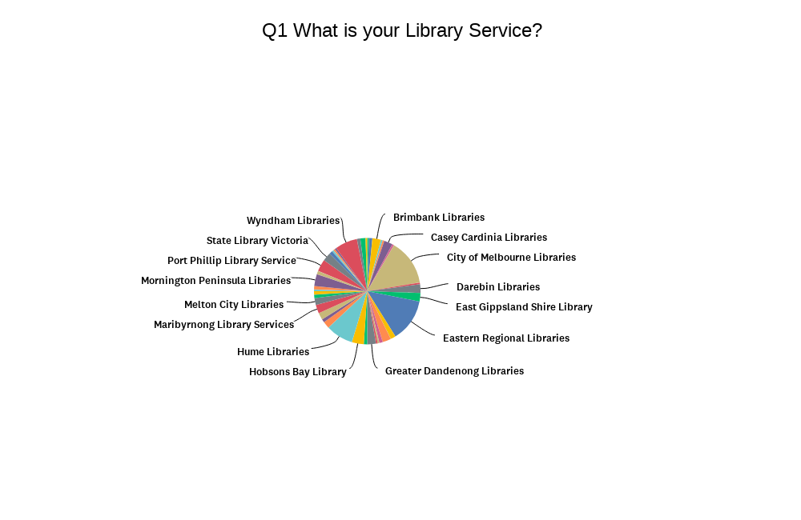

Figure 1: Library Service

The breakdown of responses by service location (Fig. 2) was as follows: metro (69%), regional (21%), rural (7%) and other (3%). For context, regional locations are often a mix of outer suburban, semi-rural areas, whereas rural areas are generally less populated and more removed from the infrastructure of regional centres. The ‘other’ category captured a temporary pop-up library, a remote service with in-house programming, and two metro/regional cross-over libraries.

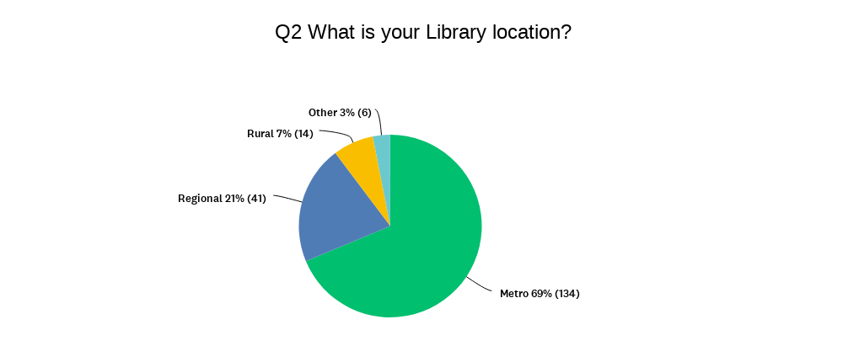

Figure 2: Location of library service

Library services were encouraged to submit multiple responses, representing staff at different levels. Respondents were asked to share information about their key responsibilities (Fig. 3), selecting all that apply from the list below:

* Strategic planning/direction
* Manage team/branch
* Develop programs/services
* Deliver programs/services
* Customer Service

Further analysis was undertaken to identify the highest level of responsibility of each respondent to draw out any differences in perceptions from customer service to leadership and management levels. This is explored in the Key Responsibilities section.

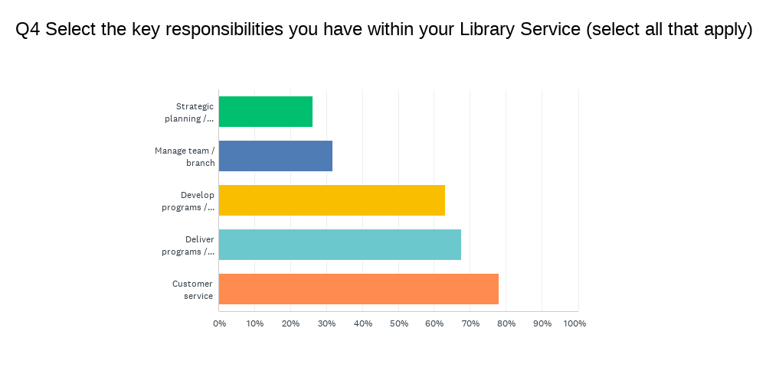

Figure 3: Respondent key responsibilities

Respondents were asked about the resourcing of a designated DEI role(s) within their library service or broader organisation (Fig. 4). Council resourcing of DEI role(s) was highest (45%), followed by 15% at both library service and council, 7% at library service only and 24% of respondents were unsure.

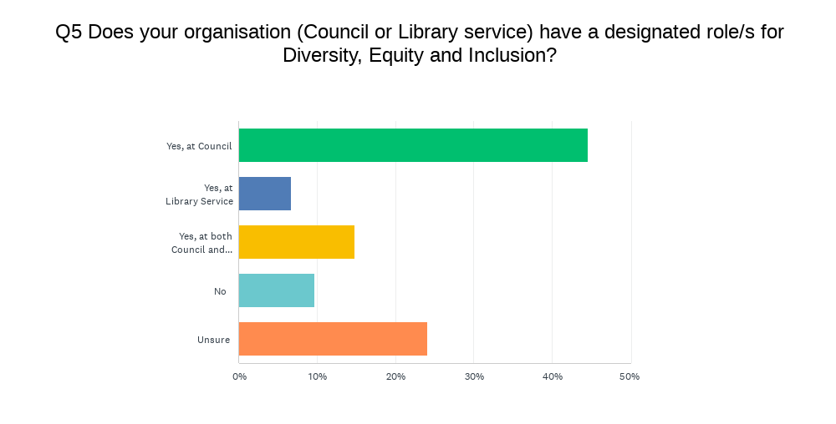

Figure 4: Designated DEI roles

When asked if they were aware of any DEI specific policies, either within their library service or broader organisation, 81% of respondents answered yes, 3% answered no, and 16% were unsure (Fig. 5). The impact DEI policies can have on staff confidence in the development and implementation of inclusive programs and services is discussed in Impact of DEI specialist roles and policies.

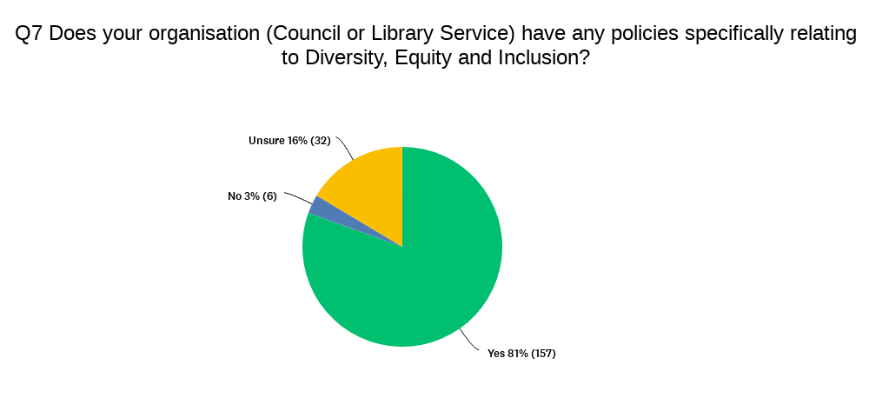

Figure 5: DEI-specific policies

## Target groups

Respondents were asked to select the cohorts for whom they provide targeted programs and services from the following:

* Culturally and Linguistically Diverse (CALD)
* Disability and access
* First Peoples
* Insecure housing
* LGBTQIA+
* Neurodivergent
* Older people
* Refugees and new migrants
* Socio-economically disadvantaged
* Other

Across the network, older people (90%), CALD communities (79%) and LGBTQIA+ communities (71%) are the most catered for groups. Socio-economically disadvantaged communities (59%), people with disability (57%), refugees and new migrants (56%) and First Peoples (51%) are largely on par. There is also growing awareness of the specific needs of neurodivergent people (44%) and people experiencing insecure housing (28%). People experiencing addiction were another target group identified by respondents. See Fig. 6 for the full breakdown of target groups.

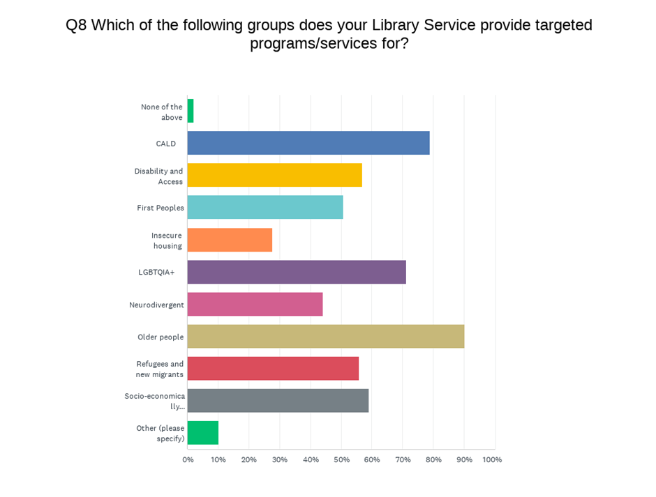

Figure 6: Target groups - overall

The most common target groups catered for by rural library services are older people (86%) and people with disability (57%). Rural libraries are less likely to cater specifically to people experiencing insecure housing (7%) compared with metro (32%) and regional (22%). Similarly, the growing awareness of neurodivergence has translated into the provision of targeted programs and services more so in metro libraries (49%) than regional (34%) and rural (14%).  See Fig. 7 for the breakdown of target groups catered for by rural locations.

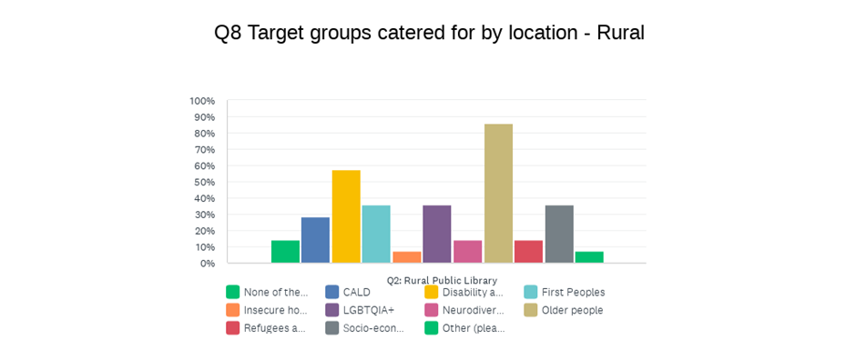

Figure 7: Target groups - rural

Regional library services align closely with the overall trend for the top three most catered for groups: older people (95%), CALD (73%) and LGBTQIA+ (71%). A similar pattern to metro services emerges for socio-economically disadvantaged (59%), people with disability (57%) and refugees and new migrants (56%) in regional areas, with a slight dip in targeted programs and services for First Peoples (37%) as compared with metro libraries (Fig. 8).

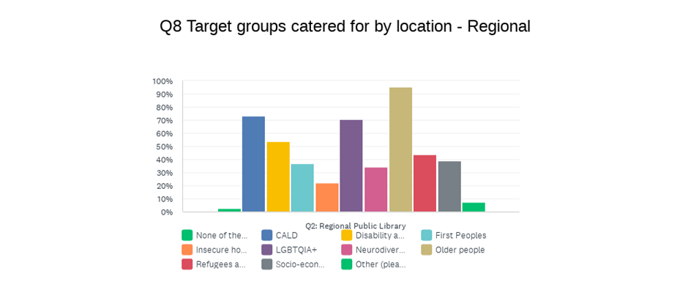

Figure 8: Target groups - regional

Metro libraries show a more even distribution of targeted programs and services across the various target groups, with strong offerings for older people (90%), CALD communities (88%), and LGBTQIA+ (76%) communities, closely followed by socio-economically disadvantaged (67%) and refugees and new migrants (64%). See Fig. 9 for the breakdown of target groups catered for by metro locations.

The percentage of services that cater specifically to people with disability are consistent across the board, regardless of location (54% to 57%).

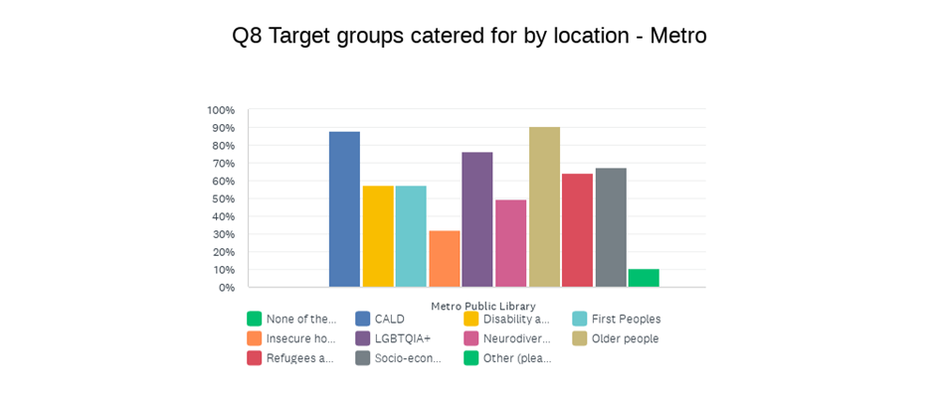

Figure 9: Target groups – metro

## Confidence in design and delivery

Respondents from rural library services had a significantly higher level of confidence developing and implementing inclusive and accessible programs/service/spaces for their communities (71%), compared with 49% from regional services. However, there was a notably lower number of survey responses from rural libraries (14) as compared with regional (41), so the weight of individual experience in rural locations may have influenced this trend. The higher confidence in rural libraries may also be reflective of the fewer target groups catered for, whereby the skills and experience are more embedded in practice. Confidence was also high across metro services as 69% of respondents agreed/strongly agreed that they felt confident in inclusive program/service delivery (Fig. 10).

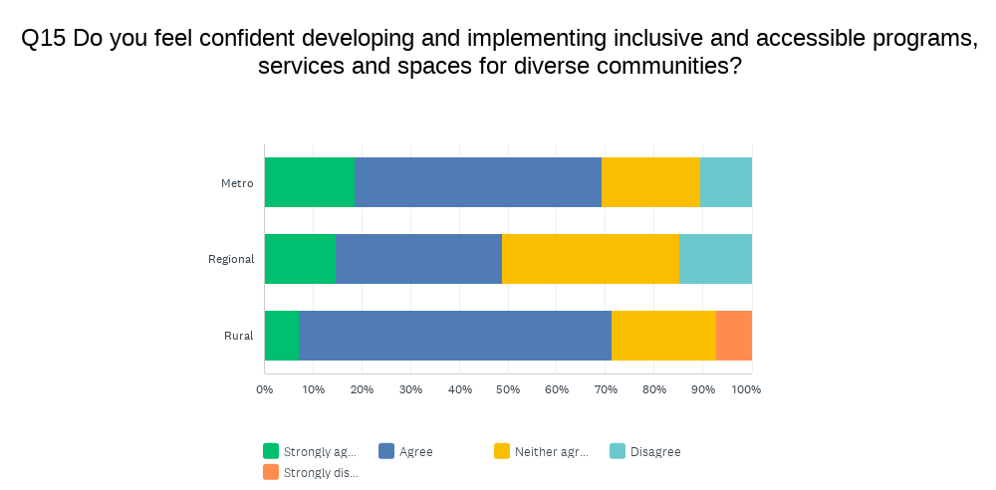

Figure 10: Confidence in design and delivery of inclusive and accessible programs, services and spaces by location

## Impact of DEI specialist roles and policies

Of the respondents who work collaboratively with dedicated DEI role(s), 77% agreed or strongly agreed that they felt confident developing and delivering inclusive programs and services for their communities, while only 7% disagreed (Fig. 11). The positive impact the support of DEI specialist roles can have in promoting inclusion is further illustrated by the lower confidence of respondents who do not work with DEI role(s) (62%). 

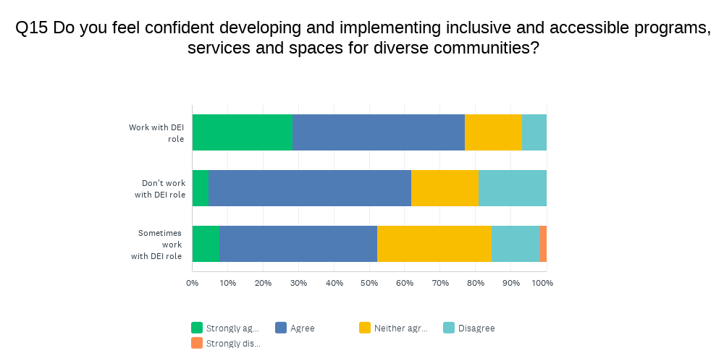

Figure 11: Confidence in design and delivery of inclusive and accessible programs, services and spaces based on working with DEI role(s)

Confidence in developing and implementing inclusive programs and services was similarly high among respondents whose organisations have policies specifically relating to DEI, 71% agreed or strongly agreed they felt confident, compared with 10% who disagreed or strongly disagreed (Fig. 12). Of the respondents who reported not having specific DEI policies at their organisations, 50% agreed or strongly agreed that they felt confident, while 33% disagreed or strongly disagreed. These results demonstrate the critical role DEI policy plays in ensuring our diverse communities’ needs are understood and provided for.

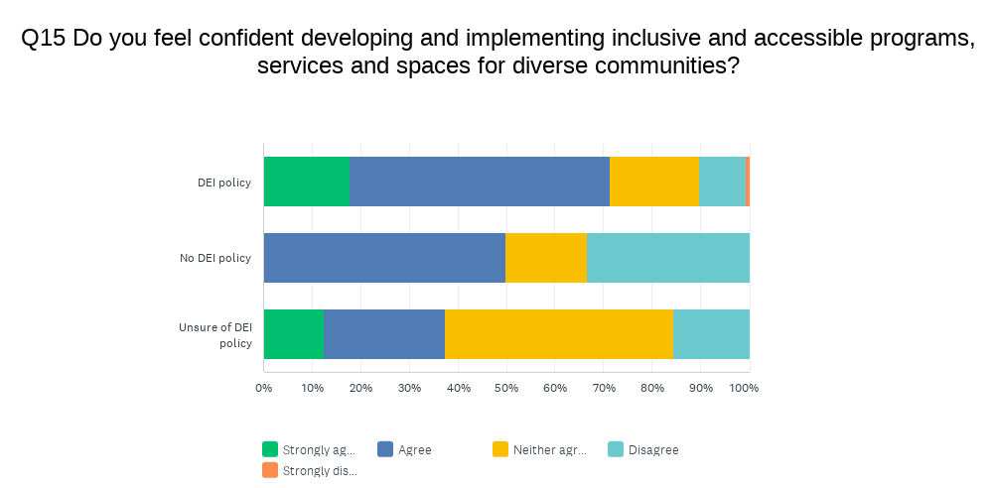

Figure 12: Confidence in design and delivery of inclusive and accessible programs, services and spaces based on DEI policies

A series of questions asking respondents to share information about the types of programs and services they provide for target groups, led to the self-selection of the program they thought was most impactful (see Fig. 13). Respondents were then asked to identify how the program came about by selecting one from the following:

* Developed for the community
* Requested by the community
* Developed in consultation with the community
* Co-designed by the community
* Co-designed and delivered by the community

This information was analysed in the context of whether respondents felt their library service was meeting the broader community needs for inclusive programs, services and spaces. Of the programs/services that were co-designed, 90% of respondents felt their library service was meeting broader community needs. When the program/service was requested by the community or developed in consultation with the community, 79% and 69% of respective respondents felt their service was meeting needs. While a sizeable proportion of programs/services were developed without community involvement, the success of these in terms of meeting community needs was still comparatively high (61%).

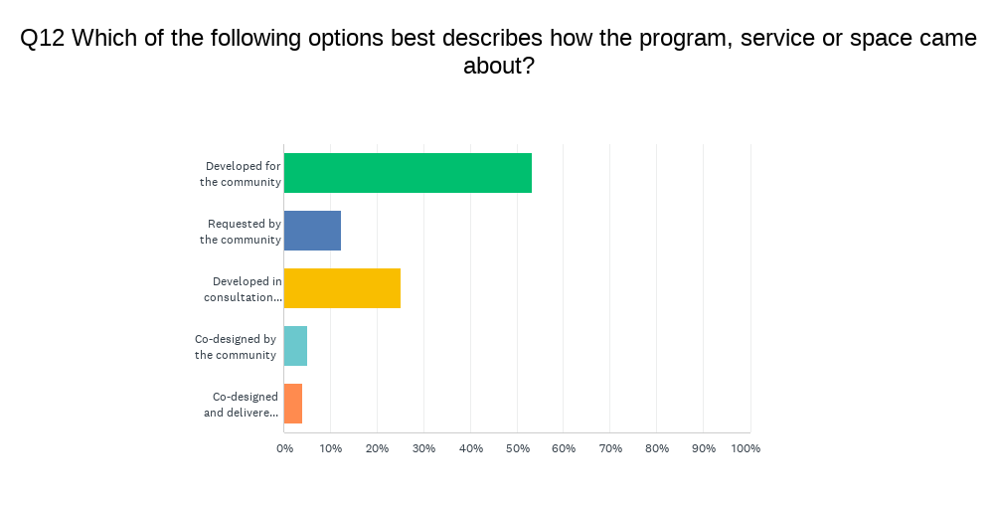

Figure 13: How the program or service came about

Responses to this question were also compared with the level of confidence respondents have in developing and implementing inclusive and accessible programs, services and spaces for diverse communities more generally. Again, co-designed programs/services have a positive impact on confidence with 80% of respondents reporting high or very high confidence. Confidence was lowest (59%) with respondents where the target program/service was developed without any community involvement.

## Key responsibilities

Respondent key responsibilities are captured in Fig. 3. Further analysis of the data was undertaken to identify the highest level of responsibility for each respondent to draw out any differences in perceptions from customer service to leadership and management levels.

Of the total respondents, around 40% were in strategic planning, leadership and/or management roles, compared with 50% being responsible for developing and/or delivering programs/services. A much lower number of respondents (10%) selected customer service as their only responsibility.

Interestingly, confidence was highest with respondents who are primarily in management roles (70%) and those responsible for the development of programs/services (73%). Confidence was lowest with respondents whose key responsibility is the delivery of programs and services, with only 52% reporting feeling confident or very confident in the provision of inclusive programs and services.

## How to equip and empower library services

Respondents were invited to share ideas for what would enhance their capacity to provide inclusive and accessible programs, services and spaces for diverse communities. This was presented as a free-text question to ensure the breadth of ideas were captured.  A word cloud highlighting the most common responses about what would equip and empower services to develop inclusive and accessible programs, services and spaces including the words community, training, staff, and funding is displayed in Figure 14. A thematic analysis was completed to obtain the below themes, quotes and information, using SurveyMonkey’s capabilities.

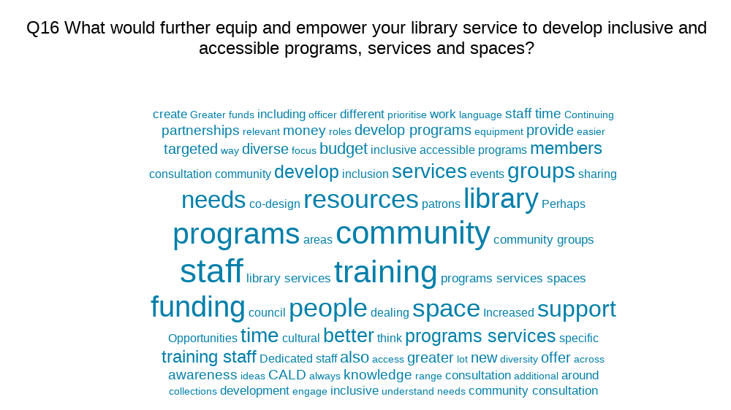

Figure 14: Word cloud of responses to survey question Q.16

From the chorus of responses received, it is clear that library staff are passionate about providing welcoming, inclusive, and accessible services and spaces, and delivering effective and meaningful targeted programs for community benefit. Significantly, respondents are also united in what they think will make a difference.

### Staffing: expertise, time, training

With the increasing awareness of ensuring libraries are welcoming and accessible to all members of the community, the demands on staff, both in terms of time and expertise have grown exponentially.

Respondents identified the need for having a greater number of staff and/or staff time to develop and deliver programs and services. A common obstacle noted was the challenge of balancing rostered desk shifts with developing and delivering meaningful and effective programming:

“More staff - we have great ideas and good intentions but often not enough time to deliver the programs properly often due to being rostered at the same time as running a program.”

Another respondent noted that, “developing new programs or services takes time, especially if working on a community-led model”. This was echoed by many more.

There was a strong emphasis on the need for specialist staff, whether through recruitment, or investing in training and upskilling existing staff (around 25% of respondents). Dedicated DEI roles at council and libraries were seen as key to the successful development and delivery of DEI initiatives. Respondents also noted the desire for further DEI training, which could include cultural competency, disability, First Nations, LGBTQA+, trauma informed librarianship, and more:

“I think further staff training on accessibility would help empower staff to feel comfortable and confident delivering/facilitating programs for a diverse range of people.”

Multilingual staff and/or resourcing for translators and translation services was also a prevalent theme, as was the push for increased representation of diverse community members through recruitment practices:

“More training for staff in specialised areas such as working with people with disabilities / better cultural training (CALD and First Nations) Also employing a more diverse workforce.”

Other specialist skills and opportunities for training identified include, Auslan, social work, co-design and ongoing cultural competency training. The following response from a survey participant eloquently summarises the challenges public library managers are grappling with to be able to better support their staff in the development and implementation of inclusive programs and services:

“Further hands-on, practical and easily implementable training for managers and others responsible for access and inclusion would increase efficiency of developing inclusive programs, services and spaces and the efficacy of those initiatives. At present, I have to conduct a lot of my own research to understand what is needed by particular sections of the community which makes delivering services slow and given the myriad of competing responsibilities I have, may result in less-than-optimal outcomes. A lack of centralisation in this area also results in a lot of unnecessary duplication of effort with many branches doing similar things in isolation.”

### Community engagement, consultation, partnerships

Respondents stressed the need to engage, consult and work together with diverse communities to develop and deliver meaningful programs and services:

“More consultation with community directly on what programs they want to see at the library. A lot of programs are based on demographic statistics, but these don't capture all diverse groups within the council area; thus, their needs are missed.”

The understanding, desire and commitment is evident, but the collective call for more resources, both in terms of staffing and funding, to approach this work with a community-led focus is compelling; one respondent clearly identifying the need for “more funding and consultation with broader council groups and the community to truly deliver tailored and impactful services, programs and events”; another advocating for the opportunity “to do more consultation and co-design with the community, including resourcing and budget to allow this”.

Further to the case for community engagement and participation was the need for “partnerships aimed at co-design of programs” and more “consultation with the communities and organisations like Arts Access, Expression Australia, Vision Australia…”. Inter-council partnerships and interdepartmental collaboration, including better access to council staff and resources, were also identified:

“Support from wider council departments. There is a lack of communication from other departments around the support we can provide the community through programming and other aspects.”

### Networking, sharing ideas, building confidence

More opportunities to network with other library services, share experiences and learn from each other to build knowledge, skills and confidence was another prevalent theme:

“Provide staff with opportunities to observe current programs in action. A common concern from staff is that they fear they will make a mistake or offend someone, and benefit from observations and having a chance to chat with someone more experienced.”

Many factors feed into the varying levels of experience and confidence across the network, including demographics, budget allocation, staff expertise and so on. One respondent argues for “greater sharing of information and resources across different public library services (e.g. reports from other library services who have trialled certain programs or initiatives, how they did it, what worked and what didn't etc)”, which would foster more of an allied network approach. Additionally, respondents proposed “programming ideas, workshops which showcase what other libraries are doing” and “support and ideas from other libraries who have developed programs with great success and how to implement those programs”.

### Funding

Significantly, close to 30% of respondents called for more funding for DEI initiatives, whether for technology and equipment, program design and delivery, events and partnerships, collection, translation services or retrofitting spaces. Responses bolstering the case for more, continued, and better funding are captured below:

“More funding to purchase appropriate equipment and resources for the particular targeted group.”

“Continued funding for library buildings with program spaces which suit the size and needs of our communities and for the staffing to develop and run these programs.”

“Better funding and resources for retrofitting spaces (e.g., all gender bathrooms, prayer rooms).”

“Funding for more staff to deliver targeted programs and to engage with new cultural groups not currently connecting with the library.”

Sharing of resources and information

Respondents were asked how they would prefer to receive additional resources to support inclusive practices. Like the above, this was presented as a free-text question to capture the breadth of ideas, and a word cloud (Fig. 15) was generated.

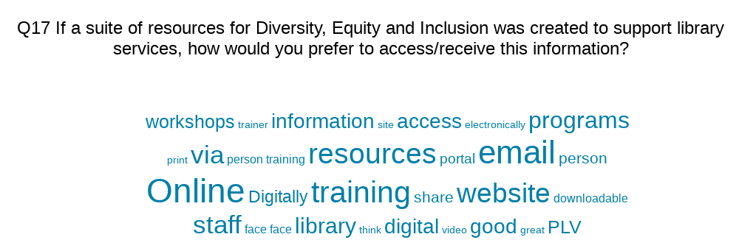

Figure 15: Word cloud of responses to survey question Q.17

Notably, close to half of the total respondents said they would like to receive this information online, with around 42% using that specific term. Some of the excellent suggestions are captured below:

* Professional development courses, training, and webinars
* Online hub accessible by libraries across the network
* PLV via website, members portal or email
* Self-paced courses
* CoMweb or other council provisions
* Forums and discussions
* Teams or Zoom
* Downloadable or printable content, including fact sheets, booklets, document packs and customisable templates

Many suggestions called for online offerings to be combined with downloadable or printable content for future reference. There were also a few suggestions for a ‘train the trainer’ approach, which would certainly increase efficiency in the development of inclusive programs, services and spaces and the efficacy of DEI initiatives.

While only 8% of respondents suggested in-person training it should be noted that this is an important consideration for the equitable access to information.

# Case Studies

## **Addiction and social stigma**

Addiction is a chronic health condition in which an individual has a strong physical or psychological need or urge to do something even if it interferes with important areas of their life or damages their physical and mental wellbeing. Addiction is commonly associated with a dependence on a substance or activity like alcohol or gambling, however addictive behaviours can also emerge from many areas like computer gaming, shopping, and work (Department of Health and Aged Care, 2023).

Addiction is commonly misunderstood and often stigmatised, particularly in comparison to conditions like mental health and is often viewed or morally judged more harshly by the public (Kulesza et al. 2014). Although prevalent theory suggests that addiction is a chronic brain disease, emerging discourse suggests that it is triggered by deep learning that “can be duly unlearned by forging stronger synaptic pathways via better habits” (Valentish 2015).

The Australian Alcohol and Drug Foundation (2019) has multiple definitions of stigma including:

* Social public stigma – discrimination brought about by prejudice and stereotypes that are endorsed by the public
* Self-stigma – internalised feelings of shame and low self esteem
* Structural stigma – discrimination (unintentional or otherwise) that is brought about by governing bodies, institutions, and legislation

Stigma is a complex problem and from an individual perspective can make people feel unwelcome, unsafe, while also playing a significant role in preventing people from seeking support. It can impact wider policies and systems which restrict access and hinder efforts to reduce harm from drug or experience dependence.

Unfortunately, stigma is understudied in the addictive behaviours literature but there is evidence to support the notion that stigma has a strong correlation with subsequent lapses in recovery after treatment (Kulesza et al. 2014). As public institutions, libraries are not immune from perpetuating stigma, however unintentionally, toward members of the community who use their spaces and who can often be perceived as a danger to themselves or other members of the community. A significant barrier for people who are experiencing addiction is stigma perpetuated by a lack of awareness and training by library staff, rendering them ill-equipped to provide meaningful support.

Libraries are ideally positioned to improve community knowledge and understanding of addiction and work to dispel myths about addiction, particularly around substance dependence and gambling. They can connect vulnerable people to available community services and promote and support help-seeking behaviour. Libraries in the United States have long been pioneers in addressing structural and social stigma as they proactively choose to be part of the crisis response to North America’s opioid epidemic, by collaborating with communities and health and wellbeing partners (Coleman & Connaway 2019).

Closer to home, PLV and SLV have developed a Health and Wellbeing Strategic Framework (State Library of Victoria 2021) to guide Victorian public libraries in raising awareness of key community needs and challenges. This includes substance abuse and gambling addiction where the library’s role is supporting partners, building skills, providing resources, making connections, and amplifying voices to positively impact the three key determinants of health: social connection, mental wellbeing, and physical health.

The Libraries After Dark initiative provides funding for libraries to extend opening hours as an alternative to the pokies. It has offered otherwise unavailable opportunities for libraries to engage in new ways with vulnerable people who are wanting to connect with others in a safe and welcoming space. Starting in 2017 as a pilot program initiated by Merri-bek Council (2023), Libraries After Dark has stretched to now include 22 participating libraries with grant funding provided by the Victorian Responsible Gambling Foundation.

City of Melbourne Libraries have also employed a social worker within their library team who is responsible for helping vulnerable people navigate the health system and connect to services as part of an emerging approach to embed health literacy in libraries as multi-purpose workspaces (Naccarella, Horwood & Elmer 2020).

These programs and initiatives offer the library as an alternative place to visit and provide specialised social worker expertise embedded within the library workforce. The following case study exemplifies a co-designed program that bridges reducing stigma and promoting literacy through community connection and art therapy.

### 

**THEMES FOR SUCCESS:**

**PARTNERSHIPS**

**DESIGN PROCESS**



### Case Study: Sharing Stories; Strengthening Communities

**Library Service:** Warrnambool Library and Learning Centre

**Location:** Regional

**Branches:** One

**Staff size:** 20

**Membership size:** 10,000

**DEI policies:** Adapted from Warrnambool Council. In house procedures and policies adhere to broader Council directives.

**Summary:** People who have experienced addiction are referred and offered to participate in a six-week creative life writing workshop as a form of art therapy. The aim is for participants to improve literacy skills and to foster feelings of connection to the community. The outcome is the creation of a co-designed learning tool to help remove the social stigma surrounding addiction against those experiencing and recovering it. The program was evaluated by the level of ongoing participant engagement and the continued evolution of the program in reaching out further into the community.

**Design Process:** The library partnered closely with the Western Regional Drug and Alcohol Centre (WRAD Health) to identify appropriate referrals to the writing workshop program. The writing workshop had two professional writer facilitators: the first provided basic life writing skills and support for participants to feel confident in their writing ability (three sessions). The second dealt more specifically with expressing one’s sensitive and potentially traumatic personal experiences (three sessions). The program was designed by the library in partnership with WRAD Health; the end-product learning tool is co-designed by the participants and animators from project partners, One Day Studios. The participants had full freedom to determine the outcome of the project. The co-design process will reflect the culmination of participants’ stories and experiences to be used as a learning tool for WRAD Health and shared with the wider public. A plain language statement was created for all parties to sign that provided participant confidentiality, scope of the project, and the right to leave at any time. Participants were also reimbursed for their time with vouchers.

**Learnings:**

* It can be challenging to identify appropriate facilitators who have extensive experience in facilitating writing workshops around very personal and sensitive subject matter
* Importance of ensuring anonymity and continued safe space for participants, particularly in a relatively small regional city
* Partnerships with local professional organisations were key to success
* A pre-existing relationship with WRAD Health for previous writing and publishing programs ensured a shared understanding of the project’s goals
* Participants became the key drivers of the program and took it to new creative areas of art therapy, as they built ownership of the program

**Staffing:**

* Two author facilitators for writing workshops
* One peer support worker
* One clinician from WRAD Health
* Two library staff members
* Two professional creators from One Day Studios

**Budget:** $43,000 total, including $33,500 from the SLV’s Health and Wellbeing   
Innovation Grant

**Advocacy and partnerships:**

Western Regional Drug & Alcohol Centre (WRAD Health)

* Identifying and referring appropriate people who are ready on their recovery journey to participate in the program
* Ongoing peer support worker and clinician present during writing workshops

One Day Studios

* Providing technical expertise and co-creators to produce animation

Author facilitators

* Suzanne Hermanoczki (Creative Writing)
* Journalist and author, Jenny Valentish, who has extensive experience in life writing with sensitive and potentially traumatic personal subject matter

**Promotion:** Due to the nature of subject matter, anonymity was an integral part of the process. WRAD Health were responsible for identifying and recruiting potential participants who were already on their recovery journey.

**Evaluation:** Participants recorded their spoken evaluation with three questions that were repeated at the beginning, middle, and end of the program. Increased scope for qualitative data provided a much richer evaluation in impact and there is a planned evaluation for the animation project for public attendance on attitudes toward addiction before and after the screening.

**Tips:** The program can be replicated to accommodate other forms of art therapy and there are many opportunities to collaborate with local creative organisations, e.g., theatre companies. Partnering with professional organisations that deal with sensitive matters is critical when targeting programming for vulnerable groups, particularly when outside expertise is required to ensure a comfortable and safe experience.

**Further information:** To find out more about these programs, email: [library@warrnambool.vic.gov.au](mailto:library@warrnambool.vic.gov.au)

## **Culturally and Linguistically Diverse Communities (CALD)**

It is important to recognise that CALD is a broad term used to identify diverse groups of people with their own culture and traditions, and there is no single definition. In this report, CALD peoples are often defined as those who have a Country of Birth different from Australia or speak a language other than English at home (Pham et al. 2021).

Australia has a long and complicated history of immigration, with the White Australia Policy abolished in only 1973 (Evershed, et al. 2023). Australia is a multicultural society that has built its economic principle around growth, with migration being an instrumental factor, as such, there are many communities from around the globe that have contributed to the rich cultural tapestry of Australia. The 2016 ABS Census showed that 28% of the population was born overseas and one-fifth speak a language other than English at home (ABS 2016). A 2013 inquiry by the Australian Government found that new migrants with lower levels of English proficiency were more likely to be represented in socio-economically disadvantaged groups due to higher rates of unemployment and reduced access to available services (Community Affairs References Committee 2014).

ALIA notes that ‘respect for diversity, individuality and equality of all’ (ALIA 2018) is central to library service delivery and this is embraced by libraries in their programming, with many respondents to the survey listing book clubs and conversation clubs for migrants and new refugees, and multilingual Storytimes. However, many services have struggled to connect with CALD communities in their catchment area, some saying ‘that [community] did not trust the library or feel welcome in either of their local Branch’ (Ferguson 2022, p.17), creating a noticeable absence from these spaces.

There is poor representation in the workforce of CALD community members. Looking at the Galleries, Libraries, Archives, Museums and Records (GLAMR) sector, there are fewer people in the workforce born overseas and people speaking a language other than English at home, when compared to the labour force. In particular, the sector is under-represented for people born in Asia and Africa (ALIA 2019a)

For libraries to ‘foster the social connections that are needed for inspiration, engagement, connection and inclusion’ within their service, they must look to employ a workforce that reflects their community (Muir, Thompson, & Qayyum 2020, p. 474). This has been implemented successfully in the case study below, which demonstrates the positive connections and relationships the library can develop with CALD communities through meaningful employment and embracing culture.

### 

**THEMES FOR SUCCESS:**

**DESIGN PROCESS**



### **Case Study: Talking Together**

**Library service:** Yarra Plenty Regional Libraries (YPRL)

**Location:** Metro

**Branches:** Nine, with a 10th branch scheduled to open in September 2023

**Staff size:** Approximately 162 employees (40 full-time)

**Membership size:** 135,957

**DEI policies:** No specific library DEI policies, however regular training includes LGBTQIA+ Awareness in the Workplace, cultural competency training, and more recently, disability awareness training.

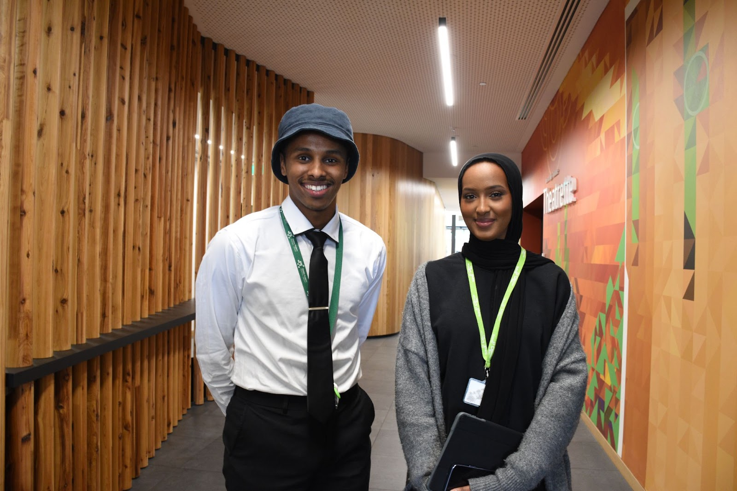

Community Program Officers

**Summary**: In 2022, YPRL implemented a project called Talking Together with the aim of making the library spaces more welcoming and inclusive for the Somali community in West Heidelberg.

Initially, the plan was to adopt a co-design approach with an outreach focus, to involve community members in program design and delivery, and encourage community engagement and participation. However, the project took a different direction after the library hired two part-time staff who were young, passionate, and connected to the Somali community. The Community Program Officers had backgrounds in youth work, criminology and engaging with diverse communities. Following a review of the project brief, they proposed reducing the outreach emphasis and instead focusing on making the library a culturally safe space and inviting the community in. The Community Program Officers were able to leverage their relationships and connections with Somali organisations within the area to drive this approach.

Over 15 activities were conducted, tailored to the needs of the Somali community, including:

* Holiday programs
* Somali Storytime which featured an outreach component to the Himilo Community Connect
* Mario Kart tournament
* Robotics classes
* ‘Baati night’ - a women's night celebrating traditional Somali dress
* Games night
* Cultural dancing

The program of community activities culminated in two large events: Careers Expo for CALD Youth and Reliving Somalia exhibition.

#### **Careers Expo for CALD Youth**

Through program evaluation and talking to the community, the project team identified a gap in career development within the Somali community. Despite higher levels of education, many Somali individuals faced lower levels of employment. To address this issue, Careers Expo for CALD Youth was organised in partnership with Himilo, a community-led organisation. The Expo featured various exhibitors and highlighted employment rights. The event also included speakers who shared their career journeys with young people. The project team observed increased library usage, including a notable presence of Somali women and children attending Storytime sessions.

#### Reliving Somalia exhibition

Talking Together culminated in the Reliving Somalia exhibition, bringing together the artistic culture of the Somali people, both historical and contemporary. These include artistic traditions in poetry, music, architecture, wood carving and other cultural arts. This program was coordinated in partnership with the Banyule Arts and Culture Team, successfully bringing Somalia into the library.

YPRL is looking to implement similar activities for other diverse groups in the area.

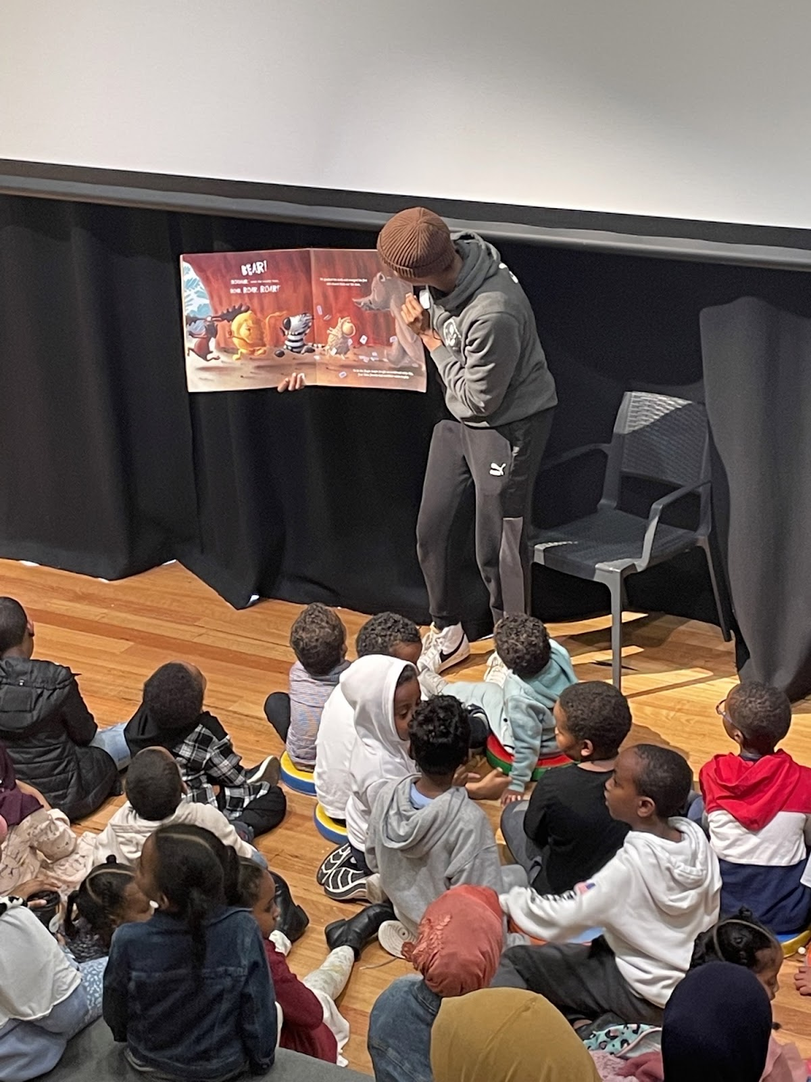

Storytime session

**Design process:** The project was funded by SLV’s Health and Wellbeing Innovation Grant. YPRL hired two part-time Community Program Officers with backgrounds in youth work and criminology, who had strong connections to the community. The team started with a needs assessment and mind mapping during the induction phase. This evaluation revealed a gap in career development opportunities for the Somali community. It also highlighted the low engagement of Somali people with the library, which was in part due to the community not seeing these spaces as a place for them.

**Learnings:** One of the key challenges encountered during the Talking Together project was the issue of capacity. The project team, consisting of two part-time staff members, faced limitations in terms of time and resources. The team members were enthusiastic and eager to accomplish a lot, but their capacity was insufficient to meet all their aspirations. In addition, the Regional Partnerships and Programs

Manager, who played a crucial role in the project, transitioned into another role, which further reduced her available time to support the staff.

Despite these challenges, the team demonstrated a proactive approach and took ownership of their work. They had regular check-ins and maintained a strong relationship with community members involved in the project, who actively participated in decision-making and consultation with library staff to ensure their ideas and initiatives could be implemented.

For future projects, assessment of available resources and their effective allocation will ensure staff have the necessary support and time to fulfil their roles. Adequate planning and realistic goal setting will help manage expectations and prevent the team from taking on more than is sustainable.

It would be beneficial for the roles to be full-time, enhancing their effectiveness and providing more capacity to execute their responsibilities. This would enable staff to further develop and implement their ideas, leading to greater outcomes.

**Anticipating Success and Securing Support:** While the project exceeded expectations, it became apparent that the initial planning did not fully anticipate the level of success achieved. The involvement of the Community Program Officers, who had strong connections within the community, played a pivotal role in the project's accomplishments. To ensure similar success in future endeavours, it will be important to secure support from managers and stakeholders early on, enabling internal staff to be convinced of the project's value and potential impact.

**Staffing:** Two part-time Community Program Officers.

**Budget:** The project cost approximately $80,000, including staff expenses. Around $20,000 was allocated to events such as festivals, careers events, exhibitions, and over 15 story times, Majority of this spend was on the two major events, Careers Expo for CALD Youth and Reliving Somalia exhibition.

**Advocacy and partnerships:** The library service partnered with the Islamic Museum of Victoria to continue breaking down community perceptions of Muslims. They have also expressed their intention to hire more staff from CALD backgrounds. The project team recognises the importance of cultural awareness training for staff and the need to be inclusive in hiring practices.

**Evaluation:** The Talking Together project successfully engaged the Somali community in West Heidelberg by creating inclusive library spaces and delivering culturally relevant programs. Positive outcomes were achieved in terms of increased access to library services and improved health and wellbeing. The ongoing connection with Himilo Community Connect, and the commitment to hiring staff from CALD backgrounds demonstrate the library service's dedication to DEI.

Recommendations for future initiatives include building on the successes of the Talking Together project, expanding community partnerships, and further enhancing staff cultural awareness and responsiveness through training.

For the Regional Partnerships and Programs Manager, one key pillar of success was when she greeted a Somali community member coming into the library asking if they were there for the cultural event, to which they said ‘No, we are just here for Storytime’.

**Tips:** To promote cultural understanding and inclusivity, providing cultural awareness training to staff members is recommended. In the initial stage, training was conducted for 20 staff members, focusing on cultural responsiveness, and encouraging individuals to reflect on their own cultural journey. Additionally, it is noteworthy that Banyule Council received a substantial grant, part of which aimed to train local businesses in effectively working with the Somali community. Leveraging these resources and expanding the cultural training initiatives can contribute to a more inclusive and respectful environment.

By implementing the learnings from the experiences of the Talking Together project, future endeavours can benefit from enhanced staff support, better anticipation of success, and proactive efforts to address cultural awareness and responsiveness. These adjustments will contribute to more successful outcomes and foster a welcoming and inclusive environment for all community members.

**Further information:** To find out more about these programs, email: [ypmail@yprl.vic.gov.au](mailto:ypmail@yprl.vic.gov.au)

## **First Nations peoples and cultures**

When speaking or writing about First Nations peoples, it is important to acknowledge the different terms used, which can be complex and nuanced as terminology has evolved over time. This report uses First Nations people/peoples; however, the project team acknowledges and respects that language preferences vary among individuals and communities, and there is no universal term that applies to all First Nations people. Aboriginal and Torres Strait Islander peoples and Indigenous Australians are commonly used, as well as more localised language to describe a specific cultural group, like Koori in Victoria (and much of NSW). Further colloquial terms like mob are often used by First Nations peoples to describe their own community, and recently the term Blak has emerged as a form of self-identification used to assert cultural pride, resilience, and a connection to First Nations identity.

When in doubt, it is always best to use specific terminology if known or, when appropriate, to respectfully ask individuals or communities about their preferred language. Respecting people's self-identification and cultural preferences is crucial in fostering positive and inclusive communication. Terms used in the case study ‘First Peoples identified roles in libraries’ are reflective of the terms used by the Aboriginal Library Assistant when interviewed.

Australia’s First Nations peoples have a rich cultural heritage dating back over 65,000 years, and possess a deep connection to the land, traditional languages, art, and spiritual beliefs. However, the history of First Nations peoples is marked by the profound impact of colonisation, which is attributed to multiple layers of disadvantage, including shorter life expectancy, higher rates of infant mortality, poorer health, and lower levels of education and employment than non-Indigenous Australians (ABS 2016).

Australian libraries play a significant role in reconciliation by promoting understanding, respect, and recognition of the histories, cultures, and rights of First Nations people. The sector has been widely proactive in its adoption of policies and practices that centre First Nations peoples, with many services looking to the ATSILIRN (Aboriginal and Torres Strait Islander Library, Information, and Resource Network) Protocols to guide their own work (Jackson 2008). However, it can be argued that the history and spaces of libraries represent a colonial path of education, and thus they do not inherently appear as welcome places for First Nations peoples (Masterson 2020), this is not helped by the stereotype of the shushing librarian which polices this public space (Jennings 2016). The library sector needs to be proactive in implementing targeted programming, services and welcoming spaces for First Nations peoples.

Across the state, libraries acknowledge the national events which are attributed to First Nations peoples; NAIDOC Week, Reconciliation Week, National Sorry Day, the National Apology to the Stolen Generations anniversary on February 13 and Invasion Day on January 26. However, programming for First Nations people outside these dates is limited. Library services that are leading the field in this space engage in First Nations Storytimes, literacy programs and talks or lectures on First Nations topics or histories. Libraries that take the most significant strides in welcoming these communities into the library are often services that employ First Nations people.

Having staff members from community will support the service to centre perspectives around the distinct needs of this community (Thorpe & Galassi 2018). This allows the library sector to “codesign and market to communities to have more staff reflecting their community. Supporting community in the world of the library” as noted by one survey respondent.

This approach is highlighted in the case study below, where employing a First Nations staff member has been transformative for the library’s relationship with the community. It is important to note that when employing identified roles, the work must be done by the whole library to support employees, to minimise the risk of burnout under the cultural load (Siversten, Ryder & Johnson 2023).

### 

**THEMES FOR SUCCESS:**

**PARTNERSHIPS**

**DESIGN PROCESS**



### Case Study: First Nations identified roles in libraries

**Library Service**: Goulburn Valley Libraries (GVL)

**Location:** Rural/Regional

**Branches:** 10 and a mobile library servicing three council areas (land area of 14,000km2)

**Staff size:** 65 staff

**Membership size:** 25,643

**DEI policies:** N/A

**Summary:** In 2019 Goulburn Valley Libraries received a grant to collaborate with and establish connections with First Nations communities in the area. As part of this initiative, they employed an Aboriginal Library Officer. Initially, the position was referred to as the ‘Woongi Officer’, which raised concerns as local Elders were unfamiliar with the term and was later changed to Aboriginal Library Officer.

This position was held by a respected Yorta Yorta Elder who was employed in a casual capacity. Her responsibilities included attending Storytimes, visiting various locations within the GVL catchment, and participating in community events. This initial position was on a contract basis and lasted for two years.

Following the retirement of the Aboriginal Library Officer, GVL recognised the need for an ongoing role that would foster a stronger connection with the community. Following active consultation with community, the role of Aboriginal Library Assistant was created, with the aim of integrating local knowledge, traditions, and networks. It was essential to find someone with strong community connections, particularly from the Yorta Yorta Community, to create meaningful impact. For this reason, they sought to advertise this position through community networks and in local papers.

The successful applicant was Julie Best, a former Koori Education Support Officer (KESO) with deep community links. Her nephew is one of two First Nations local council members in the state, and her brother, Glen James, is the only Indigenous umpire in the Australian Football League. These family and community connections have played a significant role in the success of this position and the impact she has had on the community. Julie noted that she has been known to casually drop their names to quickly build connections with young mob and non-Indigenous communities. This example highlights the importance of recruitment in an identified position, as recruiting a community member who holds a position of respect within the community will support the breakdown of barriers to library spaces that some community members perceive.

**Design process:** The role of Aboriginal Library Assistant involves organising visits to schools and playgroups, in addition to working in over 11 library branches throughout the area and activity engaging with the community through networks and contacts. Her efforts extend to organising school holiday events during NAIDOC Week and other school holiday programs, promoting cultural awareness and understanding.

A contributing factor to the success of this position and its learning outcomes are due to the staff member's enthusiasm for the role, as well as the ability to flexibly change her hours to suit the school and kindergarten schedules.

Further, during the process of naming the position, considerations were made to ensure cultural sensitivity. While the term ‘Officer’ initially made the staff member uncomfortable, the title ‘Aboriginal Library Assistant’ was deemed appropriate and respectful.

The Aboriginal Library Assistant develops her work using her extensive cultural knowledge accumulated over the years, focusing on sharing that knowledge and deep understanding of Country in a series of engaging stories based on lived experience and Dreamtime lore. For practical understanding of concepts, she runs two Storytimes for age-appropriate audiences, Prep to Grade 3, and Grade 4 to Grade 6.

Furthermore, the staff member has been involved in a program called ‘Scaly Tailed Echidnas' and has been instrumental in coordinating morning tea events for the Yorta Yorta Community. Her strong community connections have enabled her to garner support for these programs and receive assistance from other staff members.

As the position has deep community connections, there is an organisational risk that staff tend to believe that anything to do with Aboriginal or Yorta Yorta Culture should be directed to this position, when in fact it's everyone’s responsibility to share it.

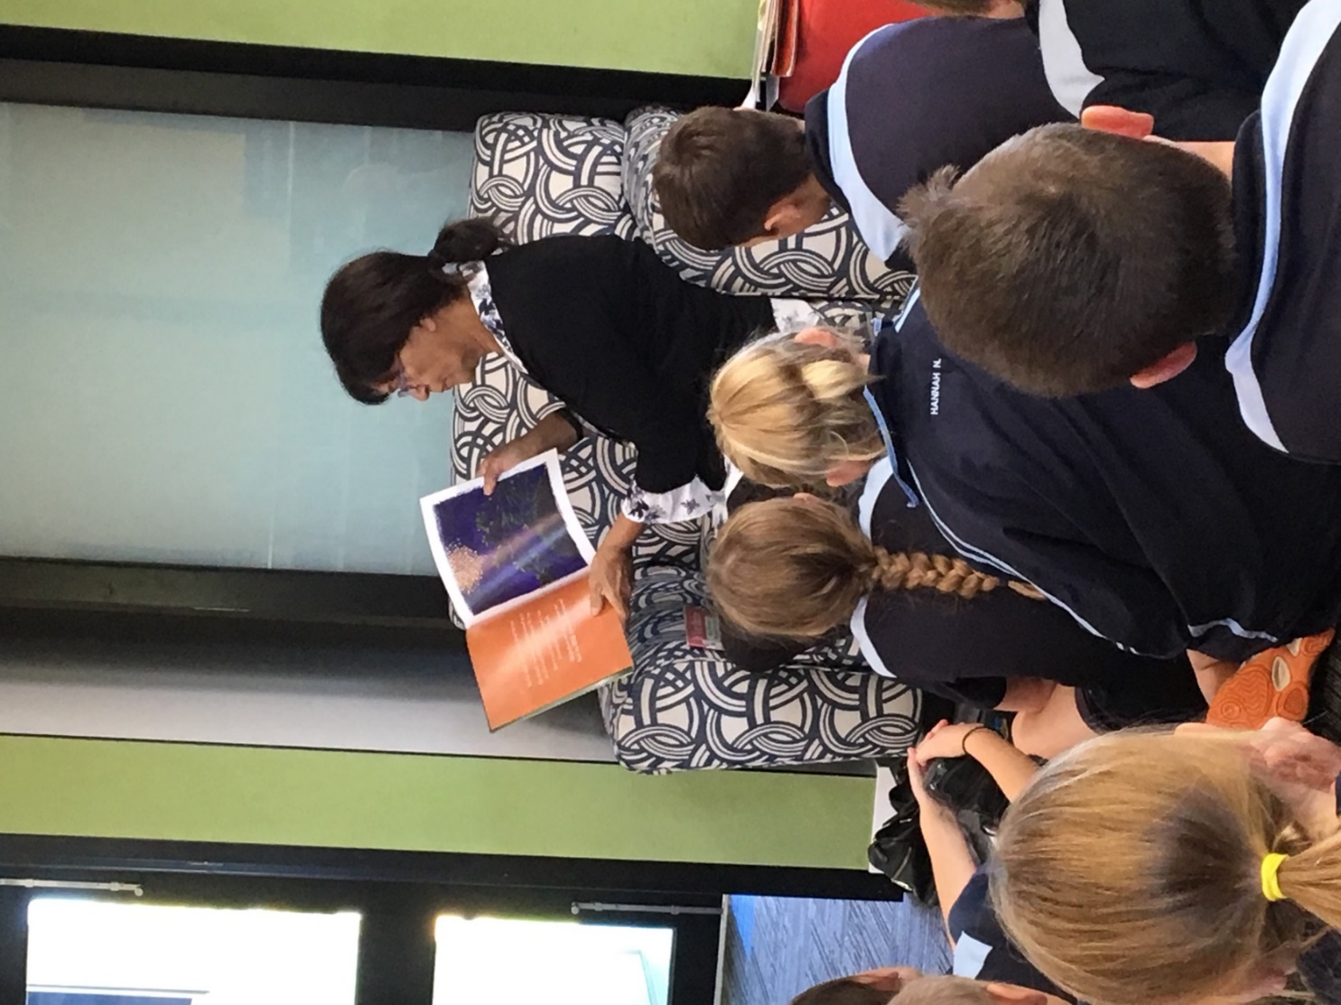

Aboriginal Library Assistant reading to students in the library

**Learnings:** Library staff sometimes feel like if they want to run a program for NAIDOC Week that it needs to be delivered by the Aboriginal Library Assistant. Jenny Willey, Services Manager at GVL, works with the Program Coordinator to ensure staff are building on Julie's knowledge and ensuring the work is evenly distributed. This risk is common with identified positions in all industries struggling with cultural burnout (Siversten, Ryder & Johnson 2023).

The Aboriginal Library Assistant plays a crucial role in creating a safe environment for the local First Nations community. A key aspect of this involves evaluating the collection to ensure titles portraying outdated representations of First Nations peoples are removed from public display, creating a more welcoming space. It is essential for organisations to ensure that these positions have meaningful work and acknowledge their significance. Simply appointing an Aboriginal Library Assistant without empowering them to act would be futile. The GVL Services Manager emphasised the importance of making this position successful, demonstrating the commitment to empowering and supporting the Aboriginal Library Assistant.

Additionally, the Aboriginal Library Assistant conducted cultural awareness training for library staff upon her arrival, contributing to a positive reception and understanding of her position within the branch. This training has been instrumental in creating an embracing environment for the new role, as culturally competent staff reduces the risk that a person holding an identified position will feel isolated.

The presence of an Aboriginal Library Assistant in the library branches has facilitated stronger connections and advocacy for the community, ensuring a culturally safe space within the library. The role has contributed significantly to maintaining a sense of cultural identity and understanding, promoting inclusivity for the local First Nations community.

**Staffing:** The hours for the role were adjusted to accommodate the outreach schedule and to maintain a familiar presence in the branch, fostering a welcoming environment for visitors. The role is currently 10 hours per week, with an additional four hours per week working in a library branch. This arrangement ensures continuity of hours and allows First Nations people to feel more comfortable when visiting the library, as they may have seen her there previously, particularly the Tatura branch, and facilitates the staff member's desired work/life balance.

**Budget:** The role has a dedicated budget of approximately $5,000 per year, allowing agency and autonomy in program decision-making. This budget covers various aspects, including catering for morning teas and resources for children's programs. The allocation of this budget empowers the staff member as a storyteller and ensures she has the necessary resources to contribute meaningfully to the library's programs.

**Advocacy and partnerships:** GVL had established connections with the local First Nations community through a grant collaboration with a local First Nations organisation. The library had previously employed an Aboriginal Library Officer, but the position was on a contract basis and lacked strong integration with the library service. This previous experience highlighted the importance of fostering stronger connections and cultural safety for the local community.

**Evaluation:** As Aboriginal Library Assistant at GVL, Julie has had a transformative impact on the library service. Her family and community connections, coupled with her dedication to promoting cultural awareness and understanding, have brought about positive change and inclusivity. Through her active engagement with the community, coordination of programs, and advocacy for cultural safety, Julie has made a significant impact on the library's service to the local First Nations community.

The evaluation of the position is primarily based on anecdotal feedback and workshop reviews, and a noticeable uptake of First Nations people visiting the library. There is no formal evaluation process in place, and attendance and anecdotal evidence serve as measures of success.

Julie actively promotes library membership within the Koori community. Initially, an Aboriginal/Torres Strait Islander origin question was included on new member forms, but it was later removed to avoid stigmatisation. The initial records showed strong membership from Aboriginal and Torres Strait Islander peoples, however no increase/decrease can be determined due to no control data being recorded.

The success of the position is attributed to the strong connections Julie maintains within the community and the empowerment she receives in her role. Her active involvement in decision-making, access to a dedicated budget, and the support received from other staff members have allowed her to create meaningful and culturally enriching programs. Overall, the role of the Aboriginal Library Assistant has been a vital addition to GVL, ensuring a more inclusive, diverse, and culturally sensitive library environment.

**Top tips for a successful First Nations identified role**

**For the organisation:**

* Create an environment where the First Nations staff member feels valued, comfortable, and safe
* Provide cultural training and background knowledge to help staff understand and appreciate First Nations cultures
* Leverage previous experiences and connections within the community to support the new staff member
* Grant additional agency and autonomy to define their work and share their culture
* Support outreach efforts by allowing flexibility in working hours to accommodate schools and organisations
* Embrace and promote cultural exchanges, such as incorporating Welcome to Country ceremonies and encouraging language learning in schools

**For individuals entering a similar role:**

* Approach the role with friendliness and confidence
* Recognise and value the knowledge and experiences you bring to the position
* Prepare for sessions and interactions to boost confidence and facilitate meaningful engagement
* Embrace and be proud of your Culture, as others may have questions and seek to learn from you
* Utilise personal relationships and community connections to enhance the impact of your role
* Be open to learning and growing, even if you initially have limited knowledge about libraries

**For succession planning:**

* Recognise that the experience may differ depending on the individual who fills the role
* Provide training and support tailored to the specific responsibilities of the position
* Encourage confidence and pride in Culture and heritage
* Foster a sense of belonging and responsibility toward the community
* Consider age and experience as potential factors in sharing knowledge and facilitating the transition

By following these tips, organisations can create a supportive environment that enables First Nations people to thrive, while individuals can make a positive impact by embracing Culture, building relationships, and continually learning and growing.

**Further information:** To find out more information, email: [gvrlc@gvrlc.vic.gov.au](mailto:gvrlc@gvrlc.vic.gov.au)

## **LGBTQIA+**

Libraries have long been safe spaces for many LGBTQIA+ people (Gay-Milliken & DiScala 2020, pp. 1-17). LGBTQIA+ visibility and inclusion can be demonstrated through book displays, rainbow spine labels, reading lists and online catalogue curation, rainbow lanyards, pronoun badges and gender-neutral bathrooms (Day 2013, pp. 46-50; Quiqley 2022).

Libraries commonly celebrate important LGBTQIA+ dates such as Pride Month, International Day against Homophobia, Biphobia, and Transphobia (IDAHOBIT), Wear It Purple Day and Midsumma Festival. Common special events include Rainbow or Drag Storytime, author talks, and more. Increasingly, libraries are also adding regular programs that are specifically curated for LGBTQIA+ communities, such as book groups, rainbow playgroups, and movie clubs.

Sadly, many libraries have recently become targets of anti-LGBTQIA+ attacks (Dexter & Estcourt 2023; Kelly 2023; Tamer 2023; Topsfield 2023) and are experiencing increased challenges towards LGBTQIA+ collections. This activity was increasing in early 2023 and culminated in May 2023 with threats of violence made towards public library staff, drag performers, families planning to attend the events, and Councillors (Tamer 2023). Many IDAHOBIT Drag Storytime events at public libraries were cancelled, postponed, or transitioned to online delivery, with some libraries noting concerns about safety for library staff, customers, and event performers (Kelly 2023; Tamer 2023; Topsfield 2023). While physical safety is paramount, cancelling LGBTQIA+ events can also impact the psychological safety of LGBTQIA+ people including library staff and the broader community. Felicity Marlowe, Manager of Rainbow Families Victoria, notes ‘it’s just the visual of the situation – cancelling sends a really detrimental message, particularly to young queers and trans young people’ (Kelly 2023). In response to the cancelled Drag Storytime events, Victoria’s Parliament House hosted a Drag Storytime event on IDAHOBIT (Dexter & Estcourt 2023).

Many library staff are passionate about delivering these events and are supported by the broader community. Rainbow Community Angels are lending their presence to library and community events, ‘to increase event safety through our highly visible, peaceful, supportive community presence’ (Thomas 2023). The Australian Services Union (ASU) is advocating for the support and inclusion of LGBTQIA+ activities (2023), with a representative from ASU commenting, ‘All librarians are entitled to work in a safe environment and the stories we have heard about abuse, hate-speech and attacks on librarians should not be tolerated’ (Topsfield 2023). In *INCITE Magazine*, ALIA President, and Yarra Plenty Regional Libraries (YPRL) CEO, Jane Cowell, wrote ‘please reach out and support each other if you see a library being targeted in this way, as receiving emails and social media posts of support really does combat the weight and stress of the negative comments and complaints’ (Cowell 2023, p. 3).

ALIA released a statement in response to these anti-LGBTQIA+ attacks, asserting:

‘This behaviour is unacceptable. Library staff deserve to be treated with respect and to feel safe at work. Library staff should never come under attack for doing their job and upholding their professional values. ALIA supports public library staff and their Councils in standing up and saying ‘No’ to these targeted attacks. ALIA joins with library communities to thank library staff for their dedication, skills and ethics in the continued delivery of vital public library services to communities.’ (ALIA 2023a)

Library programming for Pride Month appeared to be quieter in 2023. A call out to library managers identified Pride Month activities running at three library services, Maribyrnong Libraries, Port Phillip Libraries and Yarra Plenty Regional Libraries. Maribyrnong Libraries hosted a Drag Trivia Night, which is detailed in the case study below. Port Phillip Libraries delivered a Drag Trivia Night and an *Of an Age* film screening featuring a live Q&A with director Goran Stolevski. Port Phillip’s planned Drag Storytime was delivered online due to risk to staff and community, however a community led Drag Storytime was delivered by the Rainbow Community Angels on the lawns of St Kilda Town Hall with no protesters attending. YPRL delivered a comprehensive program including multiple art and craft workshops, a book presentation, online Drag Storytime, and more.

Libraries can take several steps to mitigate risks and increase safety for staff, participants, and performers, including strengthening risk assessments and risk management plans, liaising with Victoria Police, working with community groups such as Rainbow Community Angels, and more. See case study below for some examples. Robust collection development policies and/or diversity statements will also support libraries in maintaining inclusive collections which represent our diverse communities.

In continuing to program LGBTQIA+ events, especially in the face of these attacks, libraries can continue to support and include LGBTQIA+ communities:

‘Having a drag story time in your library promotes your library’s acceptance, inclusion, and recognition of diversity within your community, and may bring people to the library who otherwise would not attend. It acknowledges and values diverse family structures and provides queer role models for children who may be searching for people in their community who reflect them.’ (Winter 2020, pp. 12-13)

### 

**THEMES FOR SUCCESS:**

**BUILDING ON CORE OFFERINGS**

**PATRON-CENTRED**

**DESIGN PROCESS**



### Case Study: LGBTQIA+ events and programs

**Library service:** Maribyrnong Libraries

**Location:** Metro

**Branches:** Five

**Staff size:** 63

**Membership size:** 28,072

**DEI policies:**

[Disability Action Plan](https://www.maribyrnong.vic.gov.au/Residents/Support-in-your-community/People-with-disability), [Gender Equality Action Plan](https://www.maribyrnong.vic.gov.au/Residents/Staying-safe-and-healthy/Gender-Equality/Gender-Equality-Action-Plan-2022-2025), [LGBTIQA+ Strategy and Action Plan](https://www.maribyrnong.vic.gov.au/Discover-Maribyrnong/Our-culture-and-community/LGBTIQA-People-Families-and-Communities), [Reconciliation Action Plan](https://www.maribyrnong.vic.gov.au/About-us/Our-plans-and-performance/Reconciliation-Action-Plan)

**Summary:** Maribyrnong Libraries deliver a range of special events to mark and celebrate important LGBTQIA+ dates and regular programs that are designed specifically for LGBTQIA+ communities.

In June 2022 the library launched Queer Book Group, a community-driven program that was developed out of community need to have more spaces facilitated by people from the queer community. The first session booked out within two days, and on average 15 people attend each month, with one participant even travelling from Echuca in Northern Victoria. This willingness to travel demonstrates the demand for these programs and the capacity for libraries to be destinations for social connection in LGBTQIA+ circles. There are around 50 people on the email list, which includes reading recommendations and community updates.

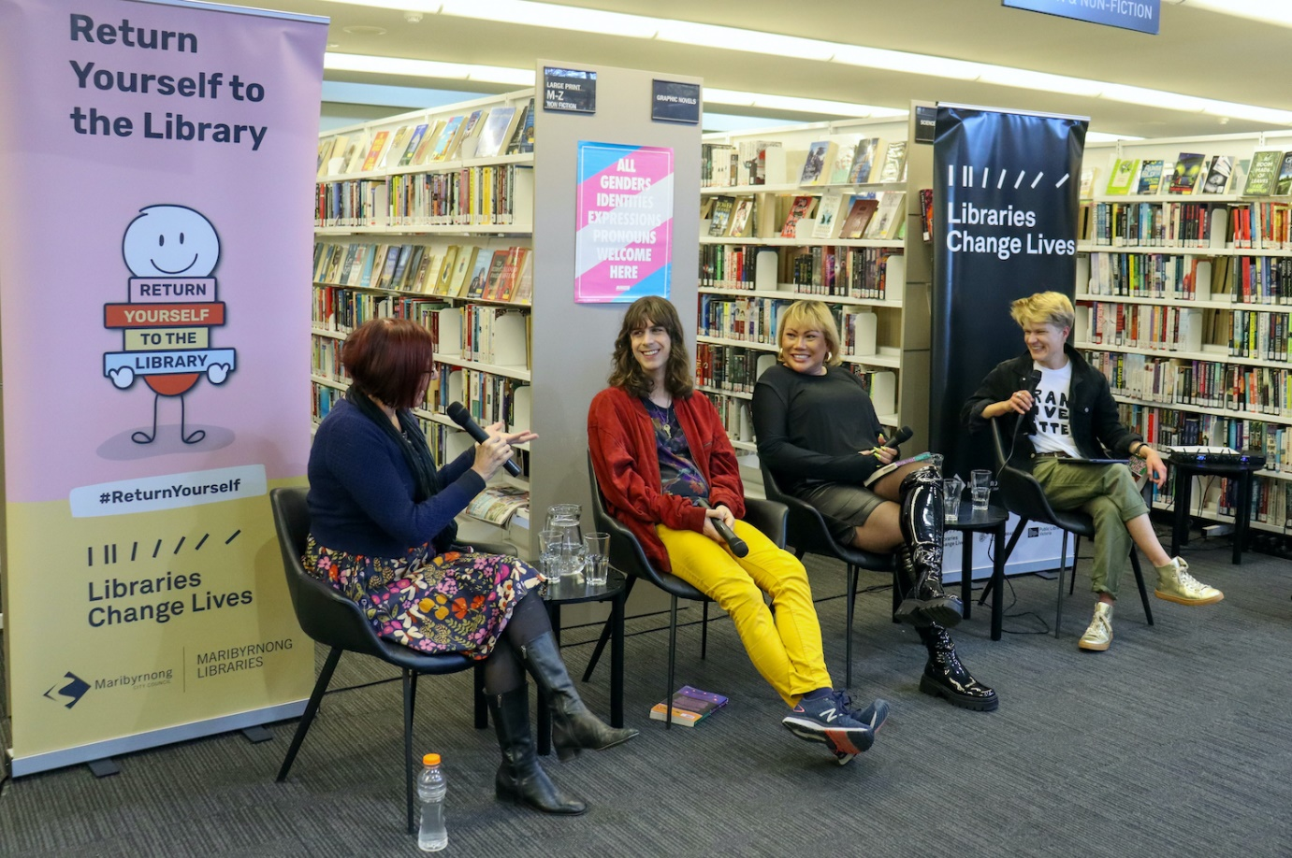

Julie Peters, Jack Nicholls, Sasja Sydek and Yves Rees speaking at a panel discussion at Footscray Library.

In late 2022, Book and Film Chat: a Program for Older LGBTI People (also known as LGBTI Book and Film Chat) was launched as a program specifically designed for the older LGBTI community. The project team notes that LGBTI is often the preferred abbreviation when working with the older LGBTI community. While branded a book and film chat program, its main purpose is social connection, providing an opportunity for making friends and facilitating discussion around the participants’ daily lives, and issues and topics related to participants as older people, as members of the LGBTI community, and their other intersectional identities. The program has nine members and is attended by roughly five people per month.

Recent special events include a Drag Trivia Night with Valerie Hex to celebrate Pride Month, and an IDAHOBIT panel event featuring one of the co-editors and three contributors to the *Nothing to Hide* anthology. 53 people attended the Nothing to Hide event and 28 people attended Drag Trivia Night, and the trivia capacity was increased to meet demand.

**Design process:** Queer Book Group was developed by West Footscray’s Weekend Librarian (and now Children’s and Youth Services Librarian). She researched library LGBTQIA+ book groups in Victoria and, at the time, could only find one currently running but it had a waitlist. The Librarian identified that there would be a community need, and at the time Maribyrnong did not run any ongoing LGBTQIA+ programs. Two library members who had requested a queer book group were consulted and decided on an informal book chat setting rather than an organised reading list.

LGBTI Book and Film Chat was designed by request and in consultation with a member of City of Maribyrnong’s LGBTIQA+ Advisory Group. Feedback included that it was not essential for the program to be delivered by someone who identifies as LGBTQIA+, and it is staffed by an Outreach Librarian who is experienced working with older people. The initial intention was to run as an alternating Book Chat and Movie Club program, where bi-monthly the group would watch and discuss a film. However, group feedback was that the main priority was to have a safe space to come together for connection, so the program design was adapted.

The special events were designed by Maribyrnong Libraries program staff, as part of the suite of special events at the library. The Drag Trivia Night was in response to requests from attendees at previous library events.

**Learnings:** There is an important element of social work with Queer Book Group and LGBTI Book and Film Chat, and the librarians regularly inform participants about services available and provide referral contact details.

Queer Book Group presented learnings regarding older LGBTI people. The program was named Queer Book Group as it was initially designed with a younger cohort in mind, and queer is a term of identity that is being reclaimed by younger LGBTQIA+ generations. The library received feedback from some of our older LGBTI community members, for whom the word queer is associated with trauma. The group was consulted about the name, and they were in favour of keeping Queer Book Group. This feedback from older LGBTI community members led to the creation of the LGBTI Book and Film Chat program.

Approximately 60% of Queer Book Group members identify as trans or gender diverse. Some of the older group members have changed their pronouns since joining the program. This may not be correlated but does speak to the power of being with community and sharing personal stories.

Programs for older people are not always safe spaces for LGBTI communities, and some members have experienced homophobia when attending other programs and events such as Seniors Clubs. There are not many programs dedicated to the older LGBTI community in Victoria, so people will travel for events like this. Some LGBTI Book and Film Chat members also attend Bent Twigs in the City of Yarra and Birds of a Feather in the Macedon Ranges. Maribyrnong has found it challenging to reach older people who also identify as LGBTI, who may be isolated and not digitally connected, and are working on more extensive community outreach to promote the program.

Due to recent attacks on library LGBTQIA+ programs, the 2023 IDAHOBIT and Pride Month events presented new and heightened challenges. The library revised and strengthened the risk management plans and risk assessment procedures, including notifying Victoria Police’s LGBTQIA+ Liaison Officers about the events so that they could be monitored for suspicious online activity, reviewing event evacuation plans, identifying next steps if the events were to be targeted by anti-LGBTQIA+ groups, and, in the case of the Drag Trivia Night, keeping the event location private and releasing the location to event participants ahead of the event. The aim was to best ensure the safe delivery of the events for the talent, library members, and staff, while also reducing the likelihood of event postponement or cancellation. The talent were consulted throughout and would have been consulted before hiring security and/or inviting police if the risk assessment deemed those steps advisable. The events did not receive any attacks or threats, so ultimately the risk assessments and management plans were not tested.

**Staffing:** Queer Book Group runs for one hour per month on a Saturday and requires an additional three hours per month in preparation, ordering books, updating book lists, and email contact with participants.

LGBTI Book and Film Chat runs for two hours per month, with the Librarian present for usually the first hour. There is also approximately an hour per week dedicated to keeping across LGBTQIA+ news and researching similar events or relevant services.

The special events were mainly planned by two library staff members, with additional assistance on event days.

**Budget:**

* Performer and author fees
* Food catering for special events
* Tea and coffee from library supplies for regular programs

**Advocacy and partnerships:** Queer Book Group was designed in consultation with library members who requested the program, and LGBTI Book and Film Chat was designed in consultation with a member of City of Maribyrnong’s LGBTIQA+ Advisory Group.

**Promotion:** Programs and events are promoted by the usual library and Council channels including website, social media, What’s On booklet, posters and flyers. They are also shared with community organisations and groups such as Victoria Pride Centre, Bulldogs Pride, Gender Queer Australia, Rainbow Network, the Bent Twigs Facebook page, and via City of Maribyrnong’s LGBTIQA+ Advisory Group.

**Evaluation:** Evaluation surveys were completed by 13 Queer Book Group members, three LGBTI Book and Film Chat members, 26 Drag Trivia Night attendees and 14 Nothing to Hide panel attendees.

Connection to community is at the heart of these programs, with 100% of respondents to the LGBTI Book and Film Chat evaluation survey reporting “I feel more connected to my community after attending.”

Many participants reported significant impacts on their connection to community, including:

“My friendship group is fairly homogeneous (we're all around the same age, all queer and trans and disabled and neurodivergent) and while that's amazing, it's also great to form connections with people who don't fit that exact pattern.”

The importance of the library offering these programs was also reported, with one Queer Book Group member identifying “a growing connected community which was very absent from council settings in the past.”

In response to the Drag Trivia Night, a representative of Bulldogs Pride and Maribyrnong Libraries member emailed the library service, writing:

‘I wanted to say thank you for standing by our community and putting this event on. In my role as the Pride Lobby Co-Convener, I've been campaigning around the drag Storytime issue, and it's been so demoralising to see Councils pull back on their LGBTIQA+ programming because of targeted harassment. We really need Councils to keep putting these events on, so I'm genuinely, deeply grateful to you and the other Maribyrnong staff.’ (pers. comm., 13 June)

**Tips:** The Librarian who runs Queer Book Group noted the benefit of these programs being facilitated by a queer person and the value of preserving queer spaces. However, this should not prevent libraries from delivering LGBTQIA+ programs if they do not have an identified LGBTQIA+ staff member to run the program.

Queer Book Group’s informal book chat structure has allowed the group to talk about approximately 200 books in the first year, broadening members’ reading habits, and encouraging people to come to the program even if it is primarily for the sense of the community. It allows the library to have a better understanding of which books are popular and improve collection curation.

Some older LGBTI people do not openly disclose their sexual orientation and/or gender identity with the wider community. Marketing programs for older LGBTI people as also for friends and allies can help make programs accessible to those who have concerns about being ‘outed’. Holding the program in a private room can also assist in creating a safe space for older LGBTI people.

For both regular programming and special events, best practice is for all library staff to receive LGBTQIA+ inclusion training. However, at a minimum, training should be provided to staff working on the programs and events.

For special events, a strong risk assessment and risk management plan will provide reassurance to staff and key stakeholders. Send your event details to the local VicPol LGBTQIA+ Liaison Officer and VicPol will monitor for any online activity targeting your event. Also consider whether a police force and/or uniformed or plain clothed security presence at your event is appropriate and of benefit, noting that many in the LGBTQIA+ community have experienced trauma with police so this may not be the preferred approach. Consider inviting Rainbow Community Angels to attend the event.

Consider all rostered staff beyond the program team to ensure smooth running of the event and supported customers and be open with the broader team about the added safety considerations.

Consult with the event talent throughout the process, including notifying them of your risk management plan and particularly if the need arises to reassess the security and/or police plan. The Nothing to Hidepanellists commented that they appreciated being consulted throughout the process.

When hosting the event in a co-located space, factor stakeholders and co-tenants and other activities happening within the space into the event’s risk assessment and risk management plan. Avoid assuming that external organisations or partners will be equally supportive of the event.

Where appropriate, consider keeping the event location private and only advertising to registered participants ahead of time.

Have referral service details ready to provide to attendees, staff, or talent, if the event raises any challenging issues.

**Further information:** To find out more about these programs or events, email: [library@maribyrnong.vic.gov.au](mailto:library@maribyrnong.vic.gov.au)

## **Neurodivergence**

Neurodivergent is a wide-ranging umbrella term coined by Kassiane Asasimasu (Chapman 2021) for people who have brain functions that diverge from what is considered typical. It simply means that people experience brain functionality differently in terms of learning, communicating, processing and interpreting feelings and emotions. It is important here to acknowledge the difference between neurodivergent and neurodiversity as the latter refers to the entire spectrum of diversity of the human mind (Singer 2023).

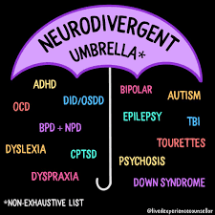

Image credit: [@livedexperiencecounsellor](https://www.instagram.com/p/CVtXcd5BjTZ/), Instagram

The public environment can be challenging for any neurodivergent individual and can include barriers such as:

* Unpredictable and unfamiliar nature of public library spaces with complex rules and behavioural expectations
* Overwhelmed senses (e.g., noisy Storytime, bright lights, busy spaces, strong smelling food)
* Navigation and wayfinding
* Experiencing and articulating emotions and feelings (Aspect 2023)

There is research that indicates neurological conditions such as Autism Spectrum Disorder (ASD) are not often mentioned in Victorian library disability and inclusion action plans (Muir & Carroll 2020). With a recent uptick in ASD diagnoses across the country, up by 25.1% between 2015 to 2018 (Australian Bureau of Statistics 2018), it is impossible to know the full extent of people who are neurodivergent in our communities, despite better community understanding of the breadth of conditions and improved diagnostic tools. Disability and accessibility plans are often focused on the physical space, so when designing a space or program, it can be challenging to ask all the right questions to be truly welcoming and inclusive.

Library staff acknowledge and understand the actions required for more inclusive libraries for neurodivergent people but face several obstacles. These often include insufficient time and money, limited control of external factors and priorities, limited awareness of existing services and providers, and limited employee training and awareness (Small, Myhill & Herring-Harrington 2015).

The survey identified that many libraries are supporting neurodivergent people, particularly regarding early literacy. Many library services facilitate regular Sensitive Storytimes that are programmed within regular Storytime rotation for children with ASD. Library staff have increasingly been offered training programs to deliver ASD friendly Storytimes that have increased staff awareness and confidence in welcoming children with autism in their Storytime programming (Paynter et al. 2020), with one survey respondent noting:

“It's clear that more needs to be done to normalise programming, services and spaces that automatically are inclusive of people with sensory disorders and other neurodivergent characteristics. Good design for people who are neurodiverse is generally good design for everybody.”

A program of note is the Next Chapter Book Club at Campaspe Library Service which offers community-based books clubs for young people and adults with intellectual and developmental needs through an affiliate program based in the United States.

Library staff have also considered how to make the appropriate changes within the physical space of their libraries. Designated Quiet Times are often advertised for people with sensory needs that augment the library space. This development was initiated by a partnership between Coles Supermarkets and ASD advocacy organisation, Aspect, based on principles of Universal Design, and now has been adopted by other corporations and public places such as libraries.

The following case study illustrates the simple intention of targeting young people who may not think that the library has any community activities for them, and unintentionally attracting people who are neurodivergent. It also provides an example of the way in which patron-centred programming has the potential to evolve and grow to cater for a much broader community.

### 

**THEMES FOR SUCCESS:**

**PATRON-CENTRED**

**DESIGN PROCESS**



### Case Study: ‘Magic: the Gathering’ and ‘Warhammer 40K’

**Library Service:** Eastern Regional Libraries (Your Library)

**Location:** Metro

**Branches:** 13 + three Reading rooms

**Staff Size:** 120

**Membership size:** 257,000

**DEI policies:** Library Plan 2021 - 2025

**Summary:** This case study is the combination of two separate activities but have significant overlap in terms of preparation, design, facilitation, and resourcing. They are often attended by the same participants.

#### Magic: the Gathering

Released in 1993, Magic: the Gathering was the first trading card game and is undoubtedly the most popular. One player takes the role of a wizard to do battle with other players by casting spells, using artefacts, and summoning creatures, defeating their opponent typically by casting spells and attacking with creatures to reduce the opponent's ‘life total’ from 20 to 0. The cards are beautifully illustrated, and play involves reading and simple arithmetic. The game is great for people who like the combination of art, words and numbers, and enjoy being creative in responding to challenges on the way to victory or defeat. The Knox Library currently holds weekly sessions on Wednesdays at 4pm to 5:30pm, with a few players often arriving early to play before the sessions start. Facilitated by staff, the sessions can be attended by anyone aged 10+, although there have been participants as young as seven. Newcomers are taught how to play to be ready to join in games with other people of various skill levels.

#### Warhammer 40K

Warhammer 40K, the most popular miniature wargame, is set in the distant future where a stagnant human civilisation is beset by hostile aliens and supernatural creatures. Players enact battles, using miniature models of warriors and fighting vehicles, on a tabletop battlefield with terrain features. These fights are resolved using dice and simple arithmetic. This game is great for people who like the artistic painting of the models and enjoy devising strategies and tactics to achieve an objective. The Knox library currently holds a monthly session on the fourth Saturday of each month at 1pm to 4:30pm. Current participants' ages range from 19 to 60, but the game is designed for anyone aged over 12. The volunteer facilitator, a schoolteacher, is very open to newcomers and will spend time offering guidance.

**Design process:** Both activities were spurred by staff having a personal interest in the game or having friends who were interested in playing and sharing their expertise and knowledge. Intergenerational interest proved an easy sell to library management and the outcome of the activities aligned with several key library plan directives around social inclusion and recreation.

#### Magic: the Gathering

Magic: the Gathering has several official formats where different cards are considered legal or otherwise. To capture the greatest number of interested people, it was decided to go with ‘kitchen table’, a non-official format where emphasis is placed on a casual social environment rather than the legality of cards, so that players of all formats can come and join in a game. In turn, anti-social or otherwise unwelcome play patterns would be gently managed by table politics under staff supervision. In this way, it was hoped that players of all strategies, formats, and styles would be able to come and enjoy themselves in the games as well as connecting socially.

#### Warhammer 40k

The sessions had a sizable up-front cost, not only in purchasing the equipment, but also for the time and expertise required to construct and paint the models. Once play mats were sourced along with a smattering of terrain, the program has enough resources for new players to be introduced to the game. The design process was driven by volunteer knowledge and expertise within agreed parameters. The volunteer advised on the recommended army size for combatants, set out a time slot sufficient for game play, and informed library staff what additional equipment would be required to start the program. Once resources were purchased, the program ran weekly with little further cost other than continued volunteer commitment.

**Learnings:** The programs were initially planned during and in-between the COVID-19 lockdowns in 2021, which proved difficult in managing the fluctuating restrictions around social distancing. Online alternatives were not explored until more certainty of restrictions lifting. There were also challenges in sourcing both equipment and expertise for ongoing commitment. These programs are often set-up and managed by people with vested personal interests who are not only willing to donate their time, but also their equipment and resources.

What is unique about these two programs, is how they were not intentionally designed to attract any particular demographic, but rather to encourage people who may not be regular visitors of the library to have an opportunity for social connection. The serendipitous outcome has been the way in which members of the community who are neurodivergent have discovered a space that caters to their interests and makes them feel welcome.

There is limited literature that speaks to why these games attract a neurodivergent audience, but there is a suggestion that the mechanical and mathematical nature of the rules within a fantastical setting appeal to those who can express their creativity without any fundamental changes to the structures of the games (Coles 2022). They also reward players who excel at attention to detail and have strong recall memory which are often attributes associated with people who have ASD or Attention-Deficit Hyperactive Disorder (ADHD) (ibid. 2022).

People and businesses who are passionate about their hobbies can also be very generous in sponsoring events to help new players get started. Game shops often host community events that people can attend but can be intimidating for new players, so the library is an ideal alternative safe space for wanting to learn.

**Staffing:**

Magic the Gathering: One library staff member responsible for teaching new players

Warhammer 40K: One volunteer

**Costing:**

Magic the Gathering: $150

Warhammer 40K: $250 plus loaned models worth hundreds of dollars

**Advocacy and partnerships:**Cardtastic in Clayton sponsored the library with discontinued Welcome Decks as well as the latest Welcome Boosters for new players. These supplies helped new players to learn how to play and get them started in building their own deck.

**Promotion**: Social media, e-newsletter and seasonal booklet.

**Evaluation:**

#### Magic the Gathering

The program has been successful at bringing people from different backgrounds and age groups together. It also seems to attract people who are neurodivergent or otherwise marginalised, especially teenagers. Starting from a core group of two, the group has grown to include seven people who come regularly, in addition to newcomers who might come to try out the game. Through game play, participants have been able to socialise and interact positively. Families of the teenage participants have expressed their approval and gratitude for the program, especially the social benefits that it offers.

#### Warhammer 40k

Since starting mid last year with one participant, the group has slowly grown to include some regular attendees and typically has three to seven people coming to play or spectate. The program seems to attract people who are neurodivergent. Additionally, there are often plenty of people of all ages who will stop to watch and chat about the game. Kids are particularly captured by the armies spread out on the playmats.

Some within the group have enjoyed it so much that they recently got together outside of the program to play at a local games shop. Clearly the program has achieved its objective in connecting members of the community.

In conversation with a local game shop regarding possible painting workshops, library staff were told about a resource pack that was freely available from the Warhammer Alliance. The library registered and soon received the pack which included some models, paints and brushes. Participants of the program not only could learn to play but were able to be involved in helping build new models to use, including painting.

**Further information:** To find out more about these programs, email: [knox@erl.vic.gov.au](mailto:knox@erl.vic.gov.au)

## **People experiencing homelessness**

While the survey identified and sought information on the theme of ‘insecure housing’, the below discussion and case study will focus on ‘people experiencing homelessness’. The project team recognises that terminology in this space is evolving, and the connotations associated with different terms can impact community perceptions of the issue, as well as empowering or alienating those with lived experience (Ionescu 2022). Per the ABS utilised definitions, the circumstances which may apply to a person experiencing ‘insecure housing’ (domestic violence, lack of housing tenure, eviction) are captured by the ‘homelessness’ (2012).

Public libraries are a natural gathering place for people experiencing homelessness due to the spaces, services and more recently, programs offered (Provence 2019). Perhaps for just as long as these services have been accessed by those experiencing homelessness, there have been tensions held by other patrons and library staff about this use. Assumptions, biases and fears play into tensions, with subjects like sense of safety, drug and alcohol use, mental illness, odour, appearance, behavioural problems and the like being invoked, often to question the validity of use of library spaces by those experiencing homelessness (Bardoff 2015; Provence 2019; Hill & Tamminen 2020).

Public libraries have come a long way in challenging existing narratives around ‘problem’ patrons and their needs; including seeking shelter, sleeping, bathing or using the bathrooms, or relaxing in library spaces. These patrons are less likely to be penalised or expelled than in the 80’s and 90’s, but for some it is difficult to let go of the sense that ‘there are correct ways to use public libraries’ (Bardoff 2015, p. 350). The comfort of other patrons has regularly appeared in this conversation, however as libraries move into the space of recognising and working to reduce barriers to access through abolition of late fees, collection development and referral information regarding lifeskills, computer skills, health and entertainment, foodbanks and job-seeking, complexities around how to comfortably welcome all people at the library emerge (Bardoff 2015; Hill & Tamminen 2020).

Laws and policies have been used to address some of these complexities, with mixed impacts. Provisions to prevent entry to those with trolleys, large bags, or those without shoes for instance are common, and within a policy document can appear to be an innocuous assertion of the shared rights and responsibilities that all library users and staff should reasonably adhere to for common comfort and safety (Bardoff 2015). However, as rights-based and anti-discrimination discourses have emerged, particularly in the 21st century, so too has our collective responsibility to assess where the *impact* of these policies is actually felt. If we accept that one if not the core principle of a public library is to provide free and democratic access to the information it holds, then restricting access to this on the basis of a person's housing status or the comfort of others is clearly an inequitable impact (ibid. 2015).

In this light, policies and services can be re-assessed to advocate more strongly for equal access and make the case for further services or programs that actively contribute to or encourage the uptake of this right being used. The introduction of social workers to public libraries is one example of this shift to inclusivity and recognises that by broadening our scope to meet social needs or act as hubs for social needs information, we must also broaden the specialised skills-base and partnerships we form (Hill & Tamminen, 2020; Provence 2019).

As public libraries increasingly move into this space, assumptions, biases and fears may continue to play into our approach, often manifesting as a homogenising of what can be the extremely diverse lives of those experiencing homelessness, or with services being designed for, rather than with those with lived experience (Hill & Tamminen 2020; Provence 2019). The below case study provides an excellent example of a project that stays true to the information sharing purpose of a library, but has done so based on the suggestions of those experiencing homelessness in a collaborative partnership with a participatory approach.

### 

**THEMES FOR SUCCESS:**

**PARTNERSHIPS**

**PATRON-CENTRED**

**DESIGN PROCESS**



### Case study: ‘What you need to know to survive on the streets’ zine

**Library Service:** City of Melbourne

**Location:** Metro

**Branches:** Six plus pop-ups

**Staff Size:** 135

**Membership Size:** 285,275

**DEI Policies:**

City of Melbourne’s [‘Inclusive Melbourne Strategy 2022-32’](https://www.melbourne.vic.gov.au/SiteCollectionDocuments/inclusive-melbourne-strategy.pdf) (2022)

City of Melbourne Libraries has a Disability, Inclusion and Access Plan

**Summary:** ‘What you need to know to survive on the streets’ is a zine created by people experiencing or with lived experience of homelessness, published by City of Melbourne Libraries in partnership with Cohealth. The zine is produced every two months by an ongoing group of eight to nine members who share information about available services (such as food, shelter, health) as well as stories, poems and artworks by members. These members meet fortnightly at the library over lunch and move through the editorial schedule, as well as making time to discuss other topics of importance or hear from guest speakers.

While the zine itself is a major outcome of the project, the participants are supported to learn and care for each other and the community, building social, emotional and practical skills. To recognise their work, members are paid $50 each session. These sessions are facilitated by the Community Learning Team Leader and a peer support worker with lived experience of homelessness supported by Cohealth. Additional support in facilitation or programming is also provided by the City of Melbourne Libraries social worker.

The zine fits comfortably within the public libraries space as a resource for information and referral while also being accessible in format and content to a cohort who may not utilise other available methods for finding out this information. Approximately 2000 zines are printed each run, with content also available online, and distributing venues also able to print additional copies if needed.

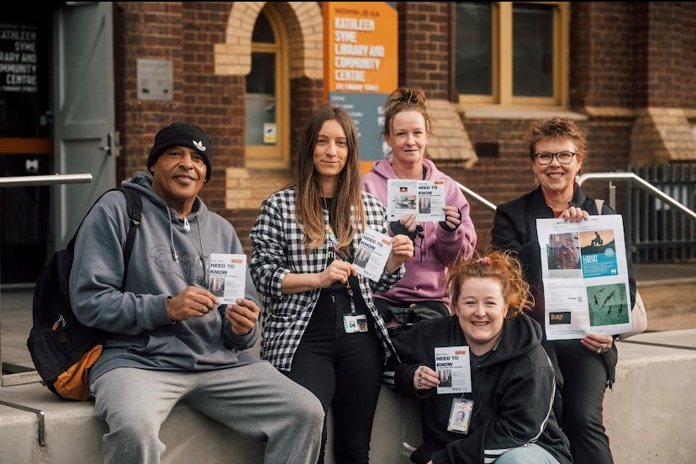

Program participants and library staff displaying copies of the ‘What you need to know to survive on the streets’ zine, in front of the Kathleen Syme Library and Community Centre

**Design Process:** This project was initiated by Cohealth who had received a City of Melbourne grant to undertake a survey of people experiencing homelessness or those with lived experience to determine what would be a useful tool for finding out information. The results of this survey determined that a zine would be the most useful method, and Cohealth ran the first iteration of this project independently, using the library as a space for sessions.

Despite there being great outcomes from the initial program, the grant funding was ending, and the project was going to be discontinued. Incidental conversations between library staff, participants and Cohealth at this time identified the ability for the library to ‘come to the table’ and support some elements of the project to enable sustainability. This includes free use of the space, facilitator support, food provision, digital editing, printing and a distribution and promotion network.

Cohealth provides the digital assets, peer support worker and associated expertise and informed support of participants, as well as facilitating payments. Both parties commit to meetings in between sessions to go through what is working and what can be improved on, as well as regularly assessing the structure based on the wants and needs of the participants at that point in time.

**Learnings:** Given the diverse and complex needs and experiences of those experiencing homelessness, there have been a number of challenges to address. While participants have shown commitment and courage in sharing their personal stories, they are often sharing experiences of trauma, mental illness, addiction and so on. The subject matter and sessions are inherently emotional and managing that space safely for all participants and facilitators requires a number of strategies. Some examples of these include: having a skilled peer support worker with lived experience, avenues for conflict resolution, regular conversations regarding group behaviours and rules as well as informed consent and code of conduct documentation. The partnership with Cohealth has been critical to implementing the above as even with the support of a library social worker, the skills required are specialist and cannot be expected of library staff.

Digital literacy and technology support has also been a challenge in creating the zine, as the website and zine creation itself requires skills that participants may not have had the opportunity to learn yet. Currently the library manages putting the zine content together digitally in collaboration with participants during a ‘live edit’, and training is being undertaken with participants so that they can manage and upkeep the website themselves.

While this program is hugely beneficial to the participants, it is important to note that the cohort needs to be ready to participate regularly in the program environment. The peer support worker has been crucial in identifying which people may best benefit from the project and referring them in. Similarly, from a library staff perspective, coming to the project from a place of wanting to build trust and relationships, with the primary motivation being that the project should be 100% about them.

**Staffing:** This project is staffed from the library by one person on a regular basis, committing to fortnightly meetings of three hours plus additional time to compile and print the zine, and regular meetings with Cohealth. Cohealth contributes approximately one day per fortnight of the peer support worker's time. Library staff time is estimated at six hours a fortnight.

**Budget:** Library funds the venue hire, facilitator, food provision and printing costs. Cohealth funds participant payments and their peer support worker.

**Advocacy and partnerships:**

* Cohealth peer support worker
* City of Melbourne Libraries social worker

**Promotion:** The zine is promoted through its distribution network, the majority of which occurs through the editorial group self-nominating and visiting key services in the municipality. The zine is also distributed across City of Melbourne library branches and Cohealth service locations as well as other council departments such as Health and Wellbeing, Aging and Inclusion, Recreation Centres and Town Hall Visitor Services.

**Evaluation:** Evaluation of this project is undertaken in an ongoing and collaborative way, with regular observational data during sessions, facilitator evaluation surveys and notes and a yearly survey for program participants. Feedback is taken from distribution venues on how much uptake the issue is having. Changes in staff approaches and understanding of the needs of patrons experiencing homelessness has been observed at the library, as well as participants promoting library services as welcoming, comfortable and helpful to their peers. This is evidenced by participants or peers using the makerspaces, using the ‘book a librarian’ service, job support services, connecting with the library social worker for support, and coming to the community lunch program with new people. Several new initiatives or key outcomes have emerged from this program including a participant’s debut art exhibition in the library and one initially reluctant participant now regularly contributing stories and beginning to write a memoir.

**Further Information:** There has been a transformation of the content participants include from just information to three self-told stories over time – this is an important step that shows the commitment and value of the project, as they are willing to write about these deeply personal experiences. The zine demonstrates the importance of storytelling and provides a document of a moment in time, from the experiences of people who may not otherwise be documented. The zine is not only an excellent resource for the target reader, but also has acted as a vector to bring people in the library.

For more information and online copies of the zine, head to <https://www.needtoknowhomeless.org/> or contact [library@melbourne.vic.gov.au](mailto:library@melbourne.vic.gov.au).

## **People with disability**

Disability is part of human diversity. It occurs across the lifespan, genders, ethnicity, and socioeconomic status. It may be temporary or permanent, total, or partial, acquired, or lifelong, visible, or hidden (Australian Library and Information Association 2019b). Most Australians have some experience of disability, whether personally or through a friend, family member or a colleague.

Public libraries universally adopt the United Nations Convention on the Rights of Persons with Disabilities (2006) definition of disability, which describes people with disability as having long-term physical, mental, intellectual, or sensory differences that, in interaction with social and environmental barriers, prevent full and equal community participation. In public library parlance, this is referred to as the social model of disability, whereby environmental and social barriers are obstacles to inclusion, rather than disability being deficits experienced by individuals (State Library Victoria 2022a).

Person-first language is widely used in Australia, including by disability organisations (People with Disability Australia 2022), and is used in this report. However, the project team also acknowledges and respects that identity-first language is important to the many people who have advocated for its use.

Around 17% of Victorians identify as living with disability, 26% of whom visited a public library in 2018 (ABS 2018). Significantly, a recent national survey for participation in the arts found that people with disability are more likely to read for pleasure than people without disability (Australia Council for the Arts 2020). Further to this, people with intellectual disability are more likely to attend arts events to improve their wellbeing and express themselves than other Australians. The data tells us that people with disability care about arts and culture but continue to experience barriers to access and participation, with the main obstacles being health concerns, cost of events and difficulty accessing venues (ibid. 2020).

It is evident that public libraries can, and do, play a vital role in the provision of opportunities for continued learning and social connection for people with often complex and multidimensional experiences of disability (Bertot, Jaeger & Wentz 2015). Libraries have a long history of providing accessible services to people with disability, with almost all providing a level of access and inclusion (Bertot, Jaeger & Wentz 2015; Kumbier & Starkey 2016). Accessible formats, such as e-books and audiobooks, are now ubiquitous, while ramps and wheelchair accessible desks are common examples of ways in which public libraries address barriers for individuals with physical disability (Jaeger 2018).

Assistive technologies, including large-screen computers, height-adjustable workstations, accessible keyboards and mouses, and software for magnification, screen reading, text to speech and speech recognition, are becoming increasingly widespread. Libraries with gallery spaces are also progressing with the development of alternative formats for exhibition labels, sensory maps, social scripts, and audio recordings, advancing equitable access to our shared cultural heritage.

The uptick in sensory and Auslan Storytimes is an encouraging trend, with libraries looking to build on core offerings in their quest to meet community needs. Despite the evolving accessibility landscape, the feeling remains that there is much more to be done. The call for specialist staff, training, time, and resources to develop and deliver targeted programs, partner with council, and expand community led activations, are common across the public library network (Kaeding, Velasquez & Price 2017), evident also in responses to the survey:

“I think we could do more around developing inclusive and accessible programs and services for people with varying disabilities”

“More training for staff in specialised areas such as working with people with disabilities”

“Co-creating these programs with people who identify as… living with a disability… would amplify the programs and ensure we deliver programs, services, and spaces that the community needs”

The principles of Universal Design advance that the design of any environment should consider the diverse needs and abilities of all people (Hamraie 2017). While building redevelopment projects can provide the perfect opportunity to embed these principles through innovative design, libraries are often faced with expensive retrofit projects to provide the facilities their communities need to feel truly welcome and included. Funding opportunities for major refurbishment projects and new builds are available through the Victorian Government’s Living Libraries Fund and Universal Design Funding initiatives (see Buildings and Spaces)

The Victorian Government’s *Disability Discrimination Act 1992* makes it a legal requirement for all councils to develop action plans that aim to reduce barriers to people with disability accessing information, services, and facilities, promote inclusion and reduce discrimination. With public libraries in Victoria being managed by councils, disability action plans have the potential to directly impact on the community via library services (Muir & Carroll 2020). While there are examples of library services across the network working closely with councils to provide targeted programs and services for people with disability, additional resourcing to support these collaborative efforts is urgently required.

ALIA’s Guidelines on library and information services for people with disabilities (2019b) are a valuable resource for the sector, providing a benchmark to ensure that a standard minimum level of service is provided across the library and information services sector. While capturing the ‘must haves’, i.e., legislative requirements, these guidelines also highlight the nuanced approach required, from identifying community needs to collection development and training. Importantly, and in keeping with the principle of nothing about us without us, partnerships with people with disability, carers, and community organisations, in program and service design and delivery will increase inclusion.

Despite the challenges, public libraries are working hard to develop and deliver impactful programs and services for diverse community members with disabilities. Some examples of what libraries are doing in this space include:

* Auslan interpretation
* Auslan Storytime
* Auslan training for library staff
* Advertising as a safe space for people with disability
* Assistive technologies
* Art and movie sessions for adults with disability
* Bluey Live experience – included audio description and a tactile experience with the characters and props (Vision Australia Information Library Service)
* Developing accessibility, braille map and audio descriptions for gallery spaces
* Hidden Disabilities Sunflower Training
* Home library and outreach services
* Low sensory programs and quiet rooms or times
* Outreach Storytimes at specialist schools for neurodivergent children and children with disability
* Partnerships with schools e.g., weekly drop-in sessions to do shelving and reading
* Periscope – Scope partnership for disability and access events (City of Melbourne)
* Science, Technology, Engineering, the Arts and Mathematics (STEAM) programming – partnership with disability organisation (Brimbank)
* The Art Connection – art workshops for people with disability (Merri-bek)
* Webinars on representation in literature and parenting with a disability
* Writing programs for people with disability
* Workshops and programs for people with a print disability, e.g., professional communications, memoir writing, poetry

With limited resources for design and delivery, public libraries are well-practised in providing inclusive and accessible programs on the ‘smell of an oily rag.’ The following case study exemplifies what can be achieved with limited funding through considered community consultation and support from specialist council staff, to deliver meaningful and impactful programs for people with disability that address identified needs and provide ongoing social connection.

### 

**THEMES FOR SUCCESS:**

PARTNERSHIPS

**PATRON-CENTRED**

**DESIGN PROCESS**

**SPECIALIST STAFF**



### Case study: Disability Access Hub

#### Art workshops

#### movie club

#### chronic pain support group

**Library service:** Greater Dandenong Libraries (GDL)

**Location:** Metro

**Branches:** Two + virtual online branch

**Staff size:** EFT 64.2

**Membership size:** 75,000

**DEI policies:**

* [Diversity, Access and Equity Policy](https://www.greaterdandenong.vic.gov.au/diversity-access-and-equity-policy) (Council)
* [Library Strategy 2022-2026](https://www.greaterdandenong.vic.gov.au/about-libraries/libraries-strategy-2022-26)
* Onboarding/induction - Equal Employment Opportunity (EEO)
* ‘[YouMeUs](https://www.youmeus.info/)’ staff training delivered through Pulse

**Summary:**

The Disability Access Hub was a community consultation and networking event developed in partnership with the Council's Community Inclusion Officer (Disability). Delivered as a series of three drop-in sessions held at separate times over three weeks, this forum invited participants to share ideas on the programs they would like to see in library spaces. Craft activities, tea and coffee were provided and created a relaxed and welcoming atmosphere. The sessions were well-attended by representatives and groups from disability organisations, individuals, and carers. Feedback came from a range of people including carers who were having difficulty finding programs both on and off the National Disability Insurance Scheme (NDIS).  This highlighted the critical role libraries play in the provision of free programs when access to NDIS funding is limited. Feedback received during these sessions led to the development of the following programs:

Art workshops (pilot):

A pilot for a monthly group run over four sessions. Participants worked on their own art projects in a facilitated environment. The tutor engaged to run the workshop specialised in working with people living with disability. The next four sessions are planned for August 2023, with a view to becoming a regular fortnightly or monthly program. Additional funding may be required for an ongoing program.

Movie Club:

An ongoing monthly program where participants are invited to watch and discuss short films, engage in conversation, and enjoy refreshments. While sessions are open to all, there is an emphasis on creating an ongoing social group for people living with disability. Screenings include closed captions and flexible volume levels and are attended by people from day programs and individuals. Attendance fluctuates, as is common with public library programming. The space has recently been refurbished with new audio-visual equipment and is comfortable and welcoming.

Chronic Pain Support Group:

Requested by a participant to address the absence of a group in the City of Greater Dandenong. This monthly, peer-to-peer group of four to six participants is currently being facilitated by the library’s Access and Inclusion Librarian and the council’s Community and Inclusion Officer (Disability), who has a wealth of experience in this space. Two sessions in and the feedback has been very encouraging. The group has drafted a list of intentions and ideas for the next 6 -12 months, including speakers and activities. An exercise physiologist with lived experience of chronic pain will be partnering with the group. Once the group is established, the intention is that it will continue without direct participation from library staff, however ongoing support will remain.

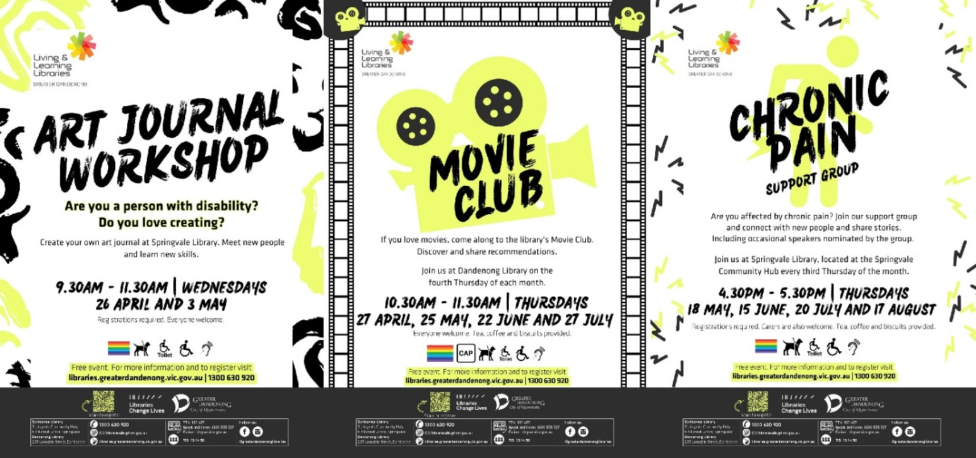

Flyers for art journal workshop, movie club and chronic pain support group programs at Greater Dandenong Libraries

**Design process:** The Access and Inclusion Librarian received several requests for programs specifically for people with disability. It was noted that while existing programs were open to all abilities, this was not always clear and sometimes led to a feeling of not being as welcome to participate. Targeted, ongoing programming would foster a greater sense of inclusion and social connection.

Library staff partnered with the Council’s Community Inclusion Officer (Disability) to design and deliver a forum for community consultation, the Disability Access Hub. The impetus was to create a welcoming and inviting space where people could find out what the library had to offer, talk about what they would like to see in the library and suggest ways the library could be made a more welcoming space.

Feedback was captured through a brief survey of four questions:

* What programs and activities would you like to see in the library?
* Would you like to be part of a regular social group at the library?
* What times and days of the week would suit you best?
* Do you have any other suggestions for the library?

Responses to the survey, combined with information captured through conversations, led to the development of the three initial programs. The Disability Access Hub will be held annually, providing an opportunity for ongoing community consultation to ensure library programming for this cohort remains relevant and inclusive.

The pilot monthly art workshops were facilitated by a tutor who was already familiar to, and well-liked by, some of the participants in the pilot session, aiding engagement. Art programs tend to book out quickly, so to ensure sessions were made available for people with disability, interested parties were prompted to contact the library for further information about how the workshops were being facilitated. This also allowed library staff to capture any additional requirements participants might have.

Movie Club was suggested by members of a local day service as an alternative to a traditional book club; the desire being for a relaxed, inclusive space to watch films, talk about them afterwards and recommend favourites to each other. The emphasis in the design of this program was on continuing social connection. Ongoing, targeted programming as an effective way to address feelings of isolation was a strong theme stemming from the inaugural Disability Access Hub.

The chronic pain support group has principles of flexibility embedded, critical to ensure an absence of judgement should participants run late or feel they are unable to attend a session. The elevated level of engagement and clear future intentions are testament to the co-design and peer-led approach.

**Learnings:** For the next iteration of the Disability Access Hub, promotion and advocacy could be enhanced through face-to-face visits with Neighbourhood Houses; specifically, reaching out to tutors or coordinators so they can spread the word to people coming into their service. Personal emails may also help to cut through the noise of overloaded inboxes. While disability organisations were present at the Disability Access Hub, more integration would be beneficial. For future art workshops, online bookings will be open, with sessions clearly marked with the intended audience.

**Staffing: Disability Access Hub**

Staff: Library Programs and Learning Coordinator, Information Librarian - Access and Inclusion, Council Community Inclusion Officer (Disability), Library Community Engagement and Innovation Officer

Time: Approximately six hours for writing project briefs, design briefs, presenting to management, discussions with the programs team, planning activities and questionnaires.

**Staffing: Art workshops (pilot)**

Tutor for four, two-hour sessions. Approximately three hours for briefs, presenting to management, looking for a tutor and communication with tutor

**Staffing: Movie Club**

Staff time to set up/pack down: one hour

**Staffing: Chronic Pain Support Group**

One-hour monthly session (may extend to one and a half hours depending on group preferences) facilitated by Access and Inclusion Librarian and Council’s Community Inclusion Officer (Disability). Exercise physiologist planned for fourth session (free) – looking at pharmacist, pain psychologist.

**Budget:**

Disability Access Hub: Minor budget for craft materials

Art workshops (pilot): $180 tutor fees per session = $720 total

Movie Club: Free movies (Kanopy), coffee, tea, biscuits, popcorn

Chronic Pain Support Group: Speakers are free, coffee, tea, biscuits

**Advocacy and partnership:** Library staff worked with other Council departments for planning and delivery of the Disability Access Hub. More integration with disability organisations is anticipated for future iterations of the community consultation and future programs. Chronic Pain Support Group is looking into partnering with various health providers, e.g., exercise physiologist, pain psychologist, pharmacist. Also, currently exploring a partnership with Monash Health.

**Promotion:** The Disability Access Hub sessions and subsequent programs were promoted to local organisations and the general public through the website, library e-news, Council’s disability e-news, social media, physical flyers, targeted emails sent to disability organisations and flyers hand dropped at community centres, disability organisations and neighbourhood houses in the area. All had some impact.

**Evaluation:** Evaluation happens at the end of each session against the goals and outcomes of the programs outlined in the project brief, as well as the library’s strategy. Both qualitative and quantitative data are collected and fed into ongoing development of programs. Questionnaires are used where appropriate as an evaluation tool for programs, however verbal or informal feedback from participants is most effective, outside of the Disability Access Hubs.

Positive feedback was received from participants of the Disability Access Hub who were excited that an event had been designed specifically for them, and their ideas were invited and valued. Attendees are keen to attend and contribute to future Hubs. Positive feedback and repeat attendance for the art workshops will help to advocate for regular, ongoing sessions. The Movie Club program is still in its infancy, and evaluation will be conducted in due course. Participants of the Chronic Pain Support Group are highly engaged, with clear intentions for the next 6 to 12 months.

**Tips:** Connect with people within your organisation, or externally, who have expertise you can learn from. Engage them in the process - it will increase your confidence and create better outcomes for the community.

**Further information:** To find out more about the Disability Access Hub and associated programs, email: [libraryprograms@cgd.vic.gov.au](mailto:libraryprograms@cgd.vic.gov.au)

## **Socio-economically disadvantaged**

The survey identified ‘socio-economically disadvantaged’ as one of the possible themes DEI interventions services may target. The below discussion and case study focus on vulnerability and disadvantage more broadly within a literacy framing, acknowledging that health and developmental outcomes are linked to disadvantage and are likely to intersect with socio-economic status, individual characteristics and life experiences (Goldfeld et al. 2018; World Health Organization 2023).

Building literacy and learning skills in public library settings are well established core principles and pillars of programming - what could be considered as the other side to the coin of free and democratic access to information (Australian Library and Information Service 2023b; State Library Victoria & Public Libraries Victoria 2021). As evidence has built regarding the benefits of education and literacy skills, particularly from an early age, public libraries too, have shifted increasingly into this space. Our life-long health trajectories are more strongly correlated with literacy than either occupation or income (Shaw 2021), which are commonly the yardsticks used to discuss disadvantage. Furthermore, the capacity to change developmental trajectories diminish as we age (Goldfeld et al. 2018), thus public libraries provide a perfect place to intervene and champion access to early years literacy in particular, following the ‘equity from the start’ principle.

However, programs like Storytime and Rhymetime are so ubiquitous and valued across the sector that it can sometimes feel like their purpose and potential is somewhat ‘settled’. Many recognise these programs as a chance to encourage library attending habits amongst families starting from an early age, extend maternal and child health services which within local government settings often interact with libraries to some degree, provide social connections for parents and children, and perhaps most importantly help build foundational literacy skills with children and parents alike, acknowledging the advantages this has over the course of a lifetime.

While all of these reasons are sufficient validation to ‘keep on keeping on’, there are a number of opportunities for library services to extend these programs with a DEI lens. Examples across the sector tap into specific cohorts experiencing disadvantage across communities aiming to provide safer environments to engage with stories and learning in culturally appropriate or sensitive ways such as sensory, rainbow, bilingual or additional language, Auslan, or First Nations Storytimes.

The above examples begin to address some of the challenges that may exist amongst marginalised population groups accessing library services if they were not already doing so, by explicitly creating spaces for *their* community to gather, with programming adjusted to suit their needs. These programs are also likely to be more effectively promoted to other groups or organisations relevant to the identified community with these relationships helping to create comfort about accessing a new service or visiting a new space.

Working towards an even more strategic approach in this space might involve asking the question ‘who in our community is experiencing the most disadvantage or has the greatest needs or risks, and how can we reach them?’ rather than ‘how can we bring in communities we have not traditionally been offering our services to?’.

Considering that ‘low literacy is associated with chronic illness, low physical and mental health status, and high rates of acute health service use’ (Shaw 2021, p. 182) and that ‘exposure to early disadvantage and inequity constitutes a significant and ongoing public health problem’ (Goldfeld et al. 2018, p. 223), taking a step back to determine needs with a layered literacy, health and wellbeing, and health promotion focus can provide new and robust approaches to how public libraries ‘do’ early years programming, as detailed in the case study below.

### 

**THEMES FOR SUCCESS:**

**BUILDING ON CORE OFFERINGS**

**PATRON-CENTRED**

**DESIGN PROCESS**

**OUTREACH**



### Case Study: Sprout Time

**Library Service:** Geelong Regional Libraries (GRL)

**Location:** Regional

**Branches:** 19

**Staff Size:** Approximately 200

**Membership Size:** 108,759

**DEI Policies:**

Has a library specific policy. Program also relates to:

* [Municipal Public Health and Wellbeing Plan ‘Our Community Plan 2021-25’](https://www.geelongaustralia.com.au/ourcommunityplan/default.aspx)
* [Municipal Early Years Plan 2018-2022](https://www.geelongaustralia.com.au/mch/documents/item/8d64ba62990bd08.aspx)

**Summary:**

Sprout Time was developed as an early intervention outreach program, to increase community connection and education for expectant or new parents who may be experiencing vulnerabilities, disengagement from education or lowered levels of literacy. The program was designed to support new parents to interact with their child in a fun and nurturing way that strengthens their child-parent bond and provides beneficial literacy support to encourage literacy development. This literacy development takes the form of building regular reading and singing into family routines to encourage language and motor skills development. It is also vital to focus on making the experience of talking, reading, sharing, singing a positive experience for all families.

Initially Sprout Time intended to work specifically with expectant young parents, however as the program developed, the focus broadened to parents with a child aged zero to five years experiencing any vulnerabilities such as young parents (<18 years), CALD communities, refugees, challenges with literacy, inequitable social determinants. As this program is delivered in an outreach format, building strong relationships with aligned local organisations who are already working with a group of people who could benefit from the program is key.

To meet the needs of these organisations and their participants, Sprout Time has been designed to be delivered flexibly. This means that depending on organisation availability, Sprout Time could run once or twice (generally 40-minute sessions), or over several weeks. Program resources are similarly tailored to meet the needs of the participants, for example materials with lots of English language text are unlikely to resonate with a group of non-English speaking parents, however the same core skills can be demonstrated through materials with more visual information or song.

**Design Process:** The idea for Sprout Time originated from a Children’s and Youth Services Librarian who recognised the gaps in service delivery for disengaged cohorts and the somewhat ‘natural’ extension of existing core library programming and skill sets. Paired with a greater focus on engaging with high-risk cohorts within the Children’s and Youth Services team, a needs analysis comprising of Census, Electoral, Organization for Economic Cooperation and Development (OECD), SLV, PLV and public health data was undertaken. Consultation with the community was not possible, as this program was developed during COVID-19, however consultation did occur with Family Services and Maternal and Child Health teams, local literacy providers and the local Aboriginal Co-op including a presentation to a group of First Nations people who work in childcare.

See the Sprout Time Program Plan (appendix 3) for a template that may be useful in your program design.

**Learnings:** Developing and delivering a program based on partnership, outreach and flexibility almost guarantees complexity, particularly during the establishment phase. In order to reach participants, strong relationships must be built with partner organisations and the library service must be determined and clear in communicating the program's value. Finding mutually available times for the program to run, especially as some settings like out of home care have rigid structures can be difficult and take time to come to fruition.

Furthermore, being adaptable to the needs of the group and updating materials accordingly takes time and expertise to do well. Another challenge faced is the level of attrition amongst program participants. On the other hand, once these relationships and resources are in place, the program can roll out with minimal cost and word of mouth continues to support the expansion of the program.

Initial consultations with organisational stakeholders helped to guide the needs analysis and ensure appropriate language/approaches were used to resonate with participants. For example, the terminology ‘low-levels of literacy’ was flagged by the Aboriginal Co-operative as potentially promoting shame, as it does not recognise literacy expressed in other important cultural mediums such as verbal storytelling. ‘Challenges to literacy’ was suggested as alternative language, and framing of the approach required to best serve the local Aboriginal community.

**Staffing:** Sprout Time has been facilitated by one Children’s and Youth Services Librarian to date, however as the program expands, more staff will be trained to deliver in their local contexts. Each week, approximately one to two hours maximum is required for preparation plus 30 minutes to two hours for delivery. As the program is run in outreach settings, there is always another facilitator already in-place to assist as needed.

**Budget:** Sprout Time received $13,000 of grant funding. Approximately 60% of this funding was allocated to salary, with the remaining 40% spent on material expenses which included baby dolls, props utilised by baby time sessions (rattles, scarves), books tailored for participants (board, little to no text, black and white).

**Advocacy and partnerships:** Initial partnerships and support from Family Services, Maternal and Child Health, Geelong Best Start and Mingo Waloom Aboriginal Best Start provided key information and ongoing referrals to Sprout Time.  Outreach partners included Bumps 2 Bubs, Baby College, Best Start, Northern Bay College and various children and youth related networks.

**Promotion:** Promoting Sprout Time has largely occurred through word of mouth and a determined approach to talking about the project by GRL staff. This included cold calling services such as neighbourhood houses, out of home care, kinship carers and attending every networking meeting available. Referrals from partners above was another avenue for promotion from a trusted source. Despite these efforts, translating promotion into engagement has been a challenge, particularly as it is a new program.

**Evaluation:** Impact evaluation is built-in to the program including simple and accessible surveys pre-session, during and post-session. The format can be mixed depending on the cohort, for example a survey with a QR code is more likely to suit young parents, while verbal feedback may be preferred for people with digital or literacy challenges, or CALD communities. Observational feedback is also taken by the facilitator during the session. At the end of each session, notes are written up by the facilitator and sent to the Manager of Children’s and Youth Services with the opportunity to informally debrief and unpack learnings and opportunities for improvement in an iterative fashion.

**Further Information:** For more information about the program, contact [info@grlc.vic.gov.au .](mailto:info@grlc.vic.gov.au) For a deeper understanding of health promotion, see [‘Integrated Health Promotion Resource Kit – Entire Practice Guide](https://www.health.vic.gov.au/publications/integrated-health-promotion-resource-kit-entire-practice-guide)’ (Department of Health 2018).

# Spaces and buildings

Victoria is home to many best practice library buildings, with accessible and inclusive features that are now becoming standard practice, including:

* All gender bathrooms
* Changing Places toilet facilities, including a height-adjustable adult-sized change table, a constant-charging ceiling track hoist system, a centrally located peninsula toilet, additional circulation space more than standard accessible toilets, an automatic door with a clear opening of 950 mm at a minimum, and a privacy screen (2023)
* First Nations spaces and names, in consultation with traditional owners
* Prayer rooms
* Universal Design, a design philosophy that ensures that products, buildings, environments, programs, services, and experiences are innately accessible to as many people as possible, regardless of their age, level of ability, cultural background, or any other differentiating factors. Universal design distinguishes itself from accessible design by focusing on user-centred design from the earliest stages of a project (Department of Families, Fairness and Housing 2023)

Funding can be a challenge in delivering inclusive and accessible designs, but there are several funding opportunities to assist library services, including the Living Libraries Infrastructure Program. Victoria’s Living Libraries Infrastructure Program helps Victorian councils and regional library corporations to provide high-quality library infrastructure to meet their communities’ changing needs (Department of Government Services 2023). Funding is provided to support projects that are accessible and meet appropriate standards for people of all abilities, contribute to local employment creation, demonstrate flexibility in meeting the long-term needs of the community, and incorporate principles of environmental sustainability design (Department of Jobs, Precincts and Regions 2022).

## Glenroy Community Hub, Merri-bek Libraries

The Glenroy Community Hub is an integrated health and lifelong learning centre designed to support, educate, and inspire locals at all stages of their life. Opening in 2022, the Hub’s centrepiece is the new contemporary library, co-located with Glenroy Memorial Kindergarten, maternal child health, a community health provider, neighbourhood learning and childcare.

Facilities include:

* All gender toilet on first floor
* All gender toilets in staff work area
* Male and female prayer rooms on first floor
* Storage space for prams and strollers

## Ivanhoe Library and Cultural Hub, Yarra Plenty Regional Library Service

Opening in 2021, the Ivanhoe Library and Cultural Hub boasts a flexible, modern design that remains sympathetic to the architecture of its iconic Art Deco neighbour the Ivanhoe Town Hall. Along with increased usability, increased accessibility, and facilities for people with disability was a major design feature. The Hub also features a much-loved Open House social enterprise cafe helping local people pathway into employment. Being a culturally welcoming space was also important to the team with co-design projects undertaken with Somali and First Nations communities, culminating in the integration of design elements and facilities as well as informing programming (see Talking Together case study).

Facilities include:

* All gender toilets
* Changing Places toilet
* First Nations map of Australia
* Open House social enterprise cafe
* Prayer room
* Yarra-me Djila Theatrette and Mungga Artist Studio names in the Woiwurrung language

## Springvale Community Hub and Library, Greater Dandenong Libraries

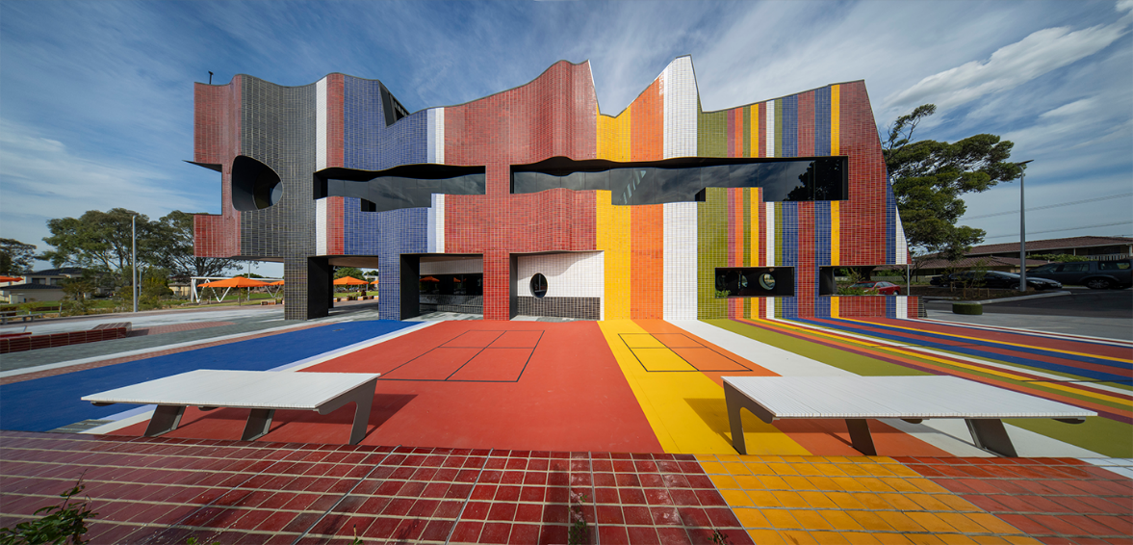

Springvale Community Hub building (Image source: Lyons Architecture)

Completed in 2020, the Springvale Community Hub and Library is in the City of Greater Dandenong, one of the most culturally diverse municipalities in Australia. The architectural vision to reflect and support the diverse immigrant community of Springvale (Wilson 2021) is realised in both the physical design of the building and the facilities on offer. The western facade features a conceptual design that amalgamates various flags symbolising the demographic makeup of the community delivering a powerful statement of diversity.

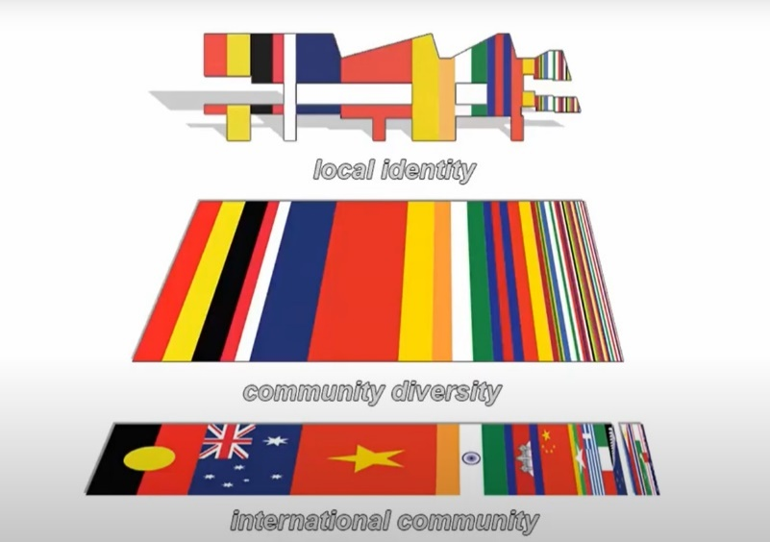

Various national flags that make up the current demographic profile of Springvale (Image source: Lyons Architecture)

Facilities include:

* Changing Places toilet
* ‘Enterprise’ rose garden (representative of the immigrant journey of Springvale)
* Hearing Loop
* Indigenous ceremonial place
* Prayer Room

## Victorian Indigenous Research Centre, State Library Victoria

The Victorian Indigenous Research Centre (VIRC) at State Library Victoria (SLV) provides an identified space within the Library for Victorian Indigenous communities to research their family history and cultural heritage through the Library’s collections, programs, and services (SLV 2022b, p. 27). Launched in 2021-2022, the VIRC provides a safe space for community in a colonial institution, supporting Indigenous ways of research and learning as an organic process.

The Centre’s five main functions are:

* Supporting Indigenous research
* Embedding Indigenous knowledge practice
* Providing a community gathering space
* Sharing Indigenous research
* Engaging with community on Country

The Centre is currently staffed by the Library’s inaugural Elder-in-residence, the VIRC Manager and VIRC Support Officer. Their collective work is ongoing and includes:

* Interfacing with colleagues, the public and community
* Providing Indigenous knowledge management and engagement
* Cultural permissions and policy
* Managing information and reference enquiries from the public
* Building cultural competence in the organisation

# Key themes for success:

## Program design

Designing library programs can be daunting. Bringing together the necessary financial, human and material resources, finding the right spaces, navigating approvals and promotions, negotiating partnerships and hoping that the ‘vision’ resonates and positively impacts the community is no small feat. Adding a DEI lens to this process can feel overwhelming, outside of a services’ knowledge-base or lived experience (Morgan et al. 2018) and beyond what is achievable when balancing work and life commitments.

That being said, programming is arguably the most effective way for services to realise DEI aspirations with community as it can be adaptive, responsive and relational in ways that collections and building design cannot. Certainly, working in program design requires a large store of motivation and genuinely felt enthusiasm for the possibilities of authentic and empowering engagement, though all library staff have a role to play. However, when all of the pieces come together, as we have seen above, magic is made.

Whether large or small in scale, the successes identified in the above case studies all relate to centring the patron’s experience and being flexible enough to adapt to needs as they are identified, while still creating something tangible enough for stakeholders to resonate with.

It is acknowledged that as a sector, service and program provision will play a greater role to meet emerging social needs and community expectations (State Library Victoria, Public Libraries Victoria & Chasing Sunrises 2013).

As the importance and requirement of community engagement has increased with the introduction of Municipal Public Health and Wellbeing Plans (Department of Health and Human Services 2020), Mental Health and Wellbeing Reforms (Department of Health 2023) and the introduction of related criteria to grant funding (State Library Victoria & Public Libraries Victoria 2022a), the onus placed on public libraries can sometimes read ‘co-design or die’. This is not to say that deeply engaging with community is too burdensome for our services, rather, how we approach programming must embrace this opportunity throughout the life of any project and carve out space, time and expertise to do it well.

The temptation to program from the ‘idea up’ is strong, and sometimes community or partner organisations will present with these proposals. Examples of this can be ‘quick wins’ that can make existing programs more inclusive such as introducing Auslan interpreters to events or captioning video content, while bigger ideas can be a good jumping off point for more research. Our role as a sector is to identify social and cultural trends and associated needs, equip teams with the knowledge to confidently enter DEI spaces, build relationships with impacted communities and ideate *together* (Australian Library and Information Association 2021). From this place, where everybody is informed (and open to learning) and able to communicate what they can and can’t offer, sustainable programs and services based on shared values desire for change will grow.

Spending time with staff to ‘place’ their work within the strategic context, develop research skills with public health and wellbeing data-sets and create branch or service-wide stakeholder maps are all necessary first steps.

Next comes creating mechanisms and documentation for detailed issue scoping and needs analysis in collaboration with colleagues and organisational stakeholders. This is a great time to identify skills and knowledge gaps and implement training or partnerships to fill these. Finally, using the networks identified, invite community to the table without preconceptions and adjust the needs analysis and social data based on what local lived experience experts are saying (ibid. 2021). The ideas that are generated after this preparatory work is complete are more likely to have community and organisational buy-in, as well as clearer objectives and evaluation metrics beyond increasing membership or borrowing.

In short, taking a longer view, acknowledging we can’t be all things to all people (at once) and intentionally creating space for community involvement in whatever form will work for the service and local participants (co-design, consultation, collaboration and so on) will embed a culture of strong program design within public libraries for the future.

## Outreach

Public library outreach can be described as ‘meeting people where they are, striving to serve those who face barriers to accessing services, and highlighting ever-evolving services and collections that are relevant to the needs of their customers’ (Yarrow & McAllister 2018, p. 198). Outreach can take many forms including mobile collections, kiosk services, programming in secondary locations, home library services, online collections, participation in events and community celebrations, or even programming in seemingly unrelated spaces to libraries’ ‘core’ offering in order to build initial relationships with communities.

Key to the success of any outreach effort is the expected outcome your library service wishes to gain, which is often left un- or ill-defined (Velasquez 2019). If it is new library members, books borrowed, increased program participants, or foot-traffic to the local library branch, then results may be mixed. In reaching many underserved or otherwise marginalised community members, these goals may not be realistic or related to what the community themselves needs or wants. At times, urgent and necessary life activities will take precedence over ‘traditional’ library engagements (Summers & Buchanan 2018), in which case, spending outreach energies on building relevance and perceived value of library offerings may be more fruitful and sustainable goals.

## Building on Core Offerings

Public libraries values are well put by ALIA’s ‘Core Values Policy Statement’, including regularly discussed themes such as; the free flow of information and ideas, connection of people to ideas, knowledge creation and learning, fostering literacy in all its forms and respect for the diversity and equality of all (2018). In practice, this directs a significant amount of library services to activities like author talks, writing workshops, book and movie clubs, early childhood literacy programs (Storytimes, Rhymetimes), digital literacy programs, home library services, social clubs, and referral-related offerings.

Many of these offerings have been running for a number of years, with some reflecting the dominant culture in which they were established. However, many have evolved over time to meet the emerging DEI expectations (i.e., Rainbow, Sensitive, Bilingual or First Nations Storytimes, conversational English classes, art workshops for people with disability, or homework clubs for vulnerable cohorts of children and young people). Approaching programming in this way provides numerous benefits to a service including:

* Leveraging existing resourcing, skills and confidence of library staff
* Utilising existing materials or resources
* Existing understanding of program and aims for management, approvals and community promotions
* Increased opportunities to engage with, proactively welcome and learn from under-served communities and presumably meet inclusion expectations
* Shared learnings from other public libraries who have experience delivering into these programs

For services that are newer to the DEI practice, building on core offerings provides achievable in-roads to cohorts that may have felt unreachable or difficult to understand. For services already offering a number of DEI related programs, auditing long-standing programs and seeking opportunities to add value will only strengthen your work. For both, and all the services in-between, using this model of programming will play an important role in embedding the critical and needs-based whole-of-community lens into the thinking of your library staff.

While building on existing programming provides ample opportunity to utilise existing resources, there needs to be strategic considerations and thought into planning, marketing, and delivering DEI focused programming. Considerations may include:

* Targeted marketing with a narrower focus to appeal to people who the program is aimed for. Consider promotional opportunities by connecting with organisations that already have built ties with the targeted cohort
* Consulting widely with cohort to effectively deliver service that actually meets their needs rather than making assumptions
* Evaluation of program success and impact need to be tailored carefully. Raw attendance figures, for example, will not be the most appropriate evaluative tool and this needs to be communicated with decision-makers and clearly defined in grant applications
* Consider alternative qualitative evaluation measures such as direct feedback, visual storytelling or participant interviews

## Specialist Staff

Embedded within the public libraries sector in Victoria is a drive to serve the community fully and equitably in all of its diversity. PLV’s ‘Strategic Plan 2023-27’ identifies in goal two that its role is to ‘support public library leadership to run innovative statewide projects that increase Victorians’ access to resources’ (Public Libraries Victoria 2023, p. 6). SLV explicitly rejects the idea that our collective health and wellbeing is simply a matter for healthcare professionals, identifying public libraries as places that can ‘support and connect our communities and partners for a healthy, thriving Victoria’ (2021, p. 7).

In placing public libraries at the nexus of innovation and public health, the responsibility on library staff regarding specialist expertise must be interrogated.  We have seen in the above case studies the breadth of communities served and the individualistic care and knowledge required to meet their needs for authentic inclusivity. Partnership approaches, as well as increased professional development opportunities for library staff will go some way in addressing these needs. However, in order to ensure we are actively managing professional boundaries (Westbrook 2015) and our responsibilities to patrons, employing specialist staff must also play a role.

Increasingly, positions for multilingual staff, translators and social workers are seen across the sector. In the case studies, respondents note how the crucial expertise they bring has improved relationships, participant outcomes and importantly the skills library staff can and should have, as well as an awareness of what is best placed to be dealt with by an expert. These examples provide an exciting start for our sector but could be expanded in practical and achievable ways based on the most prevalent needs and communities your service is working with, such as family violence or addiction experts, or First Nations community connectors.

## Partnerships

Building strong partnerships has become critically important for public libraries, community groups, government departments and businesses, in an effort to stretch every dollar invested in an ever-tightening economic climate. Given partnerships can provide cost-effective outcomes for stakeholders, it is critical that there is a shared understanding between all stakeholders of what the goals are, how achieving these goals is communicated, and that values are aligned and upheld.

Conceptually, a partnership is a mechanism for exchanging value between organisations, by integrating resources and combining expertise with the aim of creating shared value: a mutually beneficial outcome that has been realised through the transfer of strength between organisations (SLV & PLV 2022b). Partnerships can be short in scope for a specific project or can evolve over an extended period with much broader outcomes, but the key to a successful partnership in any instance requires an understanding of the partnership cycle that considers the scoping, managing, reviewing, and the sustaining outcomes of the partnership (Stibbe, Reid & Gilbert 2019).

There are several common characteristics (Sarjeant-Jenkins & Walker 2014) that define an effective, value creation partnership:

* Belief in the partnership and its focus on the people it will impact
* Willingness to take calculated risk
* Mutual trust and respect between partnering organisations
* A commitment to put in the time, energy, and resources required
* Supportive leadership from senior management
* Willingness to take ideas from all areas

In addition to committing to these principles, organisations must not only map and manage the added value that collaboration can achieve, but the value that each partner hopes to gain individually (Stibbe, Reid & Gilbert 2019)

Libraries that have been featured in this report have often had long standing working relationships with their partnered organisation, and as with any relationship, it will continue to grow over time if it’s nurtured. Partnered organisations often devise Memorandum of Understanding (MOU) documents to help keep parties accountable to agreed upon methods of communication and promised deliverables.

Particularly notable are library partnerships with health organisations where, the value of libraries as non-judgmental, familiar, place-based community institutions, is well suited to health organisations with their complementary strengths in technical expertise, funding channels, and advocacy platforms (SLV 2022). Examples of partnerships from the survey include projects with health organisations like Cohealth, other educational institutions such as specialist schools, CALD organisations like the Migrant and Refugee Centres, and internal Council departments such as Youth Services and Sustainability.

## Patron-centred

Vancouver Public Library defines patron-centred service as ‘understanding the perspectives and needs of the individual patron, which is key to providing proactive and responsive service. It involves engaging and connecting with each patron’s needs with curiosity, flexibility and empathy’ (2019, p. 1).

A patron-centred library service proactively searches to eliminate as many barriers as possible with a commitment to be accessible to all and can be effectively developed with DEI as a focal point for library services and programs. The ethos lies in responding to patron needs rather than reacting against them, and to find creative and inspiring solutions that promotes continual patron involvement in the improvement process.

A patron-centred service is extensible by nature. It adapts to the changing needs of people and an extensible library is one that has an ability to reconfigure and be reshaped to create dynamic spaces without any compromise to its values (Allison 2013, p. 180). A key indicator of patron-centred is that the program or service will often evolve or adapt quickly in response to emerging needs. Often the original intention for an idea will change after implementation, when new information is identified and adjustments are often made by patrons themselves, rather than the facilitators, as the program takes on a life of its own. Hence, the organic nature of many patron-centred services.

From observation, the most effective examples of patron-centred services focus on the individual or small groups, as larger groups become unwieldy and difficult to manage as priorities begin to stretch and grow in complexity. An effective patron-centred approach also relies heavily on a strong organisational culture of shared values that enables library staff the flexibility to adapt and respond to change without too much bureaucracy. Examples of patron centred programming are Youth Takeover nights, board gaming and pop culture themed on-going events, as well as role-playing games such as Dungeons and Dragons. The focus is on delivering events that require participants to not only engage in the activities, but also take part in coordinating the activities.

# Recommendations for next steps

The wealth of information captured in this report is testament to the dedication of the many survey respondents and others who contributed to this project. Much experience and knowledge has been captured through the eight case studies, with additional insights into the current state of DEI practice within the broader public library landscape touched on in ‘Key themes for success’.

The following recommendations for next steps have been captured, collated, and distilled from survey responses:

## Building skills, capabilities, and confidence

There has been a strong call for more staff training and awareness to build capacity in DEI. Many libraries offer DEI training, however the clear message from survey respondents is the need for more opportunities for staff development. From cultural competency training and active bystander training, to strengthening skills in co-design, library staff have identified what is required, what they need now is the resourcing to make this happen.

The ‘train the trainer’ model presents an opportunity to increase efficiency in the development of inclusive programs, services and spaces and the efficacy of DEI initiatives. Managers also have a key role to play in providing time and resources to support staff skills development and their ability to engage with communities in a meaningful and impactful way.

## Identified roles – more DEI roles at library services

To genuinely engage in DEI work, specialist skills are required in addition to training and awareness for existing library staff. Leaders must play a role in making proactive team recruitment and structuring decisions that value complementary lived experience and expertise to the library discipline. This may include reviewing community demographic data, setting targets and developing recruitment strategies to better represent, and provide opportunities for services and community to learn from one another in existing roles. It may also include designing new identified positions in response to community needs and patron presentations, and testing ways to integrate this knowledge into business-as-usual practice. Whatever the mechanism, services must be deliberate in their efforts.

## Policies and planning

When developed with a clear vision and buy-in from staff at all levels, policies can become true ‘living documents’ providing the ‘north star’ for services to orient their impact to in every facet of operations. The findings of this report show the positive impact DEI specific policies can have on confidence in meeting patron needs and implementing initiatives, which can often get lost in the perceived dullness of policy documents. Take every opportunity to share, rework or create DEI policies and highlight the transformative intentions behind them - this is how they can be truly felt and embedded in your teams’ work.

## Networking, sharing of ideas and experience

PLV and SLV are well-placed to support opportunities for networking and the sharing of experience and ideas, whether through the PLV member portal, PLV and SLV websites, or email.

The creation of a DEI Special Interest Group (SIG) via PLV may be worthwhile exploring. DEI work is already being done through other PLV SIGs, but there is a need to centralise and elevate this work as a rapidly evolving area of public library practice. A PLV member survey could assess the need of this new SIG and include a call out for interested parties to take on the role of co-conveners.

SLV and PLV recently hosted in demand DEI training on trauma-informed librarianship, social work in libraries and other topics. The library sector is hungry for further training in this space.

The increased attacks on library LGBTQIA+ programs and collections are concerning and threatens libraries’ core purpose of being a safe and welcoming space for all. As such, the role of libraries in the strident promotion of social justice has never been more important. The sector should continue to support each other and share resources and tips, with continued advocacy and support from state and national library associations.

## Additional resources

Survey respondents suggested a range of specific resources to support library staff in the development and implementation of inclusive programs and services. This list is by no means exhaustive:

* Database of suitable facilitators
* Program kits and practical resources for developing programs in support of key community dates such as NAIDOC Week
* List of key multicultural, refugee, translation, LGBTQIA+ support services, organisations, and groups
* Reference resources such as affirmative language guides
* Downloadable or printable content including fact sheets, booklets, document packs and customisable templates

# Conclusion

The overarching goal of this project was to invite colleagues from the network to share insights, experience, skills, knowledge, and ideas for how to ensure libraries meaningfully and effectively promote inclusion for our diverse communities.

It is recognised that DEI is a continually evolving space that requires an imaginative approach to adapt to changing needs. The effects of COVID-19 and lockdowns have exacerbated the marginalisation of already underserved communities. However, the sector is brimming with the courage and creativity required to find solutions that engage communities in the process and ask what it is libraries can do to ensure they feel safe and valued.

Analysis of 195 survey responses from library services across Victoria demonstrated the significant and impressive work underway to make libraries a place of welcome for all. The majority of services are providing inclusive programming and services for older people, people with disability and First Nations people, as well as CALD, neurodivergent, LGBTQIA+, socio-economically disadvantaged, and refugee and new migrant communities.

Rural and metro services reported higher confidence in developing and implementing DEI initiatives in comparison to regional services. Overall, confidence was increased when services had access to dedicated DEI staff and policies, as well as when community was involved in program or service design. This finding was echoed in respondents' suggestions for how to further their DEI work, with ‘staffing: expertise, time, training’, ‘funding’ and ‘community engagement, consultation and partnerships’ identified as the top three needs.

The aim of this report is to document what libraries are doing to achieve DEI and to share this information to equip and empower our sector. Themes and patterns of success have been distilled from survey responses and highlighted through a series of case studies that look to address a particular need identified in their community.

The project team identified several key themes for success in delivering programs, services and spaces. The case studies showed that by combining these themes, meaningful and inspiring outcomes can be achieved:

* Building on core offerings
* Partnering with organisations to create co-designed programs
* Recruiting specialist staff with unique skills
* Encompassing a patron-centred ethos

As a public libraries network, we are committed, compassionate and capable of achieving DEI hand in hand with our communities. We hope this report will provide not only practical suggestions on how to approach DEI work, but also the momentum to continue being brave and ambitious. This is where it matters most.

# References

Aalia, A 2021, ‘Trainee library officers and workplace diversity’, *INCITE Magazine*, July/Aug 2021, vol. 42, no. 4, pp. 16-17.

Alcohol and Drug Foundation 2019, *Alcohol and other drugs: Stigma. A background paper*, Alcohol and Drug Foundation, Melbourne, viewed 1 July 2023, <<https://cdn.adf.org.au/media/documents/ADF_Stigma_background_paper.pdf>>.

Allison, DA 2013, *The patron driven library: a practical guide for managing collections and services in the digital age*, Chandos Information Professional Service, Chandos Publishing, Oxford.

Aspect 2023, What is autism?, Aspect, viewed 1 July 2023, <<https://www.autismspectrum.org.au/about-autism/what-is-autism>> .

Australia Council for the Arts 2020, *Creating our future: results of the national arts participation survey*, Australia Council for the Arts, viewed 1 July 2023, <<https://australiacouncil.gov.au/advocacy-and-research/creating-our-future/>>.

Australian Bureau of Statistics 2012, A statistical definition of homelessness, viewed 8 July 2023, <<https://www.abs.gov.au/ausstats/abs@.nsf/Latestproducts/4922.0Appendix32012?opendocument&tabname=Notes&prodno=4922.0&issue=2012&num=&view=>>.

Australian Bureau of Statistics 2018, Disability, ageing and carers Australia summary findings, viewed 1 July 2023, <<https://www.abs.gov.au/statistics/health/disability/disability-ageing-and-carers-australia-summary-findings/latest-release#autism-in-australia>>.

Australian Bureau of Statistics 2016, *Estimated resident population, Country of Birth, State/Territory, Age and Sex as* *at 30 June 1996 to 2016*; ABS, Canberra, Australia, 2016.

Australian Bureau of Statistics 2016, *Census of Population and Housing: Reflecting Australia - Stories from the Census*, cat. no. 2071.0, ABS, Canberra, Australia, 2017.

Australian Library and Information Association 2018, *ALIA core values policy statement,* policy statement, Australian Library and Information Association, Deakin, viewed 1 July 2023, <<https://read.alia.org.au/alia-core-values-policy-statement>>.

Australian Library and Information Association 2019a, *Workplace diversity trend report 2019*, Australian Library and Information Association, Deakin, viewed 24 June 2023, <<https://read.alia.org.au/workforce-diversity-trend-report-2019>>.

Australian Library and Information Association 2019b, *Guidelines on library and information services for people with disabilities*, guidelines, Australian Library and Information Association, Deakin, viewed 1 July 2023, <<https://read.alia.org.au/guidelines-library-and-information-services-people-disabilities>>.

Australian Library and Information Association 2021, *Stretch targets for Australian public libraries 2020-2030*, Australian Library and Information Service, Deakin, viewed 3 June 2023, <<https://read.alia.org.au/sustainable-development-goals-stretch-targets-australian-libraries-2020-2030>>.

Australian Library and Information Association 2022, ALIA national 2022 conference, viewed 3 June 2023, <<https://www.alia.org.au/Conference/>>.

Australian Library and Information Association 2023a, Statement: respect for public library staff, viewed 25 June 2023 <<https://www.alia.org.au/Web/News/Articles/2023/5-May-2023/Statement_Respect_for_Library_Staff.aspx>>.

Australian Library and Information Association, 2023b, What we do, viewed 18 June 2023, <<https://www.alia.org.au/what-we-do>>.

Australian Public Library Alliance & Australian Library and Information Association 2021, *APLA-ALIA standards and guidelines for Australian public libraries*, Australian Library and Information Association, Deakin, viewed 3 June 2023, <<https://read.alia.org.au/apla-alia-standards-and-guidelines-australian-public-libraries-may-2021>>.

Australian Services Union 2023, Libraries: drag storytime & action, viewed 25 June 2023, <<https://www.asuvictas.com.au/libraries-drag-storytime-action/>>.

Bardoff, C 2015, ‘Homelessness and the ethics of information access’, *The Serials Librarian*, vol. 69, no. 3-4, pp. 347–360.

Berry III, JN 2019, LA County Library Is Library of the Year 2019, *Library Journal*, 28 May 2019, viewed 1 July 2023, <<https://www.libraryjournal.com/story/Equity-and-Education-for-All-Library-of-the-Year-2019>>.

Bertot JC, Jaeger, PT & Wentz, B (eds) 2015, *Accessibility for persons with disabilities and the inclusive future of libraries*, Emerald Publishing Group, United Kingdom.

Bourg, C 2017, NC is a no-go: bathrooms, libraries, and the limits of welcoming, viewed 4 July 2023, <<https://chrisbourg.wordpress.com/2017/07/28/nc-is-a-no-go-bathrooms-libraries-and-the-limits-of-welcoming/>>.

City of Greater Geelong 2018, *Municipal early years plan 2018-2022,* plan, City of Greater Geelong, Geelong, viewed 25 June 2023, <https://www.geelongaustralia.com.au/mch/documents/item/8d64ba62990bd08.aspx>.

City of Greater Geelong 2021, *Our community plan 2021-15,* plan, City of Greater Geelong, Geelong, viewed 25 June 2023, <https://www.geelongaustralia.com.au/ourcommunityplan/default.aspx>.

City of Melbourne 2022, *Inclusive Melbourne strategy 2022-32,* City of Melbourne, Melbourne, viewed 1 July 2023, <<https://www.melbourne.vic.gov.au/SiteCollectionDocuments/inclusive-melbourne-strategy>>.

Changing Places 2023, Why Changing Places, viewed 7 July 2023, <<https://changingplaces.org.au/why-changing-places>>.

Chapman, R 2021, Negotiating the neurodiversity concept, viewed 1 July 2023, <<https://www.psychologytoday.com/au/blog/neurodiverse-age/202108/negotiating-the-neurodiversity-concept>>.

Coles, J 2022, Magic: The Gathering and neurodivergence - boosts and burdens, viewed 1 July 2023, <<https://www.wargamer.com/magic-the-gathering/neurodivergence>>.

Coleman, M & Connaway, LS 2019, ‘Public libraries respond to the opioid crisis with their communities: an introduction’, *Collaborative Librarianship*, vol. 11 no. 1, pp. 43-47.

Community Affairs References Committee 2014, *Bridging our growing divide: inequality in Australia*, Commonwealth Government, Canberra, accessed 4 July 2023. <https://www.aph.gov.au/-/media/Committees/Senate/committee/clac_ctte/income_inequality/report.pdf?la=en&hash=5C9664447238EF20C25D6BB06822A5038EA08E12>.

Cooke, NA, Chancellor, R, Shorish, Y, Dahlen, SP & Gibson, A 2022, Once More for Those in the Back: Libraries Are Not Neutral, *Publishers Weekly*, viewed 1 July 2023, <<https://www.publishersweekly.com/pw/by-topic/industry-news/libraries/article/89576-once-more-for-those-in-the-back-libraries-are-not-neutral.html>>.

Cowell, J 2023, From the president, *INCITE Magazine*, vol. 44, issue 2, p. 5.

Day, S 2013, ‘Libraries as LGBTIQ venues’, *Gay & lesbian issues psychology review*, vol. 9, no. 1, pp. 46-50.

Department of Families, Fairness and Housing 2023, Universal Design, Department of Families, Fairness and Housing, Melbourne, viewed 7 July 2023, <<https://providers.dffh.vic.gov.au/universal-design>>.

Department of Government Services 2023, ‘Living Libraries Infrastructure Program’, viewed 7 July 2023, <<https://www.localgovernment.vic.gov.au/grants/living-libraries-infrastructure-program>>.

Department of Health 2023,Mental health and wellbeing reform*,* Department of Health, viewed 5 July 2023, <<https://www.health.vic.gov.au/mental-health/mental-health-wellbeing-reform>>.

Department of Health and Aged Care 2023, *What is addiction*, Department of Health and Aged Care, viewed 1 July 2023, <<https://www.healthdirect.gov.au/what-is-addiction>>.

Department of Human Services 2008, *Integrated health promotion a practice guide for service providers,* resource kit, Department of Human Services, Melbourne, viewed 5 July 2023, <<https://www.health.vic.gov.au/publications/integrated-health-promotion-resource-kit-entire-practice-guide>>.

Department of Health and Human Services 2020, *Municipal public health and wellbeing planning 2021–2025,* advice note*,* Department of Health and Human Services, Melbourne, viewed 5 July 2023, <<https://content.health.vic.gov.au/sites/default/files/migrated/files/collections/policies-and-guidelines/m/mphwp-2021-2025---advice-note-1---august2020---update.pdf>>.

Department of Jobs, Precincts and Regions 2022, Living Libraries Infrastructure Program 2022-23 Grant Guidelines, Department of Jobs, Precincts and Regions, Melbourne, viewed 7 July 2023, <<https://www.localgovernment.vic.gov.au/__data/assets/pdf_file/0018/186030/FINAL-2022-23-Living-Libraries-Infrastructure-Program-Guidelines.pdf>>.

Derr, L, Greenwood, C, Martin, H, Simpson, S & Smith, C 2019, *Who do we think we are? Understanding diversity in the Victorian public library workforce*, Shared Leadership Program report, Melbourne, viewed 15 March 2023, <<https://www.plv.org.au/projects/shared-leadership-reports/>>.

Dexter, R & Estcourt, D 2023, ‘Parliament hosts drag story time for cancelled performers’, *The Age,* 17 May, viewed 25 June 2023, <<https://www.theage.com.au/national/victoria/parliament-hosts-drag-story-time-for-cancelled-performers-20230517-p5d8y3.html>>.

Evershed, N, Ball, A, Nicholas, J, Lee, J & Luthria, K 2023, 'How immigration changed Australia – an interactive journey through history', *The Guardian*, 30 January, viewed 10 July 2023, <<https://www.theguardian.com/australia-news/ng-interactive/2023/jan/30/how-immigration-changed-australia-an-interactive-journey-through-history>>.

Ferguson, K 2022, ‘Talking together’, Incite. Deakin, ACT: Australian Library and Information Association, 43(5), pp. 16–17. <<https://search.informit.org/doi/10.3316/informit.687010615697410>>.

Gay-Milliken, L & DiScala, J 2020, ‘Going beyond book displays: providing safe spaces for LGBTQ youth’, *Knowledge Quest,* vol. 48, no. 3, pp. 1-17.

Goldfeld, S, O’Connor, M, Cloney, D, Gray, S, Redmond, G, Badland, H, Williams, K, Mensah, F, Woolfenden, S, Kvalsvig, A & Kochanoff, AT 2018, ‘Understanding child disadvantage from a social determinants perspective’, *Journal of Epidemiology and Community Health*, vol. 72, no. 3, pp. 223–229.

Hamraie, A 2017, Building Access: Universal Design and the Politics of Disability, University of Minnesota Press, Minneapolis.

Hill, T & Tamminen, KA 2020, “Examining the library as a site for intervention: a mixed-methods case study evaluation of the ‘innovative solutions to homelessness’ project”, *Journal of Library Administration*, vol. 60, no. 5, pp. 470–492.

INCITE Magazine 2021, ‘LIS Workforce Diversity Survey’, *INCITE Magazine*, July/Aug 2021, vol. 42, no. 4, pp. 4-7.

International Federation of Library Associations and Institutions 2022, IFLA-UNESCO Public Library Manifesto, viewed 24 June 2023, <<https://www.ifla.org/news/ifla-and-unesco-launch-an-updated-public-library-manifesto-at-the-87th-world-library-and-information-congress-wlic/>>.

Ionescu, D 2022, ‘How we talk about homelessness: why language matters’, *Planetizen*, 29 June, viewed 8 July 2023, <<https://www.planetizen.com/blogs/117634-how-we-talk-about-homelessness-why-language-matters>>.

Jackson, M. (2008) ‘The Aboriginal and Torres Strait Islander Library Information and Resource Network or ATSILIRN for Short’, *Incite* (Sydney), vol. 29, no. 7, pp. 14–15.

Jaeger, PT 2018, ‘Designing for diversity and designing for disability: new opportunities for libraries to expand their support and advocacy for people with disabilities’, *The International Journal of Information, Diversity, & Inclusion*, vol. 2, no. 1-2, pp. 52–66.

Jennings, E 2016, 'The librarian stereotype: How librarians are damaging their image and profession', *College & Undergraduate Libraries*, vol. 23, no.1, pp. 93-100.

Kaeding, J Velasquez, DL & Price, D 2017, ‘Public libraries and access for children with disabilities and their families: a proposed inclusive library model’, *Journal of the Australian Library and Information Association,* vol. 66, no. 2, pp. 96–115.

Kelly, C 2023, ‘Councils call off drag storytime and LGBTQ+ events in Victoria after far-right threats’, *The Guardian,* 13 May, viewed 25 June 2023, <<https://www.theguardian.com/world/2023/may/13/councils-call-off-drag-storytime-and-lgbtq-events-in-victoria-after-far-right-threats>>.

Kulesza, M, Ramsay S, Brown, R & Larimer, M 2014, ‘Stigma among Individuals with substance use disorders: does it predict substance use, and does it diminish with treatment?’, *Journal of Addictive Behaviours, Therapy & Rehabilitation*, vol. 3, no. 1, pp. 1-11.

Kumbier, A & Starkey, J 2016, ‘Access is not problem solving: disability justice and libraries, *Library Trends*, vol. 64, no. 3, pp. 468–491.

Kurtz, S 2022, ‘The Battle for the Soul of the Library’, *The New York Times*, 24 February 2022, viewed 1 July 2023, <https://www.nytimes.com/2022/02/24/opinion/battle-library-neutrality.html>.

Larsen, SE 2017, Diversity in public libraries strategies for achieving a more representative workforce, public libraries online, viewed 21 June 2023, <<https://publiclibrariesonline.org/2017/12/diversity-in-public-libraries-strategies-for-achieving-a-more-representative-workforce/>>.

Masterson, M 2020, ‘Finding the space between: leading for cultural safety in Australian public libraries’, *Journal of the Australian Library and Information Association*, vol. 69, no. 3, pp. 317-330.

Merri-Bek Council 2023, Libraries After Dark, viewed 8 July 2023,  
<<https://www.librariesafterdark.com.au>>.

Morgan, AU, D’Alonzo, BA, Dupuis, R, Whiteman, ED, Kallem, A, McClintock, A, Fein, JA, Klusaritz, H & Cannuscio, CC 2018, ‘Public library staff as community health partners: training program design and evaluation’, *Health Promotion Practice*, vol. 19, no. 3, pp. 361–368.

Muir, R & Carroll, M 2020, ‘It’s all in the plan: a document analysis of Victorian council and public library disability access and inclusion plans’, *Journal of the Australian Library and Information Association*, vol. 69, no. 1, pp. 102-15.

Muir, R, Thompson, KM & Qayyum, A 2020, ‘The Diversity We Seek: A Document Analysis of Diversity and Inclusion in the Australian Library and Information Sector Job Advertisements’, *Journal of the Australian Library and Information Association*, vol. 69, no. 4, pp. 473-495.

Naccarella, L, Horwood, J & Elmer, S 2020, ‘Public libraries as health literate multi-purpose workspaces for improving health literacy, *Health Promotion Journal of Australia*, vol. 32, no. 1, pp. 29-32.

Nguyen, T 2023, ‘LOTE collections in public libraries: a testament to Australia’s multicultural policy and practice’, *INCITE Magazine*, vol. 44, issue 2, pp. 38-39.

Norman, M & Pugh, L 2022, ‘Creating a workforce that reflects the diversity of the community through workforce planning - Efforts made, outcomes achieved and lessons learned from Wollongong City Libraries’, ALIA National Conference 2022, viewed 20 May 2023, <<https://read.alia.org.au/creating-workforce-reflects-diversity-community-through-workforce-planning>>.

Paynter, J, Simpson K, O’Leary, K, Hurley, A, Wicks, R & Westerveld, M 2020, ‘Development of an online training program for public library staff to deliver autism friendly story time sessions’, *Journal of the Australian Library and Information Association, vol.* 69, no. 4, pp. 496-522.

People with Disability Australia 2022, *PWDA language guide - a guide to language about disability*, guide, People with Disability Australia, Surry Hills, viewed 30 June 2023, <https://pwd.org.au/resources/language-guide/>.

Pham, TTL, Berecki-Gisolf, J, Clapperton, A, O’Brien, KS, Liu, S & Gibson, K 2021, ‘Definitions of Culturally and Linguistically Diverse (CALD): a literature review of epidemiological research in Australia’, International Journal of Environmental Research and Public Health, vol. 18, no. 2, p. 737.

Provence, MA 2019, ‘From nuisances to neighbors: inclusion of patrons experiencing homelessness through library and social work partnerships, *Advances in Social Work*, vol. 18, no. 4, pp. 1053–1067.

Public Libraries Victoria 2023, *Strategic Plan 2023-2027,* Public Libraries Victoria, Melbourne, viewed 2 July 2023, <https://www.plv.org.au/wp-content/uploads/2023/06/PLV-Strategic-Plan-2023-27_FINAL.pdf>.

Quiqley, R 2022, ‘The Impact of Libraries as Safe Spaces for the LGBTQ+ Community’, thesis presented to the ALIA National Conference 2022, Canberra, 29 May 2022.

Sarjeant-Jenkins, R & Walker, K 2014, ‘Library partnership and organizational culture: a case study’, *Journal of Library Administration*, vol. 54, no. 6, pp. 445-461.

Shaw, A 2021, ‘Read, speak, sing: promoting early literacy in the health care setting’, *Paediatrics & Child Health*, vol. 26, no. 3, pp. 182–188.

Singer, J 2023, Neurodiversity: definition and discussion, viewed 1 July 2023, <<https://neurodiversity2.blogspot.com/p/what.html>>.

​​Siversten, N, Ryder, C & Johnson, T 2023, ‘First Nations people often take on the cultural load in their workplaces. Employers need to ease this burden’, *The Conversation*, 31 January, viewed 8 July 2023, <<https://theconversation.com/first-nations-people-often-take-on-the-cultural-load-in-their-workplaces-employers-need-to-ease-this-burden-193858>>.

Small, RV, Myhill, WN, & Herring-Harrington, L 2015, ‘Developing accessible libraries and inclusion libraries in the 21st century: examples from practice’, *Accessibility for persons with disabilities and the inclusive future of libraries advances in librarianship,* vol*.* 40, no. 1, pp. 73-88.

State Library Victoria 2022a, *Disability action plan 2022-2024*, State Library Victoria, Melbourne, viewed 2 July 2023, <https://www.slv.vic.gov.au/sites/default/files/Disability-Action-Plan-2022_2024.pdf>.

State Library Victoria 2022b, *Annual report 2021-2022*, State Library Victoria, Melbourne, viewed 1 July 2023, <https://www.slv.vic.gov.au/sites/default/files/FINAL_2021%E2%80%9322%20Library%20Board%20of%20Victoria%20Annual%20Report_1_0.pdf>.

State Library Victoria & Public Libraries Victoria 2021, *Libraries for health and wellbeing: a strategic framework for Victoria’s public libraries towards 2024,* State Library Victoria & Public Libraries Victoria, Melbourne, viewed 18 June 2023, <<https://www.slv.vic.gov.au/sites/default/files/LFHAWB-vFIN-web_0.pdf>>.

State Library Victoria & Public Libraries Victoria 2022a, *2022/23 Libraries for Health and Wellbeing innovation grants,* grant application, State Library Victoria & Public Libraries Victoria, Melbourne, viewed 5 July 2023, <<https://www.slv.vic.gov.au/sites/default/files/form.pdf>>.

State Library Victoria & Public Libraries Victoria 2022b, *Libraries for Health and Wellbeing: A partnerships toolkit*, toolkit, State Library Victoria & Public Libraries Victoria, Melbourne, viewed 6 July 2023,  
<<https://www.slv.vic.gov.au/sites/default/files/LFHAWB-PT-FIN-web.pdf>>.

State Library Victoria & Public Libraries Victoria 2023, *2022 Victorian Public Library Census and Survey Report*, March 2023, State Library Victoria & Public Libraries Victoria, Melbourne.

State Library Victoria, Public Libraries Victoria & Chasing Sunrises 2013, *Victorian Public Libraries 2030 Strategic Framework Summary Report,* State Library Victoria, Public Libraries Victoria & Chasing Sunrises, Melbourne, viewed 5 July 2023, <<https://www.slv.vic.gov.au/sites/default/files/VPL-2030-strategic-framework-summary.pdf>>.

Stibbe, DT, Reid, S & Gilbert, J 2019, *Maximising the Impact of Partnerships for the SDGs,* report, The Partnering Initiative & United Nations Department of Economic and Social Affairs, viewed 1 July 2023,  <<https://sustainabledevelopment.un.org/content/documents/2564Maximising_the_impact_of_partnerships_for_the_SDGs.pdf>>.

Stute, N & Dempster, L 2021, ‘Undertaking inclusive employment’, *INCITE Magazine*, July/Aug 2021, vol. 42, no. 4, pp. 14-15, viewed 12 June 2023, <<https://read.alia.org.au/workforce-diversity-digital-incite-supplement-julyaugust-2021>>.

Summers, S & Buchanan, S 2018, ‘Public libraries as cultural hubs in disadvantaged communities: developing and fostering cultural competencies and connections’, *The Library Quarterly*, vol. 88, no. 3, pp. 286–302.

Tamer, R 2023, ‘Drag children's storytime event cancelled in Melbourne following violence threats’, *SBS*, 4 May, viewed 25 June 2023,  <<https://www.sbs.com.au/news/article/drag-childrens-storytime-event-cancelled-in-melbourne-following-violence-threats/wvjcczmj4>>.

Thomas, S 2023, ‘Rainbow community angels to protect LGBT community at drag storytime events in Melbourne’, *Star Observer,* 10 May, viewed 25 June 2023, *<*<https://www.starobserver.com.au/news/national-news/victoria-news/rainbow-community-angels-to-protect-lgbt-community-at-drag-storytime-events-in-melbourne/223702>>.

Thorpe, K & Galassi, M 2018, ‘Diversity, inclusion & respect: Embedding Indigenous priorities in public library services’, *Public Library Quarterly*, vol. 37, no. 2, pp. 180-194.

Topsfield, J 2023, ‘Incredibly disappointed: drag queen story time moved online after threats’, *The Age,* 15 May, viewed 25 June 2023, *<*<https://www.theage.com.au/national/victoria/incredibly-disappointed-drag-queen-story-time-moved-online-after-threats-20230515-p5d8cd.html>>.

United Nations Convention on the Rights of Persons with Disabilities 2006 Article 1, viewed 1 July 2023, <<https://social.desa.un.org/issues/disability/crpd/article-1-purpose>>.

Valentish, J 2015, ‘Why addiction isn’t a disease but a result of ‘deep learning’, *The Age,* 20 August, viewed 9 July 2023  
<<https://www.theage.com.au/national/why-addiction-isnt-a-disease-marc-lewis-seo-here-20150810-givho9.htm>l>.

Vancouver Public Library 2019, *Vancouver public library – patron-centred service guidelines*, guidelines, Vancouver Public Library, Vancouver, viewed 4 July 2023, <<http://accessola2.com/superconference2020/Sessions/2ThursJan30/Vancouver%20Public%20Library%20-%20Patron-Centred%20Service%20Guidelines.pdf>>.

Velasquez, J 2019, ‘Young adult outreach: an examination of outreach attempts at branch libraries in a large urban public library system’, *Journal of Library Administration*, vol. 59, no. 2, pp. 202–213.

Westbrook, L 2015, ‘”I’m not a social worker”: an information service model for working with patrons in crisis’, *The Library Quarterly,* vol. 85, no. 1, pp. 6–25.

Wilson, V 2021, ‘Springvale Community Hub by Lyons is a place for one and all’, *Indesign Live*, 22 July 2021, viewed 1 July 2023, <<https://www.indesignlive.com/projects/springvale-community-hub-lyons>>.

Winter, C 2020, ‘Reading with Rainbow Royalty’, *INCITE Magazine*, vol. 41, issue 11/12, pp. 12-3, viewed 13 May 2023, <<https://www.alia.org.au/Web/Research-and-Publications/INCITE/INCITE-Magazine-Download.aspx?Ordinal=7>>.

World Health Organization 2023, Social determinants of health, viewed 8 July 2023, <https://www.who.int/health-topics/social-determinants-of-health#tab=tab_1>.

Yarrow, A & McAllister, S 2018, ‘Trends in mobile and outreach services’, *Public Library Quarterly*, vol. 37 no. 2, pp. 195–208.

# Appendices

## Appendix 1

|  |
| --- |
| Survey questions |
| **1.** **What is your library service? (optional)** [drop-down list of all library services]  **2.** **What is your library location?**           -       Metro Public Library           -       Regional Public Library           -       Rural Public Library           -       Other (please specify)  **3.** **What is your role? (optional)** [free text]  **4.** **Select the key responsibilities you have within your library service (select all that apply)**  -       Strategic planning / direction  -       Manage team / branch  -       Develop programs / services  -       Deliver programs / services  -       Customer service  **5.** **Does your organisation (council or library service) have a designated role/s for Diversity, Equity and Inclusion?**  -       Yes, at council  -       Yes, at library service  -       Yes, at both council and library Service  -       No  -       Unsure  **6.** **Does your Library Service work with this staff member/s to develop programs, services and spaces?**  -       Yes  -       No  -       Sometimes  -       Not Applicable  **7.** **Does your organisation (council or library service) have any policies specifically relating to Diversity, Equity and Inclusion?**  -       Yes  -       No  -       Unsure  **8.** **Which of the following groups does your library service provide targeted programs/services for? (select all that apply)**  -       Culturally and Linguistically Diverse (CALD)  -       Disability and Access  -       First Peoples  -       Insecure housing  -       LGBTQIA+  -       Neurodivergent  -       Older people  -       Refugees and new migrants  -       Socio-economically disadvantaged  -       None of the above  -       Other (please specify)  **9.** **Please list any specific programs, services and/or spaces your library service provides that promote Diversity, Equity and Inclusion (e.g., for the above cohorts)** [free text]  **10 Of the programs, services and/or spaces you listed above, which one do you think has had the greatest impact?** [free text]  **11 Could you briefly describe the program, service or space and its impact for the community?** [free text]  **12 Which of the following options best describes how the program, service or space came about?**  -       Developed for the community  -       Requested by the community  -       Developed in consultation with the community  -       Co-designed by the community  -       Co-designed and delivered by the community  **13 If you are interested in being featured as a case study, please enter your email below (optional)** [free text]  **14 Do you think your library service meets the broader community needs for inclusive programs, services and spaces?**  -       Strongly agree  -       Agree  -       Neither agree nor disagree  -       Disagree  -       Strongly disagree  **15**  **Do you feel confident developing and implementing inclusive and accessible programs, services and spaces for diverse communities?**  -       Strongly agree  -       Agree  -       Neither agree nor disagree  -       Disagree  -       Strongly disagree  **16 What would further equip and empower your library service to develop inclusive and accessible programs, services and spaces?** [free text]  **17 If a suite of resources for Diversity, Equity and Inclusion was created to support library services, how would you prefer to access/receive this information?** [free text]  **Any further comments, questions or suggestions? (optional)** [free text] |

## Appendix 2

|  |
| --- |
| Case study questions |
| **Questions for library service:**  Library service overview   * Library service: * Branches: * Staff size: * Membership size: * Does your organisation (Council or Library Service) have any policies specifically relating to Diversity, Equity and Inclusion policies? If yes, how are these policies communicated to staff and embedded in organisational culture (e.g., onboarding, training, professional development, etc)?   Program/service/space summary   * Project name: * Branch library: * Please summarise your project in approx. 200-300 words: * How did you identify the need for the project? * Did you work with participants in designing the program? If yes, did you follow any methodology (e.g., co-design)? * Can you please describe any challenges you faced during the project or concerns raised by staff and/or community? Were you able to find a solution? If so, please describe how this solution was reached. * If you were to restart or do the program again, what would you do differently? * How many staff members work on the project (including volunteers and partner staff)? How many hours are required to run the project? * What did this project cost? If possible, please list budget breakdown: * Did you partner with any groups/organisations/businesses? If so, please describe the partnership: * How did you promote the project? * Please describe your project evaluation: * If available, please provide a selection of feedback or quotes from project participants:   Further information/top tips   * Do you have any further information you would like to share? * Do you have any top tips you would like to share?     **Questions for Partner Organisations:**   * What was your involvement in designing the project? * What were the outcomes for the project’s participants and/or your organisation’s community? * What outcomes or benefits did you achieve as an organisation, as a result of your partnership on this project? * Do you have any further information you would like to share? * Do you have any top tips you would like to share? |

## Appendix 3

|  |
| --- |
| Sprout Time program plan |
| Sprout Time program plan displayed as a flowchart with primary aim, three objectives and five strategies |