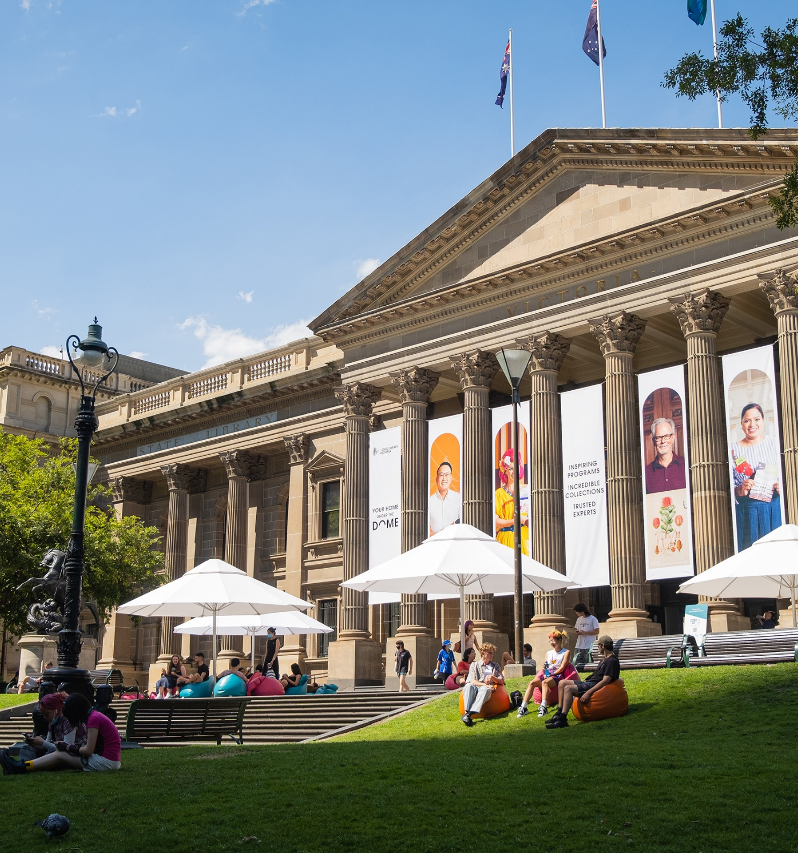
2022-2024

Disability Action Plan

Disability Action Plan
Contents
Message from the CEO 3
Introduction 4
Social model of disability 4
The approach 5
Progress on disability inclusion 5
Disability Action Plan 2022-24 goals 6
1. Access 6
2. Employment 6
3. Inclusion and participation 6
4. Attitudes and behaviours 6
Plan management 6
Disability Action Plan 2022-24 7
General 7
Access 8
Access to services, facilities and experiences 8
Digital and technology experience 9
Collection accessibility 10
Employment 11
Recruitment 11
Employee Experience 11
Inclusion and participation 12
Promote inclusion 12
Attitudes and behaviours 13
Change attitudes 13

Message from the CEO
State Library Victoria’s vision is A library for all in a changing world. At the heart of our vision is ensuring that the Library’s physical and digital spaces are welcoming, inclusive and safe spaces for all people.
We want all Victorians to have access to and be empowered by the stories and knowledge within our collection. The Library is enriched by the contributions of all employees, visitors and audiences.
This plan is important to us. It sets out a path to improve inclusion and access to the Library’s programs, collections, services and workforce for people with disability.
We made progress with our 2021 Disability Action Plan, and we recognise there is more to do. Our 2022–24 plan sets out our whole of organisation commitment to equity of access for people with disability.
I would like to thank the Australian Network on Disability for their guidance in developing this plan, as well as our employees in the Library’s Disability workstream, which is part of our Inclusion, Diversity and Access (IDA) portfolio. Their work continues to build our capability to identify and remove barriers for both visitors and employees with disability.
Sarah Slade
Acting Chief Executive Officer

Introduction
Around 1.1 million Victorians have disability, and libraries and literature are important to them. Approximately 26% of Victorians with disability visited a public library in 2018. People with disability are more likely to read for pleasure than other Australians and are more likely to attend literary events. Over 50% of people aged 65 or over have a disability and this age group are also among the strongest who read for pleasure. Despite higher rates of unemployment and a lower average household income, people with disability are more likely to donate to arts and culture than other Australians are.
People with disability care about culture, but they often experience barriers to access and participation. The main reasons given by people with disability for not attending live cultural events are the cost of entry and their mental or physical health. The Library, working with the Australian Network on Disability (AND), aims to identify and address barriers that people with disability face in engaging with and contributing to State Library Victoria.
The Disability Action Plan 2022–24 details the Library’s commitments to improving the experiences of our employees, visitors and audiences with disability. The plan draws on preliminary learnings from AND’s comprehensive assessment, and is underpinned by the Library’s values of Innovation, Collaboration, Engagement, Excellence and Respect.

Social model of disability
The social model of disability focuses on environmental and social barriers to inclusion, rather than seeing disability as deficits experienced by individuals. Applying a social model means focusing on removing barriers to equal participation, and this approach informs the Plan. This focus aligns with Victoria’s Charter of Human Rights and Responsibilities Act 2006 and the United Nations Conventions on the Rights of Persons with Disabilities.
People with disability experience barriers in relation to a range of different physical, sensory, psychiatric, neurological, intellectual, and learning related conditions or attributes.

The approach
The Victorian Disability Act 2006 requires all public sector bodies to develop action plans that:
- Reduce barriers to people with disability accessing information, services and facilities
- Reduce barriers to people with disability in obtaining and maintaining employment
- Promote inclusion and participation in the community of people with disability
- Achieve tangible changes to attitudes and practices which discriminate against people with disability.

Progress on disability inclusion
The Library’s Disability Action Plan 2020–21 included a range of actions and measures to remove barriers and improve experiences for people with disability.
To reduce barriers to people with disability accessing information, programs and services we have:
- Updated access requirements fields in the public programs booking process (EventBrite)
- Made Auslan interpretation available for selected programs
- Scheduled low-sensory and audio-described sessions for upcoming exhibitions and major public programs
- Commenced training for employees who work directly with our visitors to enable them to support access requirements
- Implemented Monsido to review accessibility of digital products including the Library’s website
- Built accessibility into the design of online membership forms.
To reduce barriers to people with disability in obtaining and maintaining employment we have:
- Made changes to recruitment processes, including adding questions that will assist with identifying and supporting adjustments
- Formed a relationship with CVGT Australia and created the opportunity to employ a neurodiverse individual within the Library’s Collection Group
- Reviewed relevant policies and procedures to ensure they reflect the social model of disability.
To promote inclusion and participation we have:
- Identified and built relationships with peak bodies such as Australian Network on Disability, and Arts Access Victoria.
To achieve tangible changes to attitudes and practices which discriminate against people with disability we have:
- Commenced internal training that covers disability awareness, understanding and removing unconscious bias, communication, and cultural safety in a disability context
- Delivered mental health first aid training to people managers
- Developed training and raised awareness of how to support colleagues with disability and empower managers to offer formal support.

Disability Action Plan 2022-24 goals
The goals for this plan align with State Library Victoria’s 2020–24 Strategic Plan and seek to address the following four areas:

Access
Goal: Reduce barriers for people with disability in accessing information, collection material, services and facilities

Employment
Goal: Reduce barriers for people with disability in obtaining and maintaining employment

Inclusion and participation
Goal: Promote inclusion and participation of people with disability in the community

Attitudes and behaviours
Goal: Achieve tangible changes in attitudes and practices which discriminate against people with disability

Plan management
The plan sets out the Library’s approach to improving experiences for people with disability. Accountability for the delivery of actions is detailed within the plan. Progress against objectives will be reported quarterly and progress summaries will be included in CEO and annual reports.

Disability Action Plan 2022-24
This plan is designed to cover a three-year period and allows for further development of specific actions as we continue the Library’s partnership with the Australian Network on Disability (AND).
Action points reflect the social model of disability and seek to leverage new technology, processes, and practices to empower communities.

General
 | Action | Responsibility | Timing | Measure
1 | Consult and connect  Establish a consultative committee / disability advisory group to assist the Library in meeting its commitment to inclusion, diversity and access | Director, Experience | 2022 | Group established with Terms of Reference in place
2 | Continuously improve  Complete AND comprehensive assessment and review and prioritise recommendations | IDA Sponsor with IDA Working Group | 2021–24 | Number of recommendations implemented
3 | Produce  Develop a disability action plan aligned with the next strategic planning period | IDA Sponsor with IDA Working Group | 2024 | Disability Action Plan developed and approved
4 | Embed  Include accessibility as part of all costing for programming, exhibitions and projects | Director, Enablers | 2022 | Expenditure on accessibility initiatives tracked and measured

Access

Access to services, facilities and experiences
 | Action | Responsibility | Timing | Measure
5.1 | Build accessibility considerations into front-of-house spaces and program design across all audiences | Director, Experience | 2022–24 | Accessibility of Library spaces audited  Building signage and navigation optimised  Access requests are responded to by front-of-house staff
5.2 | Ensure visitors with a disability have the information to confidently engage with the Library | Director, Experience | 2022–24 | Access and Inclusion webpage reviewed and consolidated, and displayed prominently on website  Key site information provided in alternate formats including Easy English and Social Scripts  Captioned and audio described content available on the website
5.3 | Cater to diverse access requirements with low-sensory environments and/or sessions | Director, Experience | 2022–24 | Designated Library quiet areas reviewed and promoted  Scope potential for quiet sessions to meet audience needs
5.4 | Develop and implement best-practice guidelines for exhibition and programming design | Director, Experience | 2022–24 | Exhibition manual developed incorporating accessibility considerations across all stages  Audio-described and Auslan tours provided for exhibitions  Public programs accessible through interpretation and description

Digital and technology experience
 | Action | Responsibility | Timing | Measure
6.1 | Redevelop website to minimise barriers, prioritising accessibility through information architecture, language, functionality and content | Director, Experience | 2022–24 | All online content developed in line with Web Content Accessibility Guidelines (WCAG) 2.1 (or highest available at the time)
6.2 | Include accessibility in the development and planning of all digital and technology strategies | Director, Enablers | 2022–24 | All D&T Portfolio projects include an assessment of accessibility requirements
6.3 | Build the principle of access by anyone from anywhere into decision-making on new technologies | Director, Enablers | 2022–24 | All new technology implemented has accessibility features
6.4 | Maintain assistive technology for visitors | Director, Enablers | 2022–24 | Assistive technology maintenance schedule and procedures implemented

Collection accessibility
 | Action | Responsibility | Timing | Measure
7.1 | Upgrade the Library’s Discovery System to ensure it conforms to accessibility standards, offers a user interface in multiple languages, and includes a voice search assistant | Director, Collections | 2022–23 | Implementation and rollout of accessibility features within Primo VE
7.2 | Improve eresource acquisition processes to include accessibility considerations | Director, Collections | 2022–23 | Accessibility criteria added to key selection criteria throughout eresource acquisition processes
7.3 | Include books with braille overlays in Children’s Quarter collection | Director, Collections | 2022–24 | Increase in collection items within the Children’s Quarter collection with braille overlays
7.4 | Increase the number of digitised items to improve online access | Director, Collections | 2022–24 | 15,000 items digitised per annum
7.5 | Ensure that demand-driven collecting practices include people with disability | Director, Collections | 2023 | Develop and implement a formal process for the acquisition of disability-related items

Employment

Recruitment
 | Action | Responsibility | Timing | Measure
8.1 | Review recruitment process to identify and address barriers that people with disability experience  Explore the possibility of attaining AND Confident Recruiter status | Head of People and Projects | 2022 | Implement a mechanism to gain feedback from candidates on their experiences of the recruitment process to establish a baseline for improvement to be measured  Improvement in candidate experience
8.2 | Create an ongoing role within the Library for recruitment through a Disability Employment Service provider | Director, Enablers | 2022–24 | Role identified and funded within Library structure

Employee Experience
 | Action | Responsibility | Timing | Measure
9.1 | Identify actions to improve the employment experience of people with disability | Head of People & Projects with IDA Working Group | 2022–24 | Number of actions identified and addressed
9.2 | Clear and transparent procedure for adjustments in place. Managers and employees know how to request assessments | Head of People and Projects | 2022–23 | Managers and employees access adjustment mechanisms as required

Inclusion and participation

Promote inclusion
 | Action | Responsibility | Timing | Measure
10.1 | Acquire collection items that profile individuals, stories and formats from and for identified communities | Director, Collections | 2022–24 | 10% of the combined original material and Rare Books collection budget is for acquisition of items from those who are often not heard, including people with disability, LGBTQI+ people, and people from migrant and refugee backgrounds
10.2 | Ensure representation in programs | Director, Experience | 2022–24 | Minimum 10% programming lead by or includes organisations, artists or curators with a disability  Accessibility requirements are incorporated into programming agreements
10.3 | Create a welcoming and inclusive environment for visitors | Director, Experience | 2022–24 | Public spaces incorporate signage (physical/digital) about access and inclusion services  Front of house staff equipped with communication tools and skills to greet and welcome visitors, including using communication apps installed on phones
10.4 | Seek feedback from users with access requirements and carers to continuously improve products, collection access and services | Director, Experience | 2022–24 | Conduct ‘mystery shopping’ visits of public spaces by people with lived experience of disability  Seek feedback from users of assistive technology to ensure it meets their needs
10.5 | Increase awareness of disability-related collections and cultural heritage | Director, Experience | 2022–24 | Create digital content promoting and providing access to resources related to voices of people with disability

Attitudes and behaviours

Change attitudes
 | Action | Responsibility | Timing | Measure
11 | All employees actively seek to improve the working environment for people with disability as part of a culture of inclusion | Head of People and Projects with IDA Working Group | 2022–24 | Increase in employees responding positively to People Matters survey measure: ‘There is a positive culture within my organisation in relation to employees with disability’

Australian Bureau of Statistics, Survey of Disability, Ageing and Carers, 2018.
Australia Council for the Arts, Creating our Future: Results of the National Arts Participation Survey, 2020.
ABS, Survey of Disability, Ageing and Carers, 2018.
Australia Council for the Arts, Creating our Future: Results of the National Arts Participation Survey, 2020.
ABS, Survey of Disability, Ageing and Carers, 2018.
Australia Council for the Arts, Creating our Future: Results of the National Arts Participation Survey, 2020.
Australia Council for the Arts, Creating our Future: Results of the National Arts Participation Survey, 2020.

