Teacher Guide:
This teacher guide complements the student worksheet for Amelia’s Book Bash session.
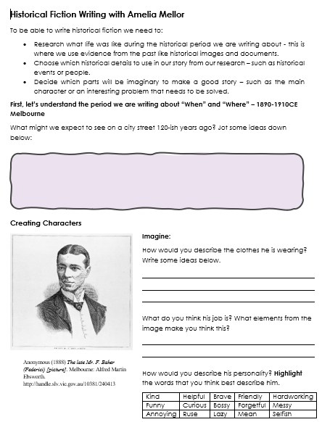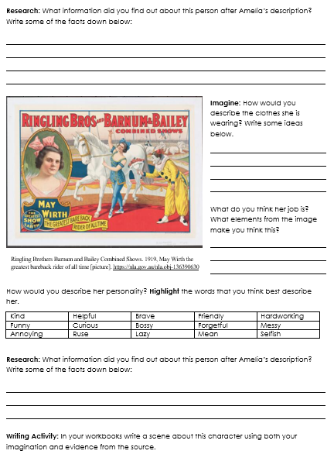

Frederick Baker Source:
Amelia will be guiding students through this source during the livestream.
For those who leave the virtual classroom early, Amelia will read out the following information to students regarding the “research” section:
Frederick ‘Federici’ Baker was born in Italy to British parents. He became an opera singer when he was 21, with a powerful, deep voice. He toured around the world playing many famous roles in popular operas and operettas, or early musicals. Many of his roles were boisterous and grand characters, such as pirate captains, army officers and emperors. On the opening night of Faust at Melbourne’s Princess Theatre in 1888, he was performing as the demonic villain Mephistopheles. While being lowered through the trapdoor on stage at the end of the show, he suddenly grabbed the edge of the floor and died of a heart attack behind the scenes. He was only 37. But his fellow cast members that night swore that he was with them at the curtain call.
A few years later, security guards, actors and maintenance workers started to report ghostly happenings in the theatre, especially at night. Some claimed they saw Federici as a pale figure! Others reported coldness in the air or the feeling of someone touching their arm. He is said to be a harmless ghost though, who never does anything more sinister than cause lights to flicker, or frown at inferior performances. Today, the Princess Theatre’s bar is named after him, and the staff leave a seat for him on the opening night of every show. It’s said to be good luck if he appears.

May Wirth Source:
We recommend students complete this section of the worksheet independently as they have completed an example with Amelia’s guidance.
Imagine section: Please also see suggested student responses for the “Imagine” section of the worksheet.
- How would you describe the clothes she is wearing? Write some ideas below.
  - Colourful
  - Athletic
  - “pretty” – bow in hair
  - Feminine
  - “ballerina” – shoes
- What do you think her job is? What elements from the image make you think this?
  - A circus performer – the clown, the stage, the horse, “greatest bare back rider of all time”
- How would you describe her personality? Highlight the words that you think best describe her. Various student answers

Research section: Read out the following for the “research” section of the worksheet.
May Wirth was born in Bundaberg, Queensland. Her father was a circus performer. In 1901 (when she was 6 or 7!), her parents split up and she was adopted by Mary Elizabeth ‘Marizles’ Wirth, who was a trick rider in Wirth’s Circus, owned by her brothers (May’s adoptive uncles). May was raised with Marizles’ daughter Stella who was two years older.
May knew a few circus tricks already and soon she was performing in balancing, tumbling and contortion acts in Wirth’s Circus. By the age of 10, she was appearing in a trick riding act with Stella and Marizles, turning somersaults on a bareback horse.
She went on to tour around Australia and the United States. The famous Barnum and Bailey Circus in the US billed her as ‘the world’s greatest bareback rider’. As a teenager, she could somersault backwards through rings, do feet-to-feet flips backwards and forwards on horseback, and leap from the ground to a galloping horse with baskets on her feet. These were difficult and dangerous acts. When she was 19, a horse got spooked during a performance and she was badly injured from being dragged around the arena by her foot. But she recovered and kept performing until her retirement in her forties. She spent the rest of a long and happy life in the US with her husband Frank. She lived into her eighties and remembered her circus days fondly.

Writing task:
Below are some sentence starter prompts you can provide students to begin writing their scene.
Sentence starter: | Connection to worksheet: | Example:
May looked down at… | Have students describe her outfit, connecting to Q1. | May looked down at her pearl shoes, tying up the white ribbon tightly around her ankles.
Her face… | Have students describe her personality through her face, connecting to Q3. | Her face was scrunched up in concentration. She was determined to make this show memorable for the audience.
Looking around she… | Have students describe the physical location, connecting to Q2. | Looking around she noticed Snowy was ready for her, pawing at the ground. Snowy was just as much a show person as May.

