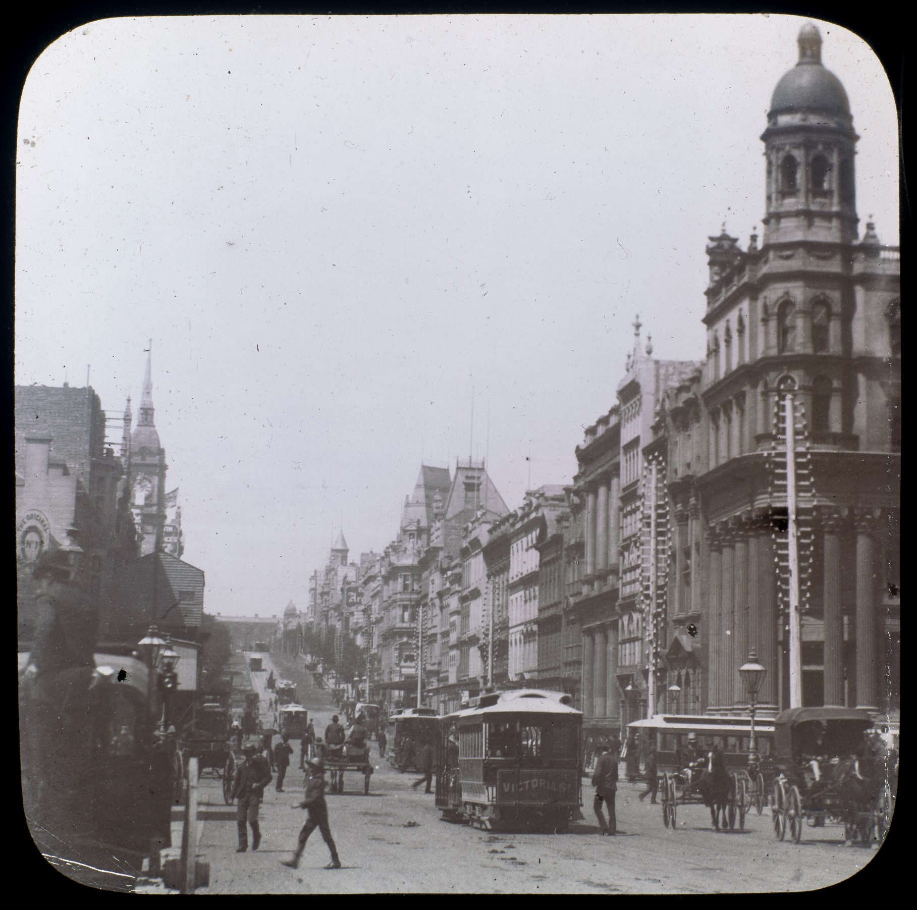
Teacher Booklet

Historical Fiction Writing with Amelia Mellor


Historical Fiction Writing with Amelia Mellor
Contents
Welcome to Historical Fiction Writing 4
Lesson 1 9
Lesson 2 11
Lesson 3 13
Lesson 4 16
Lesson 5 18
Lesson 6 20
Lesson 7 22
Lesson 8 23
Lesson 9 26
Lessons 10-12 28

Acknowledgement of Country
State Library Victoria acknowledges the traditional lands of all the Victorian Aboriginal clans, and their cultural practices and knowledge systems.
We recognise that our collections hold traditional cultural knowledge belonging to Indigenous communities in Victoria and around the country. We support communities to protect the integrity of this information, gathered from their Ancestors in the colonial period.
We pay our respects to their Elders, past and present, who have handed down these systems of practice to each new generation for millennia.
Cover image:
Collins Street, Melbourne.
Date [ca. 1890]
Identifier(s) H2016.73/3

Welcome to Historical Fiction Writing

State Library Victoria is thrilled to offer you this unit of work on historical fiction writing with Amelia Mellor. By completing this unit, students will develop an understanding of the genre and gain insights into life in Melbourne at the turn of the century. They will practise key writing skills, transferrable across genres, producing a piece of historical fiction.

How is this unit structured?
The through line of this unit of work is the understanding that historical fiction writing requires both research and creativity. For this reason, writing historical fiction can be challenging for students as the emphasis on research in the early stages can overshadow their creativity (or vice versa). Further, it can also be difficult for students to feel confident using historical sources imaginatively, as the past may be seen as having a single “right answer,” even though interpretation is central to the study of the past.
Designed to be editable, you can amend the student booklet to ensure that the program meets the needs of your students. This teacher booklet highlights each activity and provides suggested examples and extensions when applicable. The suggested duration of each lesson is approximately one hour of classroom time.

Curriculum Connections:
This unit of work meets several curriculum content descriptors for English across Levels 5-8 (see pp.5-6). Additionally, though this unit has been designed in line with the English curriculum, it also meets criteria in the Humanities - History and Critical and Creative thinking (see p.7).

Use as formative and summative assessment:
The student booklet works well as a formative assessment piece as it includes a series of activities, including short writing tasks, where students apply their new knowledge. Additionally, if you wish to use the narrative piece students create as a summative assessment, we have designed an assessment rubric for your reporting for the English curriculum (p.8).

Literacy:
Interacting with others:
- use interaction skills and awareness of formality when paraphrasing, questioning, clarifying and interrogating ideas; developing and supporting arguments; and sharing and evaluating information, experiences and opinions VC2E6LY01
Texts in context:
- examine texts, including media texts, that represent ideas and events, and identify how they reflect the context in which they were created VC2E6LY06
Analysing, interpreting and evaluating:
- analyse how text structures and language features work together to meet the purpose of a text and engage and influence audiences VC2E6LY07
- use comprehension strategies, such as visualising, predicting, connecting, summarising, monitoring and questioning, and connect and compare ideas from a variety of sources to build literal and inferred meanings VC2E6LY08
Creating Texts:
- create different types of texts, written and spoken, with developed and organised ideas for purpose and audience, and multimodal elements as appropriate VC2E6LY09
- re-read and edit their own texts and the texts of others using agreed criteria and exploring editing choices VC2E6LY10
- write legibly, fluently and automatically for sustained periods VC2E6LY11

English Level 6
Language:
Text structure and organisation:
- explain how different types of texts are typically organised into characteristic stages and phases depending on purposes, recognising how authors often adapt text structures and language features VC2E6LA03
- understand that sequence and cohesion can be created by the intentional use of repetition of text structures, language features and vocabulary VC2E6LA04

Literacy:
Interacting with others:
- use interaction skills including paraphrasing and questioning to clarify meaning, make connections to personal experience or to a text, and present and justify an opinion or idea VC2E5LY01
Texts in context:
- describe the ways in which a text reflects the time and place in which it was created VC2E5LY07
Analysing, interpreting and evaluating:
- explain characteristic features used to meet the purpose and audience in different types of texts VC2E5LY08
- use comprehension strategies, such as visualising, predicting, connecting, summarising, monitoring and questioning, to evaluate information and ideas to build literal and inferred meanings VC2E5LY09
Creating Texts:
- create different types of texts, written and spoken, with relevant, elaborated and sequenced ideas, using text structure appropriate for topic, purpose and audience, and multimodal elements as appropriate VC2E5LY10
- re-read and edit their own texts and the texts of others using agreed criteria for text structures and language features VC2E5LY11
- write legibly, fluently and automatically VC2E5LY12

English Level 5
Language:
Text structure and organisation:
- describe how different types of texts use language features and are typically organised into characteristic stages and phases, depending on purposes VC2E5LA03
- understand how texts are sequenced and can be made cohesive by using the starting point of a sentence or paragraph to give prominence to the message and to guide the reader through the text VC2E5LA04
Language for expressing and developing ideas:
- understand how vocabulary is used to express greater precision of meaning, including through the use of specialist and technical terms VC2E5LA08

Literature:
Literature and contexts:
- explore their responses to characters and events in literary texts drawn from historical, cultural or social contexts by Aboriginal and Torres Strait Islander authors and a wide range of Australian and world authors VC2E6LE01
Engaging with and responding to literature:
- compare language choices, modality, emphasis, repetition and metaphor, and topics, themes or plots in a range of literary texts VC2E6LE02
Examining Literature:
- describe characteristics of literary texts that define an author’s individual style VC2E6LE03
Creating literature:
- create texts that adapt plot structure, characters, settings and/or ideas from literary texts they have encountered, and experiment with vocabulary and literary devices VC2E6LE05

Literature:
Literature and contexts:
- identify aspects of literary texts that represent details or information about historical, cultural and social contexts in literature by Aboriginal and Torres Strait Islander authors and a wide range of Australian and world authors VC2E5LE01
Creating literature:
- create texts, experimenting with vocabulary, figurative language, storylines, characters and settings from literary texts they have encountered VC2E5LE05

Literature (continued):
Creating literature:
- create texts that experiment with literary language features and literary devices for particular purposes and effects VC2E8LE06

Language:
Text structure and organisation:
- explain how texts are structured depending on their purpose and how language features vary, recognising that some texts are hybrids VC2E8LA03
- understand how cohesion in texts is improved by strengthening internal structures and sequence, with evidence, quotations and substantiation of claims VC2E8LA04
Language for expressing and developing ideas:
- understand and use punctuation conventions, including semicolons and dashes, to extend ideas and support meaning VC2E8LA09

Language:
Text structure and organisation:
- identify and describe how texts are structured differently depending on their purpose, and how language features vary in texts VC2E7LA03
- understand that the cohesion of texts relies on devices that signal, structure and sequence, such as overviews, examples, and beginnings and endings VC2E7LA04
Language for expressing and developing ideas:
- explore the role of vocabulary in building specialist and technical knowledge, including terms that have both everyday and technical meanings VC2E7LA08
- understand the use of punctuation including colons and brackets to support meaning VC2E7LA09

Literature (continued):
Examining Literature:
- identify and explain the ways that characters, settings and events combine to create meaning in literary texts VC2E7LE04
Creating literature:
- create texts that experiment with literary language features and devices encountered in texts VC2E7LE06

English Level 7
English Level 8

Literacy:
Interacting with others:
- use interaction skills for identified purposes and contexts, including when supporting or challenging the stated or implied meanings of texts in discussion VC2E8LY01
Texts in context:
- describe how representations of people, places and events reflect the context of the text VC2E8LY04
Analysing, interpreting and evaluating:
- analyse and evaluate the ways that language features represent perspectives on an issue, event, situation, individual or group, and the ways that quotations and sources are used and repurposed in a text VC2E8LY05
- analyse how authors organise ideas to develop and shape meaning VC2E8LY06
- use comprehension strategies such as visualising, predicting, connecting, summarising, monitoring, questioning and inferring to interpret and evaluate ideas in texts VC2E8LY07
Creating Texts:
- create different types of texts, written and spoken, that raise issues, report events and advance opinions, using deliberate language and textual choices, and print, multimodal and/or digital elements as appropriate VC2E8LY08
- review and edit to refine and clarify ideas to improve the effectiveness and coherence of their own texts and the texts of others, and reflect on these processes VC2E8LY09

Literacy:
Interacting with others:
- use interaction skills when discussing ideas and information, including evaluations of the features of texts VC2E7LY01
Analysing, interpreting and evaluating:
- analyse the ways in which language features shape meaning and vary according to audience and purpose VC2E7LY05
- explain the structure of ideas such as the use of taxonomies, cause and effect, extended metaphors and chronology VC2E7LY06
- use comprehension strategies such as visualising, predicting, connecting, summarising, monitoring, questioning and inferring to analyse and summarise information and ideas VC2E7LY07
Creating Texts:
- create different types of texts, written and spoken, selecting aspects of subject matter and particular language and print, multimodal and/or digital elements to convey information and ideas to a specific audience VC2E7LY08
- review and edit their own texts and the texts of others by removing repetition, refining ideas, reordering sentences and adding or substituting words for impact and coherence, and reflect on these processes VC2E7LY09

Literature:
Literature and contexts:
- explain the ways that ideas, issues and points of view in literary texts drawn from diverse historical, cultural and social contexts by Aboriginal and Torres Strait Islander authors, and a wide range of Australian and world authors, may represent the values of individuals and groups VC2E8LE01
Engaging with and responding to literature:
- explore opinions about the language features, literary devices and text structures that contribute to the styles of literary texts VC2E8LE02
- explore the ways that literary devices and language features, such as dialogue, and still and moving images are used to create character, and to influence emotions and opinions in a range of literary texts VC2E7LE03
Examining Literature:
- explore how language features such as sentence patterns create tone and voice, and how literary devices such as imagery create meaning and aesthetic qualities in literary texts VC2E8LE05

Literature:
Literature and contexts:
- identify and explore ideas, points of view, characters, events and/or issues in literary texts, drawn from different historical, cultural and/or social contexts by Aboriginal and Torres Strait Islander authors and a wide range of Australian and world authors VC2E7LE01
Engaging with and responding to literature:
- develop an opinion about characters, settings and events in literary texts, identifying areas of agreement and difference with others’ opinions and justifying a response VC2E7LE02
- explore the ways that literary devices and language features, such as dialogue, and still and moving images are used to create character, and to influence emotions and opinions in a range of literary texts VC2E7LE03

History Levels 7 and 8
Historical Concepts and Skills:
Historical questions:
- develop and use historical questions to inform historical investigations VC2HH8S01
Using historical sources:
- explain the features, content and context of historical sources VC2HH8S03
- explain the perspectives, beliefs, values and attitudes of people and groups based on evidence from a range of sources VC2HH8S05

Historical Knowledge and Understanding
Australia (1800-1900):
- the continuities and changes associated with significant developments or events on a colony VC2HH6K03
- the role of significant individuals or groups, including Aboriginal and Torres Strait Islander Peoples, local-born colonists and migrants, on the development of or events in a colony VC2HH6K05

Australia (1900-2000):
- the causes for people migrating to Australia from Europe and Asia, including their experiences and perspectives, and their impacts on Australian society during the 20th century VC2HH6K09
- significant contributions of individuals and groups, including Aboriginal and Torres Strait Islander Peoples and migrants, to changing Australian society VC2HH6K10

History Levels 5 and 6
Critical & Creative Thinking
Levels 7 and 8
Levels 5 and 6

Questions and possibilities:
- the construction of a main question and sub-questions for different purposes VC2CC8Q01
- strategies for generating new ideas and possibilities including identifying a pattern across multiple information sources VC2CC8Q03

Reasoning:
- ways to identify, structure and communicate a conclusion and its justification where competing claims, and grounds for claims, are analysed and evaluated VC2CC8R01

Metacognition:
- ways to select, use and reflect on general and context-specific learning strategies VC2CC8M01

Questions and possibilities:
- the construction of questions for identifying and building understanding of information, possibilities, processes and activities VC2CC6Q01
- an extended range of strategies to generate new ideas and possibilities including forming a link between different information sources VC2CC6Q03

Reasoning:
- ways to identify, structure and communicate an argument that uses sub-arguments leading to a main conclusion VC2CC6R01

Metacognition:
- learning strategies suited to general and specific contexts, including different ways of identifying, expressing and organising key learning, and undertaking spaced practice VC2CC6M01

Historical Concepts and Skills:
Historical questions:
- ask and develop historical questions to direct historical investigations VC2HH6S01
Using historical sources:
- describe the features, content and context of historical sources VC2HH6S03
- describe historical perspectives and identify beliefs, values and attitudes of people and groups based on evidence from primary sources VC2HH6S05

Historical Fiction Creative Response Rubric
An effective historical fiction creative response… | My historical fiction creative response…
Includes a clear and engaging narrative arc. | Has minimal components of a narrative arc. | Has some components of a narrative arc, including a hook, exposition, conflict, rising action, climax, falling action and resolution. | Has a mostly clear narrative arc, including a hook, exposition, conflict, rising action, climax, falling action and resolution. | Has a clear and engaging narrative arc, including a hook, exposition, conflict, rising action, climax, falling action and resolution. | Has a well-crafted and highly engaging narrative arc, including a hook, exposition, conflict, rising action, climax, falling action and resolution.
Includes accurate and descriptive historical details of Melbourne in 1890-1910. | Includes minimal descriptive historical details of Melbourne 1890-1910. | Includes some descriptive historical details of Melbourne 1890-1910, in including some key words and sensory details. | Includes mostly accurate and descriptive historical details of Melbourne 1890-1910, in including key words and sensory details. | Includes accurate and descriptive historical details of Melbourne 1890-1910, in including key words and sensory details. | Includes thoughtfully selected and highly descriptive historical details of Melbourne 1890-1910, in including key words and sensory details.
Includes clear and engaging dialogue, including varied speech tags and action. | Includes minimal dialogue. | Has some dialogue but requires more varied speech tags and action. | Has mostly clear and engaging dialogue, including some varied speech tags and action. | Has clear and engaging dialogue, including varied speech tags and action. | Has well-crafted and highly engaging dialogue, including varied speech tags and action.
Features accurate spelling, punctuation and expression. | There are lots of errors in spelling, punctuation and/or expression, which make the response difficult to read and understand. | There are many errors in spelling, punctuation and/or expression. These sometimes make the response difficult to read. | There are some errors in spelling, punctuation and/or expression. | There are few errors in spelling, punctuation and/or expression. | There are no errors in spelling, punctuation and/or expression.

Lesson 1
Learning intention: | We are learning to: understand what historical fiction is
Success criteria | I can:  - explain the difference between fiction and non-fiction.  - identify and explain the key elements of historical fiction.  - describe how historical fiction is different from other types of fiction.

Pedagogical Notes:
This lesson introduces the through line of this unit of work: the understanding that historical fiction writing requires both research and creativity. After this lesson students will understand what makes historical fiction unique and the types of evidence they may come across during their research (primary and secondary). Students are also encouraged to tap into their creativity with a drawing activity.

Student Activities:
Activity: Let’s check your understanding of what makes a text historical fiction by circling which of the following statements are true:
Historical fiction is a type of non-fiction because it uses facts. | Historical fiction uses accurate details from history, but the story is based on the author’s imagination.
Historical fiction stories can include real people from history and fictional characters. | To write historical fiction, you don’t need to do any research, you just make stuff up.
Activity: Have a look at the examples of well-known stories over the page. Identify which are historical fiction and which are not.

Stories: | Yes/No:
Percy Jackson and the Lightning Thief – A boy discovers he has magical powers inherited from his father, the Ancient Greek god of the sea, and attends a school camp for demigods. | No
The Book Thief - Set in Nazi Germany during World War II in the 1940s. This story, narrated by the spirit of Death, follows a young girl who steals books and discovers the power of words. | Yes
The Wild Robot – After climate change transforms society and the environment, a lost robot learns to survive on an island inhabited only by wild animals. | No
The Silver Donkey - A soldier from World War I (1914-1918) is found in the woods by two children in France. He tells them stories while they help him return home. | Yes

Activity: Identify sources that are Primary or Secondary sources from the examples below by drawing a line to their correct category.
This activity isn’t essential for meeting the English curriculum, but if you’re also reporting on the History curriculum (particularly for the 5-6 levels), it’s recommended to complete it. This is because many students assume primary sources are “good” and secondary sources are “bad,” but both can be valuable when used appropriately. That being said, if you are focusing on the English curriculum this activity helps students see that both primary and secondary sources are valid evidence for research.
SECONDARY SOURCES
PRIMARY SOURCES
A book written in 1980CE by a historian on life on the Victorian goldfields
A coin from Ancient Rome dated to the 1st century
A piece of pottery from the year 600CE
A newspaper article from 1930

A modern textbook on Ancient Egypt
A webpage about Melbourne in the 1920s
A letter about life in Melbourne in 2010

The period you will be setting your narrative in is the turn of the century - around 1890-1910CE. The place you will be setting your narrative is Melbourne. But what did Melbourne look, feel, sound or even smell like at this time?
Additional activity: To help place this period in context you can have students investigate key events from Melbourne’s history using the timeline from Melbourne Museum.

Activity: Have a guess and draw an image of what you think Melbourne would have looked like over 130 years ago.
Provide enough time for this activity so that students can draw as much detail as possible. Students can get into pairs after they have completed their drawings to discuss what they drew and why. The more detail in their illustrations the better moving forward as you will unpack what they included, what they didn’t include and how “realistic” their drawing is using their imagination in lesson 2. This activity will ultimately highlight how important it is to use historical sources when writing historical fiction.

Lesson 2
Learning intention: | We are learning to: understand what life was like in Melbourne during the turn of the century.
Success criteria | I can:  - use evidence from sources to depict what life was like in Melbourne in 1890-1910.
Pedagogical Notes:
This lesson introduces students to their temporal context and includes visual footage of Melbourne from the Marvellous Melbourne documentary from 1910. It was considered groundbreaking at the time of publication as it provided a birds-eye-view of the city with alternative point of view angles (such as from a tram). If you would like your students to explore further footage from this period, the National Film and Sound Archive of Australia has a collection accessible to students. For your own reference, you could also watch the documentary The Lost City of Melbourne, which highlights the transformation of the city over the 19th and 20th centuries.
Student Activities:

Activity: Listen to your teacher read out a secondary source describing what Melbourne was like at the turn of the century. As you are listening, write down information in the brainstorm below answering the question – What was life like in Melbourne at the turn of the century?
The source below, written by State Library Victoria, provides a general overview for students. Additional primary and secondary sources you can use for this activity can be found on our Ergo website exploring everyday life in colonial Melbourne.
Source: Painting a picture: Melbourne at the turn of the century - State Library Victoria
“
By the 1880s, Melbourne had developed an international reputation as one of the greatest cities in the world and was called “Marvellous Melbourne”. But what did Melbourne look like at this time? If you were walking along Collins Street, you might see the young and fashionable as they 'did the Block', walking the footpaths and arcades. Telephones and electric lights were uncommon, but this was the time Melbourne’s first 'skyscrapers' appeared. The first cable tram opened in 1885 CE ferrying crowds through the streets between the horses and carriages.
In 1893 Melbourne was the centre of a banking crisis that led to what is considered the most severe depression in Australia’s History. A depression is when lots of people lose their jobs, businesses close down, and many families don’t have enough money for the things they need. The impact on Melbourne society was great. Many people left Melbourne to seek their fortune elsewhere, while others tried to survive with very little money. It didn’t take long, however, for the city to bounce back with large amounts of new infrastructure built in the first decade of the 20th century. This included Flinders Street Station, which was finished in 1910 CE.
If you were to walk through the CBD in 1910 CE it would be very different from the 1880s. The streets were strewn with rubbish and human waste - so much so that Melbourne was nicknamed “Smellbourne” by British journalists. The gas lamps were mostly replaced with electricity networks as Melbourne became a “wired” city. More cable trams were in use, and the streets had several motorised vehicles in amongst horses and carriages. Melbourne went through a lot of change at the turn of the century, and it was certainly a very different Melbourne than the one we know today!
“

Activity: As a class watch footage from 1910 exploring life in Melbourne. These clips are from a documentary titled, Marvellous Melbourne: Queen City of the South, it is the oldest surviving documentary of Melbourne.
Clip 1: https://www.nfsa.gov.au/collection/curated/asset/96861-marvellous-melbourne-melbourne-buildings
Clip 2: https://www.nfsa.gov.au/collection/curated/asset/96859-footscray-1911
Clip 3: https://www.nfsa.gov.au/collection/curated/asset/96860-marvellous-melbourne-swanston-and-collins-streets-tram

As discussed above you can review more footage in the curated collection at the National Film and Sound Archive of Australia.
Add anything new to your brainstorm about what Melbourne was like at the turn of the century from this documentary.
Sample Answers for Brainstorm
Information from Melbourne at the Turn of the century – Painting a picture
Information from Marvellous Melbourne: Queen City of the South
First cable tram in 1885CE
bicycles
Wide streets, no signs on roads
Long dresses/suits and hats
First skyscrapers were built
Dirt roads (no asphalt)
Was also called “smellbourne”
Collins street was where the young and fashionable “did the block” (socialised)
was called “Marvelous Melbourne”
Horse poo on the road
No pedestrian crossings
Wired city by 1910CE
In 1893 Melbourne was the location of a severe economic depression
Melbourne at the turn of the century.
Horse and carriages as well as motorised vehicles

Stone drains
Streets were strewn with rubbish and human waste
A lot of 3 storey buildings
Flinders Street Station current building was finished in 1910CE
Cigars/cigarettes were common


Classroom Discussion: Have another look at the drawing you created in lesson 1. How realistic was it? Did you have anything important missing? Did you include things that weren’t in Melbourne at the time? Share with your class.
Activity: Have another go and use the evidence you found from the sources and redraw what Melbourne would have looked like at the turn of the century using both your imagination and your research.
The key to this activity is for students to be able to incorporate the evidence from the source material in their illustration. As an extension you can ask students to explain the elements they’ve selected and annotate what elements were included from their research and those included from their imagination. By doing so you reinforce the through line of the unit making it visible to students (i.e. that historical fiction writing requires both research and creativity).


Quick Write Task 1: Imagine you have a time machine and you’ve gone back to Flinders Street in 1910. Using your picture above as inspiration have a go at writing a short passage describing your environment as you walk down Flinders Street. Think about all your senses (see, hear, taste, touch, smell).
Optional sentence starters: As I walk along Flinders Street, I feel…/The sound of…/Looking up I see…
This activity is designed as a low-stakes opportunity for students to write freely, without the pressure of a formal writing task. The goal is simply to get students to put pen to paper, experimenting with ideas, and building confidence in creative expression within this genre.

Lesson 3
Learning intention: | We are learning to: investigate sources, making connections to common themes.
Success criteria | I can:  - recall what life in Melbourne was like at the turn of the century.  - analyse sources for key information.  - make connections between sources and identify common themes.
Pedagogical Notes:
This lesson is integral to the success of the unit of work as the sources students unpack provide the foundation for the characters and setting in their narratives (see table below highlighting each component). To encourage student choice, two topics have been provided for this unit of work. This means that students will be required to periodically glue in worksheets relevant to their chosen topic for the rest of the booklet. All worksheets have been provided as appendices. The worksheets themselves follow the same structure despite exploring different topics so students can share their ideas with one another. The worksheets can be completed individually or in pairs, but we envision each student to have a booklet to themselves.
Main Character: The individuals in these images will be the protagonist of your students’ stories. | 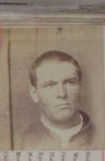 | 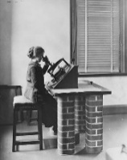
Minor Character: These individuals will be a minor character in your students’ stories. They can choose to only include them briefly or they can assign them the role of the deuteragonist. | 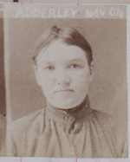 | 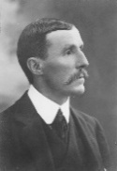
Setting Physical: Students will need to use this source (and other sources) to accurately depict the physical setting of their story. | 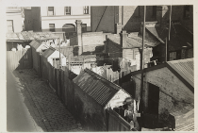 | 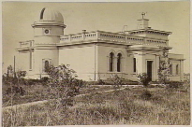
Setting Social: Students will need to use this source (and other sources) to accurately depict the society their character lives in. | 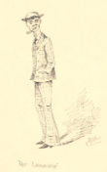 | 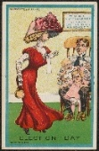
Student Activities:
Activity: Think about last lesson, what do we know about life in Melbourne at the turn of the century? List three things you remember below.
Ideally students recall it was a time of great change as Melbourne transitioned to a “modern” city.
Activity: Your teacher has a collection of sources. You will be assigned one of these sources to investigate further by answering the questions assigned to that source. Once your teacher has handed you the source glue it into your booklet on the next page and then answer the questions.
See Appendix 1 for worksheets and suggested answers.
- We recommend assigning worksheets thoughtfully, as students are likely to choose the topic of their assigned source for their writing:
  - Odd worksheets relate to the topic of poverty, crime and the working class in Melbourne at the turn of the century.
  - Even worksheets relate to the topic of women’s roles and the scientific community in Melbourne at the turn of the century.
- In the worksheet, students are asked to write down any questions they have about the source. You may choose to have a broader discussion at this point; however, many of these questions will likely be answered in the next lesson when the context of each source is provided.
- Please note: Worksheets 7 and 8 are more challenging requiring students to infer meaning beyond the literal image, understanding satire and cultural stereotypes. They are best suited to students with strong analytical and inferential skills.
Activity: Now, find three other people that have the other sources in your collection (see groups below). As a team finish the following sentence: We think the connection between the sources is…
Collection 1:
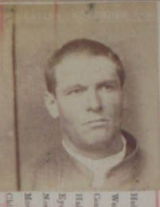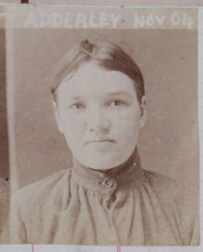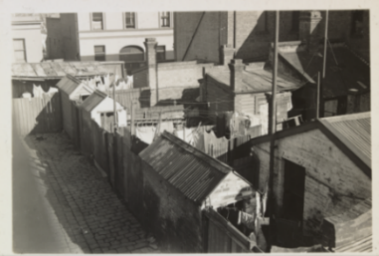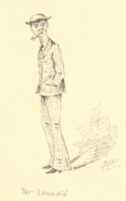
Various answers ideally – Poverty, crime and the working class in Melbourne.

Collection 2:
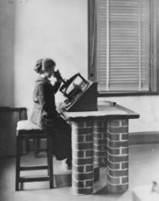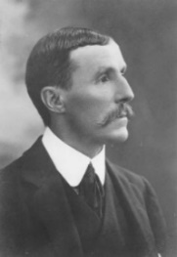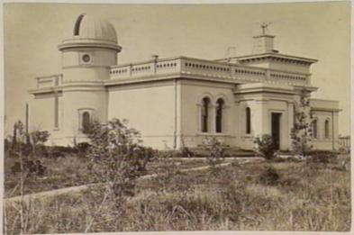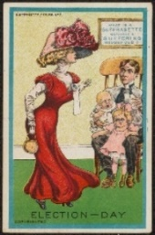
Various answers ideally – Role of women in the workforce/scientific field.
Classroom Discussion: Why was this task difficult? What information were you missing?
This is difficult for students because they are all (purposefully) missing their historical context. Further, if students didn’t read the citation at all they would find the activity extremely challenging. The goal of this is to highlight that even with the sources themselves, it’s not enough, you must understand the information “surrounding” the source as well (which they explore in the next lesson).
Make sure to read out the information below when finalising the lesson, this is also located in the student booklet. You can prompt students to highlight the key information (see suggested highlights).
Being a detective:
Researching the past is a bit like being a detective. Even though you've made a guess about what the topic might be, you can't be sure this is right because you haven’t been given the context of each source. Context is the word we give to all the things that help explain why the source exists.
This means understanding what the source is about, the ideas it reflects, and how it helps you make sense of the society the source came from. By uncovering the context of each source, you’ll be able to piece together the bigger picture, and ultimately, figure out the topic your sources are exploring.

Lesson 4
Learning intention: | We are learning to: identify the context of our sources to understand what life was like in Melbourne at the turn of the century.
Success criteria | I can:  - identify key information about the context of my source.  - identify a common topic.  - use contextual information to write a paragraph of historical fiction.
Pedagogical Notes:
The lesson has two key components: a gallery walk and a quick write activity. The gallery walk (see appendix 2 and 3) ensures students are actively participating with the contextual information of each source, engaging with the content in a more dynamic way than simply reading the information in their booklet.

Student Activities:
Classroom Discussion: What topics do we think the sources highlight? How different are our ideas? What information is missing?
Activity: Unscramble the letters below to find out what information you need!
Answer: Historical Context
Activity: Your teacher has the information you need! Follow their instructions and complete the worksheet over the page.
Print the gallery walk sheets and stick up around the room. Students will glue in the worksheet that relate to their topic and complete the answers individually.
- See appendix 2 for Gallery Walk information sheets.
- See appendix 3 for the student worksheet and answers.
Classroom Discussion: Now that you know the historical context of your sources, discuss as a class what new information you have the helps refine your guess about your topic. Once your teacher has confirmed the topic write it below:

Collection 1: Poverty, crime and the working class (focus on the Crutchy Push)
Collection 2: Role of women in the workforce and scientific endeavour (focus on Melbourne Observatory computers)
Quick Write Task 2: Now that you know your topic and have a strong understanding of your source material, brainstorm what you would hear, smell, see and feel below in the location of your topic (i.e. the setting of your story).
- Collection 1 Location: North Melbourne Slums
- Collection 2 Location: Melbourne Observatory
Sample answers explored below. We have not included taste for this scene, but you could include that if you wanted to.
Sense: | North Melbourne Slums | Melbourne Observatory
Hear | Babies crying, children laughing, horses’ hooves clattering on the cobblestones, people shouting in the street | Quiet ticking of a clock, footsteps on the wooden floor, slide of the astrograph, scribbling of dip pens
Smell | smoke from chimneys, and sewage in the gutters, cooked stew over the fire, cigarette smoke | Wood polish, flowers from the path, crisp night air
See | Crowded dirty streets, tiny houses falling apart, children playing on the streets, piles of rubbish, washing lines | Shiny instruments, cloudless night, stars, dark oak flooring, a room full of young women bent over their astrographs
Feel | Cold metal walls, wet cobbled stones, rough wood, biting wind | Cool to the touch astrograph, grainy wood, slick glass
Now, using the information you wrote down in the sensory table, in your exercise books write a paragraph describing a day in the life of someone in Melbourne at the turn of the century at that location.
Optional sentence starters:
The streets are filled with the smell of… | The morning air feels... | In the distance, I notice…
I catch sight of…and it reminds me of | The feel of…makes me think | Around me, I can hear
Students have likely been introduced to show don’t tell writing in their studies; we would recommend a revision of this here.
Optional activity: Ask students to share their ideas from the table. Write some of these up on the whiteboard. Expand on these ideas by illustrating how you can “show” rather than “tell” the senses. For example – “dirty street” becomes “rubbish piled high in the gutters” or “the smell of wood polish” becomes “the floors shone, and my nose tingled with the sharp and sweet aroma”.

Lesson 5
Learning intention: | We are learning to: know how to create interesting characters.
Success criteria | I can:  - explain the difference between a protagonist, antagonist and deuteragonist.  - develop characters that have clear motivations and personalities.
Pedagogical Notes:
For this lesson, students learn about three key characters in narratives and focus on expanding their historical individuals (represented by the protagonist & deuteragonist) and create a unique antagonist within the context of their setting. Students should be encouraged to create compelling links to the source material and historical context, however if they want to incorporate a fantastical spin (such as magic or time travel) they certainly can.
Student Activities:
Activity: Collect your character personality worksheet from your teacher and describe the personality of your characters in the space provided. You can use the word bank if you wish.
Kind | Helpful | Brave | Friendly | Hardworking | Forgetful | Messy
Funny | Curious | Bossy | Lazy | Strong | Mean | Selfish

The mini worksheet can be found in Appendix 5 on p. 25.
Intended as a hook to help students delve into the world of characterisation, students can use the word bank to inspire the personality creation of their historical characters. This activity is meant to last only a few minutes as students will expand on these ideas in the larger worksheet.
Activity: Fill in the blanks to see if you know the difference between the three character types.
Word Bank: protagonist antagonist deuteragonist stop challenges close
- The protagonist is the central figure in a story. The plot mostly follows what they do and what they are trying to achieve.
- The antagonist is the person or force that tries to stop the main character from reaching their goal. They often create problems or challenges along the way.
- A deuteragonist is someone who is close to the main character, like a friend or family member. They help support the protagonist on their journey.
Activity: Your teacher will hand you a worksheet focused on your topic. Fill in the worksheet about your protagonist and deuteragonist using inspiration from your research and your imagination.
The worksheet can be found in Appendix 6 on pp.26-27.
Students will expand on their ideas from the hook activity for the lesson. They may find this challenging because ideation is always difficult, so we’d suggest they discuss and brainstorm in small groups or pairs to start thinking about possible characteristics for the historical characters. You may need to scaffold student understanding for the following questions:
- What challenges or obstacles does this character face in their time period? and What values or beliefs are important to them? Are those common or unusual for their time?
- We suggest a class discussion to help students brainstorm possible challenges, values and beliefs for their characters. This is particularly important for the challenges question because they will likely use the answer to this for their conflict in their narrative arc.
  - Crutchy Push topic: a class discussion on poverty in Melbourne at the turn of century (connect with the source material that mentioned the depression, the challenges Valentine faced) and the role of crime.
  - Female computers topic: a class discussion on the role of women in society, perceptions of working women and their role in the scientific field at that time.
Activity: Find other people in your class writing on the same characters as you. As a group brainstorm some possible characters that might challenge the goals of your protagonist. Then select one of these ideas.
This activity could be skipped. It is to help those students that find the creative process more challenging.
Develop your antagonist further by completing the table below. Don’t worry this is just a draft of ideas, you can always change your mind later. Generate as many ideas as you can, then circle the one you like the best!
What is the name of your antagonist? What do they look like? | What is their occupation? Or, what do they “do” on a daily basis? | How do they relate to the protagonist – i.e. what relationship do they have with the protagonist? | What values or beliefs are important to them? Are those common or unusual for their time?

This activity is designed to complement the worksheet they completed for the protagonist and deuteragonist, however it explores the primary role of the antagonist as someone who challenges the protagonist from achieving their goal. By going through this worksheet when students complete lesson 9, they will understand what the conflict could be in their narrative, giving them time to “sit with” their idea and let it develop over time.
Activity: Now it’s time to draw what your antagonist looks like. It can be a profile image focusing on their face or a full body image. Think about:
- What is the colour of their eyes and hair?
- What style of hair do they have? How does this reflect the time they are from?
- What clothes are they wearing? How do the clothes reflect the time they are from?
- What facial expression do they have? How does this reflect their personality?
This activity serves as a circuit breaker, giving students a break from writing, however it also encourages students to consider the level of detail their descriptive language will need in their narrative.

Lesson 6

Learning intention: | We are learning to: connect historical evidence with an imaginative idea.
Success criteria | I can:  - unpack historical sources to understand an event.  - creatively write about an event, adding details from my imagination.

Pedagogical Notes:
This lesson focuses on modelling to students how they can incorporate historical sources into their creative writing. Amelia models how she used sources on the event of the Haymarket fire to describe the scene in The Bookseller’s Apprentice. The key here is to focus on the skill of annotating a historical source and understanding how it was used by Amelia to create an engaging piece of historical fiction. Students will, in the next lesson, use these skills for their chosen topics.

Student Activities:
In this lesson you will follow Amelia as she explains how she used source material to write her book, The Bookseller’s Apprentice in her series. First, let’s hear from Amelia about why she likes writing historical fiction.
When Amelia was researching for this book, she came across an article in The Argus, a daily morning newspaper that was published in Melbourne from 1846 to 1957. This article depicted a fire that destroyed the Haymarket theatre on Bourke Street in 1871.
Activity: Amelia is going to read this article out to you. As she is reading the article, note down some key details of the fire.
- Total destruction of the Haymarket theatre
- Fire was one of the ‘grandest spectacles ever seen’ with large crowds
- Fire was beyond the control of firefighters
- Nearby buildings were protected by firefighters and passersby
- Market property was damaged
- Large collection of live animals in cages were rescued from the fire
- Unsure how the fire started though there were rumours

Extension activity: As Amelia is reading the original article you can provide a printout (Appendix 7) for students to annotate highlighting the key information. Then later, as Amelia is reading her book section, students can circle what information she kept in from the original article. An answer key is provided in appendix 7.
Activity: Now, you are going to watch a reading of The Bookseller’s Apprentice that depicts this very event!
What information did Amelia use from the source in The Bookseller’s Apprentice? Write down any details from the article that you noticed in The Bookseller’s Apprentice below. Did you notice anything different or new? Write these down too.
What Amelia included from historical source:
- The destruction of the Haymarket theatre
- The United Insurance Fire Brigade attending
- Flames bursting through the ceiling, the iron roof falling with a crash
- The eastern wall giving way and crushing market stalls
- Large crowd of spectators
- Animals in cages “heaped together in great confusion”

What Amelia added:
- Billy working at Coles Books
- Jacko the monkey
- All the emotions of Mr Cole, Jacko and Billy
- Billy joining the bucket line of vendors and customers throwing water on the surrounding buildings
- Stray cats and wild birds
- Saving the chickens from a specific stall
- The time of the fire
Activity: Now, watch Amelia explain the information she selected from the source and the changes she made for her story.

Classroom discussion: In your opinion when writing historical fiction, which matters more: staying true to the historical record or allowing creativity to shape the story? How do authors balance accuracy with imagination?

This discussion will help students explore the relationship between sticking close to the evidence from historical sources and expanding or editing the information for their story. By reflecting on their position, when they analyse the source material in the next lesson, they will be able to identify how much (or how little) evidence they will use for their story.

Quick Write Task 3: Using the Haymarket scene as an example, imagine that you go back in time to the day of the fire and you’re watching the scene unfold. Describe the scene in a paragraph below exploring what you see, hear, feel, smell or taste.
Note: If you get stuck, listen to Amelia read her section again to get some inspiration for the words you can use. Some sources are also located below to help you.
Although students won’t be writing on this event in their narratives, this quick write provides them with the opportunity to continue practising their writing style focusing on descriptive language.

Lesson 7
Learning intention: | We are learning to: analyse historical sources as inspiration for our writing.
Success criteria | I can:  - identify key information from a source and brainstorm how I could use this information creatively.  - use facts to help me decide on the type of story I am going to tell.

Pedagogical Notes:
This lesson focuses on students interacting with a specific historical source for their topic, completing the skills modelled by Amelia in the previous lesson.
Student Activities:
Now it’s your turn to analyse a source to help you write a scene for your story, just like I did for the Haymarket fire. Your teacher will provide you with the source. Use the instructions below to help you annotate and understand the source.
Instructions:
First, read through the source to understand what it is about. Then, read through the source a second time and highlight the key information that helps explain why someone wrote the article. Finally, read through the source one more time and circle the pieces of information you think you might include in your story.
The sources can be found in Appendix 8 on pp. 32-35. By making students read the source multiple times - first for understanding, then applying this understanding in a creative context - they will be able to pick out specific elements that will work well for their narrative.
Using the table below write down some ideas for how you could incorporate your research and your imagination to come up with a story idea. Remember, you already have your characters and your setting, now you need to think about an event you could base your story around (it can be something from your article):
Information I have from my article that I might put into my story: | Creative or imaginary ideas that I can think of that have been inspired by the article that I might put in my story:
Northern terror article: Any of Valentine Keating’s offenses all listed in the article, the Crutchy Push etc.  “Women’s work” article: the role women had, application and examination process, the pay (and how men wouldn’t complete the role for that amount) etc. | Various student answers

Lesson 8
Learning intention: | We are learning to: understand language from the turn of the century and how to write dialogue.
Success criteria | I can:  - explain how the language at the turn of the century was different to today.  - write dialogue using appropriate expressions and words from the turn of the century.
Pedagogical Notes:
The process of writing historical fiction is challenging for students not only because of the research that is required to accurately depict the past, but because the way characters act and speak from that period are difficult to relate to and understand let alone recreate in their own writing. Students have a good understanding of the setting and their characters but to write about the past convincingly we designed this lesson to focus solely on the dialogue students will include. Through a series of scaffolded activities students will learn about the differences in dialogue from the turn of the century as well as key skills required more generally when writing dialogue.

Student Activities:

Activity: As a class complete a brainstorm listing all the different words or phrases used in your articles that we don’t use in our everyday speech – make sure to define the words you don’t know. Two examples are provided from the article on the Haymarket Fire.
This activity is intended as a warmup activity to encourage students to highlight any words they are unfamiliar with. Highlighting that this is normal because they spoke and wrote very differently than we do today. The two examples given in the booklet are from the Haymarket fire article. Other terms possibly identified by students are listed below.

Do any interesting words or phrases stand out from the article that
we don’t really use in regular conversation?
Premises – building/land
Watchman – A guard
From student booklet:

From Northern Terror article:
- publican – a person who owns or manages a pub,
- leniency – being more forgiving than expected,
- cripple/s – a term used for someone with a physical disability that is not used today as it is considered offensive,
- ruffianly – from ruffian, someone that is violent and doesn’t follow the law,
- subjoined – to add to

From Women’s Work article:
- Indebted – owing gratitude, giving thanks
- Commenced – started
- Thus – as a result of
- “all quarters” – everywhere, diverse places


Activity: Your teacher has a copy of some language and expressions that could come in handy when writing your story. Stick this in below, then complete the activity on the worksheet and decode the sentences!
This just highlights some terminology students might want to use in their stories. Make sure to mention to students that when writing their narratives they should have this page easily accessible.

Tips for writing dialogue in stories:
The activities in this section help scaffold students to write accurate and engaging dialogue by identifying accurate punctuation of the quotation marks, varying the use of speech tags and adding actions to their dialogue.
Activity: Add the quotation marks to the following sentences.
- “I’m so excited to see the fireworks tonight,” Emily said.
- “Do you really think that’s a good idea?” Liam asked.
- “I wish I could eat a mountain of chocolate,” Sara sighed.

Activity: Rewrite the sentence below three times changing the speech tag:
“I’m so excited to see the fireworks tonight”, said Emily.
Examples: “I’m so excited to see the fireworks tonight,” Emily growled/“I’m so excited to see the fireworks tonight,” Emily blurted/“I’m so excited to see the fireworks tonight,” Emily wavered.
Activity: Have a go at rewriting your three sentences above adding action to the sentence. You can remove the speech tag entirely (like the first example above) or keep it in (like the second example).
“I’m so excited to see the fireworks tonight,” Emily growled, rolling her eyes.
“I’m so excited to see the fireworks tonight,” Emily blurted as her cheeks turned crimson.
“I’m so excited to see the fireworks tonight,” Emily wavered, wringing her hands nervously.
Activity: Have a go at rewriting one of your sentences above and have another character respond. Make sure you use the above dialogue punctuation rules.
Example:
“I’m so excited to see the fireworks tonight,” Emily wavered, wringing her hands nervously.
“Are you really?” Tom replied, perplexed. “Because you don’t seem to be.”

Quick Write Task 4: Imagine your protagonist is having a discussion with their deuteragonist. It can be about anything you like, or you can use the examples below. Using the vocabulary supplied by Amelia that you stuck in your booklet, write a piece of dialogue over the page between the two characters. Make sure to consider the tips for writing dialogue in stories.
This encourages students to apply the various skills from this lesson, including the use of language and expressions specific to the topics students have chosen. It may be challenging at first for students, so sentence starters are provided below.
Prompt 1: Valentine Keating and Harriet Adderley have a chat about the Terrible Ten.
“I can’t believe Tommy got carted.” Harriet shook her head in disbelief…

Prompt 2: A female computer and Pietro Baracchi are discussing a fascinating collection of stars identified by a Repsold Machine.
“Sir, I was hoping you could confirm some unusual results for me,” Deirdre requested…

Lesson 9
Learning intention: | We are learning to: understand what makes an effective story.
Success criteria | I can:  - list the different parts of a narrative.  - explain what the setting is and its role in “setting up” the story.  - identify a problem that my story will focus on resolving.

Pedagogical Notes:
Students probably have an awareness of the narrative arc so this will likely be a revision lesson for them. In short, students explore all the key elements of a narrative arc, brainstorm for their narrative piece and receive (as well as provide) feedback on their ideas.
Student Activities:
Activity: It has been a little while since you wrote about your characters. If you had to describe your characters in one sentence, what would you write?
My protagonist is…
My deuteragonist is…
My antagonist is…
This is intended to reorient students so that they’re thinking about their characters and their motivations in preparation for the narrative arc brainstorm.
The Narrative Arc:
If you have more ideas – you can always write more stories. For this task you will be writing one short story. But how do you write a compelling story? Let’s have a look at the following clip to see what Amelia suggests.
In this clip Amelia goes through all the elements outlined in the visual over the page providing both definitions and suggestions for making a strong narrative.
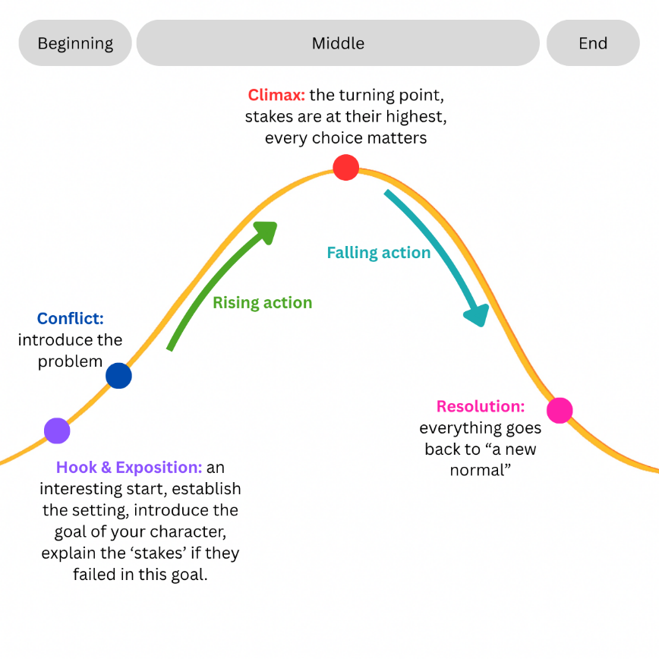
Now it’s your turn to brainstorm by planning three narrative arcs! In your exercise book. Why three? Your first idea might not be your best, so explore different storylines to spark creativity.

Then, select the one you like the most and complete the mapping task over the page.

You can use the suggestions provided on page 31 or create your own — just check with your teacher for approval if you do.
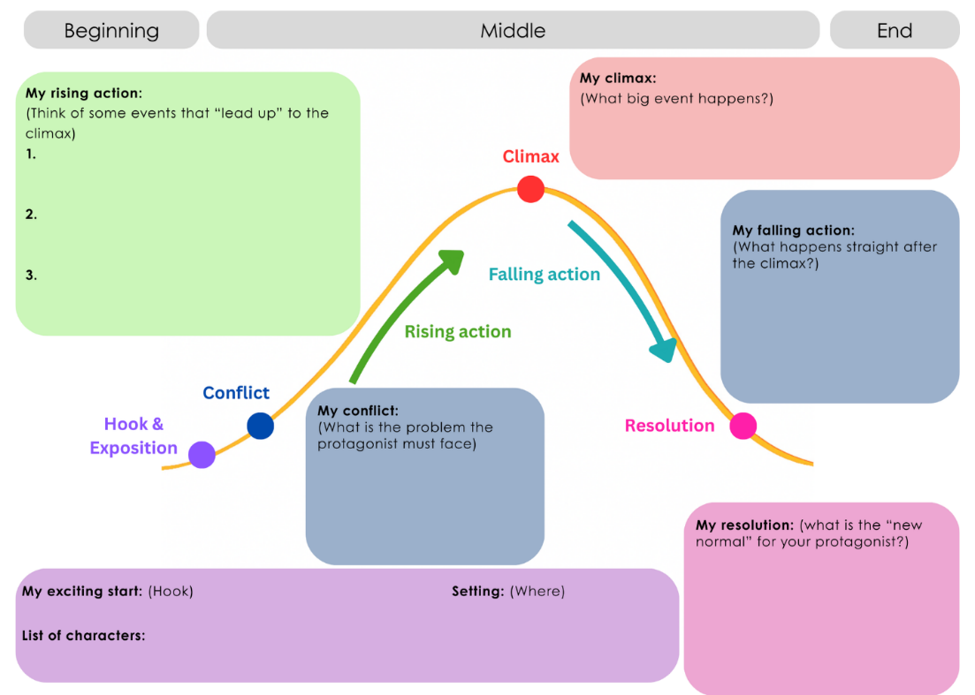
It is highly recommended that the suggestions provided to students (on p. 31 of the student booklet) are used by students.
Students will insert information from their favourite brainstorm into this worksheet (left).
Ultimately, this activity encourages students to consider all the elements of their narrative to ensure that they have a purpose to their writing. They are then prompted to share their idea with a peer or their teacher to receive feedback.

Activity: Now that you’ve selected the narrative you want to write and expanded on your ideas by adding information into your narrative arc worksheet share your plan with a peer or your teacher to get some feedback.

Lessons 10-12
Learning intention: | We are learning to: draft, edit and write a story.
Success criteria | I can:  - draft a story that follows the key features of historical fiction.  - edit a story for accuracy and detail.
Pedagogical Notes:
Depending on how much time you’d like to provide for this activity this could take several lessons. Students are encouraged to draft and edit. A checklist is provided for students when reviewing their work. Their pieces of work can then be marked according to the rubric in this booklet on p. 8.
Student Activities:

Students write their first draft and edit using the checklist below.
- My story has all of the elements of a narrative arc:
  - Hook
  - Exposition
  - Conflict
  - Rising Action
  - Climax
  - Falling Action
  - Resolution
- My story includes information from my research including:
  - a realistic depiction of Melbourne at the turn of the century
  - key words or phrases used during this period
  - sensory details that describe the setting of the story
- My story includes elements of my imagination so that:
  - my story is engaging and interesting
  - my story is unique and not just a retelling of the past
- My story includes accurate punctuation and spelling including:
  - appropriate dialogue (with quotation marks and correct punctuation)
  - proper use of full stops, commas, question marks etc.
  - correct spelling throughout
And there you have it! By completing this unit of work your students have engaged in a variety of skills required to write a compelling and authentic piece of historical fiction. We hope you enjoy teaching it!

