Historical Fiction Writing with Amelia Mellor
To be able to write historical fiction we need to:
- Research what life was like during the historical period we are writing about - this is where we use evidence from the past like historical images and documents.
- Choose which historical details to use in our story from our research – such as historical events or people.
- Decide which parts will be imaginary to make a good story – such as the main character or an interesting problem that needs to be solved.
First, let’s understand the period we are writing about “When” and “Where” – 1890-1910CE Melbourne
What might we expect to see on a city street 120-ish years ago? Jot some ideas down below:

Imagine:
How would you describe the clothes he is wearing? Write some ideas below.
What do you think his job is? What elements from the image make you think this?
How would you describe his personality? Highlight the words that you think best describe him.
Kind | Helpful | Brave | Friendly | Hardworking
Funny | Curious | Bossy | Forgetful | Messy
Annoying | Ruse | Lazy | Mean | Selfish

Creating Characters
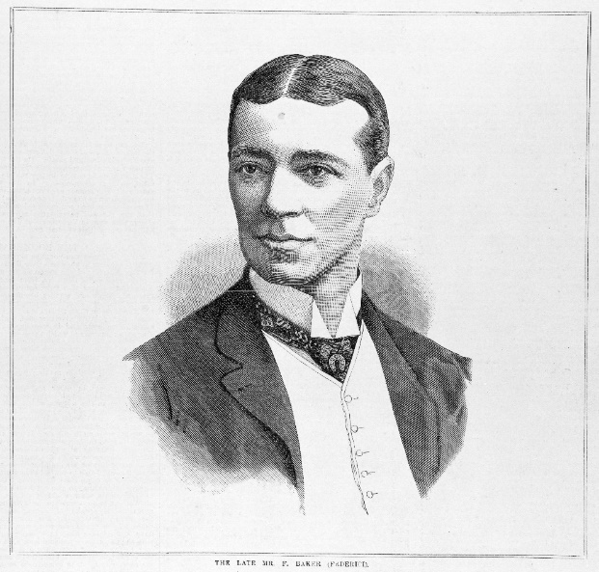
Anonymous (1888) The late Mr. F. Baker (Federici) [picture]. Melbourne: Alfred Martin Ebsworth.
http://handle.slv.vic.gov.au/10381/240413

Research: What information did you find out about this person after Amelia’s description? Write some of the facts down below:
Imagine: How would you describe the clothes she is wearing? Write some ideas below.
What do you think her job is? What elements from the image make you think this?

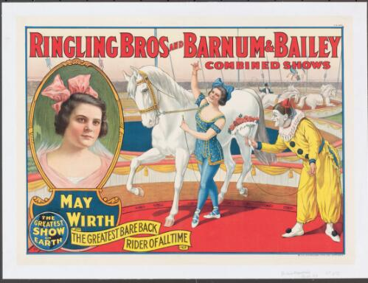
Ringling Brothers Barnum and Bailey Combined Shows. 1919, May Wirth the greatest bareback rider of all time [picture]. https://nla.gov.au/nla.obj-136390630

How would you describe her personality? Highlight the words that you think best describe her.
Kind | Helpful | Brave | Friendly | Hardworking
Funny | Curious | Bossy | Forgetful | Messy
Annoying | Ruse | Lazy | Mean | Selfish

Research: What information did you find out about this person after Amelia’s description? Write some of the facts down below:
Writing Activity: In your workbooks write a scene about this character using both your imagination and evidence from the source.

