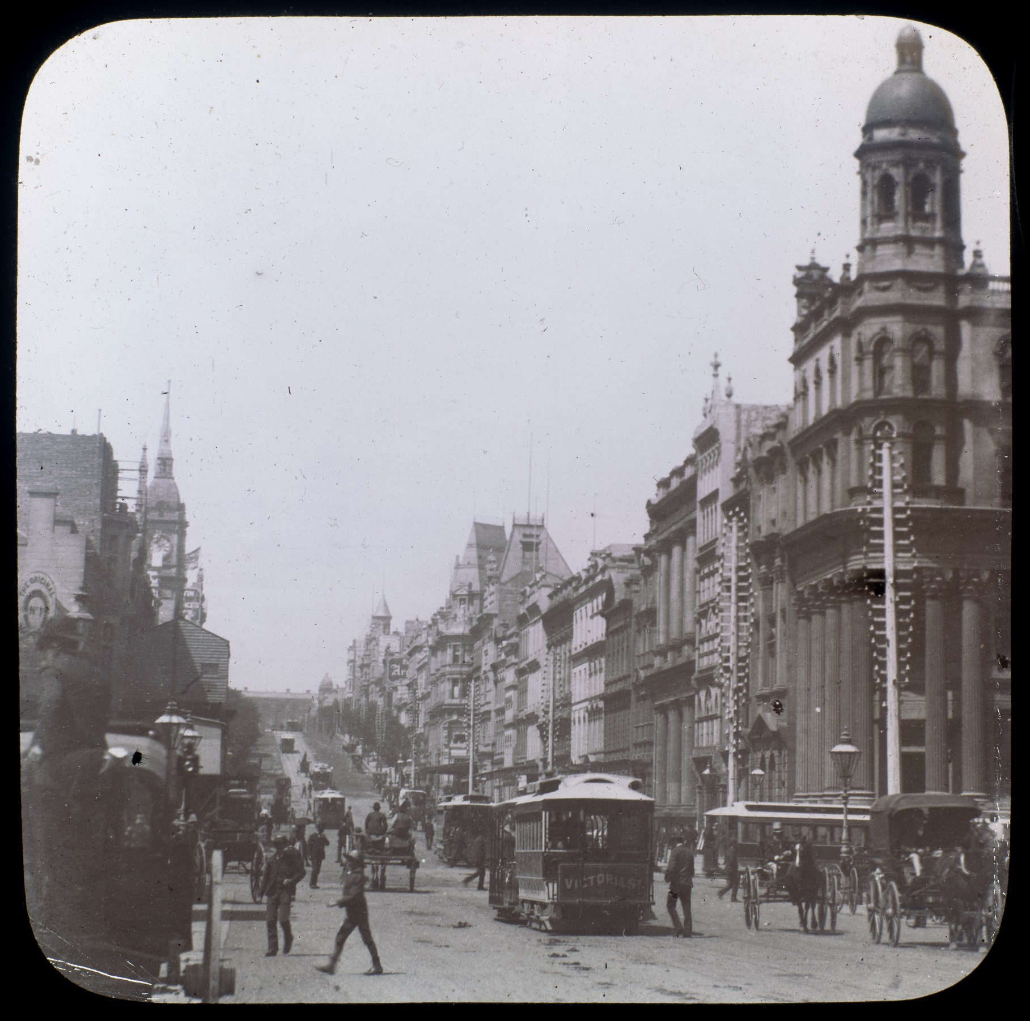
Student Booklet

Historical Fiction Writing with Amelia Mellor


Historical Fiction Writing with Amelia Mellor
Contents
Introduction 4
Lesson 1 4
Lesson 2 7
Lesson 3 9
Lesson 4 12
Lesson 5 15
Lesson 6 19
Lesson 7 219
Lesson 8 23
Lesson 9 28
Lessons 10-12 32

Acknowledgement of Country
State Library Victoria acknowledges the traditional lands of all the Victorian Aboriginal clans, and their cultural practices and knowledge systems.
We recognise that our collections hold traditional cultural knowledge belonging to Indigenous communities in Victoria and around the country. We support communities to protect the integrity of this information, gathered from their Ancestors in the colonial period.
We pay our respects to their Elders, past and present, who have handed down these systems of practice to each new generation for millennia.
Cover image:
Collins Street, Melbourne.
Date [ca. 1890]
Identifier(s) H2016.73/3


Introduction
Welcome to Historical Fiction Writing with Amelia Mellor. In this unit of work, you will be working with Amelia to write your very own piece of historical fiction! Amelia Mellor is the author of The Grandest Bookshop series which explores life in Melbourne at the turn of the 20th century.

Lesson 1
Learning intention: | We are learning to: understand what historical fiction is.
Success criteria | I can:  - explain the difference between fiction and non-fiction.  - identify and explain the key elements of historical fiction.  - describe how historical fiction is different from other types of fiction.
Fiction vs. Nonfiction
When we write there are two distinct categories that our writing can fall into:
Fiction | Non-fiction
Writing is made up or created from your imagination.  Involves the invention of characters, settings and narrative complications that the writer created.  Typically used to entertain and explore themes.  Comes in many genres (for example, science fiction, crime, fantasy, romance). | Writing explores factual stories based on real people, information or events.  Uses information about real events, people and places (facts).  Typically used to inform and relay accurate information that can be fact-checked.  Can be written in many forms such as books, essays, articles, research papers and textbooks.
But where does historical fiction fit?
In short, historical fiction is a genre of fiction. Historical fiction is a tricky one because you use facts just like non-fiction writers do. However, you create a story from your imagination using those facts. In other words, although you use information from the past, such as historical events or people, the story you write is from your imagination.

Activity: Let’s check your understanding of what makes a text historical fiction by circling which of the following statements are true:
Historical fiction is a type of non-fiction because it uses facts. | Historical fiction uses accurate details from history, but the story is based on the author’s imagination.
Historical fiction stories can include real people from history and fictional characters. | To write historical fiction, you don’t need to do any research, you just make it up.

Activity: Have a look at the examples of well-known stories over the page. Identify which are historical fiction and which are not.

Stories: | Yes/No
Percy Jackson and the Lightning Thief – A boy discovers he has magical powers inherited from his father, the Ancient Greek god of the sea, and attends a school camp for demigods.
The Book Thief - Set in Nazi Germany during World War II in the 1940s. This story, narrated by the spirit of Death, follows a young girl who steals books and discovers the power of words.
The Wild Robot - After climate change transforms society and the environment, a lost robot learns to survive on an island inhabited only by wild animals.
The Silver Donkey - A soldier from World War I (1914-1918) is found in the woods by two children in France. He tells them stories while they help him return home.

Historical Fiction is framed by the past:
A key part of historical fiction writing is to use evidence from the past to enrich the story. This evidence is found by reading source material. Sources come in two forms, primary and secondary.
Primary sources are items or writings from the time, about the time. They can be photographs, diaries, film footage, letters, works of art, interviews, newspapers, artefacts, and more. Secondary sources are different because they are about the time, but not from that time. For example, textbooks, historians’ writings, documentaries, some artwork and more.
Throughout this unit of work, you will be exploring both primary and secondary sources, using these as inspiration for your writing. Let’s make sure we understand the difference between them.

Activity: Identify sources that are Primary or Secondary sources from the examples below by drawing a line to their correct category.
Hint: The easiest way to know if something is a primary or secondary source is to find out the date it was made.

PRIMARY SOURCES
SECONDARY SOURCES
A coin from Ancient Rome dated to the 1st century
A modern textbook on Ancient Egypt
A piece of pottery from the year 600CE
A webpage about Melbourne in the 1920s

A book written in 1980CE by a historian about life on the Victorian goldfields
A newspaper article from 1930
A letter about life in Melbourne in 2010

But what do I do with the sources once I find them?
To successfully immerse your reader in the past, you need to research before writing. Unlike other types of fiction, this kind of story relies on real historical details.
What period will I be learning about for my piece of historical fiction?

The period you will be setting your narrative in is the turn of the century, around 1890-1910CE. The place you will be setting your narrative is Melbourne. But what did Melbourne look, feel, sound or even smell like at this time?
Activity: Have a guess and draw an image of what you think Melbourne would have looked like over 130 years ago:

By using your imagination, you have drawn what you think Melbourne would have looked like at the turn of the century. But remember, historical fiction writing is about being inspired by historical sources. Next lesson you will look at some historical sources from the turn of the century in Melbourne to help inspire your writing.

Lesson 2
Learning intention: | We are learning to: understand what life was like in Melbourne during the turn of the century.
Success criteria | I can:  - use evidence from sources to depict what life was like in Melbourne in 1890-1910.

What was life like in Melbourne at the turn of the century?
Last lesson you created a picture of what you think Melbourne looked like at the turn of the century. In this lesson, let’s find out how accurate that drawing was!

Activity: Listen to your teacher read out a secondary source describing what Melbourne was like at the turn of the century. As you are listening, write down information in the brainstorm below answering the question – What was life like in Melbourne at the turn of the century?

What was life like in Melbourne at the turn of the century?



Activity: As a class, watch footage from 1910 exploring life in Melbourne. These clips are from a documentary titled, Marvellous Melbourne: Queen City of the South. It is the oldest surviving documentary of Melbourne.
Q: Why is there no sound?
A: Films at this time were silent.
Add anything new to your brainstorm about what Melbourne was like at the turn of the century from this documentary.
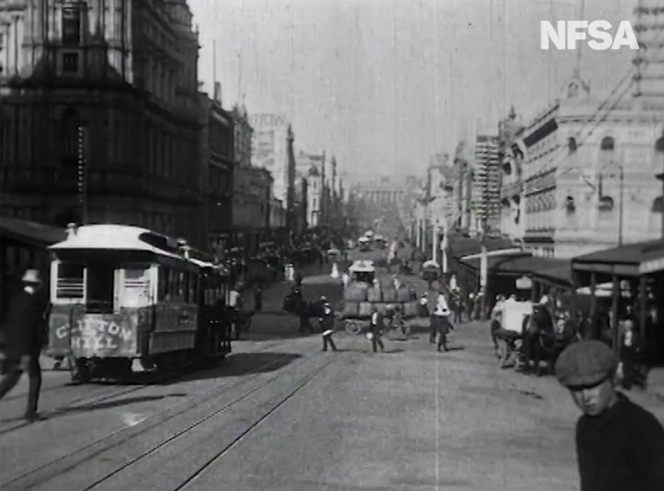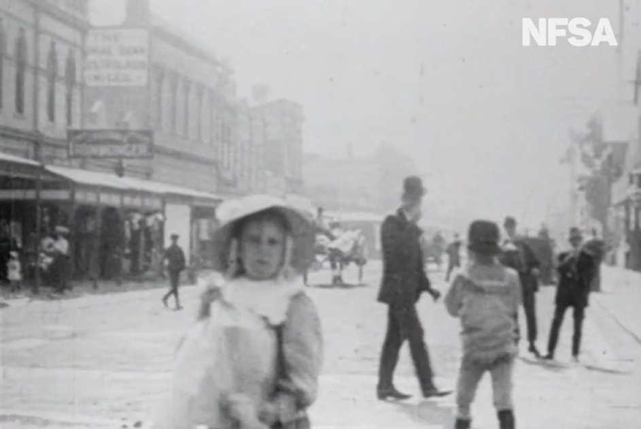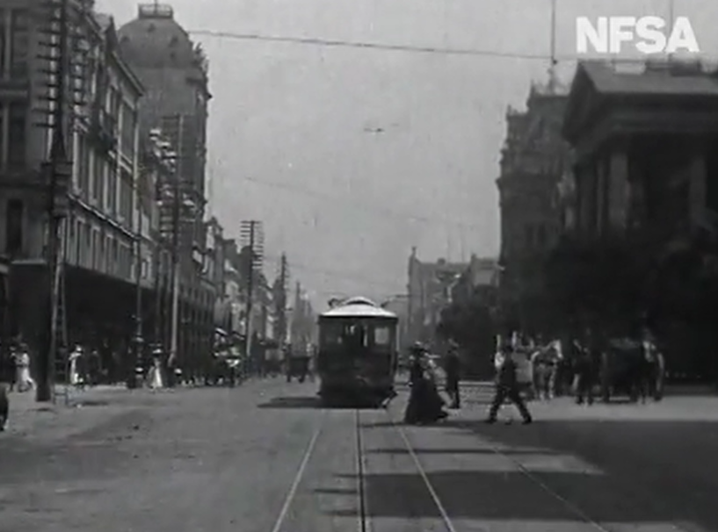
Images from Marvellous Melbourne: Queen City of the South, 1910CE.

Classroom Discussion: Have another look at the drawing you created in lesson 1. How realistic was it? Did you have anything important missing? Did you include things that weren’t in Melbourne at the time? Share with your class.
Activity: Have another go and use the evidence you found from the sources to redraw what Melbourne would have looked like at the turn of the century using both your imagination and your research.


Quick Write Task 1: Imagine you have a time machine and you’ve gone back to Flinders Street in 1910. Using your picture above as inspiration, in your exercise books write a short passage describing your environment as you walk down Flinders Street. Think about all your senses (see, hear, taste, touch, smell).
Optional sentence starters: As I walk along Flinders Street, I feel…/The sound of…/Looking up I see…

Lesson 3
Learning intention: | We are learning to: investigate sources, making connections to common themes.
Success criteria | I can:  - recall what life in Melbourne was like at the turn of the century.  - analyse sources for key information.  - make connections between sources and identify common themes.
Recap
Activity: Think about last lesson, what do we know about life in Melbourne at the turn of the century? List three things you remember below:

Inspiration for your story:
Hello, I’m Amelia! I’m so excited to be working with you to write your own piece of historical fiction.
When I was writing The Grandest Bookshop I completed a lot of research. So much, in fact, that I have two topics I didn’t include in my series that you get to use for your writing. But these topics are a surprise! I want to see if you can investigate the sources like a detective before I reveal the topics.

Activity: Your teacher has a collection of sources. You will be assigned one of these sources to investigate further by answering the questions assigned to that source. Once your teacher has handed you the source, glue it into your booklet on the next page and then answer the questions.

Glue in your Primary Source worksheet here

Activity: Now, find three other people that have the other sources in your collection (see groups below). As a team finish the following sentence: We think the connection between the sources is…

Collection 1:
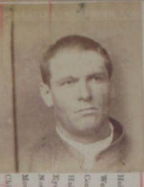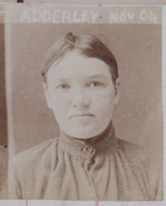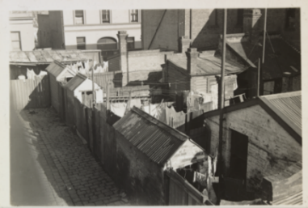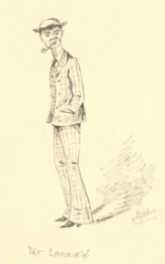
Collection 2:
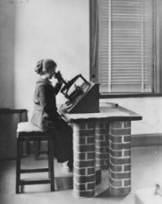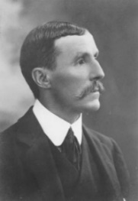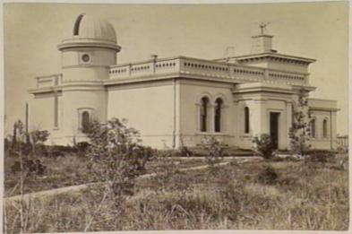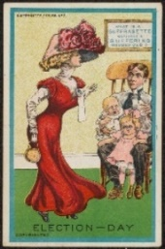

Classroom Discussion: Why was this task difficult? What information were you missing?


Being a detective:
Researching the past is a bit like being a detective. Even though you've made a guess about what the topic might be, you can't be sure this is right because you haven’t been given the context of each source. Context is the word we give to all the things that help explain why the source exists.
This means understanding what the source is about, the ideas it reflects, and how it helps you make sense of the society the source came from. By uncovering the context of each source, you’ll be able to piece together the bigger picture, and ultimately, figure out the topic your sources are exploring.
But that’s for next lesson!

Lesson 4

Learning intention: | We are learning to: identify the context of our sources to understand what life was like in Melbourne at the turn of the century.
Success criteria | I can:  - identify key information about the context of my source.  - identify a common topic.  - use contextual information to write a paragraph of historical fiction.
Welcome back! Last lesson you examined a collection of sources in a group and guessed a topic that connected them all together. This lesson you are going to find out what that topic is.

Classroom Discussion: What topics do we think the sources highlight? How different are our ideas? What information is missing?
Activity: Unscramble the letters below to find out what information you need!
Cstr trex tiHon ilcao
_ _ _ _ _ _ _ _ _ _ _ _ _ _ _ _ _
Activity: Your teacher has the information you need! Follow their instructions and glue the worksheet on the next page.

Classroom Discussion: Now that you know the historical context of your sources, discuss as a class what new information you have that helps refine your guess about your topic. Once your teacher has confirmed the topic, write it below:

Glue in your worksheet here

Quick Write Task 2: Now that you know your topic and have a strong understanding of your source material, brainstorm what you would hear, smell, see, and feel below in the location of your topic (i.e. the setting of your story).
- Crime & the Crutchy Push: North Melbourne Slums
- Women & Science: Melbourne Observatory

What do you hear:
What do you smell:
What do you see:
What do you feel:
In your exercise books, use the information you wrote down in the sensory table, to write a paragraph describing a day in the life of someone in Melbourne at the turn of the century at that location.
Optional sentence starters:
The streets are filled with the smell of… | The morning air feels... | In the distance, I notice…
I catch sight of…and it reminds me of | The feel of…makes me think | Around me, I can hear
How did you go? Now that you have an understanding of the historical context of your piece of writing, you are ready to start thinking about your characters!

Lesson 5
Learning intention: | We are learning to: know how to create interesting characters.
Success criteria | I can:  - explain the difference between a protagonist, antagonist and deuteragonist.  - develop characters that have clear motivations and personalities.
What is your character like?
In this lesson you are going to explore what makes an interesting character when writing historical fiction. But first, let’s use our imagination to describe the personalities of the people we’ve researched so far…

Activity: Collect your character personality worksheet from your teacher and describe the personality of the characters from your research. You can use the word bank if you wish.
Kind | Helpful | Brave | Friendly | Hardworking | Forgetful | Messy
Funny | Curious | Bossy | Lazy | Strong | Mean | Selfish

Glue in your “Character Personality” mini-worksheet here

When we are writing characters, we need to consider the role they will play in the narrative. For your story, you will have a protagonist and a deuteragonist. You may also include an antagonist.
Character type: | Definition:
Protagonist | The main character in a story. The story is mostly about them and what they want or need.
Antagonist | The character or idea that tries to stop the protagonist from doing what they want or need, causing problems or challenges that the protagonist must overcome.
Deuteragonist | A supporting character to the protagonist. They are someone close to the protagonist. For example, a friend or family member.

Extension: A deuteragonist can be assigned a specific trait such as,
- Foil: A character that is very different from the protagonist - it helps to show what makes the protagonist special.
- Confidant: A character that the protagonist trusts and talks to about their thoughts and feelings; they know they can share their inner most secrets.
Activity: Fill in the blanks to see if you know the difference between the three character types.

Word Bank: protagonist antagonist deuteragonist stop challenges close
- The _______________ is the central figure in a story. The plot mostly follows what they do and what they are trying to achieve.
- The ______________ is the person or force that tries to __________ the main character from reaching their goal. They often create problems or _____________ along the way.
- A _____________ is someone who is ______________ to the main character, like a friend or family member. They help support the ______________ on their journey.

Building the protagonist and deuteragonist:
Your protagonist and deuteragonist for your story have been chosen for you from the sources. It is up to you to make up an antagonist (this is explored in more detail below). Although you have information about your protagonist and deuteragonist from your research, there is still a lot of information missing. This is where your creativity comes in!
Activity: Your teacher will hand you a worksheet focused on your topic. Fill in the worksheet about your protagonist and deuteragonist using inspiration from your research and your imagination.

Glue in your “character brainstorm” worksheet here

Building the antagonist:

Remember the antagonist is normally a character that holds an idea or value that works against the protagonist.
Activity: Find other people in your class writing on the same characters as you. As a group brainstorm some possible characters that might challenge the goals of your protagonist. Then select one of these ideas.
Develop your antagonist further by completing the table below. Don’t worry, this is just a draft of ideas, you can always change your mind later. Generate as many ideas as you can, then circle the one you like the best!
What is the name of your antagonist? What do they look like? | What is their occupation? Or, what do they “do” on a daily basis? | How do they relate to the protagonist – i.e. what relationship do they have with the protagonist? | What values or beliefs are important to them? Are those common or unusual for their time?

Imagine your antagonist:
Activity: Now it’s time to draw what your antagonist looks like. It can be a profile image focusing on their face or a full body image. Think about:
- What is the colour of their eyes and hair?
- What style of hair do they have? How does this reflect the time they are from?
- What clothes are they wearing? How do the clothes reflect the time they are from?
- What facial expression do they have? How does this reflect their personality?

Lesson 6
Learning intention: | We are learning to: connect historical evidence with an imaginative idea.
Success criteria | I can:  - unpack historical sources to understand an event.  - creatively write about an event, adding details from my imagination.

Historical Fiction Writing – An Educated Guess
Historical fiction authors can’t get every detail ‘accurate’ because many details are lost to time or are impossible to know. Although accuracy is important to make the historical setting come to life, telling an interesting story is also important.
In this lesson you will follow Amelia as she explains how she used source material to write her book, The Bookseller’s Apprentice. First, let’s hear from Amelia about why she likes writing historical fiction.
When Amelia was researching this book, she came across an article in The Argus, a daily morning newspaper that was published in Melbourne from 1846 to 1957. This article described a fire that destroyed the Haymarket theatre on Bourke Street in 1871.
Activity: Amelia is going to read this article out to you. As she is reading the article, note down some key details of the fire.

Historical Fiction in action:
Activity: Now, you are going to watch a reading of The Bookseller’s Apprentice that depicts this very event!
What information did Amelia use from the source in The Bookseller’s Apprentice? Write down any details that came from The Argus article and note down anything that was different or new.
Activity: Now, watch Amelia explain the information she selected from the source and the changes she made for her story.
Classroom discussion: In your opinion, when writing historical fiction, which matters more - staying true to the historical record or allowing creativity to shape the story?

A note on descriptive language:
What you probably noticed about the language in the article, and in Amelia’s book, is that it had a lot of descriptive language. Descriptive language is when a writer uses words that help the reader see, hear, feel, smell, or taste what is happening. It paints a picture in your mind and makes the story feel more real and exciting. It is important in storytelling because it helps the reader feel like they are really there experiencing the story. It makes the characters, places, and events come alive instead of just being plain facts. Make sure to include this type of language in your writing to help it come alive.

Quick Write Task 3: Using the Haymarket scene as an example, imagine that you go back in time to the day of the fire and you’re watching the scene unfold. In your exercise books, describe the scene in a paragraph exploring what you see, hear, feel, smell or taste.
Note: If you get stuck, listen to Amelia read her section again to get some inspiration for the words you can use. Some sources are also located below to help you.

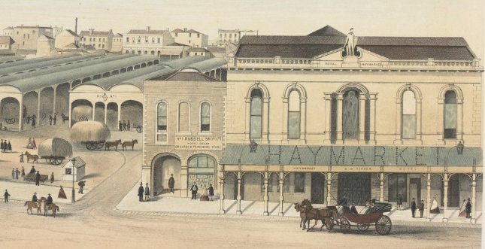
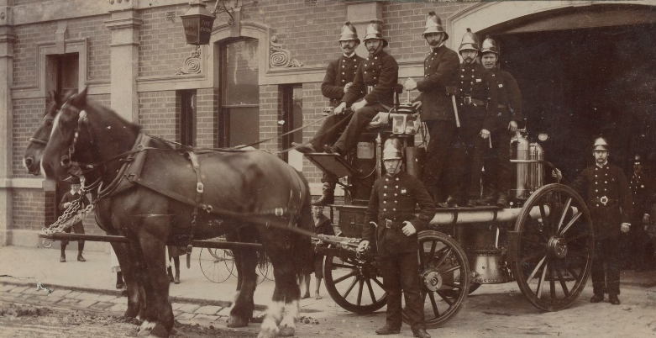

Illustration of the Haymarket theatre from 1864.
Collingwood horse-drawn fire engine from 1898.

Lesson 7
Learning intention: | We are learning to: analyse historical sources as inspiration for our writing.
Success criteria | I can:  - identify key information from a source and brainstorm how I could use this information creatively.  - use facts to help me decide on the type of story I am going to tell.
Now it’s your turn to analyse a source to help you write a scene for your story, just like I did for the Haymarket fire. Your teacher will provide you with the source. Use the instructions below to help you annotate and understand the source.

Instructions:
First, read through the source to understand what it is about.
Then, read through the source a second time and highlight the key information that helps explain why someone wrote the article.
Finally, read through the source one more time and circle the pieces of information you think you might include in your story.

Paste in your source here
(You will need to fold it to fit)

Using the table below write down some ideas for how you could incorporate your research and your imagination to come up with a story idea. Remember, you already have your characters and your setting, now you need to think about an event you could base your story around (it can be something from your article):
Information I have from my article that I might put into my story: | Creative or imaginary ideas that have been inspired by the article that I might put in my story:

Lesson 8
Learning intention: | We are learning to: understand language from the turn of the century and how to write dialogue
Success criteria | I can:  - explain how the language at the turn of the century was different to today.  - write dialogue using appropriate expressions and words from the turn of the century.
What did Melbournians at the turn of the century sound like?
You’ve done all your research — you know what Melbourne looked like and how people lived at the turn of the century. You can also describe your setting and have a detailed protagonist, deuteragonist, and antagonist created. But here’s something you might not have thought of: do you know how they spoke?
People back then didn’t talk quite like us. Language was usually more formal, social expectations and manners were very different, and some of their words and expressions have fallen out of use today. If you want your characters to feel real, they need to sound like they belong to their time. For example, instead of saying, “Okay, cool, thanks” or “Sounds good”, a Melburnian in 1900 might say something more like, “That will do nicely, thank you,” or “Capital” (meaning “excellent”). One of the biggest differences was how they addressed one another. Last names were mainly used between everyone except family and very close friends. It was also polite to call people ‘sir’ or ‘madam’ - which can seem quite cold and unfriendly to Australians today.
It’s difficult, though, to know how they spoke when you don’t have many examples. So, let’s review some of the sources we’ve looked at and write down some examples of words we wouldn’t use today but were in our articles.
Activity: As a class complete a brainstorm listing all the different words or phrases used in your articles that we don’t use in our everyday speech – make sure to define the words you don’t know. Two examples are provided from the article on the Haymarket Fire.

Premises – building/land
Watchman – A guard

Do any interesting words or phrases stand out from the article that
we don’t really use in regular conversation today?


Activity: Your teacher has a copy of some language and expressions that could come in handy when writing your story. Stick this in below, then complete the activity on the worksheet and decode the sentences!

Paste in your language and expressions
sheet here (you will need to fold it)

Writing dialogue in stories:
Dialogue is the word we use for any speech that is included in a text.
This can include:
- Things that characters say to each other
- Things that characters say to themselves (inside their head, if they are talking to themselves)
In novels, we can tell it is dialogue because it will have quotation marks.
1. Everything that someone says is put in quotation marks.
For example: “I can’t believe it!” exclaimed Maria or “If only I’d listened to Bob,” grumbled Barry.
Activity: Add the quotation marks to the following sentences.
- I’m so excited to see the fireworks tonight Emily said.
- Do you really think that’s a good idea Liam asked.
- I wish I could eat a mountain of chocolate Sara sighed.

2. Vary your speech tags.
Don’t just use “said” i.e. “he said/she said/they said”. Making your character say things in different ways can help the reader understand the motivations of your characters and the way they feel.
Include other emotive speech tags like the ones below:
Neutral | Happy/Excited | Sad/Quiet | Angry/Strong | Uncertain/nervous
replied | exclaimed | muttered | yelled | stuttered
asked | laughed | sighed | snapped | stammered
added | cried (i.e. shouted) | mumbled | growled | blurted
remarked | gushed | sobbed | grimaced | doubted
stated | cheered | whispered | demanded | wavered

Activity: Rewrite the sentence below three times changing the speech tag:
“I’m so excited to see the fireworks tonight,” Emily said.
Did you notice how the sentence changed meaning with each new speech tag? Maybe Emily whispered in one and shouted in the other, maybe she mumbled and was being sarcastic. This is why writing more than just ‘said’ can be helpful.

3. Include action with some of your speech tags to help with the pacing and descriptive writing in your story.
Although it’s fine to write:
“I don’t believe you,” she said.
You can include action words to highlight how the character feels or what they are doing as they speak, replacing the speech tag altogether.
“I don’t believe you.” She crossed her arms and glared at me.
The above example doesn’t include a speech tag; you can still include a speech tag if you think it “feels right” in your writing. What you will notice is the actions can make the same dialogue have a different feel (or tone). For example:
“I don’t believe you,” she said, laughing and staring at me in wonder.
Has a very different feel to:
“I don’t believe you.” She crossed her arms and glared at me.
Activity: Have a go at rewriting your three sentences above adding action to the sentence. You can remove the speech tag entirely (like the first example above) or keep it in (like the second example).

3. Punctuation of dialogue is important.
There are some set rules when writing dialogue with regards to punctuation. See the list below:
- If you are adding a speech tag, use a comma, not a full stop, inside the quotation marks.
For example: “I wish I lived in a house made out of chocolate,” Sara said.
- When a speaker changes, move the dialogue to a new line.
For example:
“I wish I lived in a house made out of chocolate,” Sara said.
“Me too,” Maree sighed, imagining a house full of chocolate furniture.
Activity: Have a go at rewriting one of your sentences above and have another character respond. Make sure you use the above dialogue punctuation rules.
Quick Write Task 4: Imagine your protagonist is having a discussion with their deuteragonist. It can be about anything you like, or you can use the examples below. Using the vocabulary supplied by Amelia that you stuck in your booklet, write a piece of dialogue in your exercise books between the two characters. Make sure to consider the tips for writing dialogue in stories.
Prompt 1: Valentine Keating and Harriet Adderley have a chat about the Terrible Ten.
Prompt 2: A female computer and Pietro Baracchi are discussing a fascinating collection of stars identified by a Repsold Machine.

Lesson 9
Learning intention: | We are learning to: understand what makes an effective story
Success criteria | I can:  - list the different parts of a narrative.  - explain what the setting is and its role in “setting up” the story.  - identify a problem that my story will focus on resolving.

Activity: It has been a little while since you wrote about your characters. If you had to describe your characters in one sentence, what would you write?
My protagonist is…
My deuteragonist is…
My antagonist is…
What makes a strong narrative?
When you are writing your story, you will also need to consider the “bones” of the story. What will happen in the story? What will the ending look like?
This can be really difficult to do because you have so many ideas you want to put down on paper. By focusing on one idea, you will be able to have a strong narrative that has a satisfying ending.
The Narrative Arc:
For this task you will be writing one short story. But how do you write a compelling story? Let’s have a look at the following clip to see what Amelia suggests.
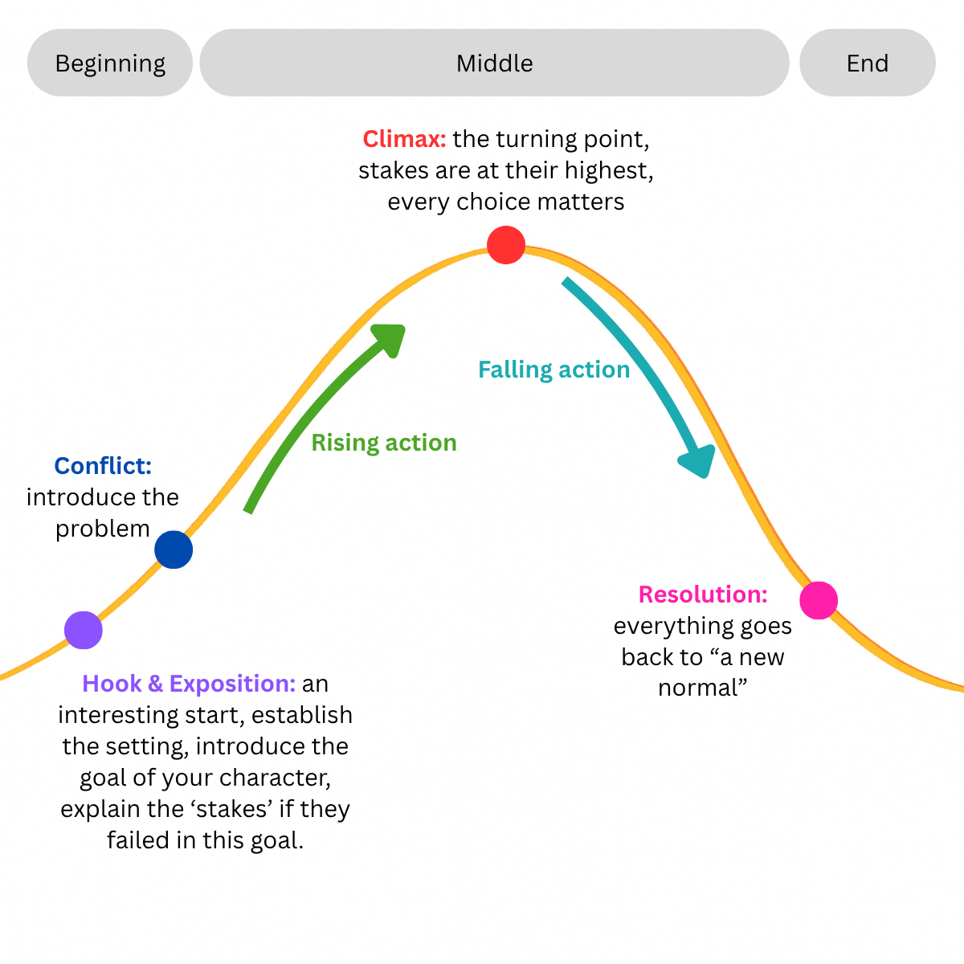
Now it’s your turn to brainstorm by planning three narrative arcs! In your exercise book. Why three? Your first idea might not be your best, so explore different storylines to spark creativity.

Then, select the one you like the most and complete the mapping task over the page.

You can use the suggestions provided on page 31 or create your own — just check with your teacher for approval if you do.

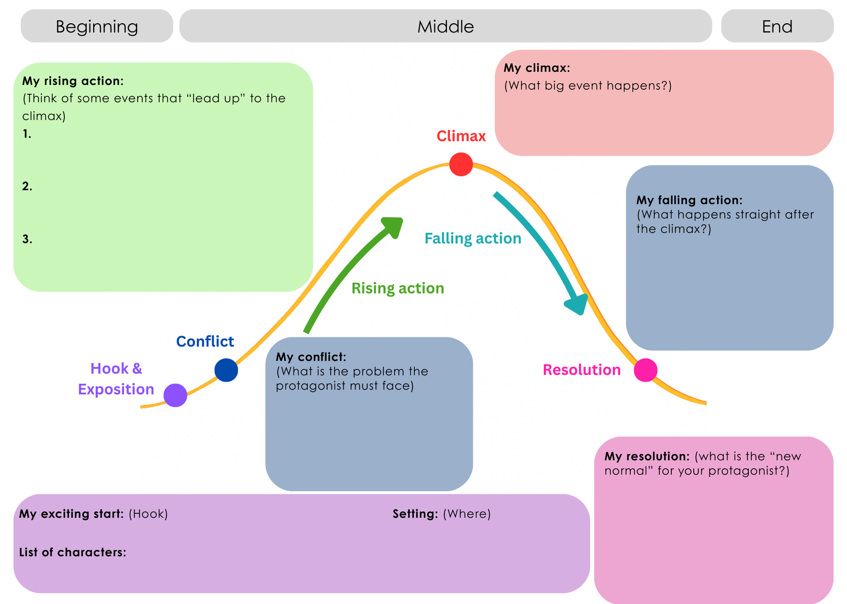

Narrative ideas for your story:
Poverty, crime and the working class – The Crutchy Push
- The Initiation – As a 16-year-old boy in 1895 (who perhaps has lost his leg in an accident recently), Valentine Keating decides to join the Crutchy Push. He has to prove himself to the older lads and men by doing something daring or dangerous.
- Larrikin and Donna – The imperfect love story of Valentine Keating and Harriet Adderley. How did they meet? Did they get along at first? What made them fall for each other?
- Raid Gone Wrong – Valentine Keating and his mates in the Crutchy Push plan a raid on a certain person or business. Things go terribly wrong. For example, they could run into another gang, a group of off-duty or undercover police, or someone who is a very accomplished fighter (e.g. a professional boxer, Olympic fencer, or even an old lady with a lot of hat pins – a popular weapon for women’s self-defence). In the end, Valentine might escape or might almost escape but then get caught.
Role of women in the workforce and scientific endeavour – Female Computers at Melbourne Observatory
- A Peek at the Universe – A young woman or teenage girl who works at the Observatory decides to sneak into the telescope house to view the stars for real, instead of just as pictures on the glass plates. Then she gets caught! Will the astronomers punish her, or truly understand her passion for space at last?
- Suddenly Promoted – One of the male assistant astronomers calls in sick one afternoon. Pietro Baracchi, the eager and kindly Government Astronomer, needs a replacement for that night’s work fast. He chooses one from among the six star measurers at the Observatory. How will she convince Mr Baracchi to keep her on as his assistant?
- A Most Peculiar Discovery – A pair of star measurers who work together discover something unusual on one of the astrographic photo plates – perhaps a new comet, or even an alien spacecraft! (The idea of people living on Mars was in the popular imagination at this time, helped along by books like The War of the Worlds.) How will these women convince their colleagues and bosses to take their unusual discovery seriously?
A note on the ending of your story (your resolution):
These are off the table because they are not resolutions. They just end the story or break it off – they don’t solve the characters’ problems or answer the readers’ questions. How to get around this? Make sure you have a clear conflict that can be resolved.

Amelia has three kinds of endings that are “not allowed”. These are:
- It was all a dream. (Including ‘or was it?’)
- Everyone suddenly dies.
- To be continued.


Get some feedback!
Activity: Now that you’ve selected the narrative you want to write and expanded on your ideas by adding information into your narrative arc worksheet, share your plan with a peer or your teacher to get some feedback. They can see if you have a clear complication, a strong resolution or if you’ve included enough detail about your characters in the exposition. They might see something that you’ve missed.

Lessons 10-12
Learning intention: | We are learning to: draft, edit and write a story.
Success criteria | I can:  - draft a story that follows the key features of historical fiction.  - edit a story for accuracy and detail.

What is a first draft? Why draft?
A first draft is the very first version of your story. It’s where you get all your ideas down on paper — even if they’re not perfect yet. Think of it as building the bones of your story - you’re just trying to start. We draft because good writing doesn’t usually happen all at once! Drafting lets you:
I can’t even remember how many drafts I did of Bookseller’s Apprentice…
- Get your ideas out of your head before you forget them.
- See what works and what doesn’t in your story.
- Make mistakes — and then fix them later.
- Improve your story by adding more details, fixing problems, and making it more exciting.
In your exercise books, it’s time to write your first draft!

Why is editing important when writing a story?

Editing is how you turn your good story into a great story. That is why authors, like Amelia, have editors. Editors help the author make their story clearer, fix any mistakes and make the characters and overall plot stronger.
Activity: Use the checklist below to help you edit your piece of historical fiction. Go back over your draft with a different colour pen to show your edits.
- My story has all of the elements of a narrative arc:
  - Hook
  - Exposition
  - Conflict
  - Rising Action
  - Climax
  - Falling Action
  - Resolution
- My story includes information from my research including:
  - a realistic depiction of Melbourne at the turn of the century
  - key words or phrases used during this period
  - sensory details that describe the setting of the story
- My story includes elements of my imagination so that:
  - my story is engaging and interesting
  - my story is unique and not just a retelling of the past
- My story includes accurate punctuation and spelling including:
  - appropriate dialogue (with quotation marks and correct punctuation)
  - proper use of full stops, commas, question marks etc.
  - correct spelling throughout

Now you are ready to re-write your story with your edits!
Well done, you’ve written an engaging piece of historical fiction.
I wish I could read it!
How about you share it with a friend or family member?
I’ve enjoyed helping you write this story, and I hope you continue writing in the future.
Amelia

