Historical Fiction Writing with Amelia Mellor
Teacher Booklet Appendices

Contents:
Appendix 1 – Primary Source worksheets and answers pp. 2-12.
Appendix 2 – Gallery walk information sheets pp. 13-20
Appendix 3 – Gallery walk student worksheets and answers pp.21-24
Appendix 5 – Character mini-worksheet p.25
Appendix 6 – Character brainstorm worksheet pp.26-27
Appendix 7 – Extension Activity: Haymarket Fire Source Analysis pp. 28-31
Appendix 8 – Sources for Story pp.32-35
Appendix 9 – Language and Expressions for each story pp.36-39

Primary Source worksheet 1:
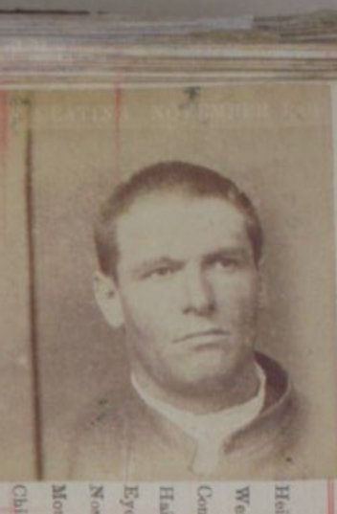
Step 1: Write down anything you notice about the source as a brainstorm below:

Step 2: Divide the source into four equal sections (2x2 grid). Look at the details in each section. Is there anything “new” that you didn’t notice in step 1? The smallest detail could help you figure out what the source is. Add any new information above.

Source: Victorian Government, (1904). “Image from the Central Register for Male Prisoners: Prisoner 30591” (Page 255). Accessed via Public Records Office of Victoria database.

Step 3: Read the information underneath the source and answer the questions below:
When was this source created? (Date)
Who created this source? (Author)
What type of source is it?

Why do you think this source exists? What was its original purpose? What makes you say this?

Step 4: Do you have any question/s about the source that could be answered with further research? Write them down here (these will be answered next lesson):

Primary Source worksheet 2:
Step 1: Write down anything you notice about the source as a brainstorm below:

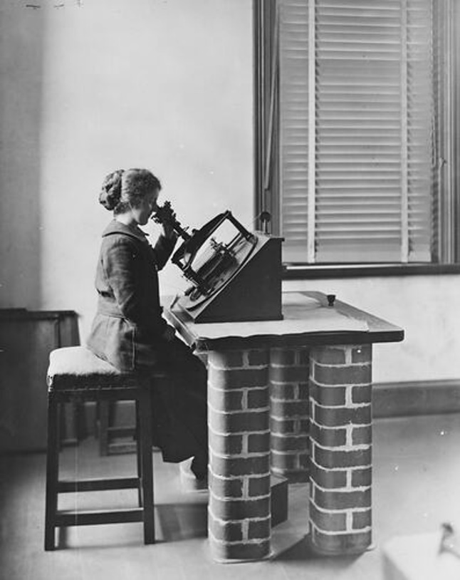
Source: Photographer Unknown, (c.1905). “An assistant ‘computer’ working on the Astrograph Project, Melbourne Observatory” Accessed via Museums Victoria.
Step 2: Divide the source into four equal sections (2x2 grid). Look at the details in each section. Is there anything “new” that you didn’t notice in step 1? The smallest detail could help you figure out what the source is. Add any new information above.

Step 3: Read the information underneath the source and answer the questions below:
When was this source created? (Date)
Who created this source? (Author)
What type of source is it?

Why do you think this source exists? What was its original purpose? What makes you say this?

Step 4: Do you have any question/s about the source that could be answered with further research? Write them down here (these will be answered next lesson):

Primary Source worksheet 3:
Step 1: Write down anything you notice about the source as a brainstorm below:

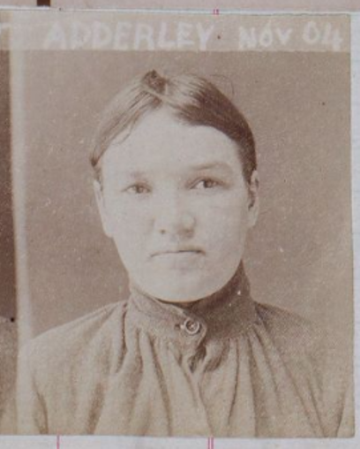
Source: Victorian Government, (1904). “Image from the Central Register of Female Prisoners: Prisoner 6931” (Page 18). Accessed via Public Records Office of Victoria database.

Step 2: Divide the source into four equal sections (2x2 grid). Look at the details in each section. Is there anything “new” that you didn’t notice in step 1? The smallest detail could help you figure out what the source is. Add any new information above.

Step 3: Read the information underneath the source and answer the questions below:
When was this source created? (Date)
Who created this source? (Author)
What type of source is it?

Why do you think this source exists? What was its original purpose? What makes you say this?

Step 4: Do you have any question/s about the source that could be answered with further research? Write them down here (these will be answered next lesson):

Primary Source worksheet 4:
Step 1: Write down anything you notice about the source as a brainstorm below:

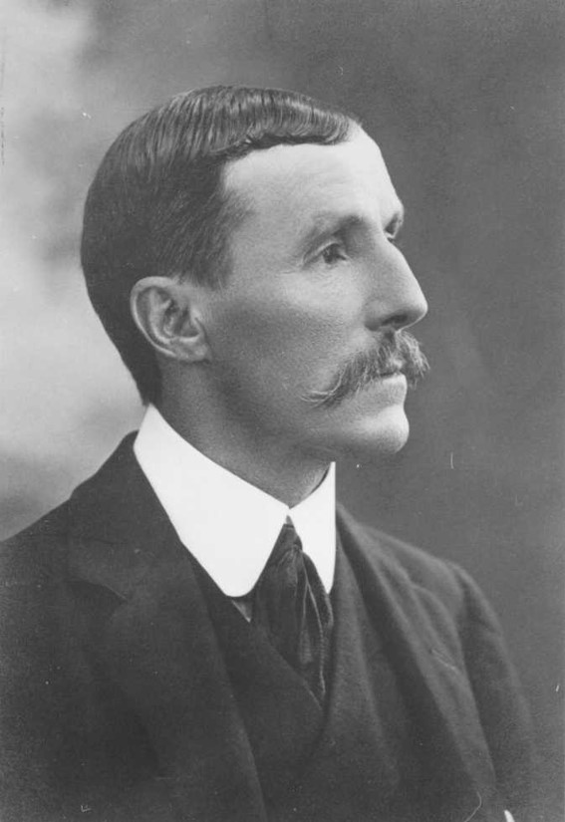
Source: Royal Society of Victoria, (1904). “Presidential Portrait Baracchi, Pietro Paolo Giovanni Ernesto” Accessed via Encyclopedia of Australian Science and Innovation.

Step 2: Divide the source into four equal sections (2x2 grid). Look at the details in each section. Is there anything “new” that you didn’t notice in step 1? The smallest detail could help you figure out what the source is. Add any new information above.

Step 3: Read the information underneath the source and answer the questions below:
When was this source created? (Date)
Who created this source? (Author)
What type of source is it?

Why do you think this source exists? What was its original purpose? What makes you say this?

Step 4: Do you have any question/s about the source that could be answered with further research? Write them down here (these will be answered next lesson):
Primary Source worksheet 5:
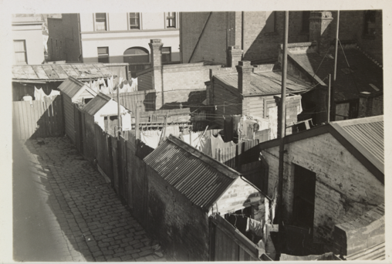
Source: Barnett, F.O., (1935). “Fitzroy Slums”. Accessed via State Library Victoria.

Step 1: Write down anything you notice about the source as a brainstorm below:

Step 2: Divide the source into four equal sections (2x2 grid). Look at the details in each section. Is there anything “new” that you didn’t notice in step 1? The smallest detail could help you figure out what the source is. Add any new information above.

Step 3: Read the information underneath the source and answer the questions below:
When was this source created? (Date) |  | Who created this source? (Author)
What type of source is it? |  | Why do you think this source exists? What was its original purpose? What makes you say this?

Step 4: Do you have any question/s about the source that could be answered with further research? Write them down here (these will be answered next lesson):

Primary Source worksheet 6:
Step 1: Write down anything you notice about the source as a brainstorm below:

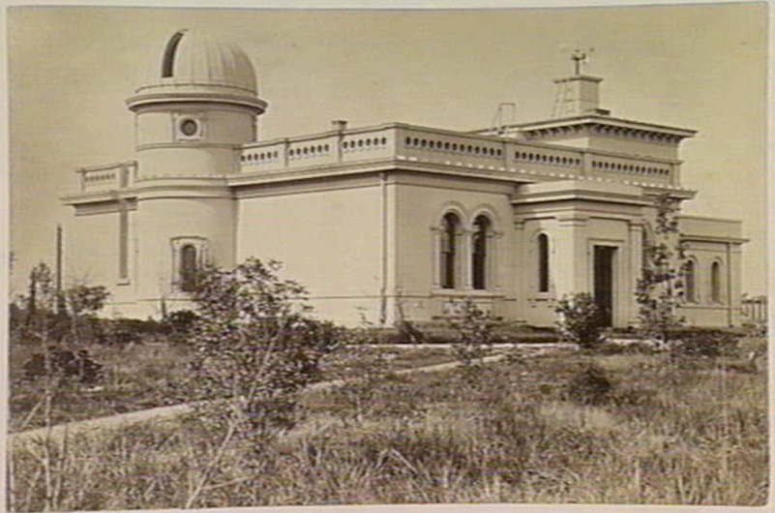
Source: Nettleton, C., (c.1878). “Melbourne Observatory”. Accessed via Royal Historical Society of Victoria

Step 2: Divide the source into four equal sections (2x2 grid). Look at the details in each section. Is there anything “new” that you didn’t notice in step 1? The smallest detail could help you figure out what the source is. Add any new information above.

Step 3: Read the information underneath the source and answer the questions below:
When was this source created? (Date) |  | Why do you think this source exists?
What type of source is it?  Who created this source? (Author) |  | What was its original purpose?  What makes you say this?

Step 4: Do you have any question/s about the source that could be answered with further research? Write them down here (these will be answered next lesson):

Primary Source worksheet 7:
Step 1: Write down anything you notice about the source as a brainstorm below:

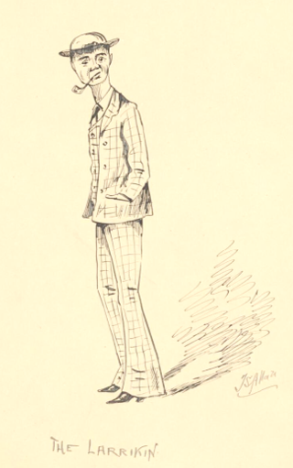
Source: Stuart Allan, J., (1895). “The Larrikin” Accessed via National Library of Australia.

Step 2: Divide the source into four equal sections (2x2 grid). Look at the details in each section. Is there anything “new” that you didn’t notice in step 1? The smallest detail could help you figure out what the source is. Add any new information above.

Step 3: Read the information underneath the source and answer the questions below:
When was this source created? (Date)
Who created this source? (Author)
What type of source is it?

Why do you think this source exists? What was its original purpose? What makes you say this?

Step 4: Do you have any question/s about the source that could be answered with further research? Write them down here (these will be answered next lesson):

Primary Source worksheet 8:
Step 1: Write down anything you notice about the source as a brainstorm below:

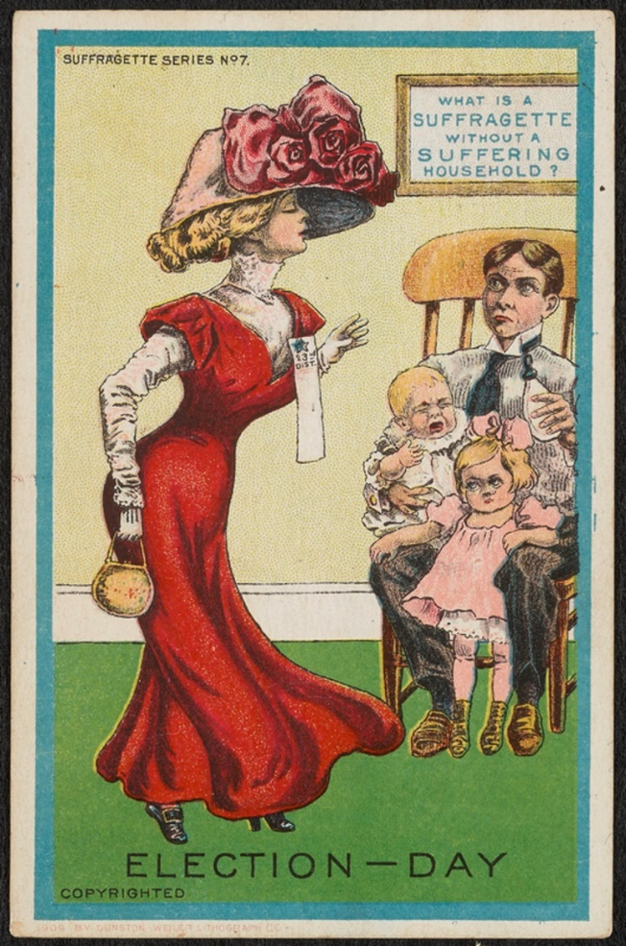
Step 2: Divide the source into four equal sections (2x2 grid). Look at the details in each section. Is there anything “new” that you didn’t notice in step 1? The smallest detail could help you figure out what the source is. Add any new information above.

Source: Unknown artist, (1909). “Election Day” Ann Lewis Women’s Suffrage Collection.

Step 3: Read the information underneath the source and answer the questions below:
When was this source created? (Date)
Who created this source? (Author)
What type of source is it?

Why do you think this source exists? What was its original purpose? What makes you say this?

Step 4: Do you have any question/s about the source that could be answered with further research? Write them down here (these will be answered next lesson):

Primary Source Worksheet Answers
Worksheet 1: Valentine Keating
Elements in the image: Adult white male, shaved head, scowling/unhappy expression, gaze directed away from the camera, plain white background, wearing a white shirt with an open collar, less formal than the suits seen in other images students have analysed, may indicate lower social status.
  - When was this source created? (Date). 1904
  - Who created this source? (Author). Victorian Government
  - What type of source is it? A photograph
  - Why do you think this source exists? What was its original purpose? What makes you say this? The source is a mugshot from the Central Register for Male Prisoners, documenting the physical appearance of a criminal. The title identifies the subject as Prisoner 30591, confirming the photograph was part of the prison record. Original purpose was likely to show the appearance of the criminal and to keep track of what crimes he committed.

Worksheet 2: Female Computer at Melbourne Observatory
Elements in the image: A woman seated at a desk, table legs made of solid brick cemented to the floor (so it can’t move), sits on a cushioned stool, examining an optical instrument resembling a microscope (the astrograph). She wears a coat and skirt with her hair in a bun. She appears to be in a darkened room with closed blinds, possibly to protect the sensitivity of the instrument. Her clothing and posture suggest a cold working environment, the environment itself feels quite stark/uninviting.
  - When was this source created? (Date). 1905
  - Who created this source? (Author). Photographer Unknown
  - What type of source is it? A photograph
  - Why do you think this source exists? What was its original purpose? What makes you say this? To document the work of an assistant computer on the Astrograph Project at Melbourne Observatory. The woman demonstrates the process of using the instrument, the photograph is likely intended as a record of scientific practice. However, it is also evidence the role women played in the scientific endeavour.
Worksheet 3: Harriet Adderley
Elements in the image: A woman facing the camera, hair tied back, wearing a high-buttoned blouse. Facial expression appears stern or resigned. Has “Adderley Nov 04” written on it, likely her surname and date the picture was taken. Has a plain backdrop, possibly a wall. Red lines beneath the photo suggest it was mounted on lined paper (probably the prison record).
  - When was this source created? (Date). 1904
  - Who created this source? (Author). Victorian Government
  - What type of source is it? A photograph
  - Why do you think this source exists? What was its original purpose? What makes you say this? Mugshot from the Central Register for Female Prisoners (Prisoner 6931), documenting her appearance as part of prison records. Original purpose was likely to show the appearance of the criminal and to keep track of what crimes she committed.

Worksheet 4: Pietro Baracchi
Elements in the image: Well-groomed man in a three-piece suit, moustache, neatly styled hair, gazing to the side. His formal clothing suggests wealth. Background is indistinct, clearly a stylised portrait shot. Overall presentation is composed, clean, and professional, indicative of a “high-status” or important individual.
  - When was this source created? (Date). 1904
  - Who created this source? (Author). Royal Society of Victoria
  - What type of source is it? A photograph
  - Why do you think this source exists? What was its original purpose? What makes you say this? A formal portrait titled “Presidential Portrait Baracchi,” likely commissioned to commemorate his role as President of the Royal Society of Victoria. Note: Students might think he is royalty because of the term “Royal Society of Victoria” – explain that this term is given to the research institution that promotes the scientific endeavour it isn’t connected to the British royal family.

Worksheet 5: Fitzroy Slums
Elements in the image: Cluster of modest brick buildings with corrugated iron roofs, a lot of laundry drying on lines, cobblestone path or driveway. Nicer, painted buildings appear in the background, while the foreground buildings are deteriorated, indicating disparity. Numerous chimneys suggest cold weather and heating by fire is required. The buildings look poorly built.
  - When was this source created? (Date). 1935
  - Who created this source? (Author). Barnett, F.O.
  - What type of source is it? A photograph
  - Why do you think this source exists? What was its original purpose? What makes you say this? This one is tough, it would help to provide the context about the photographer, Frederick Oswald Barnett, who was a social reformer who wanted to raise awareness about the poor living conditions of those living in Melbourne’s slums. The photograph therefore highlights the poverty that existed in the Fitzroy slums and the contrast between wealthy and poor housing.

Worksheet 6: Melbourne Observatory
Elements in the image: White formal building with a prominent dome, arched windows, surrounded by a path, grass, and shrubs. Small circular window under the dome and an apparatus visible on a chimney or tower (weather station). The isolation of the building from other buildings suggests it’s located away from “urban” areas, (this is to reduce light pollution).
  - When was this source created? (Date). 1878
  - Who created this source? (Author). Nettleton, C.
  - What type of source is it? A photograph.
  - Why do you think this source exists? What was its original purpose? What makes you say this? To visually record the architecture and setting of the Melbourne Observatory, showcasing its facilities and prominence.

Worksheet 7: The Larrikin
Elements in the image: Sketch of a young man in a suit, hat, and flared trousers, smoking a pipe, hands in pockets, with exaggerated features and posture. His foolish expression and the title “The Larrikin” suggest the image is a caricature. His stance and dress are portrayed as slightly ridiculous. The “Larrikin” is a badly behaved young man that disregards social conventions or social norms.
  - When was this source created? (Date). 1895
  - Who created this source? (Author). Stuart Allan, J.
  - What type of source is it? A cartoon.
  - Why do you think this source exists? What was its original purpose? What makes you say this? To satirize or critique the figure of the ‘larrikin’ — a term associated at the time with rebellious or delinquent youth — by depicting him as unintelligent and socially deviant.
Worksheet 8: Election Day
Elements in the image: Woman in a striking hat and dress walking away from a distressed man and children. The man appears angry and overwhelmed, trying to care for the children while the woman looks proud and defiant. Poster reads “What is a suffragette without a suffering household,” linking the woman to the suffragette movement and depicting her as selfish and neglectful.
  - When was this source created? (Date). 1909
  - Who created this source? (Author). Unknown artist
  - What type of source is it? A political cartoon.
  - Why do you think this source exists? What was its original purpose? What makes you say this? To undermine and ridicule the suffragette movement by portraying women campaigners as abandoning their domestic duties and destabilising family life, aiming to evoke guilt and opposition to women’s suffrage. Students will need to be taught what a suffragette is – a woman who actively campaigned for women’s right to vote.
Gallery Walk
Source: Image from the Central Register for Male Prisoners 30337-30738 (1903-1905), Prisoner 30591 (Page 255). Accessed via Public Records Office of Victoria database.
Who is this an image of? Valentine Keating of the notorious Crutchy Push (Gang), 1904, aged 25.

What is the context of this source?
Around the turn of the 20th century, Melbourne was home to a lot of gangs also known as “pushes”.
This is a mugshot of Valentine Keating who joined the Crutchy Push when he was 16. He became its leader in 1900.
The Crutchy Push was located in North Melbourne.
They were named the Crutchy Push because most of the members had an amputated leg and walked on crutches.
They would threaten shopkeepers, bartenders and unfortunate pedestrians with violence to get money, food and alcohol from them.
This mugshot is from the time he was sent to jail after seriously wounding a police officer with his girlfriend and another gang member.

Gallery Walk

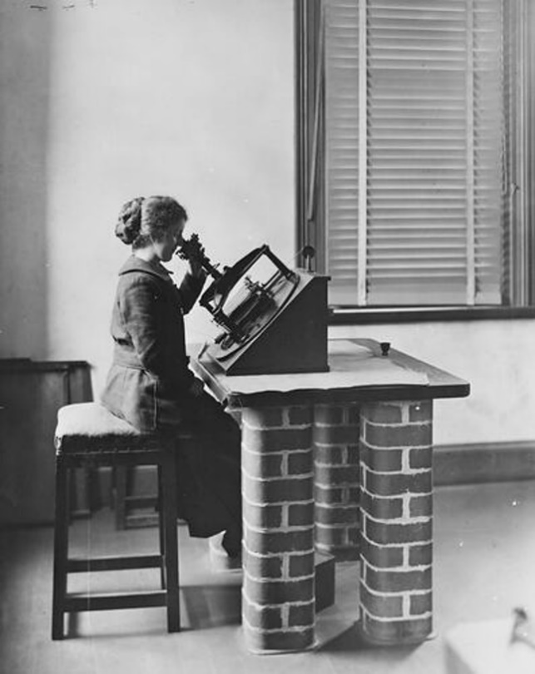
Source: Photographer Unknown, (c.1905). “An assistant ‘computer’ working on the Astrograph Project, Melbourne Observatory” Accessed via Museums Victoria.
Who is this an image of? We don’t know the name of the woman pictured here. She is described as a young ‘computer’ (someone who measured the stars) using a Repsold Machine (an instrument used in astronomy) at the Melbourne Observatory.
What is the context of this image?
At the turn of the twentieth century women were employed to measure the stars and were called computers.
The Melbourne Observatory hired six women to help map the entire visible universe.
The women would work in teams, analysing and recording measurements from astrographic plates (photos of the stars on glass).
The women had to pass a science exam to get the position at the Observatory, but they were not respected as much for their work as they should have been. It was a widely held opinion in those days that women’s brains were inferior to men’s, especially for ‘rational’ subjects like maths and science.
Being a star measurer required precision and attention to detail – rephrased as ‘a woman’s delicate touch’ – but it was also seen as too boring for ‘serious’ men of science to waste their time doing.

Gallery Walk
Source: Image from the Central Register of Female Prisoners 6914-7411 (1904-1918), Prisoner 6931 (page 18). Accessed via Public Records Office of Victoria database.
Who is this an image of? Harriet Adderley, 1904, aged 23.
What is the context of this image?
Harriet Adderley was Valentine Keating’s girlfriend; she was involved in the attack on the police man Valentine found guilty of in the first image of this collection and was sent to prison for a year.
Harriet wasn’t part of the Crutchy Push and wasn’t usually Valentine’s partner in crime.
Keating tried to claim that she wasn’t guilty so she’d get out of trouble, but she was sentenced anyway.
Adderley’s ancestry is British. This is interesting because the Irish, of which Keating was one, typically disliked the British because of Ireland’s long history of oppression and exploitation by the British.

Gallery Walk
Source: Pietro Baracchi c. 1880s, Government Astronomer at the Melbourne Observatory. Image via Encyclopaedia of Australian Science and Innovation
Who is this an image of? Pietro Baracchi, astronomer, boss of the Melbourne Observatory from 1895.
What is the context of this image?
Pietro Baracchi was the Government Astronomer, boss of the Melbourne Observatory, from 1895 to 1915.
He may look stern in this photo, but he was apparently an enthusiastic, friendly and somewhat open-minded man.
He was born in Florence, Italy, in 1851, to wealthy parents. He was educated by a private tutor as a child and studied maths and astronomy at university.
He was in charge of handling Melbourne’s part of the International Astrograph Project, for which the star measuring women were hired.
Although he had a great passion for astronomy, he wasn’t that good at handling some other responsibilities of the Government Astronomer, like managing the Observatory’s funds (probably because he was wealthy his whole life) or meteorology (he didn’t think predicting the weather was important for science).

Gallery Walk
Source: Fitzroy slums by F. O. Barnett, 1935. From State Library Victoria, F. Oswald Barnett Collection.
What is this an image of?
The Fitzroy slums in 1935.

What is the context of this source?
These are the Fitzroy slums; a slum is a neighbourhood with crowded houses of poor quality where the poor would live. Similar slums were all over Melbourne from the mid-1800s to 1940s.
This cobbled laneway, with these small plain houses clustered close together, would have been a familiar sight in Melbourne around the turn of the century in suburbs like North Melbourne, Carlton, Richmond, Fitzroy and Collingwood.
The city’s poorest people lived in ‘slum pockets’ like these. Often, large families would live in just one or two rooms.
Some of the houses were very hastily built, like ‘kit houses’, which were basically an entire house made of sheets of metal that would be brought to the site as a flatpack.
With people living so close together and plumbing and drainage being poor, diseases like cholera spread easily.

Gallery Walk

Source: Nettleton, C., (c.1878). “Melbourne Observatory”. Accessed via Royal Historical Society of Victoria.
What is this an image of? The main building of the Melbourne observatory in the 1880s.

What is the context of this image?
The Melbourne Observatory still stands today between the Royal Botanic Gardens and the Shrine of Remembrance. The buildings are mostly intact, although the domed tower at the left of this picture no longer exists.
They’re painted mostly in a yellowish cream colour. This grand style of architecture is called Italianate probably because of the Italian history of telescopes and observatories.
On the inside, the buildings have high ceilings and wooden floors.
The main building contains several different rooms where different tasks used to be completed.
The Observatory opened in 1863, and it closed for scientific use in 1945 due to light pollution and out-of-date instruments, but they still work and can be seen on historical tours.

Gallery Walk
Source: Stuart Allan, J., (1895). “The Larrikin” Accessed via National Library of Australia.
What is this an image of? A cartoon sketch of a larrikin, a term given to someone who acts cheeky or playful and doesn’t follow the rules. Drawn in pen and ink – from his book ‘Colonials Black and White’ a set of 38 cartoons depicting colonial life in New Zealand.

What is the context of this image?
This image is called The Larrikin. Around 1900, a larrikin wasn’t just a joker—they were part of a rebellious, working-class youth culture.
In booming Melbourne, even labourers and tradesmen were earning good wages, so they could afford stylish clothes, known as “flash duds.”

Larrikins stood out with their flared pants, patterned suits, red scarves, wide-brimmed hats, and pipes—symbols of pride in their working-class background. At the same time, the “ideal” young man was expected to be neat, polite, and educated—he would wear plain clothes, a bowler hat, and smoke cigarettes.
The slouch and blank expression in the drawing aren’t accidents—they reflect the snobbish view that working-class young people were lazy or unintelligent.
Someone like Valentine Keating might not have dressed exactly like this, but people still would’ve seen him as a larrikin.
Female larrikins were often called “donnas” or “donahs.” They followed fashion trends but went bigger—like wearing the biggest feathered hats they could find.

Gallery Walk

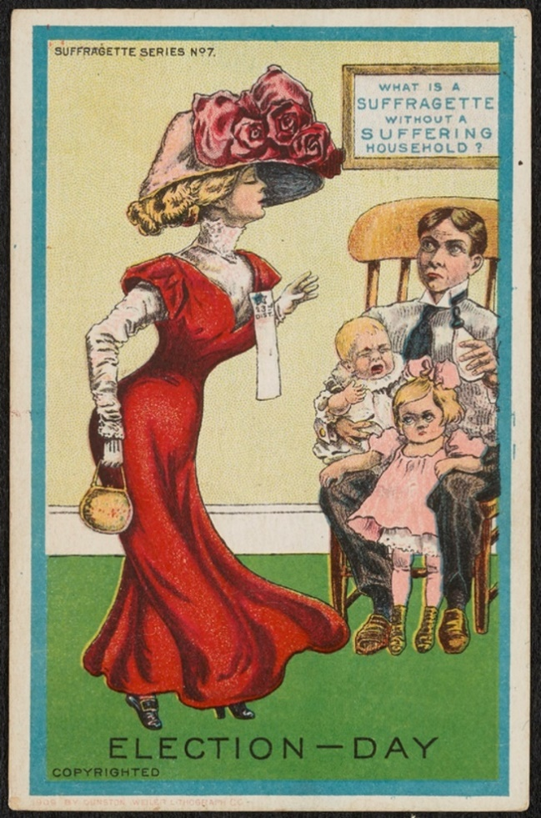
Source: Unknown artist, (1909). “Election Day” Ann Lewis Women’s Suffrage Collection.
What is this an image of? A cartoon of a suffragette, an activist that campaigned for women’s right to vote, leaving to vote whilst the family (a father and two kids) are shown as visibly upset staying at home.
What is the context of this image?
This cartoon postcard is mocking suffragettes—it was often argued in the early 20th century that if women gained more rights, society would be turned upside down and collapse.
The woman’s clothes are supposed to make her look vain and foolish. The crying baby and frowning toddler are intended to make the woman seem selfish, and probably to make women reading this cartoon feel guilty as well.

In the 19th century, women were discouraged from university studies and expected to quit any job they had when they got married. Women weren’t allowed to own property, their money had to be given to their husbands, and they couldn’t vote. Instead, they were expected to dedicate their entire lives to supporting their husbands and children.
The star measurer character would probably be dealing with this in her everyday life. There would likely be people in her life who didn’t believe women should work in science.

Source: | 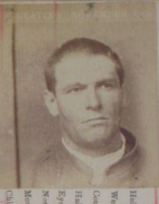 | 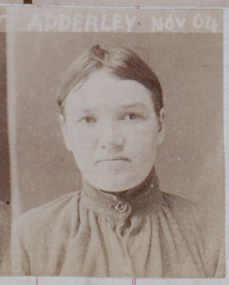 | 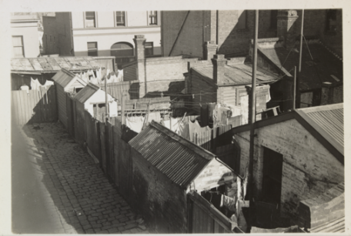 | 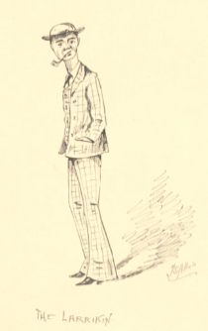
Historical context:
What did you find out about the source?
Using this information, what do you think the topic is for this collection of sources? How has your thinking changed from last lesson?

Source: | 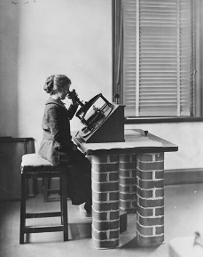 | 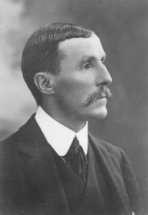 | 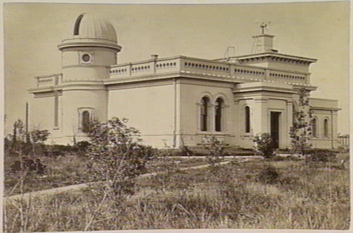 | 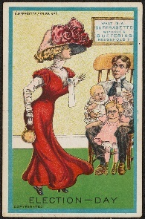
Historical context:
What did you find out about the source?
Using this information, what do you think the topic is for this collection of sources? How has your thinking changed from last lesson?

Source:
Historical context:  What did you find out about the source? | Valentine Keating  Was part of the Crutchy Push (gang) and was 25 when photo was taken  He joined the gang at 16, was the leader by age 20/21  The gang was from North Melbourne  Most members had an amputated leg and used crutches  Threatened people to get money, food or alcohol  Went to jail after seriously wounding a policeman | Harriet Adderley, 23yrs  This is a photo after she was sentenced to jail  Valentine’s girlfriend  Went to jail as part of the attack on a policeman with Valentine  Wasn’t a gang member.  Is of British descent (Valentine was Irish) > interesting because the Irish and British generally didn’t like each other | Image of Fitzroy slums (crowded houses of poor quality)  Familiar in North Melbourne  City’s poorest lived here  Large families lived in one or two rooms  Houses could be made from sheets of metal  Plumbing and drainage wasn’t great – resulting in the spread of diseases | A cartoon called the larrikin  A larrikin was someone who was playful and didn’t follow the rules – they were a rebel  Larrikins were working class people that had extra money to buy clothing that went against what was considered “ideal”  Society saw working class people as lazy; this is shown in the image.  Valentine may not have worn these clothes but was considered a larrikin.  Females were called donnas and exaggerated the female “ideal”
Using this information, what do you think the topic is for this collection of sources? How has your thinking changed from last lesson?
Various student answers

Source:
Historical context:  What did you find out about the source? | Image of a computer, a woman who would measure the stars  Unknown name  Melbourne observatory hired six of these women who worked together  Women had to be educated  The women weren’t as respected because they were considered “inferior” in intelligence  Computers needed to be precise and thorough  Men thought they would waste their time doing this work | Photo of Pietro Baracchi  Was the government astronomer at Melbourne observatory (the boss)  Was friendly, enthusiastic and open-minded  Born in Florence, Italy, was wealthy and educated privately  Was the boss of the computers  He wasn’t very good at administration, managing funds and didn’t care about meteorology (predicting the weather) | Image of Melbourne observatory in 1880s  Intact today (but not the domed part)  Italian designed building, is yellow/cream  Multiple rooms in the one building  Used until 1945 but light pollution stopped its use | Cartoon of a suffragette (activist who campaigned for women’s right to vote)  “suffered household” – a father with two unhappy kids highlights the view that women should dedicate their lives to their families.  Woman is shown to be selfish to be pro-women’s vote  By extension – it was thought women shouldn’t work in the sciences
Using this information, what do you think the topic is for this collection of sources? How has your thinking changed from last lesson?
Various student answers

The words I would use to describe Valentine Keating are…

I think this because…

The words I would use to describe Harriet Adderley are…

I think this because…

The words I would use to describe the female computer are…

I think this because…

The words I would use to describe Pietro Baracchi are…

I think this because…

Character | How would you describe the personality of this character? | What goal do they want to achieve? Is there something they wish more than anything? | What relationships does this character have that influences their behaviour? | What challenges or obstacles does this character face in their time period? | What values or beliefs are important to them? Are those common or unusual for their time?
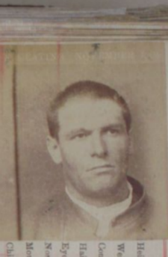
My protagonist:
Valentine
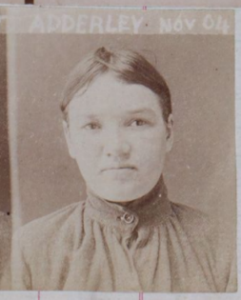
My deuteragonist:
Harriet

Character | How would you describe the personality of this character? | What goal do they want to achieve? Is there something they wish more than anything? | What relationships does this character have that influences their behaviour? | What challenges or obstacles does this character face in their time period? | What values or beliefs are important to them? Are those common or unusual for their time?
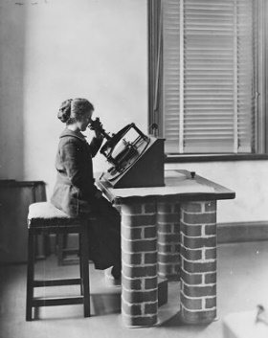

Possible Name:
______________
______________
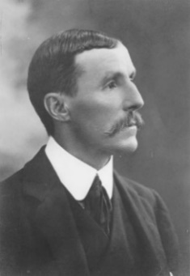
My deuteragonist:
Pietro

Extension Activity: The Haymarket Fire Source Analysis
As you listen to Amelia read the article, annotate using the key below. Colour in each box in a different colour using highlighters or coloured pencils and use these colours for your annotations.
Highlight the key information in the article. | Circle the information Amelia used in her story.

DESTRUCTION OF THE HAY MARKET THEATRE BY FIRE.
The Argus, Page 5, Saturday 23 Sep 1871
We have to record the total destruction of the Haymarket Theatre in Bourke Street by fire. This place of amusement has now been closed for several years…At the time of the fire it was under lease to Mr. Coppin, also the lessee of the Theatre Royal. Although so rarely open to the public, it was in complete order as a theatre […] and the premises were carefully looked after […].
At about 8 o’clock last evening the fire was first observed. [A watchman (security guard) was heading home, when a passing boy gave the alarm. The watchman went back into the theatre and saw that the kitchen was on fire. The watchman, a stage carpenter and an oyster-seller from the market tried to use the firehoses on the premises but the fire spread quickly and they had to flee from the choking smoke.]
By this time, however, the alarm had been given more fully, and the United Insurance Fire Brigade […] appeared on the scene. Their first plan was to carry the hose into the courtyard, but from this they were soon driven away by the increasing flames and smoke. Firemen were also stationed at other points of the building, their endeavours being directed to prevent the flames spreading to the adjoining houses. In this work they were speedily joined by the Emerald Hill, Hotham, and East Collingwood local fire brigades. Altogether nine [horse-drawn] fire engines were directed on the burning premises.
…the efforts of the fire brigades proved successful, and with some small exceptions the damage was confined within the walls of the theatre and front buildings, stretching from Bourke to Little Collins Streets. On the western side a number of houses were closely adjoining the theatre buildings, but a strong nearly south-westerly wind kept the flames from them…
[…] The fire afforded one of the grandest spectacles ever seen in Melbourne […] Some six or seven minutes after the first alarm was given, the flames burst through the roof…with a speed which could scarcely be told in minutes, so rapid was it, the flames extended through the theatre on one side, and into the Apollo Hall on the other, till they streamed out through the windows facing Bourke Street. ln 10 minutes more, the iron roof of the theatre fell in with a crash, and a huge volume of black smoke issued forth to be changed in another second into an enormous body of rolling, roaring flames. The wind, being high, blew clouds of burning fragments across the street, and but for that interval of space, the houses for a considerable distance must have been placed in serious jeopardy.
At this stage the fire was utterly beyond control. It does not, indeed, happen often in any man’s life to see flames of such volume and brilliancy. The whole city was lit up by the glare, and every spire and tower stood out in bold relief, as they reflected the ruddy light…After the fire had been nearly 20 minutes burning, the upper portion of the eastern wall of the theatre gave way, and fell outwards, crushing a number of the small market stalls…Being mostly of wood, they soon caught fire, but were speedily extinguished.
About half-an-hour after the fire broke out, it was at its height. It then gradually burnt out, utterly destroying everything within the four walls […] The Bourke Street front remains, but inside, from end to end, is only smoking ruins. So splendid a sight as such a fire afforded drew, of course, a large crowd of spectators, and at one time not less than 10,000 people were watching the flames.
Fortunately…some 70 men of the East Melbourne Artillery [soldiers, had arrived and] there were also 40 foot-police on the ground […]. They were much needed, for there was a good deal of exposed property to protect…the centre of the Eastern Market place presented a strange spectacle. Cages of all sorts of birds…guinea pigs, rabbits, pens of fowls, geese, and turkeys, were heaped together in great confusion. Of course, there was some thieving, and not a little loss on that account […]
The origin of the affair is believed to be that during the day a fire was lit in the kitchen of the hotel to enable the boys to clean [with hot water] some pint-pots. The fire was left unextinguished, and some hot cinders may have fallen on the floor and set it on fire. It seems that the fire certainly broke out at that particular spot. It should be mentioned, however, that the neighbourhood is alive with rumours as to a previous strong expectation that the theatre was to be burnt down on the previous evening. [The reporter then gives an account of a neighbour’s child relaying this rumour – including seeing ‘three strange men’ enter the building.]

Extension Activity: The Haymarket Fire Source Analysis
Teacher Key
What key information is included in the article? | Circle the information Amelia used in her story.
DESTRUCTION OF THE HAY MARKET THEATRE BY FIRE.
The Argus, Page 5, Saturday 23 Sep 1871
We have to record the total destruction of the Haymarket Theatre in Bourke Street by fire. This place of amusement has now been closed for several years…At the time of the fire it was under lease to Mr. Coppin, also the lessee of the Theatre Royal. Although so rarely open to the public, it was in complete order as a theatre […] and the premises were carefully looked after […].
At about 8 o’clock last evening the fire was first observed. [A watchman (security guard) was heading home, when a passing boy gave the alarm. The watchman went back into the theatre and saw that the kitchen was on fire. The watchman, a stage carpenter and an oyster-seller from the market tried to use the firehoses on the premises but the fire spread quickly and they had to flee from the choking smoke.]
By this time, however, the alarm had been given more fully, and the United Insurance Fire Brigade […] appeared on the scene. Their first plan was to carry the hose into the courtyard, but from this they were soon driven away by the increasing flames and smoke. Firemen were also stationed at other points of the building, their endeavours being directed to prevent the flames spreading to the adjoining houses. In this work they were speedily joined by the Emerald Hill, Hotham, and East Collingwood local fire brigades. Altogether nine [horse-drawn] fire engines were directed on the burning premises.
…the efforts of the fire brigades proved successful, and with some small exceptions the damage was confined within the walls of the theatre and front buildings, stretching from Bourke to Little Collins Streets. On the western side a number of houses were closely adjoining the theatre buildings, but a strong nearly south-westerly wind kept the flames from them…
[…] The fire afforded one of the grandest spectacles ever seen in Melbourne […] Some six or seven minutes after the first alarm was given, the flames burst through the roof…with a speed which could scarcely be told in minutes, so rapid was it, the flames extended through the theatre on one side, and into the Apollo Hall on the other, till they streamed out through the windows facing Bourke Street. ln 10 minutes more, the iron roof of the theatre fell in with a crash, and a huge volume of black smoke issued forth to be changed in another second into an enormous body of rolling, roaring flames. The wind, being high, blew clouds of burning fragments across the street, and but for that interval of space, the houses for a considerable distance must have been placed in serious jeopardy.
At this stage the fire was utterly beyond control. It does not, indeed, happen often in any man’s life to see flames of such volume and brilliancy. The whole city was lit up by the glare, and every spire and tower stood out in bold relief, as they reflected the ruddy light…After the fire had been nearly 20 minutes burning, the upper portion of the eastern wall of the theatre gave way, and fell outwards, crushing a number of the small market stalls…Being mostly of wood, they soon caught fire, but were speedily extinguished.
About half-an-hour after the fire broke out, it was at its height. It then gradually burnt out, utterly destroying everything within the four walls […] The Bourke Street front remains, but inside, from end to end, is only smoking ruins. So splendid a sight as such a fire afforded drew, of course, a large crowd of spectators, and at one time not less than 10,000 people were watching the flames.
Fortunately…some 70 men of the East Melbourne Artillery [soldiers, had arrived and] there were also 40 foot-police on the ground […]. They were much needed, for there was a good deal of exposed property to protect…the centre of the Eastern Market place presented a strange spectacle. Cages of all sorts of birds…guinea pigs, rabbits, pens of fowls, geese, and turkeys, were heaped together in great confusion. Of course, there was some thieving, and not a little loss on that account […]
The origin of the affair is believed to be that during the day a fire was lit in the kitchen of the hotel to enable the boys to clean [with hot water] some pint-pots. The fire was left unextinguished, and some hot cinders may have fallen on the floor and set it on fire. It seems that the fire certainly broke out at that particular spot. It should be mentioned, however, that the neighbourhood is alive with rumours as to a previous strong expectation that the theatre was to be burnt down on the previous evening.
[The reporter then gives an account of a neighbour’s child relaying this rumour – including seeing ‘three strange men’ enter the building.]

Source for Poverty, crime and the working class in Melbourne
NORTHERN TERROR
“CRUTCHY PUSH” LEADER – RECORD OF OFFENCES
Page 3, The Herald (Melbourne), Friday 9th September 1904

Valentine Keating, aged 25 years, was yesterday sentenced to six months’ imprisonment by Judge Chomley on conviction of unlawfully wounding an hotel-keeper in North Melbourne. The Judge said that there was no direct evidence that he had actually joined in the attack on the unfortunate publican, but the jury found him guilty.
Keating is a one-legged man who walks by the aid of a crutch, which […] he has been proved to use time and again as an offensive weapon with terrible effect. Fourteen years ago, before he had entered his teens, he was first convicted [of physical assault], and the record of his offences now constitutes a monument [huge amount of evidence] of misplaced leniency [‘wrongful mercy’ – the writer is saying judges are too easy on him].
With two exceptions, his misdeeds have been confined to North Melbourne, where he is the acknowledged leader of the notorious “Crutchy Push”— a band of ferocious cripples [this term for physically disabled people is considered very hurtful today, though some have reclaimed it] who are a constant menace to the suburb. The police took their lives in their hands when they attempted to arrest him or any of his ruffianly followers, but, as will be seen by the subjoined list of convictions, Keating has always been treated with astonishing leniency by the magistrates.
His record of convictions is as follows:
- 20th October. 1899.— Assaulting a Chinese [this was considered a neutral way to describe people back then but is not acceptable now]. Fined 10s [shillings = $100AUD today but it’s a very rough conversion]; in default [he didn’t pay up], one month [in jail].
- February 16th, 1897.— Stealing a pair of trousers, one month [in jail].
- March 3rd, 1898.— Assault on Senior-Constable Healey, fined 15s [shillings]; in default, seven days. [didn’t pay, so got seven days in jail]. Assaulting Constable Walsh, fined 15s [shillings]; in default, seven days.
- July 4th, 1898.— Insulting behavior, fined 2s 6d [2 shillings, 6 pence = $25AUD today]; in default, twelve hours. Assaulting Constable M’Glynn, fined 2s 6d; in default, twelve hours.
- July 27th, 1898.— Stealing a case of oranges, one month.
- March 9th, 1899.— Insulting behavior, fined £2 [pounds = $400AUD today]; in default, one month.
- July 13th, 1899.— Stealing a macintosh [raincoat], one month.
- January 25th, 1900. — Stealing money and goods, one month.
- July 12th, 1900. — Obscene language, fined 20s [20 shillings = 1 pound]; in default, fourteen days. Inciting a prisoner to resist [told someone else to fight the cops], fined 20s; in default, fourteen days.
- February 17th, 1902.— Obscene language, fined £5 [$1000AUD today]; in default, one month. Assaulting Constable Noone, fined £2; in default, fourteen days. Assaulting Constable McSweeney, fined £2; in default, fourteen days. [about $1850AUD in today’s money and 2 months in jail altogether.]
On Monday next, Keating is to appear at the North Melbourne Court, with two companions, to answer a charge of unlawfully and maliciously wounding Senior-Constable John Mulcahey last Monday evening.

Note: In its original context, this article appears on a large and dense page of news, printed in narrow, tight columns.
The bottom of the page is crowded with ads for ladies’ hats, cashmere undershirts, and a sale of ‘salvage goods’ – damaged goods rescued from a shipwreck. Even the top margin has two ads squeezed into it: ‘Try the new cigar – CREMO’ immediately followed by ‘Arnold’s Balsam: The great cough remedy.’

Source for role of women in the workforce (scientific field)

WOMEN’S WORK AT THE MELBOURNE OBSERVATORY
‘Woman’s Corner’ Column, Page 13, Brisbane Courier, Saturday 31st of May 1902.
Note: Originally published in ‘Woman’s Sphere’ magazine. The Brisbane Courier would have got permission to reprint it in their newspaper.
The title of the magazine ‘Woman’s Sphere’ means something like ‘Woman’s World’ or ‘Woman’s Domain’. It was often said at this time in history that ‘the woman’s sphere (world) is the home,’ but the magazine’s message was that women’s world should be the whole world – that women belong everywhere, not only in the home as wives and mothers.
However, the ‘Woman’s Corner’ of the Brisbane Courier is essentially the “women’s section” of that newspaper, so the context and message is a bit different.

We are indebted (says “Woman’s Sphere”) to Mr. [Pietro] Baracchi, Government Astronomer [at the Melbourne Observatory], for the material from which these notes are taken. […]
The employment of young ladies at the Observatory commenced in 1898. In January of that year Mr. [Henry Chamberlain] Russell, the director of the Sydney Observatory, and Mr. Baracchi decided to form a “Measuring Bureau” to deal with the measurements […] of all the stellar photographs taken at the Sydney and Melbourne Observatories in connection with the International Astrographic Scheme [a scientific project by major observatories around the world]. A part of this scheme was to obtain a […] series of photographs […] containing the images of all stars [that can] be seen with the aid of a telescope.
Eighteen of the chief observatories of the world undertook to carry on this work, among them being those of Sydney and Melbourne. The Perth Observatory joined in last year. Each of the co-operating observatories was [given a region of the night sky] suitable to its geographical position. Thus Melbourne has to deal with the South Polar region.
By the beginning of 1898, Sydney and Melbourne had completed two-thirds of their catalogue series of photographs, and it became important to commence their measurement without further delay […]
Paris and Greenwich [Observatories in Paris, France; and Greenwich, England] had set the example of employing ladies for this kind of work. Some of [them] have already done work of the highest excellence that may produce far-reaching results. […]
When it became known that Mr. Baracchi was going to employ women at £40 a year, applications came in from all quarters. An examination of the candidates was held [i.e. the women applying took a science exam], and four were at once employed in November, 1898. Two more were subsequently taken on. […] Women had already proved their capability [for this work] in Paris and Greenwich; it requires young eyes, a delicate sense of touch, and infinite patience; the work now being done at the Melbourne Observatory could not be done quicker or better by the most skilled and experienced of men.
Of course these operations have to be carried on with the aid of powerful microscopes. It is necessary to have movable lines across the plates [of the microscopes, for measuring]. After numerous experiments it was found that the most suitable [material was] threads from the webs of spiders, the finest silk proving too coarse. […] It is work requiring a high degree of skill and most delicate manipulation. At the present rate of progress, about 100,000 stars are measured and catalogued in one year by the six ladies.
Other work is also being done by women at the Observatory [Amelia’s note: to sum it up, five other women undertook scientific work related to recording measurements, studying photos of the sky, and sorting paperwork. They also answered letters and telephones.] They have three weeks’ holiday in the year, in addition to all public holidays. Their hours are from 9 a.m. to 6 p.m. on weekdays, and to noon on Saturdays. […]
(The editor of “Woman’s Sphere” has only one remark to make […] and that is that £40 a year is an utterly inadequate remuneration for such work [about $8000AUD today, but it’s hard to say]. No men would undertake it at more than double the amount.)

Note: ‘Woman’s Corner’ includes other items of news, printed in dense, tight columns. Right next to this article is an ad for Robur Tea. Below it is a column about physical education at school, “drill”, which says training will turn boys into ‘healthy and intelligent men’ and girls into ‘healthy and intelligent mothers’ (a message slightly at odds with that of Woman’s Sphere magazine). Other articles in the ‘Woman’s Corner’ include a piece on the benefits of skipping for exercise, one about keeping a wedding simple to save money, some short romantic stories, and a ‘Cookery’ section with recipes for ox-tail soup, crumpets, and pigs-in-blankets – the ‘pigs’ being oysters rather than sausages!

Language and Expressions for Valentine Keating & the Crutchy Push Story:
awake: aware of something or seeing through something. ‘He’s awake’ = ‘he’s onto our plan!’
Bridget Keating: Valentine Keating’s mum. She once knocked him out by accident while attempting to hit a policeman with a chair. Valentine also had a brother and a sister, but I haven’t been able to find their names.
carted: arrested.
(to) cop: to seize, arrest or capture. ‘Copper’ to mean ‘police officer’ comes from ‘cop’ = ‘catch’. So does ‘fair cop’ = ‘fair enough, you’ve got me there’. ‘Pig’ in reference to ‘police’ also dates back to at least the beginning of the 1800s.
Crutch him!: the command to strike a victim with a wooden and metal crutch. The narrow end would be used to jab the victim in the stomach to make them fold over, and the wide end would be used to whack the victim in the back of the head.
David Walsh: another member of the Crutchy Push.
done: convicted of a crime. We still use ‘done’ in this way sometimes!
donna: a female larrikin. Rarely involved in pushes, but bold, sassy and gaudily dressed.
flash: its meaning ‘cool/snazzy/fancy’ probably comes from convict and criminal slang, in which ‘flash’ could mean a lot of things. ‘To be flash to [something]’ = to understand it, ‘to patter good flash’ = to speak criminal slang well. ‘To do [something] out of flash’ = to do it for show, for attention.
George Hill: The only two-legged member of the Crutchy Push, who had an amputated arm and half a brick sewn into his sleeve. Died in 1900 or 1901, after which Valentine Keating became the leader.
John Collins: another member of the Crutchy Push.
larrikin: a troublemaker or petty criminal, usually a young man. Some of them dressed in a very distinctive way, shown in Lesson 1. The word is said to come from Irish boys or young men in the mid-1800s who would claim to be ‘larking’ (having fun – a lark = a joke, a fun activity) when they were suspected of doing anything dodgy. The spelling of ‘larking’ as ‘larrikin’ imitates an Irish accent.
pins or gams: legs.
push: a gang. They had particular territories and usually robbed local shops, pubs and pedestrians. Other than the Crutchy Push, some notable names were South Melbourne’s Flying Angels, the CBD’s Bourke Street Rats, Carlton’s Bouveroos (after Bouverie Street), and North Fitzroy’s Freeman Street Push.
Righto, Val: The usual answer given to ‘crutch him!’ after Valentine Keating became the leader of the push. Have the men of the Crutchy Push use first names and nicknames because they’re mates.
Shinboners: The North Melbourne football club, now the Kangaroos. The Crutchy Push were big fans of them.
Terrible Ten: a group of burly policemen tasked with hunting down and arresting Melbourne pushes in the first decade of the 1900s.

Activity: Read the example using the words and expressions provided by Amelia. Underneath each sentence write how we would say the sentence in today’s language.
1. “Move your pins, boys — the Terrible Ten are awake!”
__________________________________________________________________________________
2. “Crutch him proper, Davey, before we all get carted.”
__________________________________________________________________________________
3. “Flash work, George — that copper didn’t know what hit him.”
__________________________________________________________________________________

Language and Expressions for the female computers at Melbourne Observatory:
astrograph: telescope designed for taking photographs of stars (‘photo’ won’t be in common usage yet in your story). Your characters may visit a part of the Observatory called the Astrograph House and the star measurers will deal with astrographic plates, pieces of clear glass with the star images on them.
astronomy: the scientific study of things beyond Earth’s atmosphere, including stars and planets.
astronomer’s chair: a chair with an adjustable back that would allow an astronomer to lie down instead of bending down to look through a telescope.
celestial: a poetic adjective, often used in this historical period to describe things in space – ‘the celestial dome’ = the sky, ‘celestial bodies’ = planets, stars, moons.
Commendatore (com-mend-a-tor-eh): Italian ‘Sir’, as in a knighthood. You should call Pietro Baracchi ‘Commendatore Baracchi’ in your story instead of ‘Mr’ or ‘Pietro’.
computer: a person (typically a woman) who computes (determines or calculates) the distances between stars as shown by an astrographic image. You can call her a ‘star measurer’ if phrases like ‘Why, Mother, I am to become a computer!’ feel too weird.
Great Melbourne Telescope: the biggest telescope at the Observatory. It was built outside.
heavens: the sky or space. Sometimes a very mild swear: ‘good heavens!’
Martians, Venusians, moon-men: what people in the Victorian and Edwardian eras called aliens. This was more of a ‘fanciful imagining’ than a real subject of science, but your characters might joke about it. Aliens were mostly imagined to look just like humans, although HG Wells’ War of the Worlds depicted terrifying giant tripod creatures from Mars.
meteorology: the scientific study of phenomena within Earth’s atmosphere, especially to do with weather prediction. The Melbourne Observatory was responsible for weather forecasts in the 19th and early 20th centuries, but Pietro Baracchi didn’t consider this important.
Miss [Surname], Mr [Surname]: All the women at the Observatory should be called ‘Miss [Surname]’ by their colleagues, except maybe close female friends. ‘Miss’ indicates they’re not married, since married women were strongly discouraged from working at this time, and ‘Ms’ (often used today) wasn’t coined yet. The men should be called ‘Mr’ unless they have another title like ‘Dr’. These titles indicate a level of formality that people in their time considered appropriate for work. Among adults, first names were for family, close friends or couples. One exception is female servants: housekeepers were called ‘Mrs’ and lower-ranking maids were called by their first names.
phenomenon (singular), phenomena (plural): a fact or situation observed to happen. ‘The meteor shower was a marvellous phenomenon,’ or ‘the astronomer studied celestial bodies and phenomena.’
Pluto: Don’t mention Pluto. It wasn’t discovered until 1930.
Repsold machine: a scientific instrument for examining astrographic plates. The user looks through an eyepiece that is essentially a microscope.
sir, madam: This sounds absurdly formal to Australians today but was considered proper and polite in 1895-1905, especially to higher-ranking people, and especially at work.
south equatorial telescope: A telescope at the Observatory housed in a fairly small outbuilding. This telescope is featured in Amelia Mellor’s The Lost Book of Magic and survives today.

Activity: Read the example using the words and expressions provided by Amelia. Underneath each sentence write how we would say the sentence in today’s language.

1. “Miss Clarke, would you be so good as to bring me the next astrographic plate? Commendaore Baracchi wishes the phenomenon in Orion measured before supper.”
__________________________________________________________________________________
2. “Good heavens, Miss Evans — mind you don’t smudge that plate. The last computer to ruin an astrograph was nearly dismissed on the spot.”
__________________________________________________________________________________
3. “I feel as though I’ve spent half my life peering at the heavens through this contraption.”
_________________________________________________________________________________

