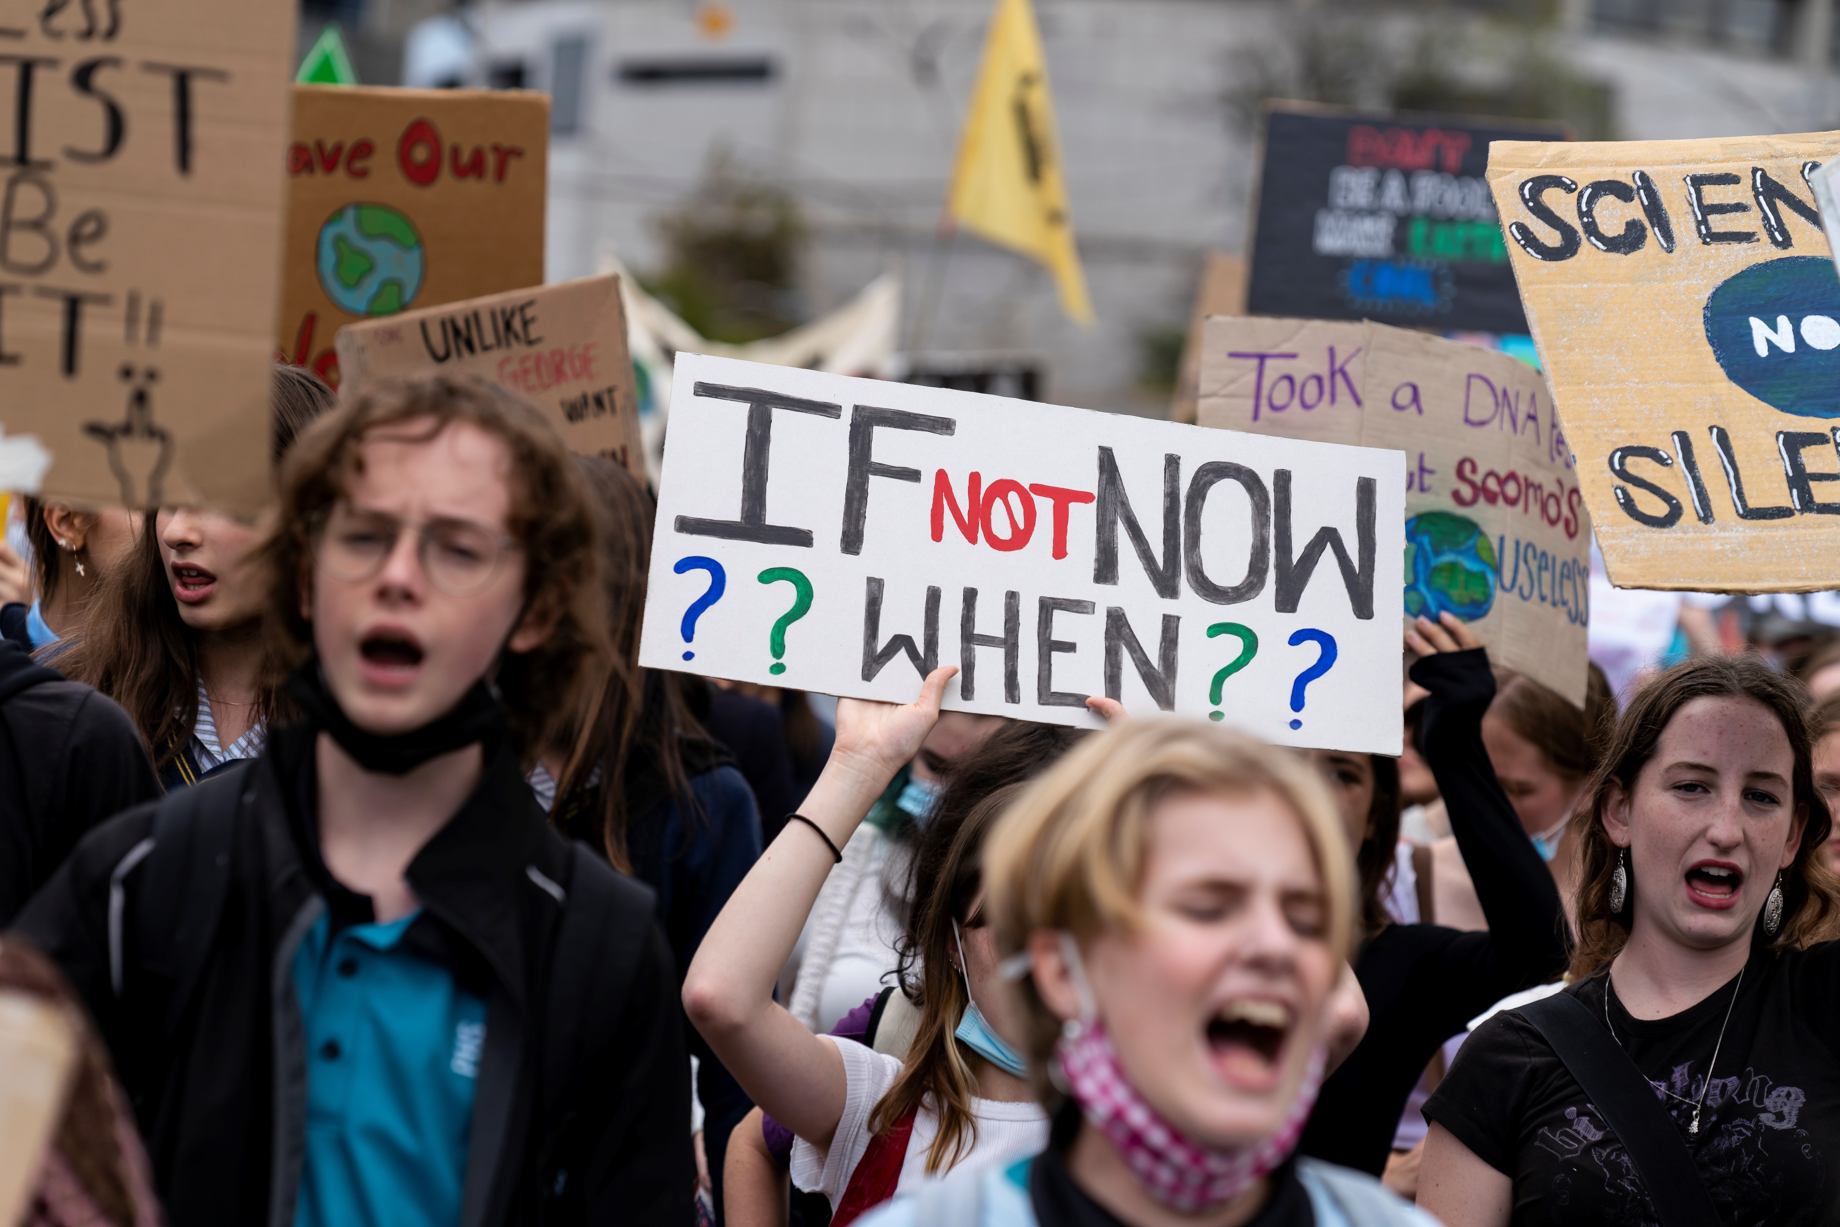

Big Ideas for Young Minds
Teacher Booklet
Year 5 and 6
Civics and Citizenship

Acknowledgement of Country

State Library Victoria acknowledges the traditional lands of all the Victorian Aboriginal clans, and their cultural practices and knowledge systems.
We recognise that our collections hold traditional cultural knowledge belonging to Indigenous communities in Victoria and around the country. We support communities to protect the integrity of this information, gathered from their Ancestors in the colonial period.
We pay our respects to their Elders, past and present, who have handed down these systems of practice to each new generation for millennia.

Cover Image:
Matt Hrkac
Schools Strike for Climate 2022
https://www.flickr.com/photos/matthrkac/albums/72177720297607987/with/51960583630

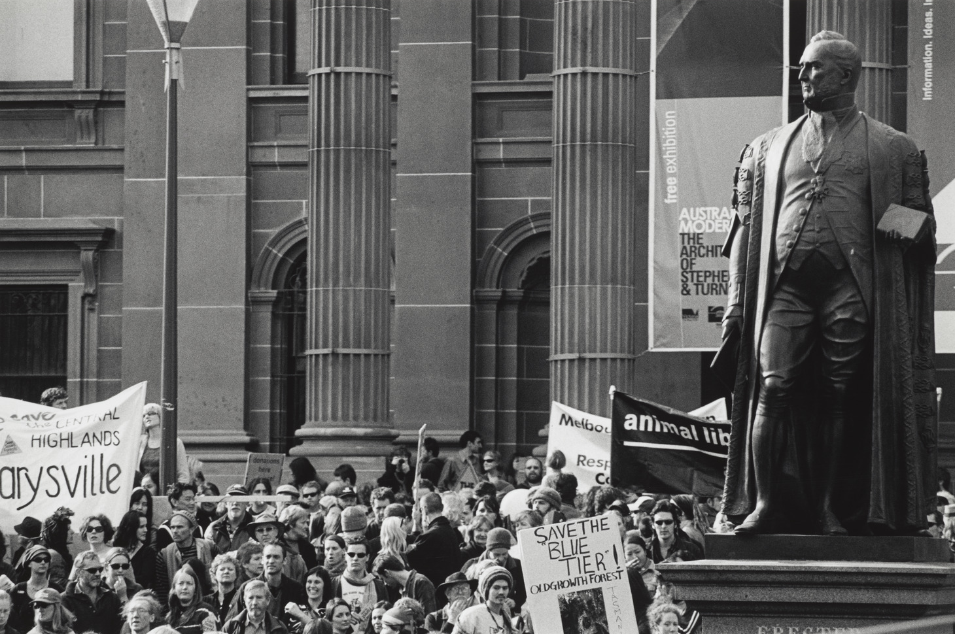

Introduction
Sideris, Harold. (2004) Crowd of protesters gathered around statue of Redmond Barry. H2004.102/2 Hunt, Maylei. (2017) Let’s eat cake. H2019.239/12

Welcome to Big Ideas for Young Minds

The Big Ideas for Young Minds program is designed to empower students to make a difference in their community. Students will be guided step-by-step through the unit, including hearing from change-makers from key organisations to learn from their experience working for positive social change. This teacher guide will help you customise your lessons so they are fit for purpose for your students. This guide also provides additional notes and pedagogical tools to engage your students with the program.

Watch this clip introducing our change makers.

Curriculum Connections

This project aligns with the Civics and Citizenship curriculum at levels 5 and 6:

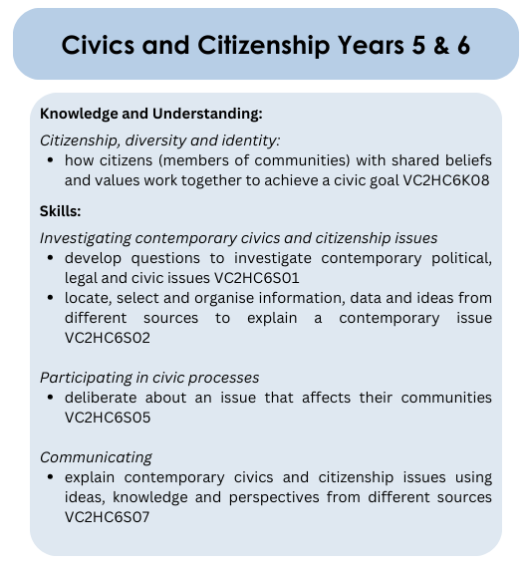

In addition, this project meets the curriculum for the critical and creative thinking general capability at levels 5 and 6:
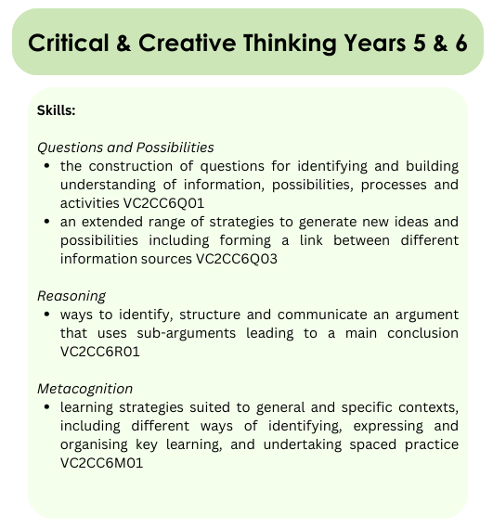

Suggested Lesson Outline

The following is a suggested outline for your lessons. Adapt according to your students’ needs.

Lesson 1: “Introduction” (p. 6) and “Why Change?” (pp. 7-8) sections of the booklet.

Lesson 2: “Caring for your community” (pp. 9).

Lesson 3: “Choosing a problem” (pp. 10).

Lesson 4 & 5: “Researching your problem” (pp. 11-12)

Lesson 6: “Picking a solution” (pp. 13-14)

Lesson 7: “Ideas to communicate your solution” (pp. 15-16)

Lesson 8 & 9: “Delivering a pitch” (pp. 17-18)

Lesson 10: Revision and prepare for the pitch.

Use as a summative assessment task

We have included an optional summative assessment task for the pitch presentation. This task builds on the work students have completed throughout the Big Ideas for Young Minds student booklet. For reporting purposes, the assessment aligns to the Civics and Citizenship and Critical and Creative Thinking general capability of the Victorian Curriculum (see content descriptors on previous pages).

Task Structure:

The task will be assessed in two key areas: Presentation Content and Presentation Delivery. Within these two areas students are expected to do the following:

- Explain their chosen problem, including outlining the impact on the community

- Identify a solution that is realistic and effective, explaining how it addresses the problem

- Present a well-developed idea that communicates the solution
- Demonstrate effective preparation by responding confidently to audience questions
- Outline their ask clearly and specifically (what resources they require)

- Use effective tone, volume, pauses, body language and eye contact when delivering the presentation

- Create a visually appealing presentation, with effective slide design

Logistics

Teachers have the option on how students will present the assessment. Students could present in front of a teacher panel, SRC representatives or members of the local community or council.

If delivering to the class, you could get the class viewing the presentations to pretend to be members of the local council who have the power to approve a certain number of projects (see example below). You could have a monetary amount attached and it is up to the class to decide which projects to fund for the betterment of their local community. This way students also engage in critical and creative thinking by assessing the viability of their peers’ projects. They will be required to justify their selection of projects and ultimately make some difficult decisions on which projects to fund.

Example:
You are part of a working group for the local council to improve your community. You have $10,000 in funding to approve ideas that tackle a problem relevant to your community. As a group you must come to consensus as to which projects to fund.

As you listen to each pitch presentation consider ideas that…

- tackle a problem relevant to your local community that community members will ‘get behind’
- have been carefully considered and explained, with all contingencies mapped out
- have the ‘wow’ factor - you think that the idea really could result in change in your local community

Take notes on each presentation using the above criteria, marking each presentation out of 5.
Then, list your top three presentations explaining your selection. You will need to negotiate with other panel members to decide which presentations will be funded.

Big Ideas for Young Minds – Pitch Presentation

Your task: Deliver a pitch presentation highlighting a problem, solution, idea and ask to tackle a problem in your local community.

An effective pitch presentation includes… | My pitch presentation…
Problem and solution  • an explanation of the problem and how it impacts the community  • an explanation of the solution and how it addresses the problem | Minimal explanation of the problem and how it impacts the community. Minimal explanation of the solution and how it addresses the problem. | Some explanation of the problem and how it impacts the community. Some explanation of the solution and how it addresses the problem. | Good explanation of the problem and how it impacts the community. Good explanation of the solution and how it addresses the problem. | Detailed explanation of the problem and how it impacts the community. Detailed explanation of the solution and how it addresses the problem. | Comprehensive explanation of the problem and how it impacts the community. Comprehensive explanation of the solution and how it addresses the problem.
Idea and activations  • a creative and original idea that communicates the solution  • examples to activate the idea | There is minimal outline of the idea or how it communicates the solution. There were minimal examples to activate the idea. | The idea communicates the solution but could be more creative and original. There were a few examples to activate the idea. | The idea communicates the solution in a mostly creative and original way. There were some examples to activate the idea. | The idea communicates the solution in a very creative and original way. There were several examples to activate the idea. | The idea communicates the solution in an extremely creative and original way. There were a range of varied examples to activate the idea.
Ask and audience questions  • a clear, specific and realistic ask  • effective preparation to confidently respond to audience questions | There is minimal outline of ‘the ask’ or it was not clear, specific and realistic. Demonstrated minimal preparation to respond to audience questions. | The outline of ‘the ask’ was mostly clear, specific and realistic. Demonstrated some preparation by responding mostly well to audience questions. | The outline of ‘the ask’ was clear, specific and realistic. Demonstrated effective preparation by responding well to audience questions. | The outline of ‘the ask’ was very clear, specific and realistic. Demonstrated very effective preparation by responding confidently to audience questions. | The outline of ‘the ask’ was extremely clear, specific and realistic. Demonstrated extremely effective preparation by responding confidently to audience questions.
Presentation Delivery
Delivery style  • effective presentation skills including intonation, pauses, volume and eye-contact. | The presentation was not very engaging. Greater attention to presentation skills, such as intonation, pauses, volume and eye-contact was required. | The presentation was engaging at some points. It displayed some effective use of presentation skills, such as intonation, pauses, volume and eye-contact. | The presentation was generally engaging. It displayed generally effective use of presentation skills, such as intonation, pauses, volume and eye-contact. | The presentation was very engaging. It displayed effective use of presentation skills, such as intonation, pauses, volume and eye-contact. | The presentation was extremely engaging. It displayed excellent use of presentation skills, such as intonation, pauses, volume and eye-contact.
Slide design  • visually appealing slides | The slide design was not visually appealing. Greater attention to design choices, such as minimal slides, limited text and the use of visuals was required. | The slide design was at times visually appealing. It included some effective design choices, such as minimal slides, limited text and the use of visuals. | The slide design was mostly visually appealing. It included generally effective design choices, such as minimal slides, limited text and the use of visuals. | The slide design was visually appealing. It included effective design choices, such as minimal slides, limited text and the use of visuals. | The slide design was very visually appealing. It included excellent design choices, such as minimal slides, limited text and the use of visuals.

Introduction

Extension Activity:

Students can explore the websites of Oxfam Australia, Sustainability Victoria and Who Gives a Crap to understand the context of each organization from the change makers in the videos:

Oxfam Australia: https://www.oxfam.org.au/about-us/

Sustainability Victoria: https://www.sustainability.vic.gov.au/about-us

Who Gives a Crap: https://au.whogivesacrap.org/pages/about-us

Students can also explore the website of OzHarvest a change maker involved in the Big Ideas for Young Minds event in 2026.

Ozharvest: https://www.ozharvest.org/who-we-are/

Why change?

Learning intention: | We are learning to: understand why people work for change.
Success criteria | I can:  - explain why change is important  - order key moments of change in Australia’s history  - reflect on the impact of change

Tasks in student booklet

- Watch this clip from our change makers. Why do they think it is important to work for change? Write down 3 points that you found interesting below.

- It is sometimes hard to notice change happening. It can also be easy to take for granted rights and freedoms we enjoy today. Using the following website identify the year the events listed below resulted in change.

Students will be required to access the National Museum Australia interactive timeline Defining moments in Australia History for this task. A small selection of events was chosen for this activity to highlight to students how we enjoy rights and freedoms today because of change makers in the past.

Please note: When students are exploring the timeline and have clicked on an event to learn more information let them know to click the ‘back’ button in their browser rather than the ‘x’. If students click on the ‘x’ they will return to the start of the timeline and will need to find their place again.

Event | Year | Key notes
Free Compulsory Secular Education in Victoria | 1872 | The Victorian Government's Education Act introduced free, secular (non-religious), and compulsory education for children aged 6–15. Indigenous children could attend but faced an "exclusion on demand" policy, allowing their removal at community members' request.
Women’s right to vote | 1894 | SA was the first place in the world to give women the right to vote. When women were given the right to vote in national elections, women who were First Nations or non-European were excluded until 1962.
Polio Vaccine introduced | 1956 | Polio is an incurable disease that could cause permanent paralysis and death, and it was most common in children. Australia was declared polio free in 2000 because of routine immunisation.
Indigenous Australians’ right to vote | 1962 | Aboriginal and Torres Strait Islander peoples were unable to vote at federal and state elections. The Commonwealth Electoral Act amended this granting them the right to vote, however voting was not compulsory for Indigenous Australians until 1984.
Sex Discrimination Act | 1984 | The Sex Discrimination Act was passed which ensured women had the same access to employment and services. As part of this act, sexual harassment was also made illegal.
National Firearms Agreement | 1996 | After the devastating Port Arthur massacre, the government tightened gun laws, banning certain firearms, restricting ownership, and mandating safe storage and state registration. In 2023, gun registration transitioned from state and territory control to a unified national register.
Budj Bim UNESCO World Heritage Status | 2019 | Under the UNESCO World Heritage List the Budj Bim Cultural landscape became the first location in Australia to be recognised for its Aboriginal cultural significance. The site is one of the oldest aquaculture sites in the world. With this recognition, the site is protected by international treaties with conservation efforts in place to ensure it remains accessible to all.
Same Sex Marriage Legalised | 2017 | The Marriage Act was amended to grant same-sex couples the right to marry. In 2004 marriage was defined as, “the union of a man and a woman to the exclusion of all others.” With the legalisation of same-sex marriage this definition was altered to “a union of two people”.

- Reflect on the events listed; which one do you think is the most important change in Australia and why? Write your answer below.

- Look at the image below. What do you think this is? Draw a picture of what you think it turns into in the box on the right.

This source is from the Centre for Australian National Biodiversity Research and can be found here. We purposefully removed the link for students as it has the name of the tree.

- Your teacher is now going to reveal what the items above turn into. What do you think we can learn from seeing their transformation?

The picture depicts Mountain Ash or Eucalyptus regnans seeds. From this activity students can visualise change. You can remind students of this visual throughout the project.

You can also provide students with the fun facts:
- The tree is known by three names: Mountain Ash (in Victoria), Swamp Gum (in Tasmania) and Stringy Gum.
- It is also the second tallest tree in existence, with Sequoia (redwoods) native to North America the tallest tree. The tallest Mountain Ash on record is located in Tasmania and is 100.5 metres high!

You can find historic images of the tree here on our website:
- https://viewer.slv.vic.gov.au/?entity=IE466175&mode=browse
- https://viewer.slv.vic.gov.au/?entity=IE889140&mode=browse
- https://viewer.slv.vic.gov.au/?entity=IE870388&mode=browse

You can also search for other images online to show the students, including the images found on the page sourced for the seeds image.

Caring for your community

Learning intention: | We are learning to: reflect on our community and how it could be improved.
Success criteria | I can:  - define the word community  - reflect on what I like about my community and how it could be improved  - reflect on what annoys me about my community and how it could be improved

Tasks in student booklet

- Write your own definition of the word community. What does this word mean to you?

For this activity, it is important that the students try to articulate what they think the word community means before prompting or reviewing definitions. If you want to challenge them, you could ask them to use exactly 25 words to write their definition.

After students have attempted this task, you can then provide them with definitions to further expand their definitions, see: Cambridge definition and Merriam-Webster definition.

- As a class, list similar key words and themes that your class noted down when defining community.

Students might include the following: place, people, faith, beliefs, gathering, group etc.

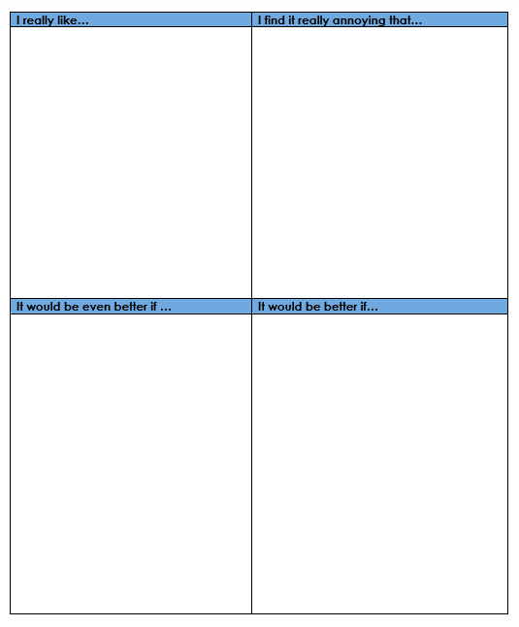
- Watch this clip from our change makers. What are two pieces of advice they offer about bringing about change in your community.

- Thinking about your community, write down some things that you really like and other things that annoy you. For both, try to put down a suggestion for how they could be better.

- Then ask at least two classmates to share their response and write it down as well.

- For homework, find two people in your community and ask them what they like and what annoys them. Ask them how each could be improved.

Students complete in a table format for tasks 4, 5 and 6.

Please note for forward planning task 6 requires students to speak with members of their community (family members, neighbours, local business owners and so on).

Choosing a problem

Learning intention: | We are learning to: select a problem in our community that is relevant and interesting
Success criteria | I can:  - list the problems in my community  - evaluate the importance of each problem to me  - select a problem to focus on for this project

Tasks in student booklet

- Using sticky notes, write down each of the things you and the people you asked said they liked. Then on different coloured sticky notes write down all the things people said they found annoying.

Feel free to adapt to this activity if you don’t want to use sticky notes. Please note, you will need to change the instructions in the student booklet for this section.

- As a class, group the problems on the sticky notes into similar areas. There might be areas like transport, amenities, infrastructure, environment, entertainment and so on.

You can also modify the activity to one in table groups rather than a whole classroom activity. Please note, you will need to change the instructions in the student booklet if you choose this modification.

If students are struggling to group problems, you could provide the categories such as, Infrastructure, Environment, Amenities, Entertainment, Safety, Education, Recreation, Community Spirit, Economy, Health & Wellness, Transportation, Culture.

- Look at all the problems identified in your community and answer the questions below.
  - What do most people like in your community?
  - What do most people find annoying in your community?

- Watch this clip from our change makers. What are two things to consider when choosing a problem?

- Reflecting on all the problems you have listed, select one to focus on for your project and write this down below. You do not need to know the solution yet.

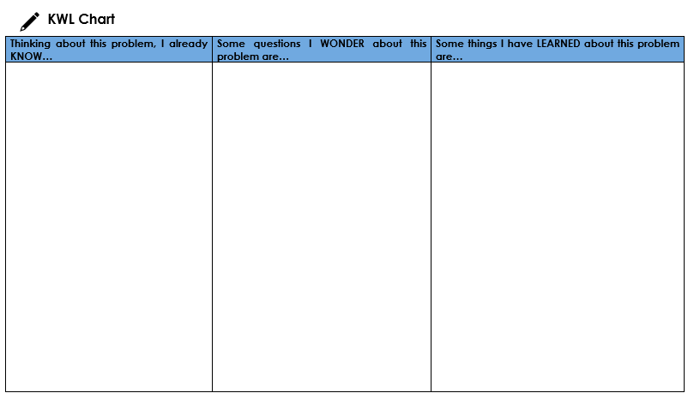
If students are struggling to come up with a problem or you want them to be able to explain why they picked the one they did, try doing the 5-Whys activity.

Students can use the prompts included when selecting their focus: The problem in my community that I would like to change is, and I would like to pick this problem because…

- Fill in the Know, Wonder, Learn table about your problem (on the next page). You only need to fill in the ‘Know’ and ‘Wonder’ for now (the ‘Learn’ section will come at the Research stage).

Researching your problem

Learning intention: | We are learning to: research our problem
Success criteria | I can:  - identify where I should do my research  - use research templates to gather information  - engage with others in my community to gather evidence

Tasks in student booklet

- Watch this clip from our change makers. What advice do they give about researching your problem?

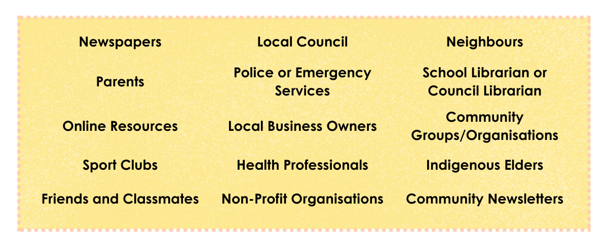
- Look at the information locations below and circle which ones you think might be useful for your research. If needed, add any others you can think of under the box.

You may add more information locations or provide more specific locations (particularly for online resources) if you have any in mind that you wish for your students to use.

- Selecting the research templates that are most useful for your topic, conduct your research. Things you might explore include why does this problem exist and why hasn’t it been solved? Who is affected by this problem and what do they need or want?

You can download these templates from our website. There are three research templates for note-taking and two survey templates for students. We have provided a selection of templates to encourage student choice.

Note-taking templates:

The templates can be used to guide your students with their research and note-taking of information. There are many note-taking techniques that students can use; these should only be seen as a snapshot of possible methods.

Please note, in the templates we have inserted the sample inquiry questions from the booklet, however, feel free to take these out if you wish for your students to generate their own.
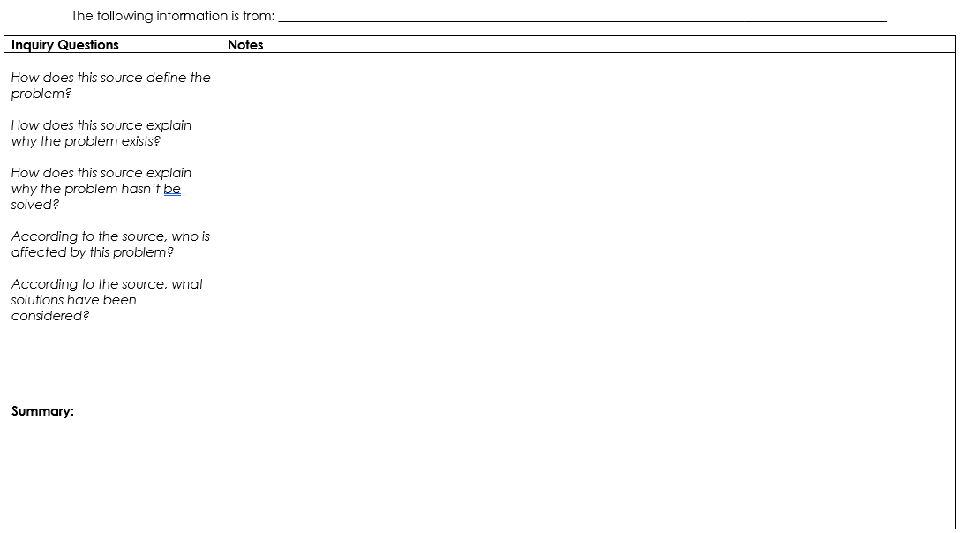
Style 1: Cornell Note Taking
  - This style is a helpful tool to summarise information from one source.
  - This template has been modified for ease of use for this project and includes inquiry questions.
  - We would recommend using this in an A4 format.

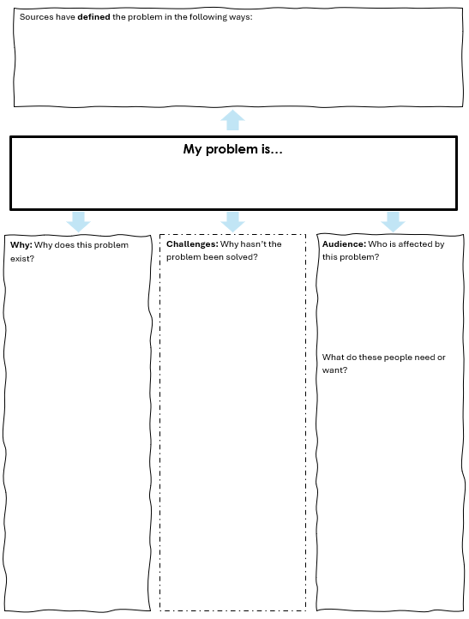
Style 2: Mind Mapping
  - This style is a helpful tool to summarise key information from multiple sources.
  - This template provides more guidance for students when researching for their project.
  - In addition, we suggest students record where they get their information from when using this style in case they need to return to specific research. A numbered bibliography is provided, and students are encouraged to assign the source number to their notes whilst mind mapping. Students can also colour code their numbered sources to help them keep track of their sources.
  - We would recommend using this in an A3 format.

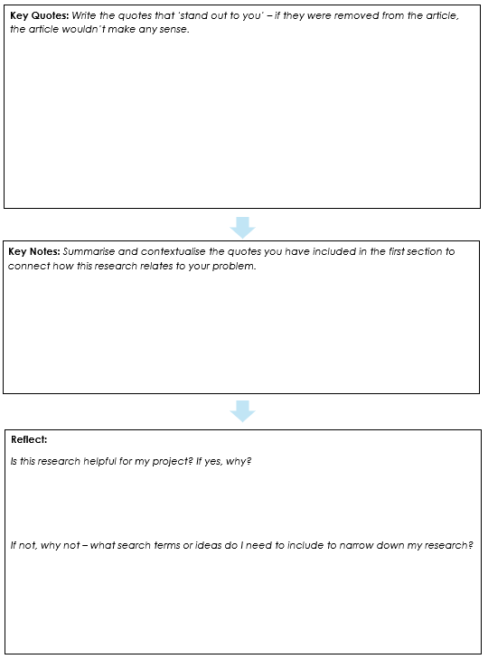

Style 3: Key ideas only
  - This style is a helpful tool to summarise information from one source.
  - This style is a helpful tool for students to identify the ‘through line’ or ‘key message’ of a source by focusing on key quotes to then summarise.
  - It asks students to reflect on the suitability of the source for their research and highlights how research is a process.
  - We would recommend using this in an A4 format.

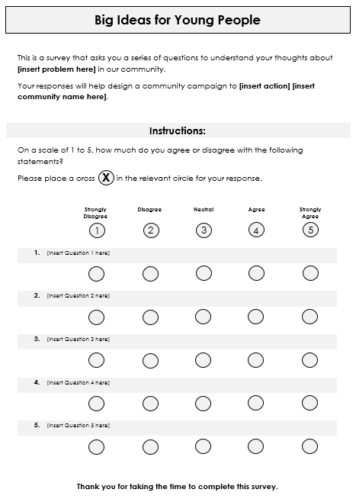
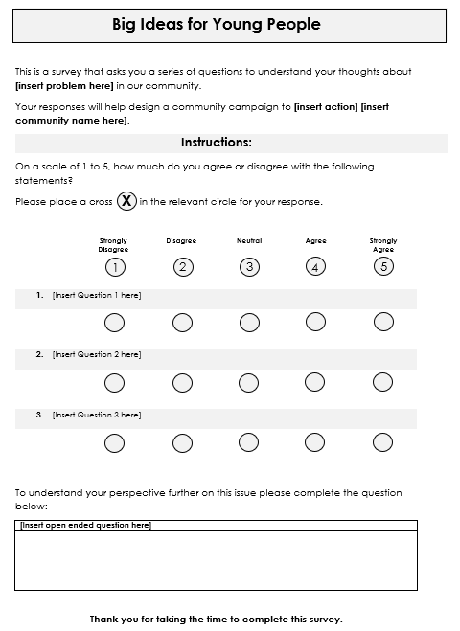
Survey Templates:

The survey templates are designed for students to canvas their community.

Instructions are included for students with these templates, including how to create strong closed questions and what to do with the data once it’s collected to inform their project (including a tally template for students to use when analysing their results).

Students may choose to do a digital form, rather than hardcopy for their survey.

- When you have finished your research, write out your key findings in the ‘Learned’ column of the KWL chart listed on the previous page.

Picking a solution

Learning intention: | We are learning to: understand what makes a great solution
Success criteria | I can:  - evaluate possible solutions to a problem  - brainstorm solutions to a problem  - explain my solution to other people and get feedback to improve it  - develop a solution that is realistic and effective

Tasks in student booklet

- Watch this clip from our change makers. What advice do they give about coming up with a solution to your problem?

- Evaluate the following possible solutions to the problem of ‘There is too much single-use plastic waste’. On a scale of 1 – 5, rate how effective you think the solution will be and explain why you gave it that rating.

1 = Not effective or realistic 5 = Very effective and realistic

Problem | Possible solutions | Rating | I gave that rating because…
There is too much single-use plastic waste | Booby trap plastic bags |  | This is dangerous and most likely not effective. People may be angry or frightened and then not support your idea.
There is too much single-use plastic waste | Ban single-use plastic bags |  | This ban is only focusing on plastic bags. As plastic bags make up a large percentage of single use plastic, banning them in shops will reduce the amount of single-use plastic. It will hopefully make people more conscious of bringing reusable bags.
There is too much single-use plastic waste | Invent an environmentally friendly plastic eating bug |  | While this is a cool idea, it will be difficult to achieve without a team of scientists to help. This might be a bit hard to achieve!
There is too much single-use plastic waste | Ban all single-use plastic |  | While this is ambitious, it is not very practical or realistic. It would be very hard to implement and there are examples where single-use plastic is needed. E.g. in hospitals.

- Brainstorm solutions to your problem. You are not focusing on how you are going to achieve it, just what you would like to achieve. Remember, it needs to be effective and realistic.

The table provided for this activity provides students with enough space for three possible solutions, you can insert more space if required.

- Select which solution is achievable and write down why your solution was chosen in the space on the next page.

Students are provided the sentence starters: “My solution is…” and “This is a good solution to the problem because…”

Get some feedback – test your solution by explaining the problem you are trying to address and your solution to a classmate or someone in the community. Build your confidence and ask for their suggestions. Write down any helpful feedback you receive below.

Again, you could get students to use the 5 Whys activity to test the strength of their solution.

Ideas to communicate your solution

Learning intention: | We are learning to: understand how you use an idea to communicate a solution
Success criteria | I can:  - explain the problem, solution and idea of two different change campaigns  - brainstorm ideas to communicate my solution  - select an idea and explain why it is effective

- Watch this clip from our change makers. What advice do they give about coming up with a great idea to communicate your solution?

- Below are examples of a problem, solution and idea from Who Gives a Crap and Oxfam Australia. Using two different colours, highlight the boxes that match the organisation using different colours. Fill in the blank identifying if it is a problem, solution or idea.

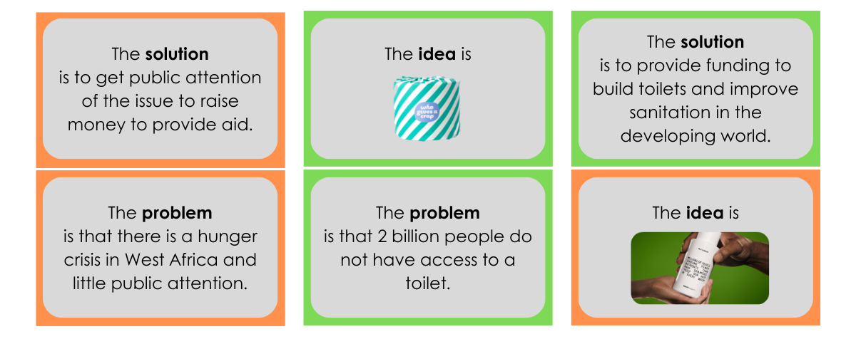
- Your teacher has selected a change campaign for you to examine. Using the information
from the campaign, identify and explain the problem, solution and idea.

Here are two examples you could use. If you don’t think they are right for your students, you can pick a different campaign to focus on.

Campaign One – TAC Road Safety ad:
- The problem highlighted is that too many people are dying on Victoria roads (213 in 2020, it was 288 people in 2025)
- The solution put forward is drivers need to drive safely on Victorian roads so we can reduce the road toll to zero.
- The idea used to communicate the solution is empathy, encouraging people to imagine how they would feel if it was their family who were the victims of road accidents. They want people to see the value of human life and want to protect it.

Campaign Two – Taika Waititi anti-racism ad:
- The problem highlighted is the prevalence of racism in our society.
- The solution put forward is to get people to reflect on their behaviour and how they may have contributed to spreading racism. It also encourages people to be mindful in the future.
- The idea used to communicate the solution is satire and humour, encouraging people to be racist. This is meant to be shocking and make people see that racist behaviour is actually wrong.

Students are provided with the following sentence starters to complete this activity:
- The change campaign chosen by your teacher is…
- The problem highlighted is…
- The solution put forward is…
- The idea they use to communicate the solution is…

- Brainstorm as many ideas as you can for your problem. They might start sensible but may get silly and crazy as you go on. Don’t worry if they are impractical or impossible yet, it is just about getting ideas down.

You can set a challenge for your students e.g. write 20 or 50 ideas down. The point is to get them to think beyond the usual or expected ideas.

Here are some different types of ideas they could come up with:

- Behaviour change campaign – this is aimed at getting people to stop behaving one way and start behaving another way. E.g. Quit smoking ads, TAC safe driving ads, water safety etc.

- Fundraising campaigns – fundraising money to go towards a cause. This might be money to start an ethical business; an invention that will lead to change; buy specific supplies for groups in need and so on. With this one, it is best if the students can think of exactly what the money would be spent on and how much they would need.

- Petition or protest – this is often employed when you want rules, laws or policies to be changed or when you want the groups with the power and money to make something happen. For example, protests to demand the Federal Government stop subsiding fossil fuel companies OR a petition to remove asylum seeker children from detention centres. Depending on what the students are focusing on, they might be aiming their petition or protest to the school, local council, State Government or Federal Government. The aims and demands of the petition and/or protest need to be very clear.

- Pick an idea for your solution.

It is important students check that there isn’t someone already doing their idea in their community. They need to offer something new.

Students can use the prompts included when selecting their idea: “My idea is…” and “This is a good idea to communicate my solution because.”

Delivering a pitch

Learning intention: | We are learning to: deliver a great pitch
Success criteria | I can:  - take notes while watching a presentation  - explain my problem or the opportunity that exists  - brainstorm ways to activate my idea  - design my pitch  - prepare some responses in case of shutdowns

- Watch this clip Pitching and Problem-Solving presentation by Ivor Vaz from Oxfam Australia. Take notes on what he says is important to include in your pitch.

- Complete the steps suggested over the page by Ivor from the Pitching and Problem-Solving clip.

Students follow the steps suggested including:
- Step One: Start with, ‘You know how…’
- Steo Two: Follow that with, ‘What we do is…’
- Step Three: End with, ‘In fact, …’

- Ivor talks about how you might activate your ideas. Do a brainstorm about all the ways you could activate your ideas. Choose some to include in your pitch.

This is all about trying to bring attention to their idea. You might like to use a lotus diagram for their brainstorming. In the middle boxes, the students can brainstorm 6-8 activation ideas and then they can add the details of what would be required to implement each one.

Here are some areas they might like to think about:
- Host some entertainment – a concert, play, movie night etc. to bring attention to your idea.
- Hospitality – have a BBQ, cake stall, social gathering etc. to bring people together to talk about your idea and get people to act.
- Create media – make posters, videos, and other media to advertise your idea.
- Write an article for the local newspaper/newsletter – could be a letter to the editor or opinion piece.
- Organise a community challenge or competition – a walk-a-thon, colour run, art contest, trivia night centred around your idea.
- Host an educational workshop or talk – invite speakers or have workshops where people complete hands-on activities to understand your idea and to get people to act.
- Launch a petition or pledge campaign – get people to show their support by signing a petition or committing to an action connected to your idea, use this data to petition local council/state government/federal government.

- Now you need to outline your ASK. What do you need to make your idea happen? Money, materials, volunteers, location? Be specific in your answer.

For example, if the student’s idea is to build a BMX track, this might be their ask of the council:
- Money:
  - Design drawings: $10,000
  - Engineering specifications: 10,000
  - Construction costs: $100,000
  - Signage: $5000
  - Total: $125,000
- Materials: Printed posters, flyers and emails sent to community members asking for feedback on the proposal.
- Location/Venue: the vacant crown allotment land at 1 Clark Street is the ideal location but would require council approval for use. The land connects to the bike path that loops around the town. By placing the BMX bike path here, it would further encourage families and young people to get outside and exercise.

- Let’s get some final wisdom from our change makers. Write down two pieces of advice they give about the secret to a great pitch.

- Spend some time putting your pitch together. Your teacher will have some more suggestions about how to make a great presentation.

Review the assessment criteria for guidance on what to include in the pitch presentation.

An activity you might like to do with your class is to go into class and deliver a really bad presentation (it can be even more effective if you don’t warn them you are doing it on purpose). You might have slides with too much writing and a colour font that is hard to read. You might mumble, avoid eye-contact and generally present in a way that is not engaging. You can then get feedback from the students about what you could have done to make the presentation better.

- Ivor also says that you need to pre-empt shutdowns. Practise delivering your pitch to as many different people as possible. Ask them to challenge your pitch and make a list of the possible shutdowns. Then write some prepared responses in case they come up.

Students are guided to use the sentence starter, ‘Thank you, that’s an excellent question…’ when responding to questions.

End of Booklet

