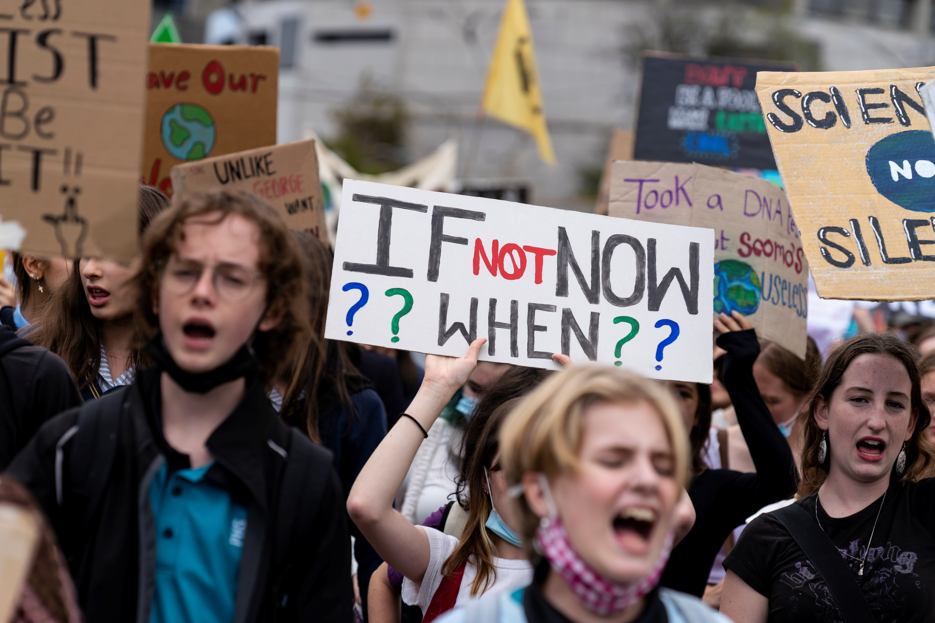


Big Ideas for Young Minds
Student Booklet

Year 5 and 6
Civics and Citizenship

Acknowledgement of Country
State Library Victoria acknowledges the traditional lands of all the Victorian Aboriginal clans, and their cultural practices and knowledge systems.
We recognise that our collections hold traditional cultural knowledge belonging to Indigenous communities in Victoria and around the country. We support communities to protect the integrity of this information, gathered from their Ancestors in the colonial period.
We pay our respects to their Elders, past and present, who have handed down these systems of practice to each new generation for millennia.

Cover Image:
Matt Hrkac
Schools Strike for Climate 2022
https://www.flickr.com/photos/matthrkac/albums/72177720297607987/with/51960583630
Introduction

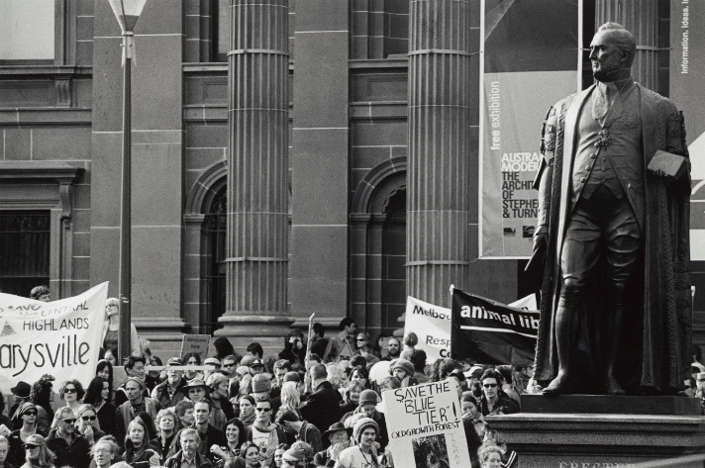

Sideris, Harold. (2004) Crowd of protesters gathered around statue of Redmond Barry. H2004.102/2
Hunt, Maylei. (2017) Let’s eat cake. H2019.239/12

Welcome to Big Ideas for Young Minds
State Library Victoria has a long history of being a site of protest and people calling for change. Groups come to our forecourt to demand better rights, the end to war, for laws to change, for solidarity with oppressed people and for many more reasons.
We know that having a say about what happens in your community is a right that everyone should enjoy, but sometimes young people can be overlooked. Big Ideas for Young Minds is designed to help you be a voice for change in your community. It will guide you through picking a problem, developing a solution and coming up with an idea to communicate your solution. Finally, you will learn how to pitch your ideas so you can get others to support your call for change.
Introduction to our change makers:

The Library has been lucky to work with a team of talented change makers who will help guide you through each step of this unit. Let’s meet them!

Watch this clip introducing our change makers.






Ivor Vaz Inga Hamilton Jehan Ratnatunga Kate Kendall
Oxfam Australia Resource Smart Schools Who Gives a Crap Entrepreneur
& Mayor

Why change?

Learning intention: | We are learning to: understand why people work for change.
Success criteria | I can:  - explain why change is important  - order key moments of change in Australia’s history  - reflect on the impact of change
Watch this clip from our change makers. Why do they think it is important to work for change? Write down 3 points that you found interesting below.


It is sometimes hard to notice change happening. It can also be easy to take for granted rights and freedoms we enjoy today. Using the following website, list the year these key moments of change occurred.
Event | Year | Key notes
Free compulsory secular education in Victoria |  | The Victorian Government's Education Act introduced free, secular (non-religious), and compulsory education for children aged 6–15. Indigenous children could attend but faced an "exclusion on demand" policy, allowing their removal at community members' request.
Women’s right to vote |  | South Australia was the first place in the world to give women the right to vote. When women were given the right to vote in national elections, women who were First Nations or non-European were excluded until 1962.
Polio vaccine introduced |  | Polio is an incurable disease that could cause permanent paralysis and death, and it was most common in children. Australia was declared polio free in 2000 because of routine immunisation.
Indigenous Australians’ right to vote |  | Aboriginal and Torres Strait Islander peoples were unable to vote at Federal and State elections. The Commonwealth Electoral Act amended this granting them the right to vote. However, voting was not compulsory for Indigenous Australians until 1984.
Sex Discrimination Act |  | The Sex Discrimination Act was passed which ensured women had the same access to employment and services. As part of this act, sexual harassment was also made illegal.
National Firearms Agreement |  | After the devastating Port Arthur massacre, the government tightened gun laws banning certain firearms. They also restricted ownership, and mandated safe storage and state registration. In 2023, gun registration transitioned from state and territory control to a unified national register.
Budj Bim UNESCO World Heritage Status |  | Under the UNESCO World Heritage List the Budj Bim Cultural landscape became the first location in Australia to be recognised for its Aboriginal cultural significance. The site is one of the oldest aquaculture sites in the world. With this recognition, the site is protected by international treaties with conservation efforts in place to ensure it remains accessible to all.
Same Sex Marriage Legalised |  | The Marriage Act was amended to grant same-sex couples the right to marry. In 2004 marriage was defined as, “the union of a man and a woman to the exclusion of all others.” With the legalisation of same-sex marriage this definition was altered to “a union of two people”.


Reflect on the events listed; which one do you think is the most important change in Australia and why? Write your answer below.


Look at the image below. What do you think this is? Draw a picture of what you think it turns into in the box on the right.
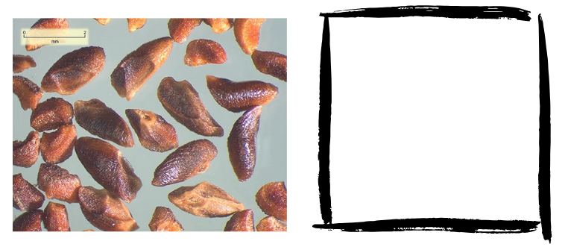
©Centre for Australian National Biodiversity Research.

Your teacher is now going to reveal what the items above turn into. What do you think we can learn from seeing their transformation?

Caring for your community

Learning intention: | We are learning to: reflect on our community and how it could be improved.
Success criteria | I can:  - define the word community  - reflect on what I like about my community and how it could be improved  - reflect on what annoys me about my community and how it could be improved
Write your own definition of the word community. What does this word mean to you?


As a class, list similar key words and themes that your class noted down when defining community.

Watch this clip from our change makers. What are two pieces of advice they offer about bringing about change in your community.

Thinking about your community, write down some things that you really like and other things that annoy you. For both, try to put down a suggestion for how they could be better.

I really like… | I find it really annoying that…
It would be even better if … | It would be better if…

Then ask at least two classmates to share their response and write them down as well.
I really like… | I find it really annoying that…
It would be even better if … | It would be better if…

For homework, find two people in your community and ask them what they like and what annoys them. Ask them how each could be improved.

I really like… | I find it really annoying that…
It would be even better if … | It would be better if…

Choosing a problem

Learning intention: | We are learning to: select a problem in our community that is relevant and interesting
Success criteria | I can:  - list the problems in my community  - evaluate the importance of each problem to me  - select a problem to focus on for this project

Using sticky notes, write down each of the things you and the people you asked said they liked. Then on a different coloured sticky note write down all the things people said they found annoying.

As a class, group the problems on the sticky notes into similar areas. They might be areas like transport, amenities, infrastructure, environment, entertainment and so on.

Look at all the problems identified in your community and answer the questions below.

- What do most people like in your community?

- What do most people find annoying in your community?

Watch this clip from our change makers. What are two things to consider when choosing a problem?

Time to pick your problem!
Reflecting on all the problems your class has listed, select one to focus on for your project and write this down below. You do not need to know the solution yet.
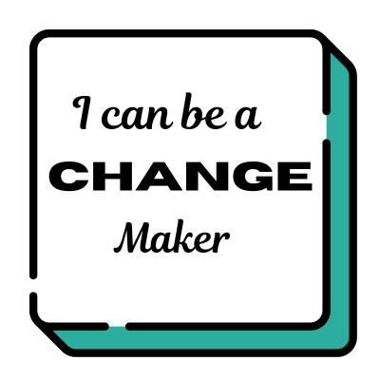
The problem in my community that I would like to change is…

I would like to pick this problem because…

Fill in the Know, Wonder, Learn table about your problem (on the next page). You only need to fill in the ‘Know’ and ‘Wonder’ sections for now (the “Learn” section will come at the Research stage).

KWL Chart
Thinking about this problem, I already KNOW… | Some questions I WONDER about this problem are… | Some things I have LEARNED about this problem are…

Researching your problem

Learning intention: | We are learning to: research our problem
Success criteria | I can:  - identify where I should do my research  - use research templates to gather information  - engage with others in my community to gather evidence
Watch this clip from our change makers. What advice do they give about researching your problem?


Look at the information locations below and circle which ones you think might be useful for your research. If needed, add any others you can think of under the box.
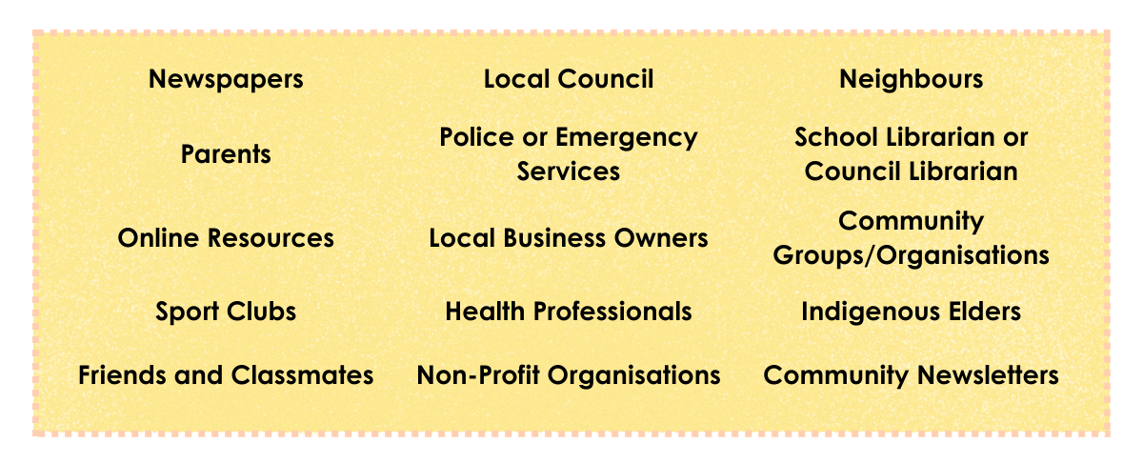

Selecting the research templates that are most useful for your topic, conduct your research.
Things you might explore include why does this problem exist and why hasn’t it been solved? Who is affected by this problem and what do they need or want?
When you have finished your research, write out your key findings in the ‘Learned’ column of the KWL chart listed on the previous page.

Picking a solution

Learning intention: | We are learning to: understand what makes a great solution
Success criteria | I can:  - evaluate possible solutions to a problem  - brainstorm solutions to a problem  - explain my solution to other people and get feedback to improve it  - develop a solution that is realistic and effective
Watch this clip from our change makers. What advice do they give about coming up with a solution to your problem?


Evaluate the following possible solutions to the problem of ‘There is too much single-use plastic waste’. On a scale of 1 – 5, rate how effective and realistic you think the solution will be, and explain why you gave it that rating.
1 = Not effective or realistic 5 = Very effective and realistic

Problem | Possible solutions | Rating | I gave that rating because…
There is too much single-use plastic waste | Booby trap plastic bags
There is too much single-use plastic waste | Ban single-use plastic bags
There is too much single-use plastic waste | Invent an environmentally friendly plastic eating bug
There is too much single-use plastic waste | Ban all single-use plastic

Brainstorm solutions to your problem. You are not focusing on how you are going to achieve it, just what you would like to achieve. Remember, it needs to be effective and
realistic.

Problem | Possible solutions | Rating | I gave that rating because…

Select which solution is the most effective and realistic. Explain your solution on the next page.

My solution is…

This is a good solution to the problem because …

Get some feedback – test your solution by explaining the problem you are trying to address and your solution to a classmate or someone in the community. Build your confidence and ask for their suggestions. Write down any helpful feedback you receive below.

Ideas to communicate your solution

Learning intention: | We are learning to: understand how you use an idea to communicate a solution
Success criteria | I can:  - explain the problem, solution and idea of two different change campaigns  - brainstorm ideas to communicate my solution  - select an idea and explain why it is effective
Watch this clip from our change makers. What advice do they give about coming up with a great idea to communicate your solution?


Below are examples of a problem, solution and idea from Who Gives a Crap and Oxfam Australia.
- Using two different colours, highlight the boxes that match the organisation using different colours.
- Fill in the blank identifying if it is a problem, solution or idea.
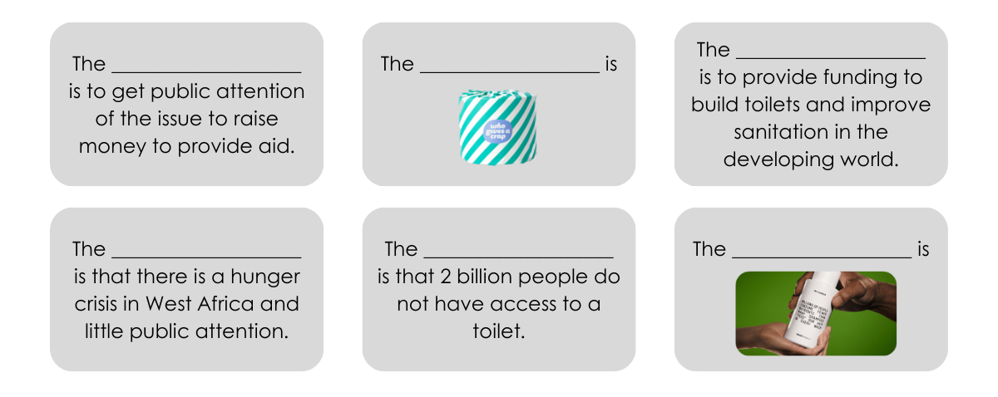Tip: Not sure? Have another look at the clips for the campaigns as a refresher.

Your teacher has selected a change campaign for you to examine. Using the information from the campaign, identify and explain the problem, solution and idea.

The change campaign chosen by your teacher is…

- The problem highlighted is…

- The solution put forward is…

- The idea they use to communicate the solution is…

Now it’s your turn!

Brainstorm as many ideas as you can for your problem. They might start sensible but may get silly and crazy as you go on. Don’t worry if they are impractical or impossible yet, it is just about getting ideas down.


Pick an idea for your solution.

My idea is…

This is a good idea to communicate my solution because …

Delivering a pitch

Learning intention: | We are learning to: deliver a great pitch
Success criteria | I can:  - take notes while watching a presentation  - explain my problem or the opportunity that exists  - brainstorm ways to activate my idea  - design my pitch  - prepare some responses in case of shutdowns
Watch this clip the Pitching and Problem-Solving presentation by Ivor Vaz from Oxfam Australia. Take notes on what he says is important to include in your pitch.

Complete the steps over the page from the Pitching and Problem-solving presentation.

You have already completed the steps of picking a problem, choosing a solution and coming up with an idea.

Yay, you have already done most of the work!

Have a go at wording them with Ivor’s lines at each step of the pitch.

Step One: Start with, ‘You know how…’

Step Two: Follow that with, ‘What we do is…’

Step Three: End with, ‘In fact, …’



Ivor talks about how you might activate your ideas. Do a brainstorm about all the ways you could activate your ideas. Choose some to include in your pitch.

Now you need to outline your ASK. What do you need to make your idea happen? Money, materials, volunteers, location? Be specific in your answer and write it below.

Let’s get some final wisdom from our change makers. Write down two pieces of advice they give about the secret to a great pitch.

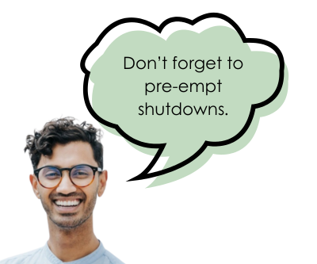
Spend some time putting your pitch together. Your teacher will have some more suggestions about how to make a great presentation.

Ivor also says that you need to pre-empt shutdowns. Practise delivering your pitch to as many different people as possible.
Ask them to challenge your pitch and make a list of the possible shutdowns.
Then write some prepared responses in case they come up.

Pre-empt: Thank you, that’s an excellent question…

